Discover Milan with Kids

Our Concierge’s top 10 recommendations to enjoy a fun family vacation in one of the most bustling Italian cities
May 11, 2018, Milan, Italy

 | 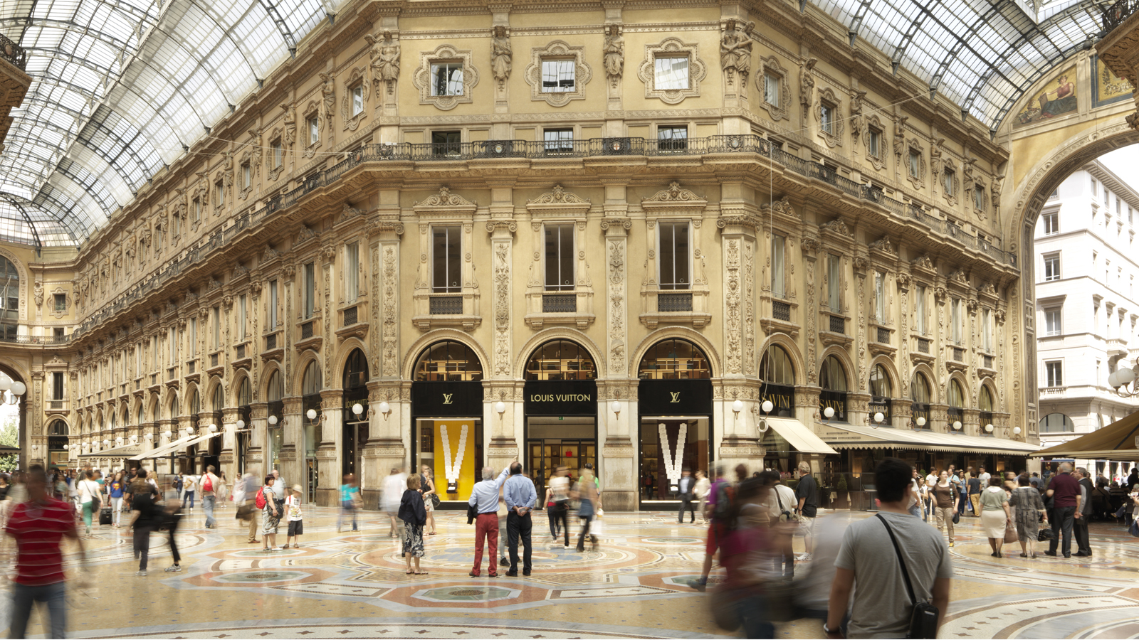 | 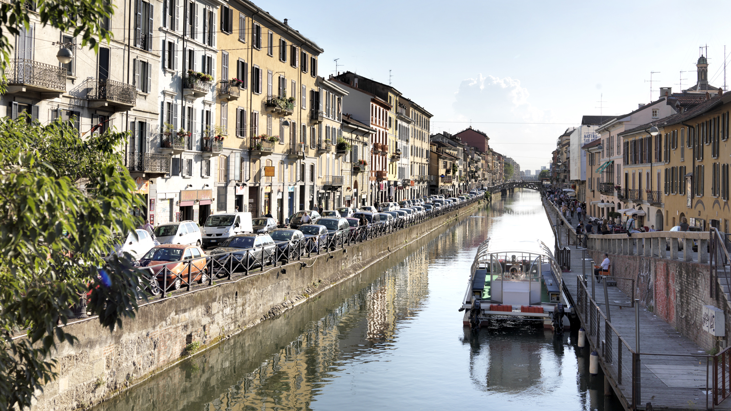
If Milan is famous for fashion and design it is also a great city for a fun family break.
Here are the top 10 recommendations of places and experiences to enjoy with children from the Concierge team at Four Seasons Hotel Milano.
1. Tailor Made Tours of Milan's Most Iconic Places
Start the day by walking through Milan’s panorama with personalised itineraries to explore the true essence of the city. Discover the shimmering marble cathedral of the Duomo, the church of Santa Maria delle Grazie and the 14th-century Sforza Castle with its magnificent Simplon Park. Guests can also admire the most modern skyscrapers in the City Life area and Gae Aulenti square, while the Navigli area and the Brera district offer the perfect spots for bicycle rides.
2. Museum of Toys
Puppets, marbles, action figures and dolls await kids who will throwback in time and discover the history of toys at the Museo del Giocattolo e del Bambino with its exhibition of perfectly conserved toys dated from the 18th century to the 1950s.
3. MUBA
Do not miss a visit to MUBA, a museum specifically created for children from 1 to 12 years old including innovative games, multi-sensorial experiences and interactive installations to support the development of an incredible creativity through this unusual way of education.
4. Kids at Pirelli Hangar Bicocca
One of the best galleries of contemporary art in Milan housed inside a greatly reborn 20th century factory, promotes a series of unique activities for children. Kids, an initiative created by Pirelli Hangar Bicocca, organises different projects, laboratories, displays and exhibitions for letting children and teenagers feel, understand and appreciate the different aspects of today’s art.
5. Teatro alla Scala and Great Performances for Children
The most celebrated theatre in Italy, the Teatro alla Scala, presents Great Performances for Children, a project born with the idea of welcoming little guests to the temple of Italian opera with famous plays, such as Rossini’s Barber of Seville, and magical concerts specifically adapted for kids. Time to take a seat!
6. Eataly's Kids Cooking Class
Eataly, the world's leading ambassador of Italian cuisine, offers fun cooking classes for children in the beautiful building close to the lively Corso Como area. Pasta, traditional desserts and a lot of other themes from the most authentic Italian culinary traditions await children for food experiences under the close supervision of Eataly’s talented chefs.
7. Shopping Therapy
For a perfect mom and daughter moment, there is nothing better than enjoying an exceptional shopping experience in the capital of Italian fashion. Just a few steps from the Hotel, Milan’s Fashion District provides a unique occasion to visit the best couture houses with a personal shopper, before heading to The Spa at Four Seasons Hotel Milano for a signature after-shopping treatment.
8. Soccer Experience
Italy is known all over the world for soccer. A tour for fathers and sons take guests to watch exciting games in the famous San Siro stadium, have an exclusive look to the trophies, learn everything about the most important Italian teams including Milan and Inter and finally visit the official stores. Can’t wait to scream “Goal!”
9. The Countryside of Milan
For those looking for a relaxing day dedicated to nature, the Concierge team can organise unforgettable educational day trips in the countryside to immerse guests in the rural atmosphere of classical Milanese farms. Meet local experts and join them in crafting laboratories, seed planting, vegetable picking and animal sightseeing.
10. A Day at Lake Como
Thinking about Lake Como means romantic getaways, enchanting sunsets and intimate dinners but this incredible area, not far from Milan, also offers rare ways to have fun with all the family. Starting the trip with a funicular railway to reach Brunate, a village over Como, to admire the mesmerising panorama and take amazing shots. After exploring the most colourful small towns and historical villas of the territory, such as Cernobbio and Tremezzo, guests will take a boat to breathe the fresh air of the lake and - in the regulated areas - may catch a tasty trout. Lunch with lake view can be organised in one of the oldest restaurants of the area, Crotto dei Platani, dating from the 19th century. And before heading back to Milan, do not forget to taste a delicious gelato.

RELATED

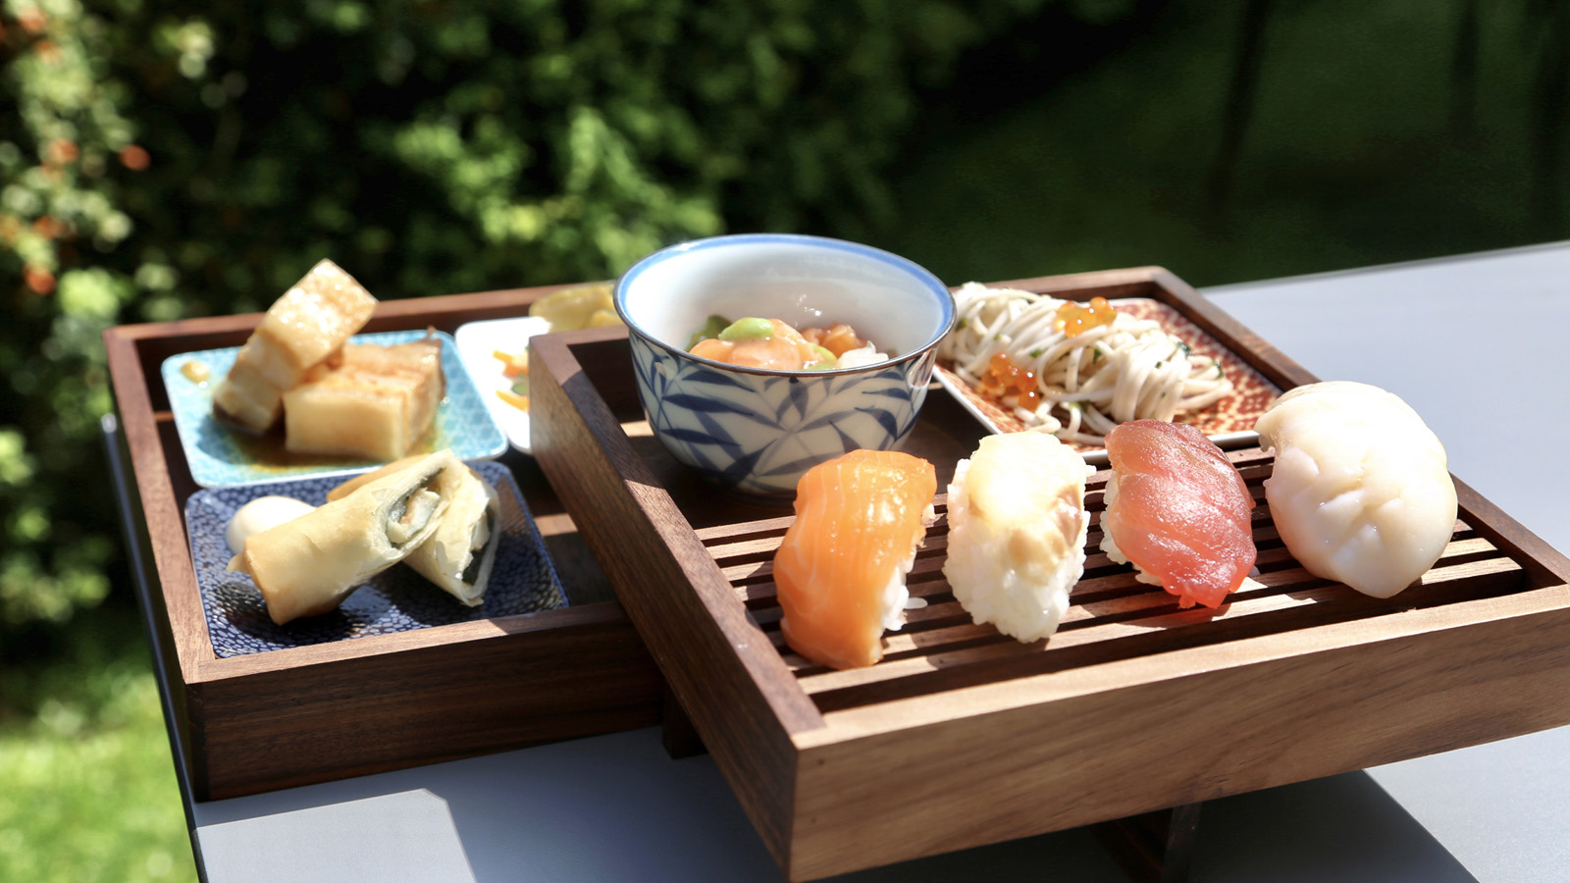 | April 23, 2018, Milan, Italy  Four Seasons Hotel Milano riapre il suo giardino con il menù “Japanese Tastes & Flavours”  https://publish.url/it/milan/hotel-news/2018/garden-menu-2.html
April 23, 2018, Milan, Italy
With the Arrival of Spring, Four Seasons Hotel Milano Reopens its Peaceful Cloistered Garden to Enjoy a Meal “Al Fresco” in the Heart of the City’s Vibrant Fashion District
https://publish.url/milan/hotel-news/2018/garden-menu.html

PRESS CONTACTS

Anita Ruozzi
Public Relations and Marketing Communication Coordinator
Via Gesu, 6/8
Milano
Italy
anita.ruozzi@fourseasons.com

+39 02 7708 1123

Caroline Mennetrier
Director of PR and Marketing Communication
Via Gesù 6/8
Milano
Italy
caroline.mennetrier@fourseasons.com

+39 02 7708 1795

