Beirut’s Highest Rooftop Pool, Bar and Lounge Reopens at Four Seasons Hotel Beirut with a Refreshed Look by Bernard Khoury

Hotel unveils highly anticipated rooftop experience, offering guests a new year-round destination for relaxation and socialising
June 20, 2019, Beirut, Lebanon

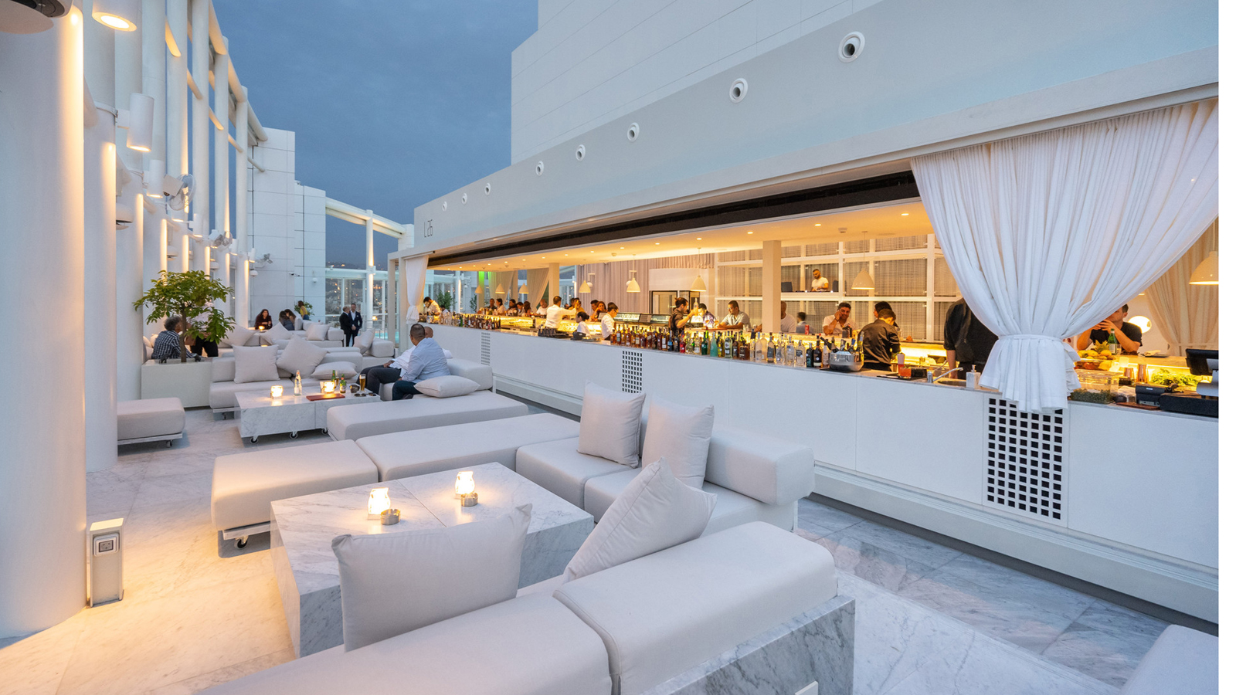
Experience sky-high luxury at Level 26, the new rooftop pool, bar & lounge at Four Seasons Hotel Beirut, an urban retreat for sun-soaked swims during the day and memorable year-round evenings made complete with handcrafted drinks and culinary delights.
Stepping into - or as the design would have it, out to - Level 26 is a breath-taking experience. Guests are welcomed by a lively atmosphere with an open space filled with white furniture, abundant white marble, a refreshed pool and an impressively long bar. The chic bar creates a social focal point for the bustling space and features stylish white accents with a white marble stone bar top. Guests can also take in the best views the city has to offer, stretching from the Mediterranean Sea to the Lebanese mountains, from Level 26’s outdoor patio, which is complete with both high tables and lush lounge seating.
“The entire rooftop lounge is designed to accommodate different times of use and types of events,” says Bernard Khoury, the architectural mastermind behind Level 26’s new look. “The white centrepiece bar can be enjoyed in all weather conditions. Its glass facades retract to connect with the exterior and remaining lounge area, giving guests the feeling that they are inside but also outside at the same time. All elements of the rooftop, from the floors to the pool and even the furniture pieces, are draped in marble, reflecting the sky in all its states.”
The international Pan-Asian and sushi menu created by Executive Chef Apostolus Dimou, comprised of creative and shareable plates, mirrors the elegant atmosphere that radiates from Level 26 with signature dishes including shrimp tempura bao buns, black cod miso and matcha crepe cake. The menu is completed with an inventive list of original cocktails and mocktails carefully concocted by expert mixologists.
“Whether guests are lounging underneath the sun or the stars, enjoying sunset drinks, or ensconced in a futuristic-looking glass bar as rain pelts down, the Level 26 experience is one they can’t find elsewhere,” says Rami Sayess, Regional Vice President and General Manager at Four Seasons Hotel Beirut. “We’re ready for everyone to experience this special place and give it a vibe unlike any other. Level 26 is absolutely the place to be in Beirut.”
Level 26, Pool and Lounge area is open daily from 7:00 am to 6:00 pm and Bar & Lounge area from 6:00 pm to 2:00 am. For reservations contact: + 961 -70-010555.

RELATED

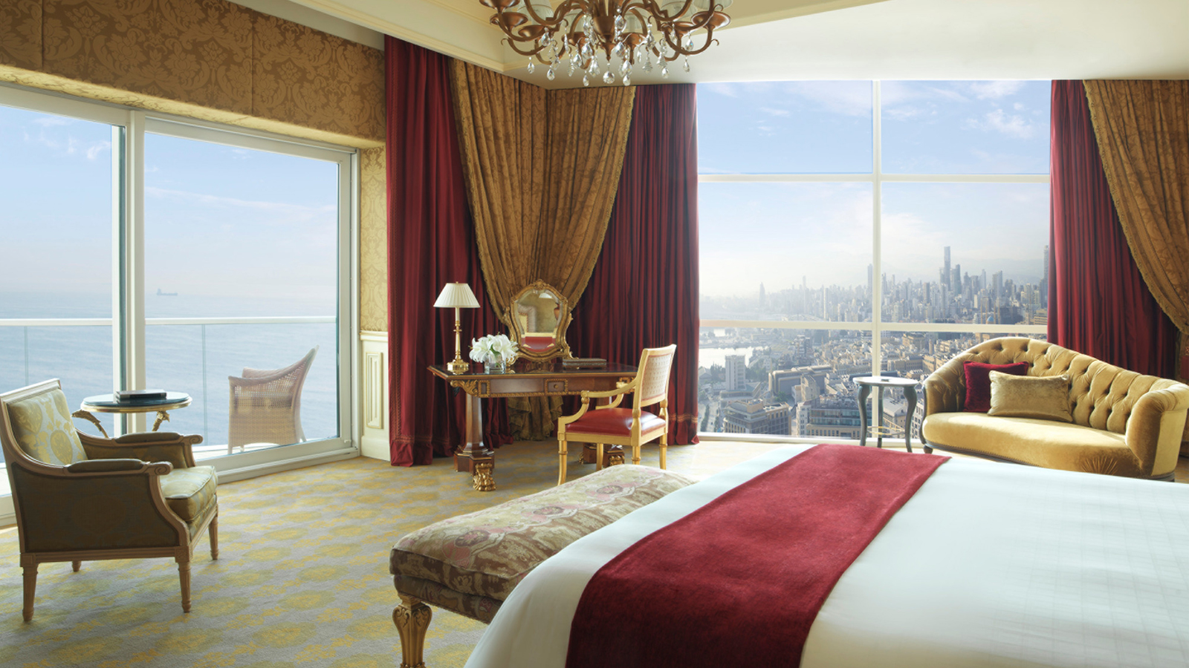 | May 29, 2019, Beirut, Lebanon  فندق فور سيزونز بيروت يحصد جوائز مرموقة في جوائز السفر العالمية 2019  https://publish.url/ar/beirut/hotel-news/2019/world-travel-awards-2.html
May 29, 2019, Beirut, Lebanon
Top Recognitions Awarded to Four Seasons Hotel Beirut at World Travel Awards 2019
https://publish.url/beirut/hotel-news/2019/world-travel-awards.html

PRESS CONTACTS

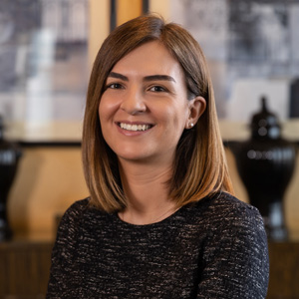 | Nada Atieh  Director of Public Relations & Communications  1418 Avenue Professor Wafic Sinno  Beirut  Lebanon  nada.atieh@fourseasons.com  +961 70 008829
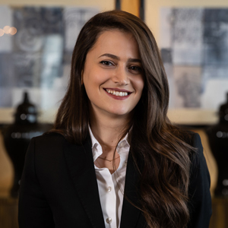 | Christina Jeokjian  Public Relations Coordinator  1418 Avenue Professor Wafic Sinno  Beirut  Lebanon  christina.jeokjian@fourseasons.com  +961 1 761000

