NOW OPEN: Four Seasons Hotel Minneapolis Ready to Welcome Guests from Near and Far

The Star of the North beckons travellers and the Twin Cities community to stay and play next to the mighty Mississippi River and vibrant North Loop neighbourhood
June 1, 2022, Minneapolis, USA

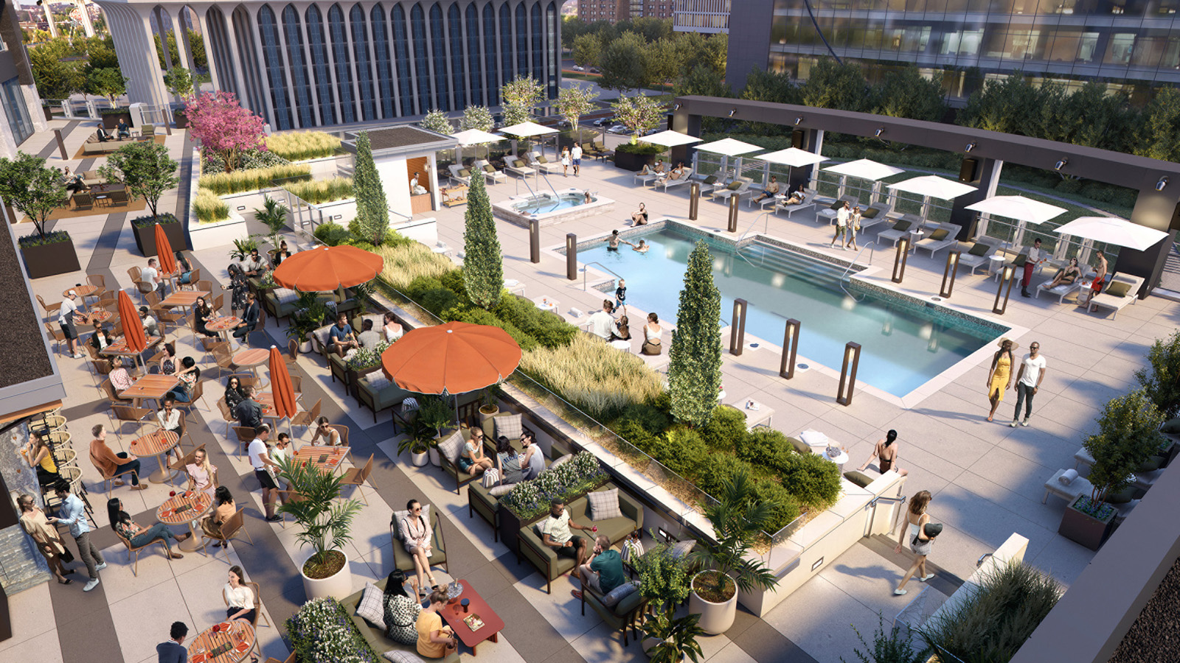
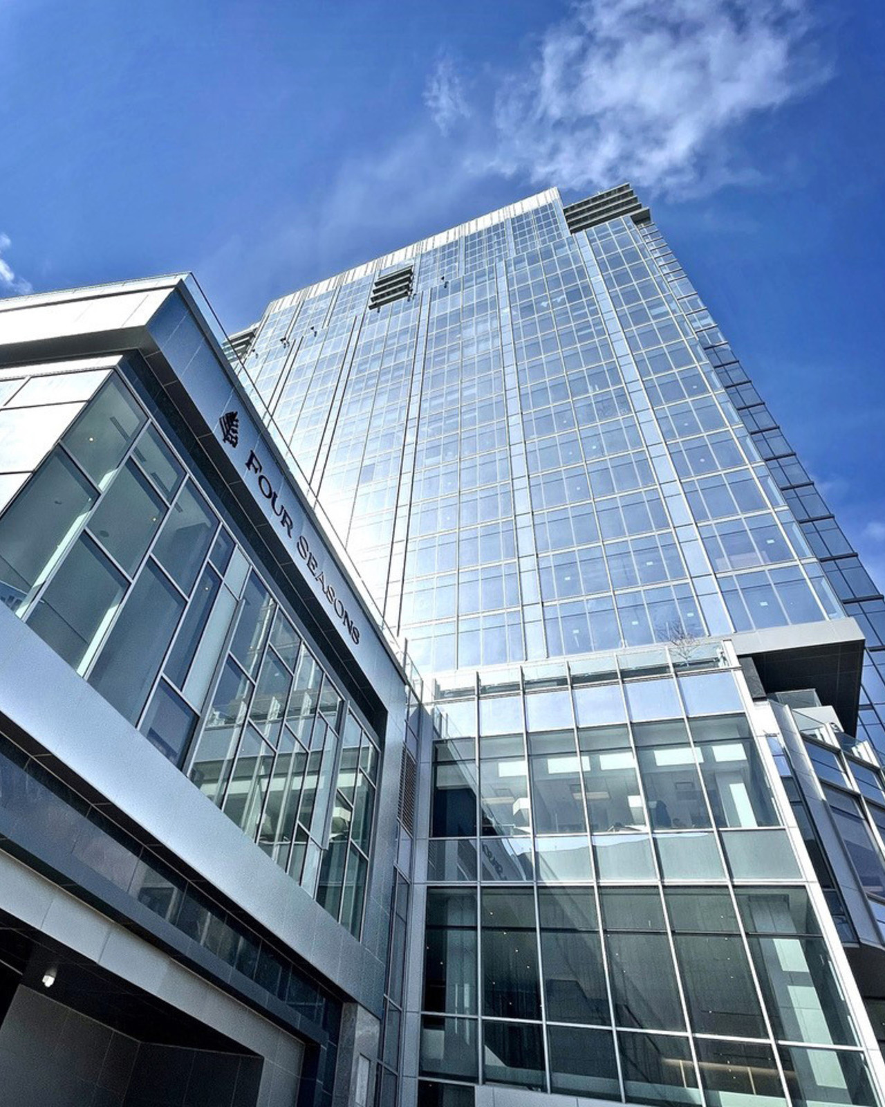 |  | 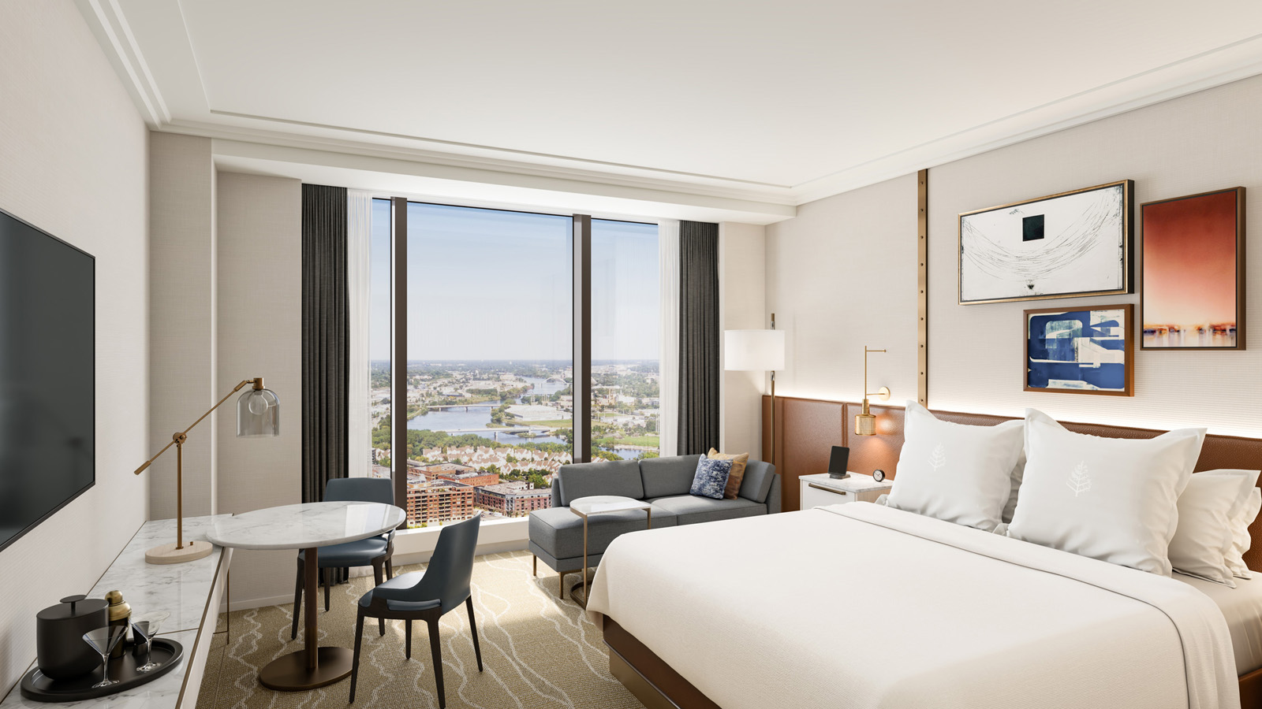
Rising 36 storeys above the city and firmly rooted in its dynamic downtown, the all-new Four Seasons Hotel Minneapolis is now open.
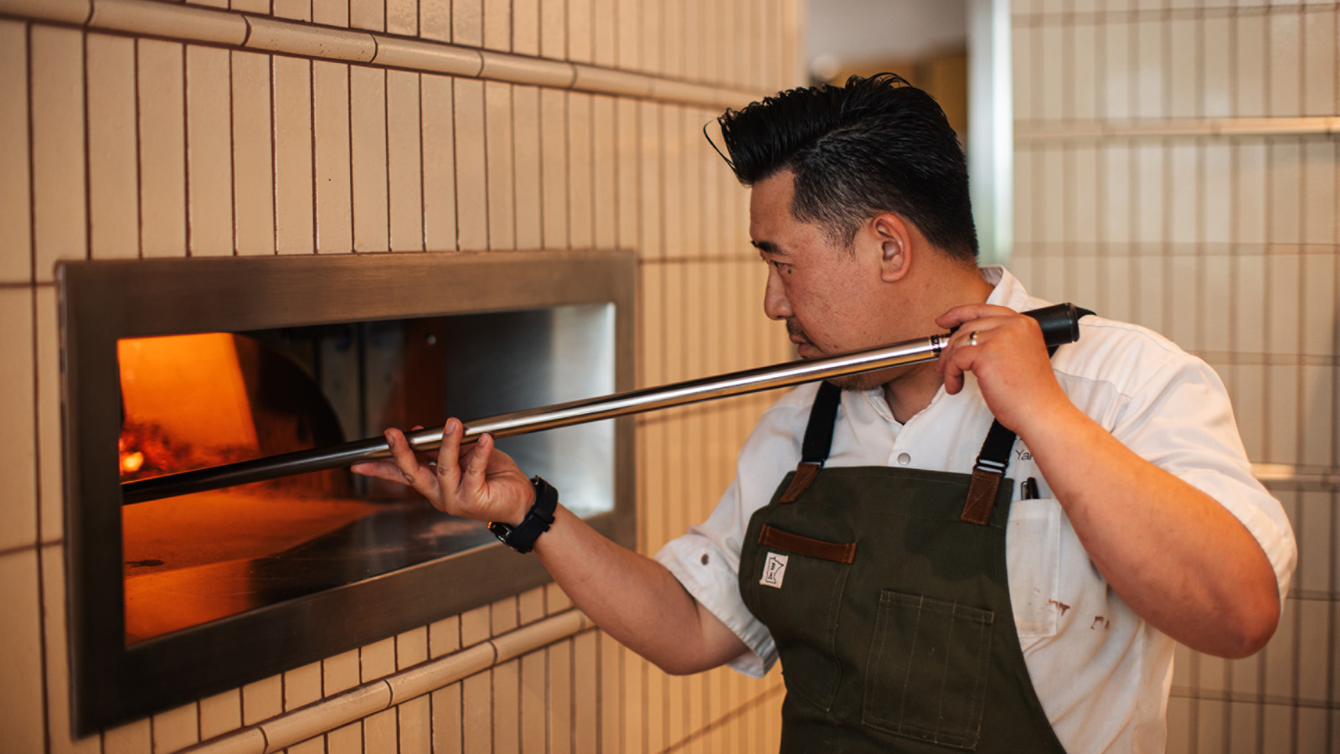 | 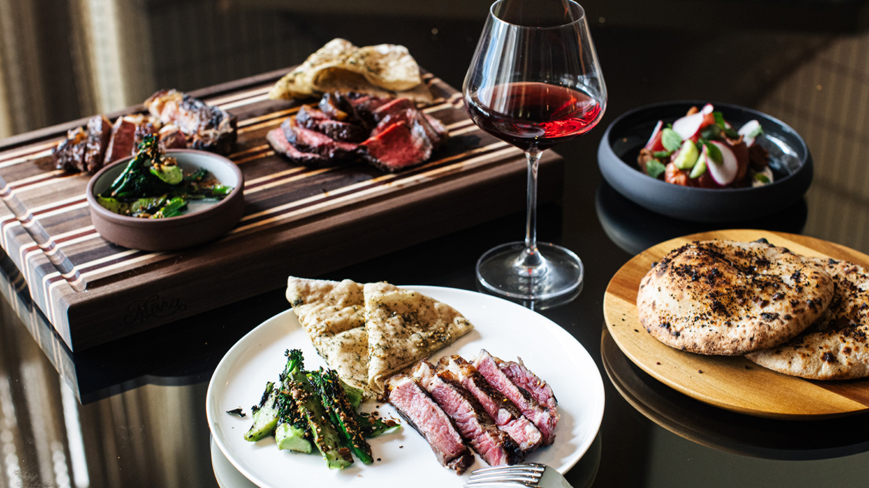 | 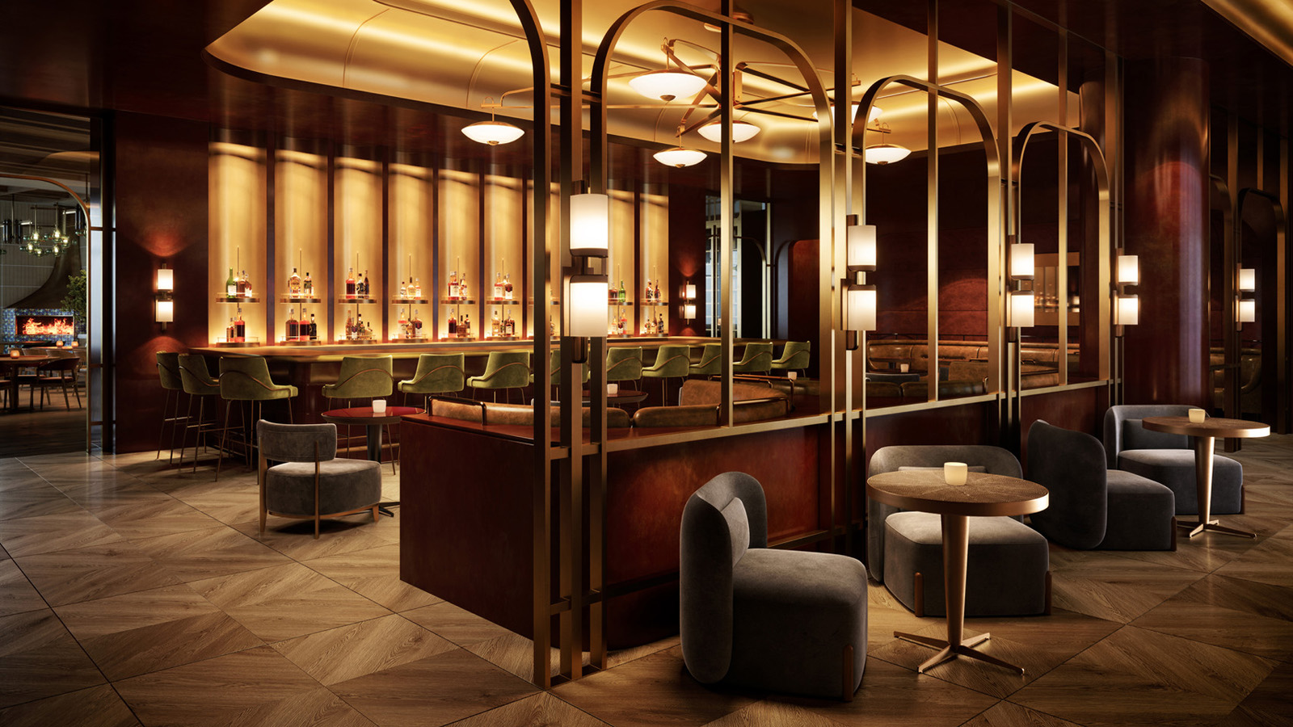
Welcoming guests on June 1, 2022, the Hotel boasts 222 spacious rooms, all with unobstructed, inspiring views; new dining concepts by local award-winning chef and restaurateur Gavin Kaysen; more than 16,000 square feet (1,500 square metres) of event space, and an entire floor dedicated to wellness and fun – complete with an evolving and sustainable spa, an indoor pool with floor-to-ceiling windows, and an outdoor pool on the city’s largest terrace.
“From the beginning, this project has been envisioned as much more than a hotel. It’s a gathering place for the local community as much as a place for visitors to stay,” says Christian Clerc, Four Seasons President – Hotels and Resorts. “Working with our esteemed owner-partners United Properties, whose commitment to their home city continues to inspire us, our passionate team is proud to offer elevated service and style in this important centre of business, leisure, culture and community.”
Four Seasons Hotel Minneapolis will be led by General Manager Florian Riedel, who began his career as a Four Seasons busser 27 years ago, and has been on the ground in Minneapolis for 10 months building a team of more than 300 people to bring Four Seasons service to the Twin Cities.
“We are incredibly excited to open our doors to community members and travellers from near and far,” says Riedel. “In the months leading up opening, we have made so many connections, thanks in large part to our locally-recruited staff who can’t wait to share their love of Minnesota with visitors, while forming even closer bonds with our neighbours and colleagues throughout the Twin Cities.”
Community Commitment
Four Seasons Hotel Minneapolis is committed to contributing 3,500 hours per year to the community, with a focus on downtown restoration efforts, social justice programs and health and wellness initiatives. Additionally, Four Seasons Hotel Minneapolis prioritizes local sourcing as well as energy, water and waste reduction, which includes eliminating single-use plastics from the guest experience.
Director of Marketing Chris White, who recently returned to Minnesota’s hospitality scene, notes that Four Seasons Hotel Minneapolis is on a mission to deliver experiences that bring people together and draw them to the Twin Cities. “Whether you’re a flight or footsteps away, we look forward to welcoming you to the Star of the North. This is a special place, and great things are happening here.”
Inspiring Views
Located high above the city on the building’s 23rd to 30th floors, 183 guest rooms and 39 suites give way to sweeping skyline and river views from floor-to-ceiling windows. Smallwood, the interior designers of the Hotel’s public spaces and accommodations, complemented each offering with bright and calming colours, crisp linens, marble table tops set against woollen carpets and half-wall wood panels accented by brass details. Numerous in-room features include a private MyBar outfitted with locally-sourced snacks, a Nespresso coffee maker, plush robes and slippers, premium Wi-Fi and a 65-inch flat-screen TV. Plus, guests enjoy signature Four Seasons Beds, twice daily housekeeping, same day laundry and overnight shoeshine, 24-hour in-room dining, and more.
“The lavish 30th-floor Presidential Suite is our most stunning accommodation, perfect for a family or entertaining with its full kitchen, two bar areas and up to three bedrooms – but our River-View Executive Suites are proving to be very popular too. With open layouts, they’re studio-style suites that feel both intimate and spacious at the same time, thanks to sweeping city and river views in two directions,” notes Minnesota native Dawn Turbes, the Hotel’s Director of Sales.
Destination Dining and Bar Scene
In partnership with Four Seasons, two-time James Beard Award-winning local chef and restaurateur Gavin Kaysen has created two new Mediterranean-inspired dining concepts: Mara, an every-occasion restaurant and bar, and Socca, a cheerful street-front café. Offering restorative experiences at the intersection of land, sea and craftsmanship, menu offerings are rooted in Chef Kaysen’s travels through the south of France and skills honed during his time working alongside Michelin-starred Chef Daniel Boulud.
The Hotel’s third dining option is an oasis of sunshine and socializing. Located on the fourth-floor pool plaza, Riva Terrace invites guests to enjoy aperitivo hour and coastal Italian cuisine by Executive Chef Martín Morelli. With views of the city skyline, it’s a nearly year-round destination for locals and visitors alike thanks to heating elements, a hot tub and cozy fire tables.
Beverage Director Adam Witherspoon and sommelier Paul Hennessy further elevate these dining destinations as well as Twin Cities makers, brewers, distillers, and crafters through their Mediterranean-meets-Minnesota cocktail enterprise and global wine program.
In addition to food and beverage pairings, global design leaders AvroKO complete the dining experience with reflections of both the Mediterranean coast and countryside as well as Minnesota's mill history and continued commitment to industry and innovation.
Holistic Wellness, Featuring an Evolving and Sustainable Spa Concept
Open to Hotel guests and day visitors, The Spa at Four Seasons presents signature rituals for body and soul inspired by Minnesota’s natural beauty. Director of Spa LeAnne Latham's nourishment-through-nature concept includes experiences both indulgent and effective, such as the Honey Haven Ritual featuring a full body scrub and body wrap following by a pampering massage. Just the Two of Us is an opportunity to share a spa experience with a friend or loved one and includes a restorative soak and hour-long massage in the intimate songbird suite. Evolving with the seasons, spa experiences are enhanced through the creative reuse of florals and with natural, plant-based and cruelty-free products.
The full floor wellness facilities also include an indoor pool; sauna, steam and cold plunge; and relaxation lounge with private spaces. The 24-hour, naturally lit, Harley Pasternak-designed fitness facility is stocked with state-of-the-art equipment by TRX, LifeFitness, Peloton and Tonal.
Meeting and Mingling
The Twin Cities’ premier address for weddings, events and business meetings, Four Seasons offers 10 unique venues – including the city’s largest outdoor terrace – across 16,500 square feet (1,500 square metres) of event space. Every room boasts up-to-the-minute technologies and neutral décor, offering maximum flexibility for wedding couples, hosts and planners to make each space their own.
“The epitome of elegance and style, our event spaces feature natural colours, discrete recessed lighting and ceiling rigging points to personalize celebrations and make what guests dream of a reality,” shares Director of Events Noelia Roblero, who began her Four Seasons tenure in 2007. “Plus, every room is filled with natural light, and all indoor venues are located on the skyway level, offering direct access to our vibrant Downtown.”
Meeting planners, event hosts and wedding couples are invited to email sales.minneapolis@fourseasons.com for more information.
Living at Four Seasons
Four Seasons Hotel Minneapolis is also home to 34 fully-serviced Four Seasons Private Residences on its uppermost floors, overseen by Director of Residences Mark James Syputa.
More in Minnesota
In celebration of its opening, the Hotel is offering an Experience More package, featuring a USD 100 credit per night per room or USD 200 per night per suite, with a two night minimum stay. The credit may be applied to food and beverage, or spa. Reservations may be made online or by calling 1 800 819 5053. Upcoming events include:
- The Stone Arch Bridge Festival from June 18 to 19, 2022 is a showcase of more than 200 visual and culinary artists along the riverfront, walking distance from the Hotel
- The 50th anniversary of Pride Twin Cities takes place June 25-26, 2022 at Loring Park
- Performances at the Guthrie Theater in its 60th anniversary season
- The Beautiful Collection, an exhibition of more than 300 pairs of Prince’s custom-made shoes at Paisley Park, continues through summer 2022
- Mall of America’s 30th anniversary
- Hennepin Theatre Trust 100th anniversary encompassing the Orpheum, State and Pantages theatres, along with The Hennepin event centre and 824 Hennepin, home to the Brave New Workshop comedy theatre
- The Minnesota State Fair in St. Paul from August 25 to September 5, 2022
- On the heels of the NCAA Women’s Final Four in April, Allianz Field will host the 2022 MLS All-Star Game featuring the best of the US vs the best of Mexico’s LIGA on August 10, 2022
- Hotel concierge can also assist with tickets to the Twins, Vikings, Wild, Whitecaps, Timberwolves, Lynx, United FC and Aurora FC
Four Seasons Hotel Minneapolis is located at the top of the pedestrian Nicollet Mall in the heart of downtown, just steps from the Mississippi River and with easy access to major league sports venues and the city’s best places to shop, dine, enjoy live performances and explore. Just 20 minutes from Minneapolis-St. Paul International Airport, Four Seasons is also a gateway to limitless recreational opportunities in the state, with 11,000+ lakes, 4,000+ miles of bike trails, 400+ golf courses, and 66 state parks.

RELATED

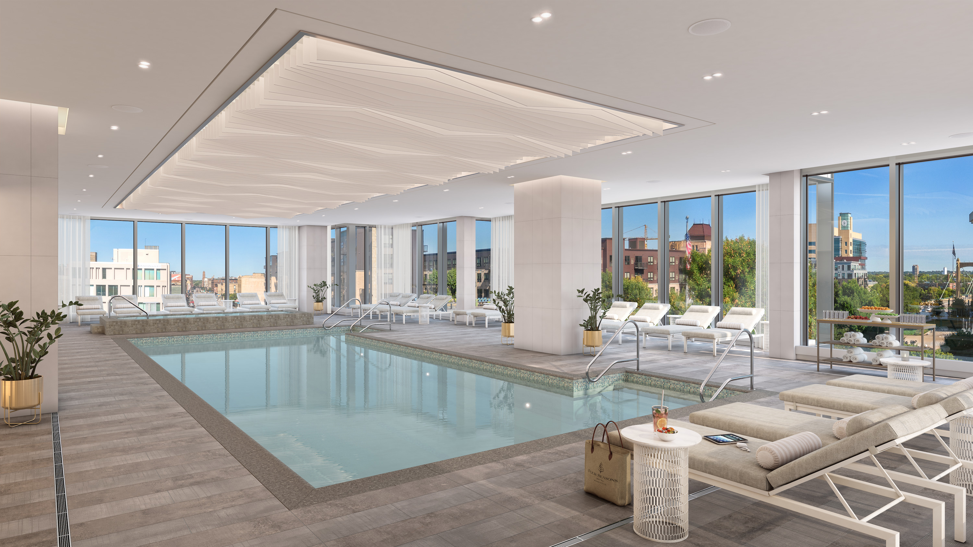 | May 27, 2022, Minneapolis, USA  Spa Reservations Open at Four Seasons Hotel Minneapolis  https://publish.url/minneapolis/hotel-news/2022/spa-reservations-live.html
May 26, 2022, Minneapolis, USA
Exploration of Global Wine to Debut at Four Seasons Hotel Minneapolis
https://publish.url/minneapolis/hotel-news/2022/wine-program.html

PRESS CONTACTS

Allie Stoneberg
Director of PR and Communications
245 Hennepin Avenue
Minneapolis
USA
allie.stoneberg@fourseasons.com

+1 651 428 8612

