Passion and Purpose Meet Michelin-Starred Vision

December 16, 2022, Maldives at Landaa Giraavaru, Republic of Maldives

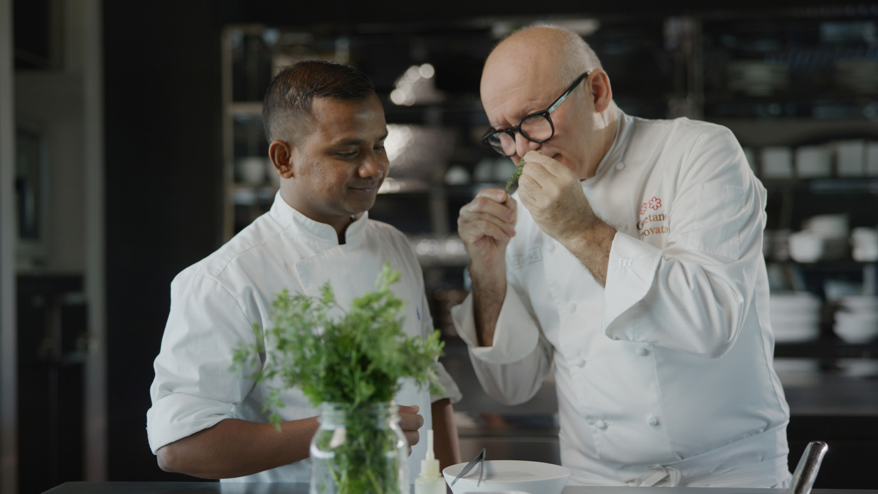
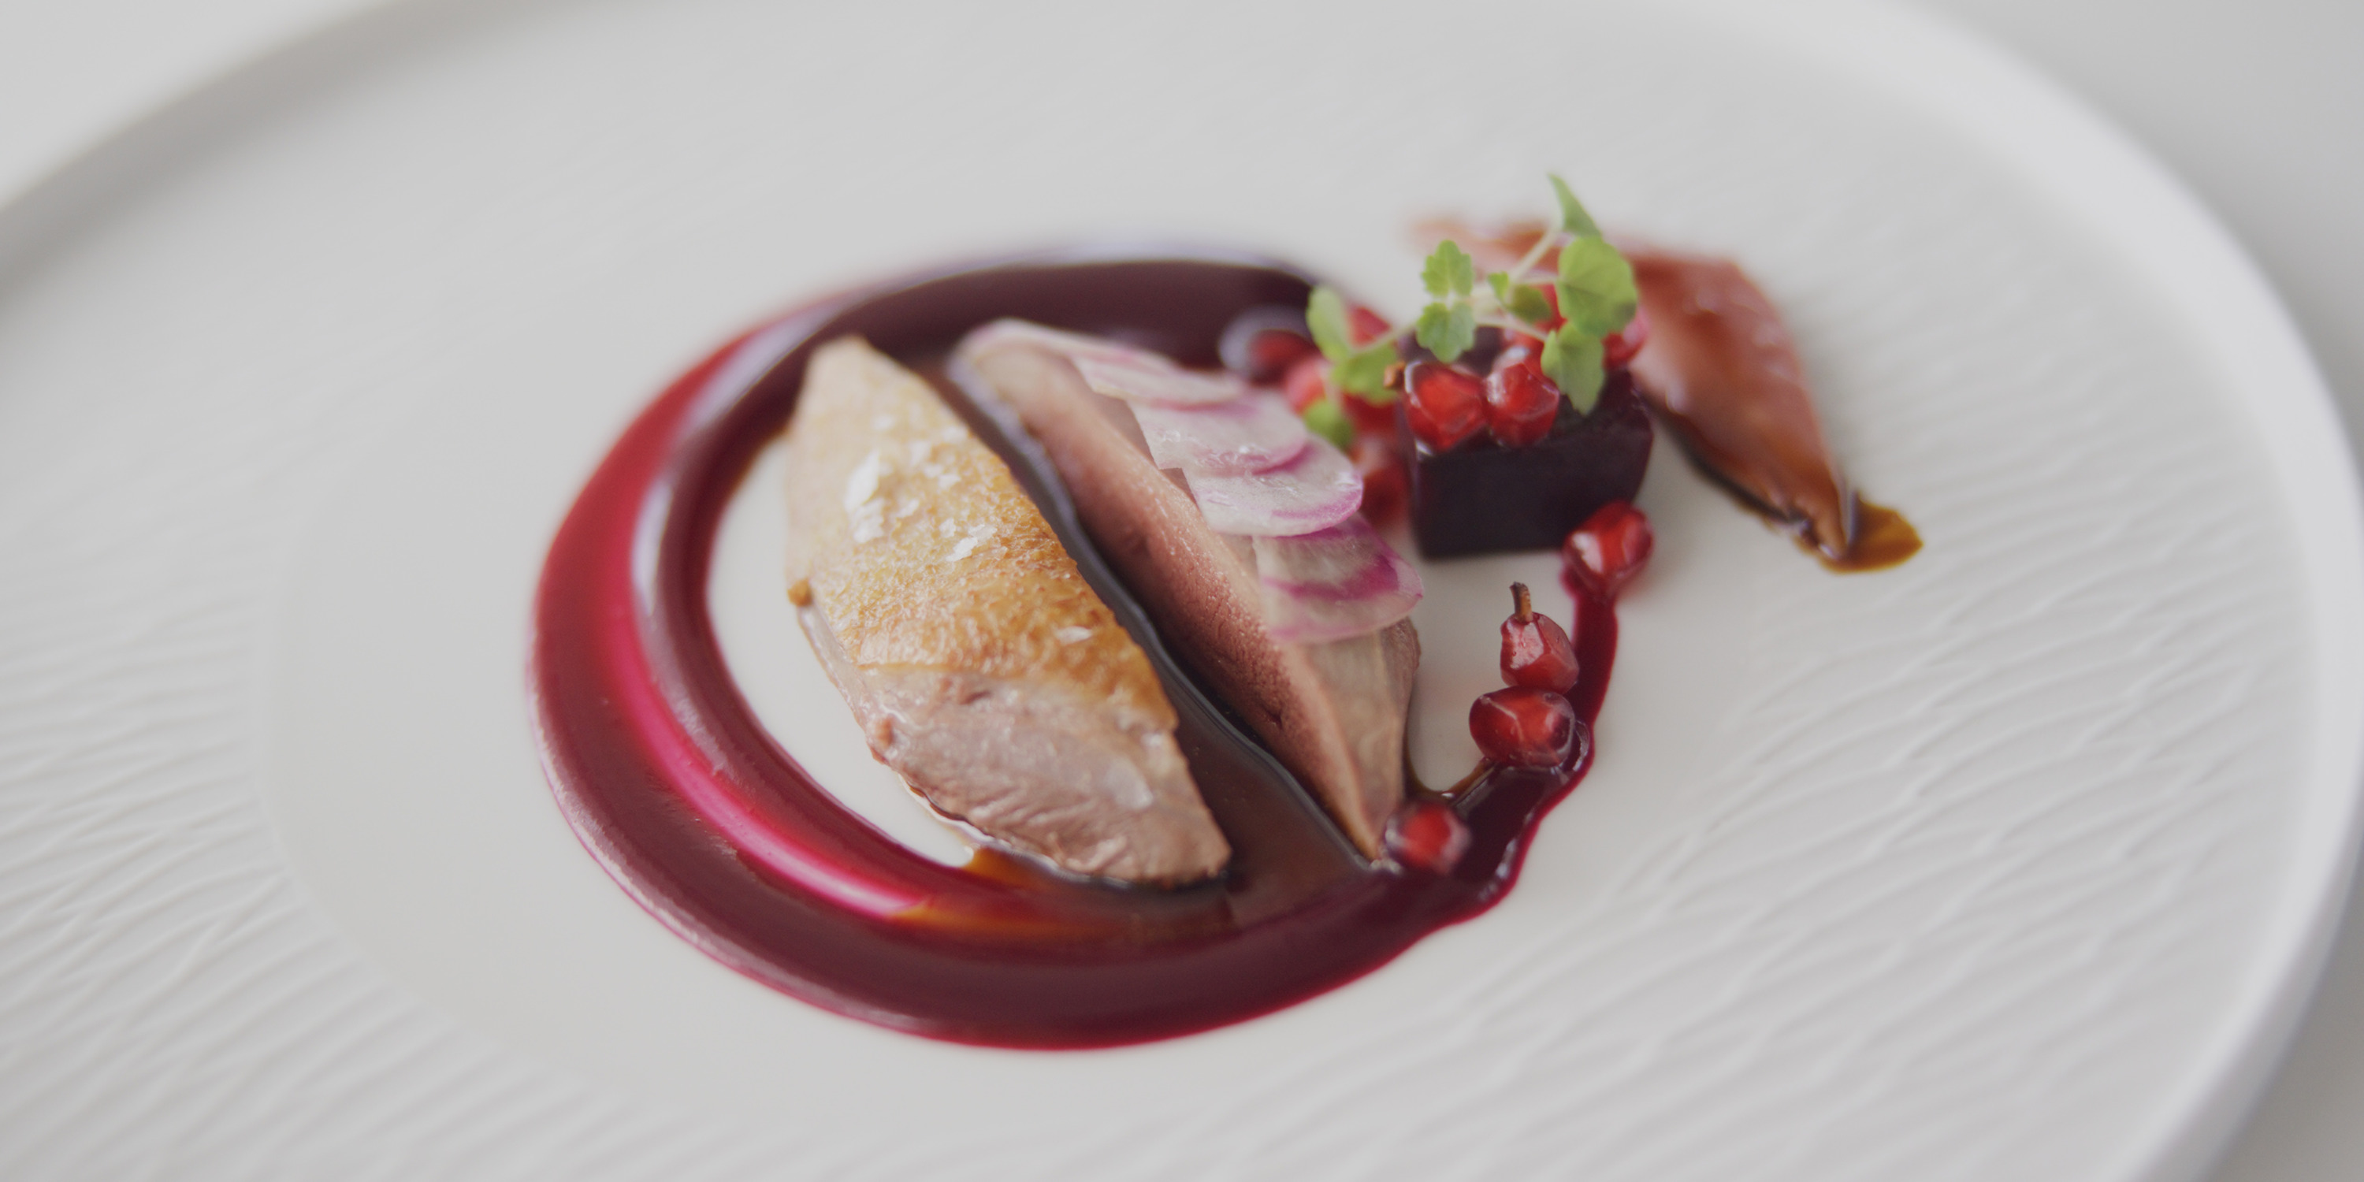 | 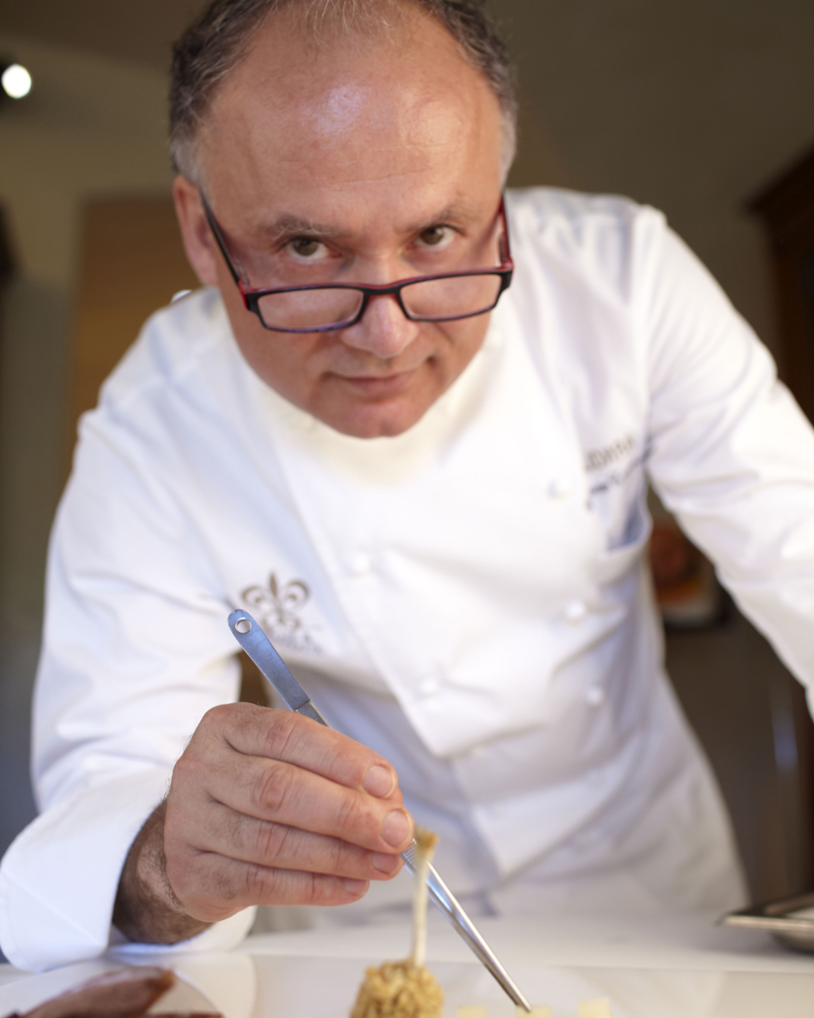 | 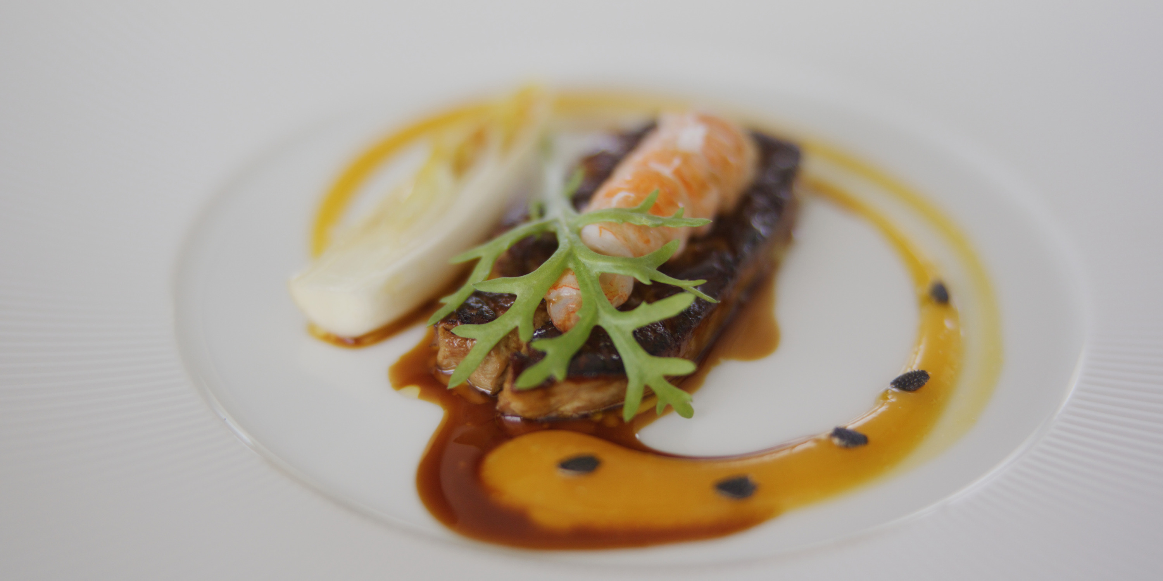
A passion project infused with purpose, two-Michelin-starred Gaetano Trovato and Four Seasons Resort Maldives at Landaa Giraavaru collaborate to nurture Maldivian culinary talent in Tuscany.
Sharing is at the heart of culinary maestro Gaetano Trovato’s vision. After forty years of sharing superlative dining experiences with guests, the two Michelin-starred chef is realising a long-held dream of sharing his passions with the next generation of global chefs.
As part of an exclusive ongoing collaboration with Four Seasons Resort Maldives at Landaa Giraavaru, talented young Maldivian chefs have been flown to Chef Trovato’s new Tuscan restaurant, Arnolfo The Frame, to learn their craft alongside the visionary himself.
Watch the inspirational video of this “dream” project infused with precision and vision, heart and art.
The Arnolfo dégustation dinner showcasing Chef Trovato’s exclusive new menu is now available at Landaa Giraavaru’s Blu Beach Club. Only two tables are available per evening, reservations are essential.
Chef Gaetano Trovato will be back in residence at Four Seasons Landaa Giraavaru from February 27 to March 5, 2023. To experience Arnolfo artistry in the Maldives, click here, email: reservations.mal@fourseasons.com or contact the Central Reservations Department at tel: (960) 66 00 888.

RELATED

December 15, 2022, Chiang Mai, Thailand
Hop into the Year of the Rabbit with Four Seasons Resort Chiang Mai
https://publish.url/chiangmai/hotel-news/2022/lunar-new-year-2.html

December 14, 2022, Langkawi, Malaysia
Festive Glow: Discover Intraceuticals Facials at Four Seasons Resort Langkawi
https://publish.url/langkawi/hotel-news/2022/intraceuticals-spa-facials.html

PRESS CONTACTS

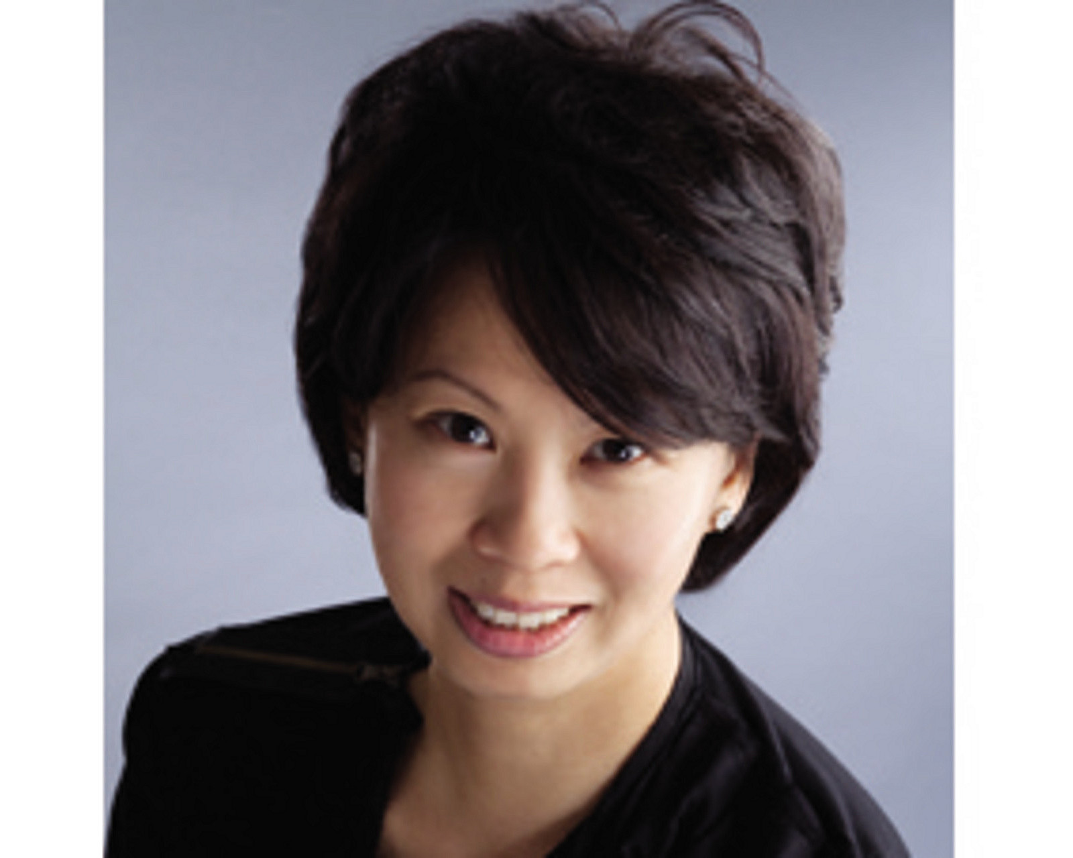 | Juliana Ang  Senior Director of Public Relations and Communications  Tourism Court, #04-00, 1 Orchard Spring Lane  Singapore  247729  juliana.ang@fourseasons.com  (65) 6514 82 81

