Introducing the Circle of Connection Spa at Four Seasons Resort Seychelles at Desroches Island

Menu of Terres d’Afrique treatments restore and rejuvenate amid the purity of nature on Desroches Island
June 11, 2018, Seychelles, Desroches Island

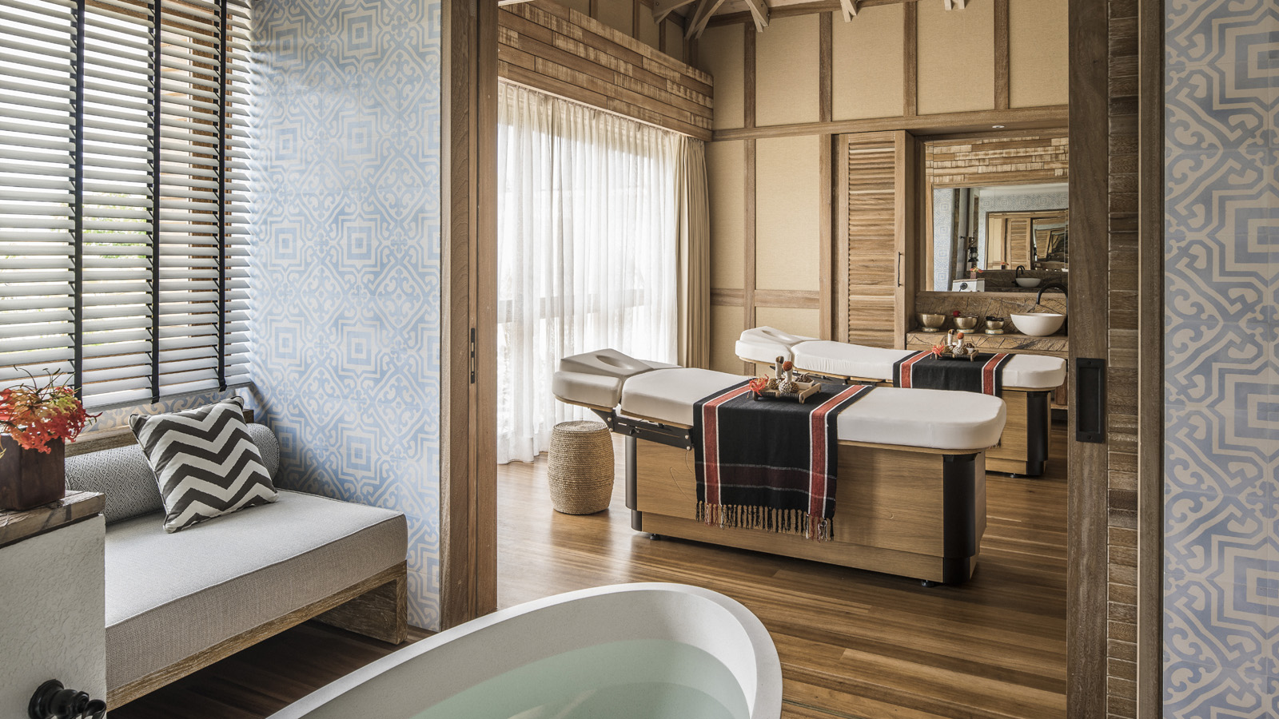
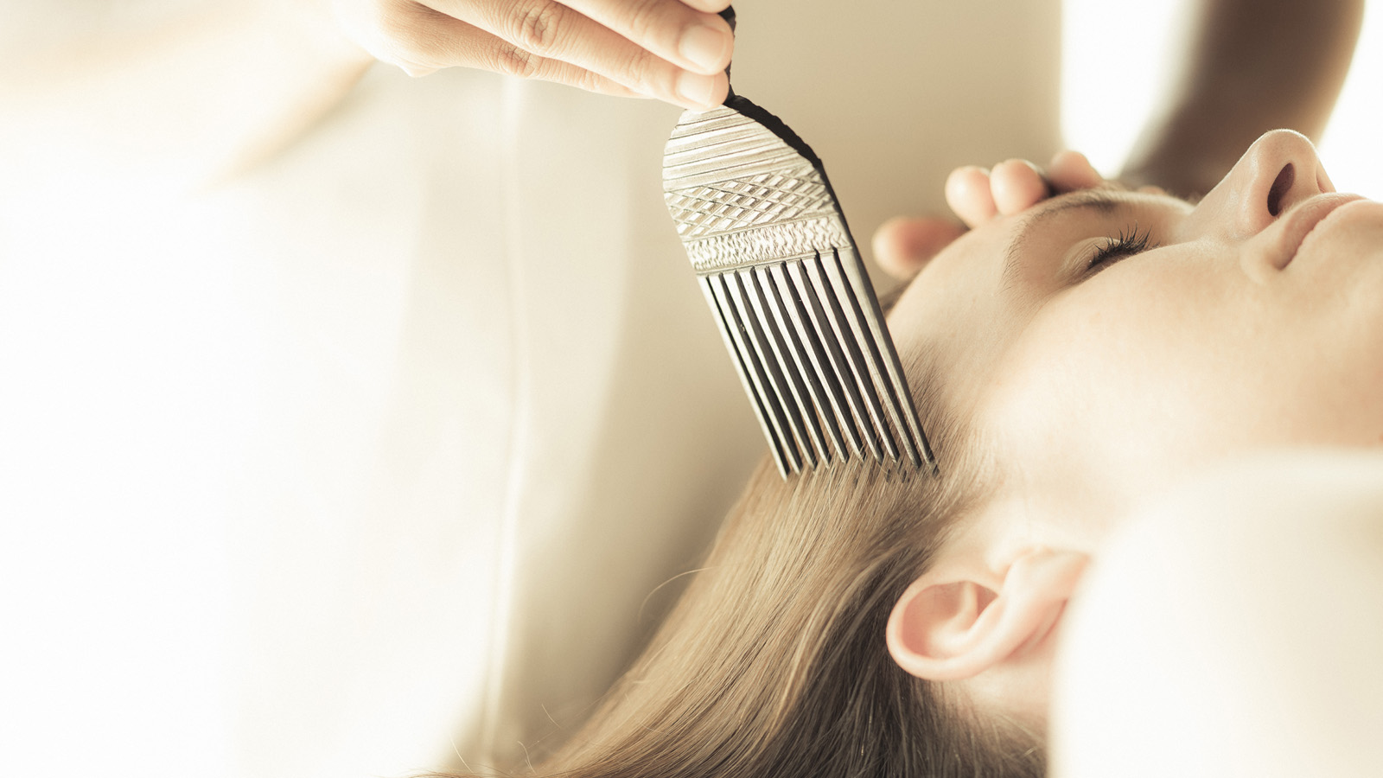 | 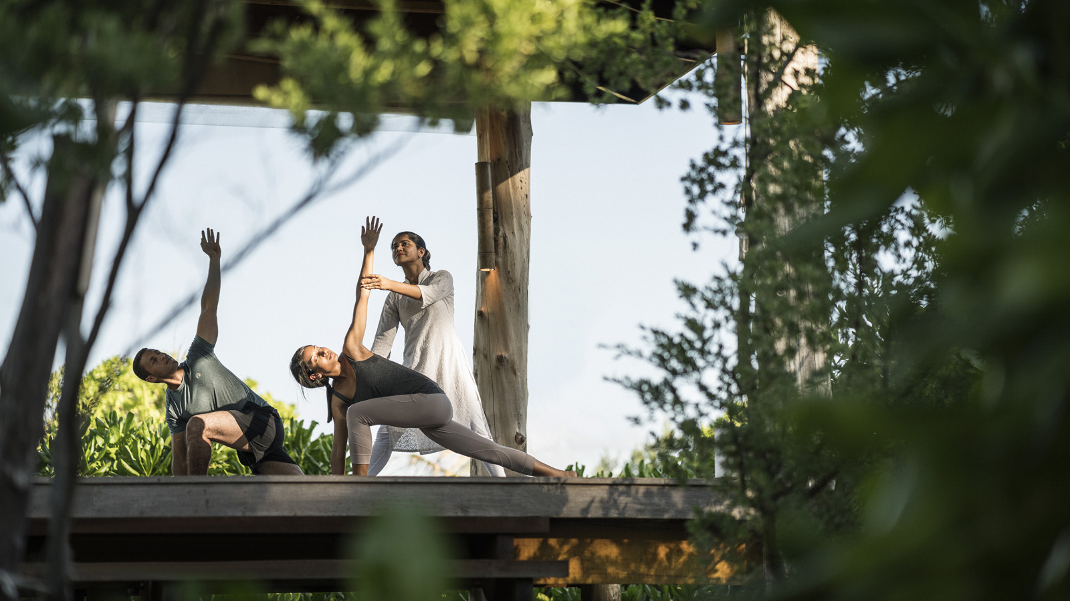 | 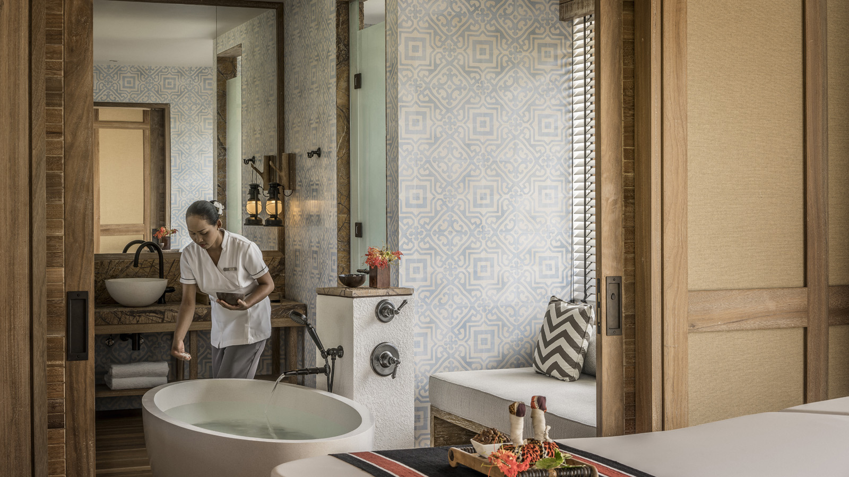
In the cocoon of the Outer Amirantes, a new home exists for natural wellness at the Circle of Connection Spa, which lies at the southerly point of the newly opened Four Seasons Resort Seychelles at Desroches Island – the only resort on this 6 kilometre (3.8 mile) coral island.
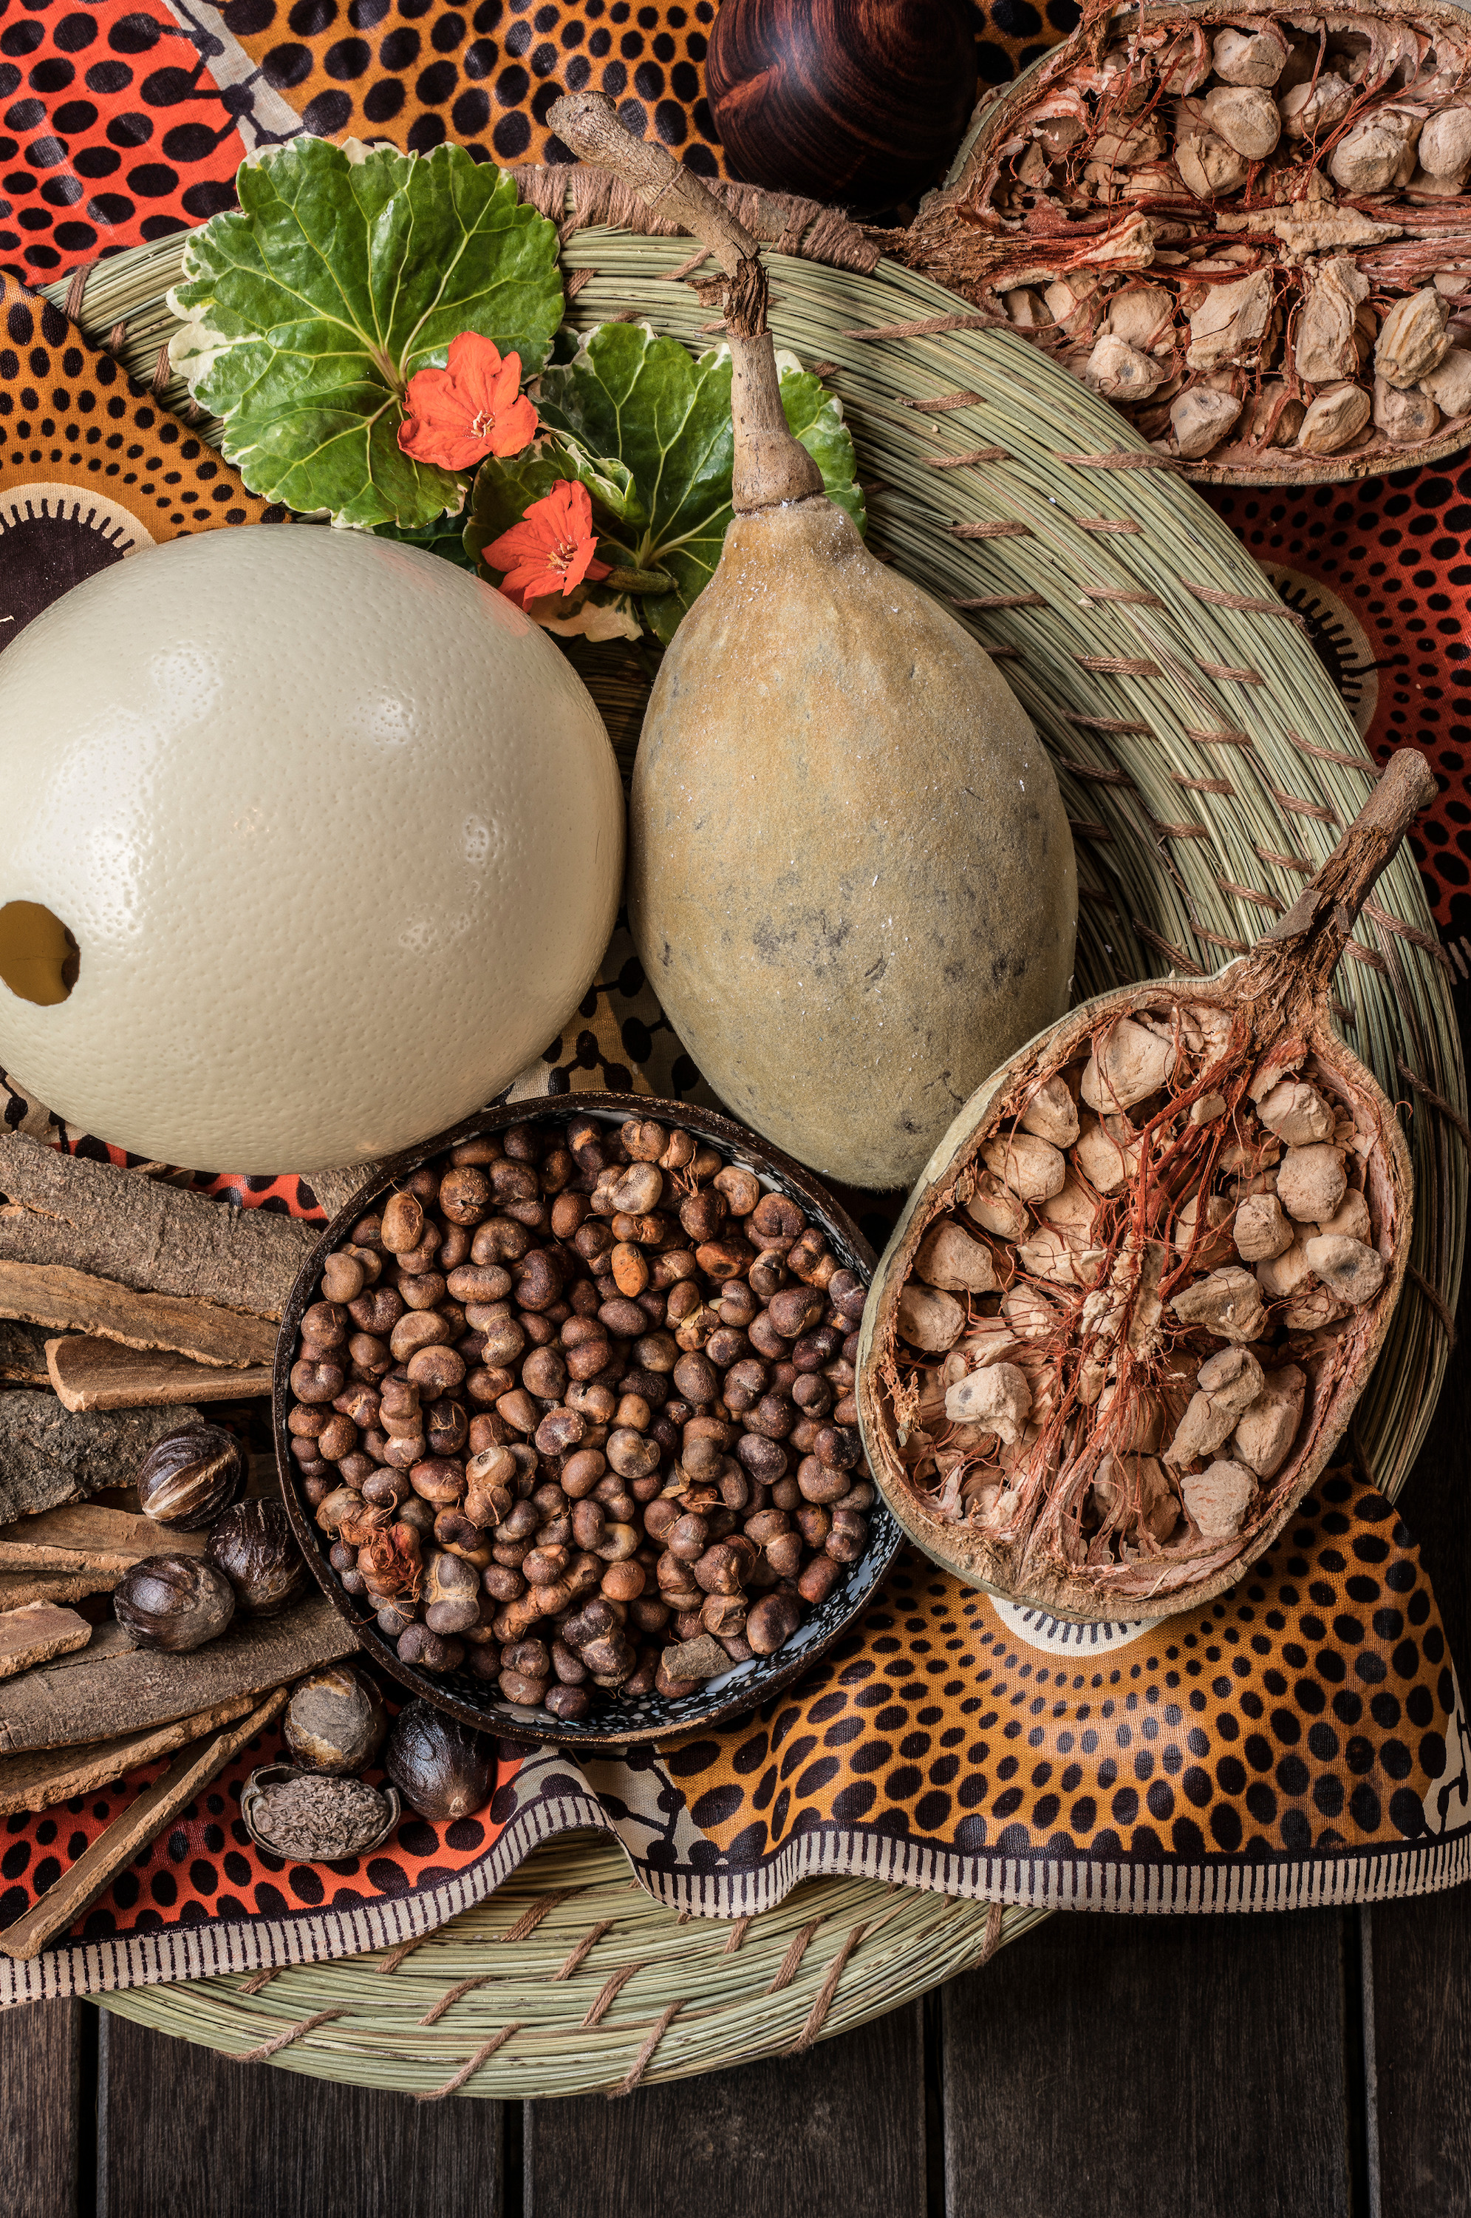
Through an exclusive partnership with the organic Terres d’Afrique, the Circle of Connection Spa draws on natural products to stimulate wellbeing and awaken the senses in a setting that promotes connection to relaxation, one’s inner self and the island’s serenity.
“Desroches is such an incredible destination,” says Sandie Johnnessen, Senior Spa Director. “The purity of the nature, the untouched beauty of the island and the surrounding ocean, and the tranquillity of its remoteness, all combine to create a setting that feels naturally rejuvenating. Our Circle of Connection Spa aims to capture this very essence of Desroches; the feeling that each day is in tune with our own energy cycles and beyond that, the greater circle of life.”
These connections are brought to life by a spa menu that has been designed to evoke the five senses; touch, sound, sight, scent and taste. “Next to each menu item, a coloured circle denotes which sense that treatment is most connected to, allowing guests to choose their preferred area of focus,” explains Sandie.
In the menu, a range of 60 and 90 minute Desroches Discovery Massages, Facials and Body Treatments are complemented by a selection of 15 minute Enhancers, while six signature Sensory Connection Rituals range from 90 minutes to three hours. Among the signature rituals are:
- Rhythms of Desroches (sound) - From crashing waves to whispering wind, singing birds to the sublime sound of silence, bask in the aural splendour of Desroches combined with a euphonious nod to the island’s African heritage. Massage and music meet with a sea-inspired sand, salt and aloe scrub and body mask; a harmonising sound bath of chimes, rain sticks and singing bowls; and a soak in regenerating sea salts accompanied by calming ocean sounds.
- Textures of Desroches (touch) - Connect to the island’s multi-layered sensations with this somatosensory four-handed experience: a harmonious recreation of the soft morning breeze, warm midday sun, cool ocean waters, and stimulating sand. Feathers, crystals, African combs, coconut beads, and the synchronised movements of two therapists combine to incredible effect in an exfoliating sand and coconut bead body mask, followed by a four-handed massage: an invigorating sensory treat featuring a constant alternation of hot and cold crystal balls. Return to blissful relaxation with a soothing head massage beneath a warm stream of coconut oil. The experience ends with a Sound of the Waves Massage, featuring a soothing rolling technique that mimics the sound and motion of waves using eggs filled with heated baobab seeds.
Complementing the choice of Terres d’Afrique treatments, a full yoga menu is available to guests in both group and private sessions, led by Yogi Ganga Sadhuka. Yoga sessions are able to take place in the Spa’s yoga pavilion or in the privacy of a guest’s own pool cabana or garden. Furthermore, to allow reflection and share in a celebration of each day, guests are able to join the Spa’s therapists in the daily Connection Ceremonies every morning and evening.
Open daily from 9:00 am to 9:00 pm, the Circle of Connection Spa features six couple’s treatment suites and a separate hair and beauty salon. To make a reservation, contact the Spa at: spa.sdi@fourseasons.com.

RELATED

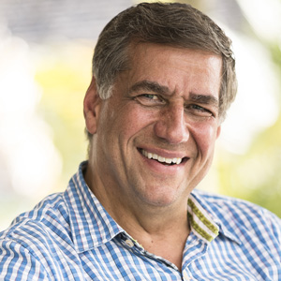 | March 29, 2018, Seychelles  Four Seasons Appoints Edward Linsley as Senior General Manager of both Four Seasons Resorts in Seychelles  https://publish.url/seychelles/hotel-news/2018/new-senior-general-manager-edward-linsley.html
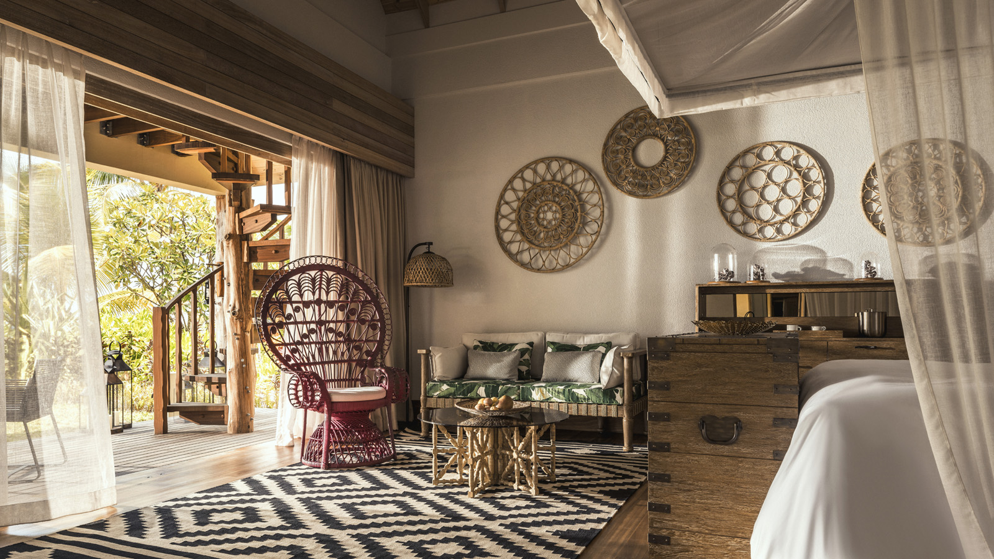 | March 1, 2018, Seychelles, Desroches Island  Four Seasons Hotels and Resorts Annuncia L'Apertura del Four Seasons Resort Seychelles at Desroches Island  https://publish.url/it/seychellesdesroches/hotel-news/2018/now-open-4.html

PRESS CONTACTS

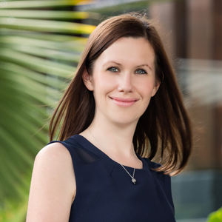 | Debbie Duval  Senior Director of Public Relations and Communications  Beau Champ  Mauritius  debbie.duval@fourseasons.com  (230) 402 3100
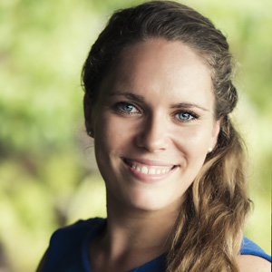 | Amy Sefton  Public Relations Manager  Petite Anse, Baie Lazare, P.O. Box 1397  Victoria, Mahe  Seychelles  amy.sefton@fourseasons.com  +248 439 3016

