Four Seasons Hotel Guangzhou Launches a Family Dream Castle in the Clouds

February 4, 2021, Guangzhou, China

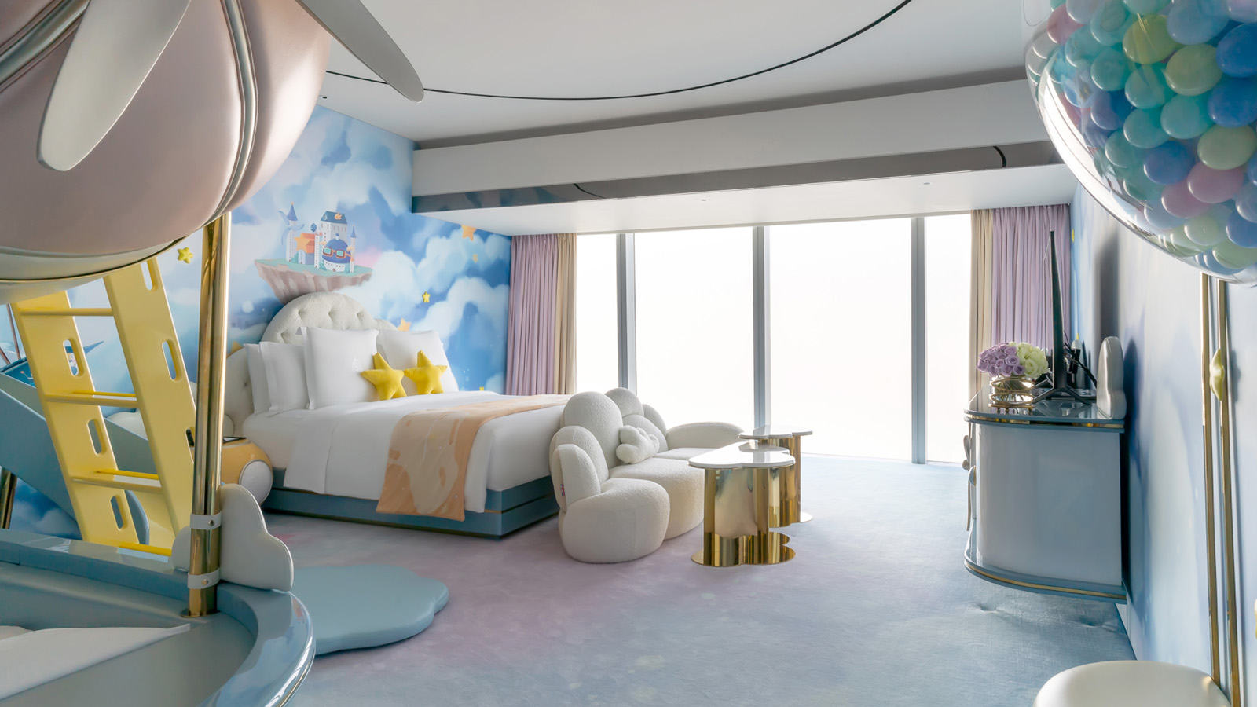
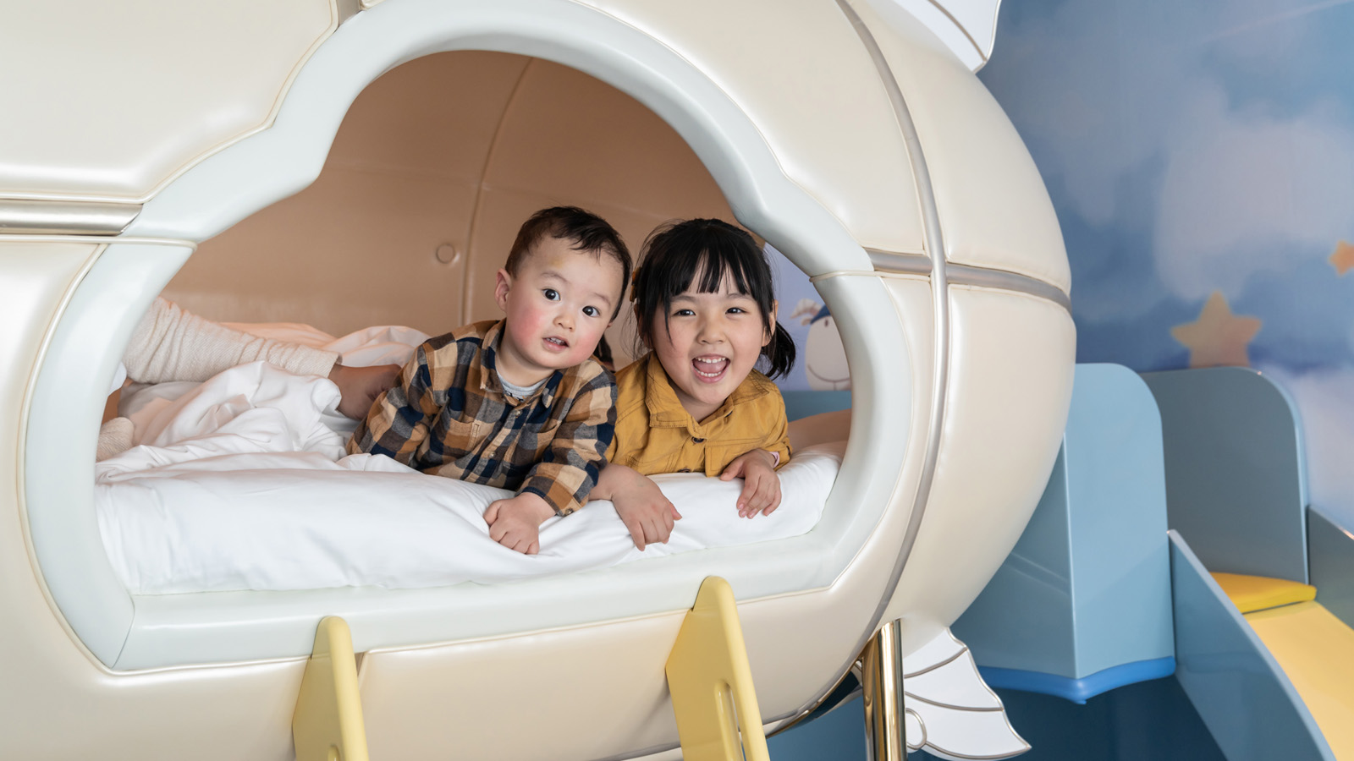 | 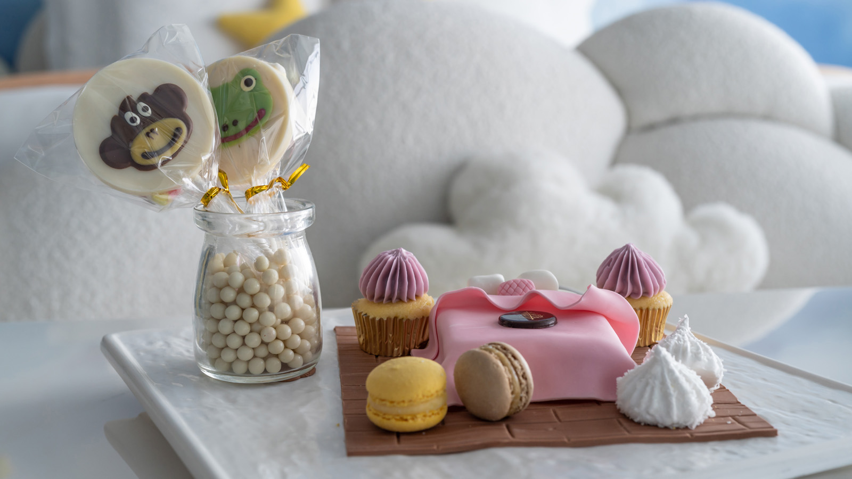 | 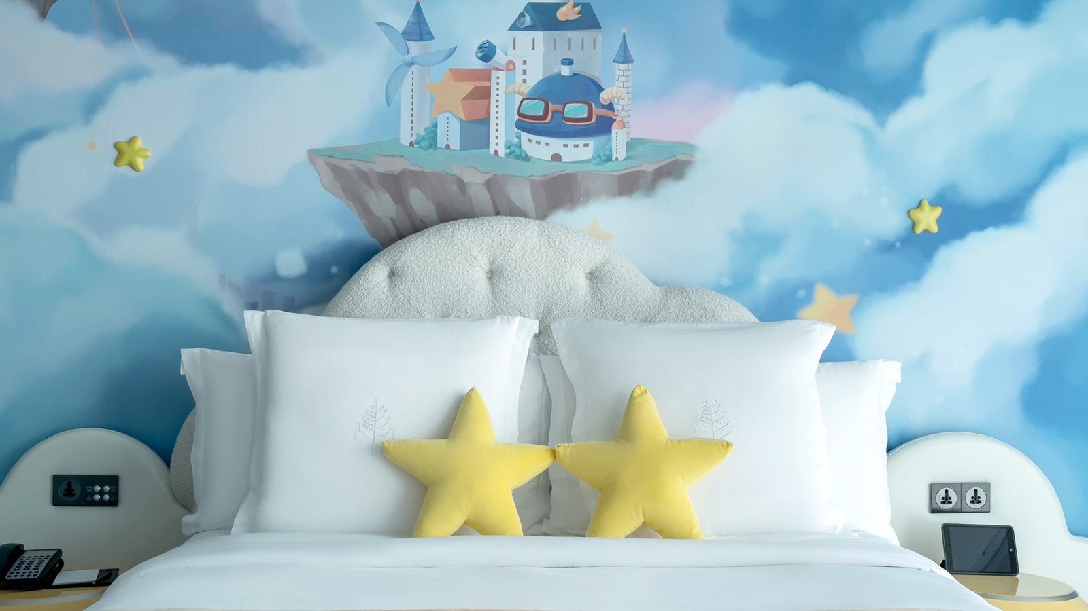

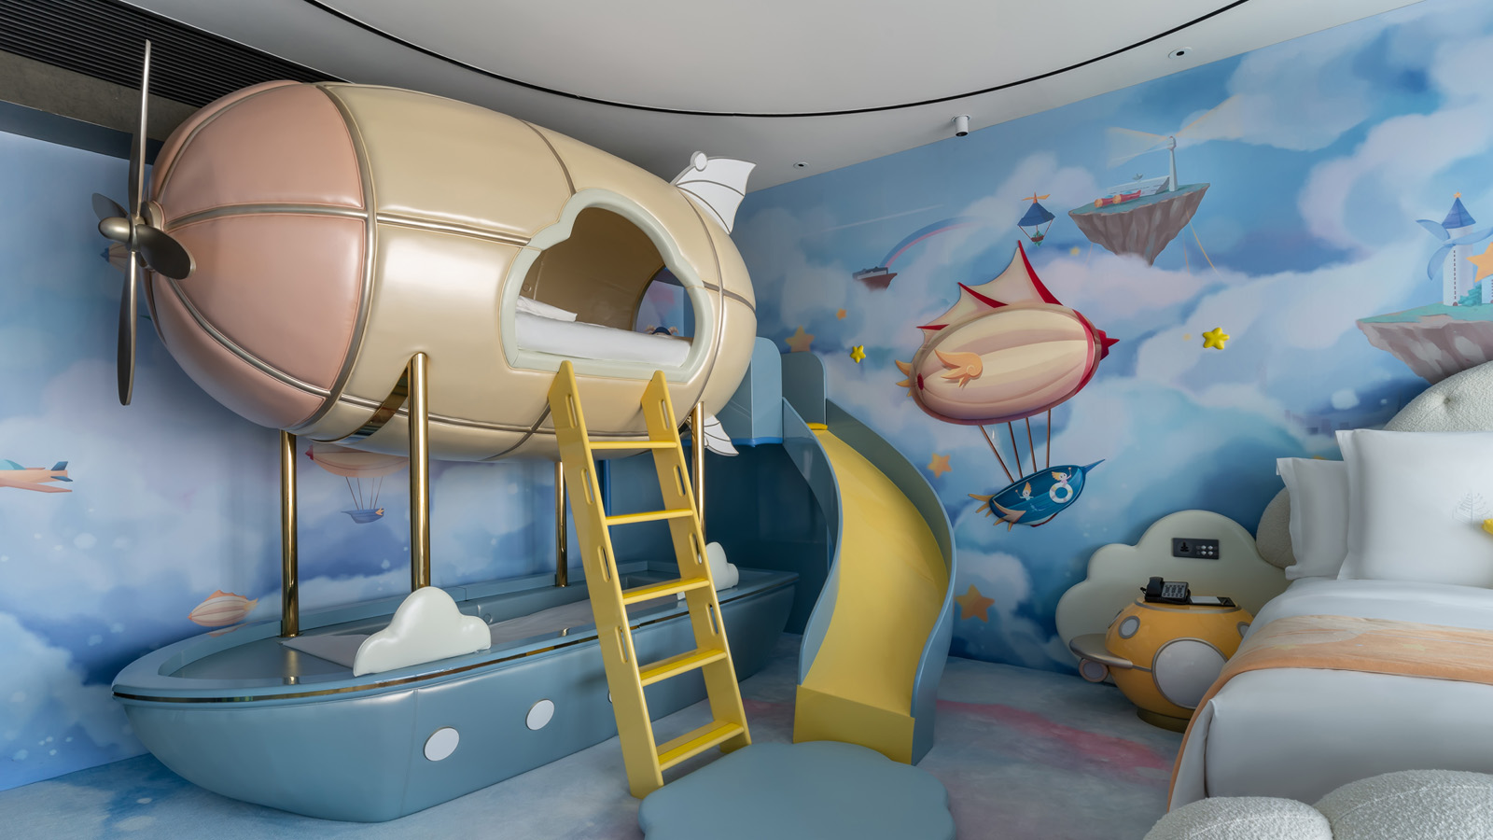

RELATED

February 4, 2021, Guangzhou, China
广州四季酒店打造云端「梦幻云堡」 呈献“沉浸式”亲子入住体验
https://publish.url/zh/guangzhou/hotel-news/2021/dream-castle-family-accommodations-2.html

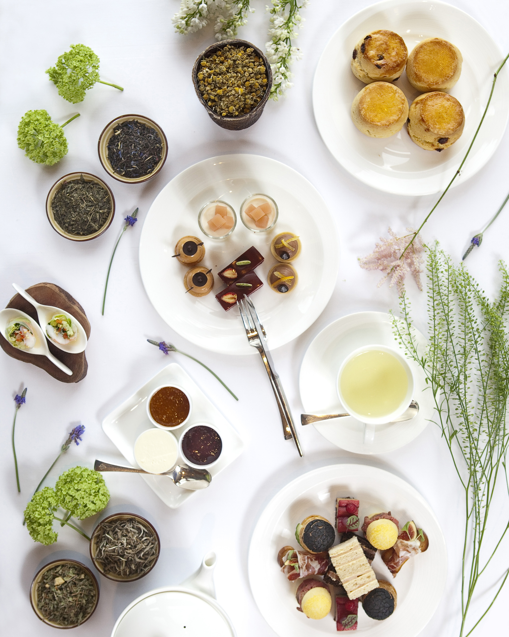 | February 2, 2021, Hong Kong, China  香港四季酒店呈献最新美食推介  https://publish.url/zh/hongkong/hotel-news/2021/food-and-beverage-promotions-3.html

PRESS CONTACTS

Ditty Liu
Director of Public Relations
5 Zhujiang West Road, Pearl River New City, Tianhe District
Guangzhou
China
ditty.liu@fourseasons.com

86 (20) 8883-3901

