Four Seasons Hotel Istanbul at the Bosphorus Welcomes Guests to New Poolside “Meyhane,” Anason 34

Four Seasons Hotel Istanbul at the Bosphorus introduces a pop up restaurant in its unique poolside location, overlooking the beautiful Bosphorus Strait
August 8, 2019, Istanbul at the Bosphorus, Turkey

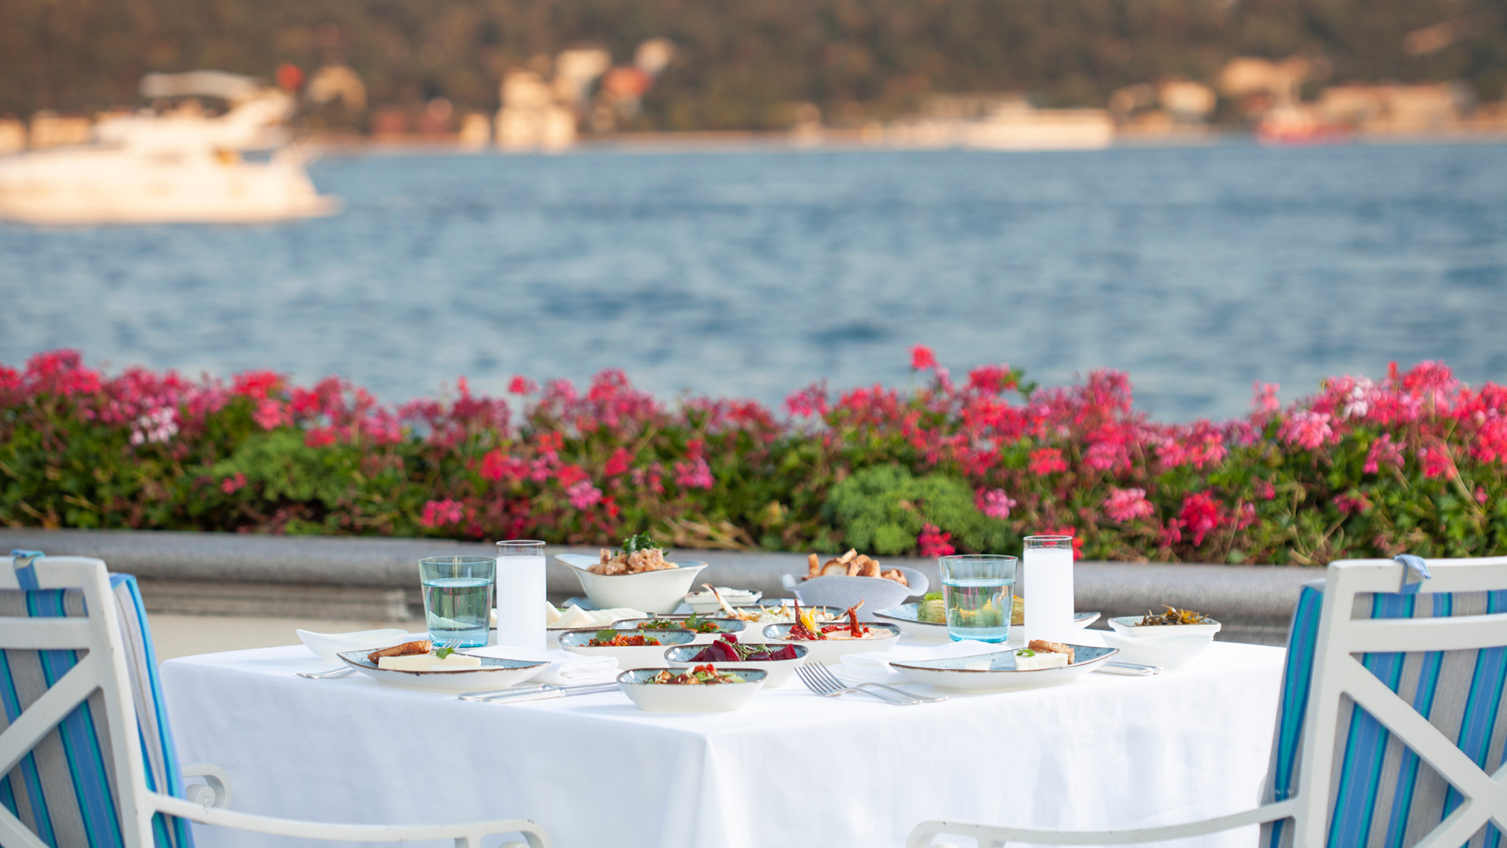
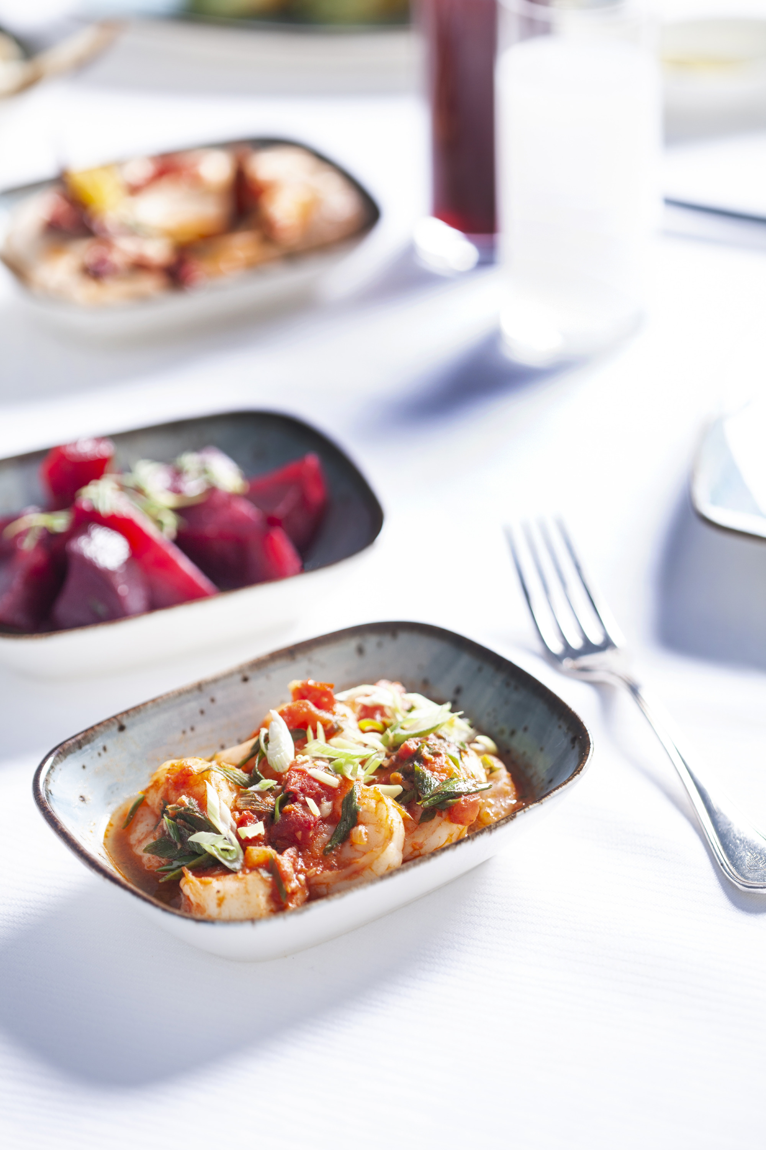 | 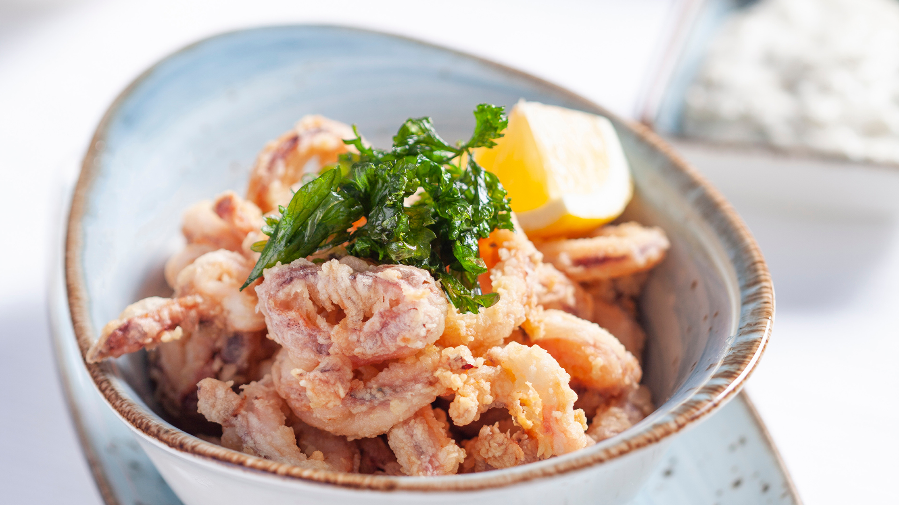 | 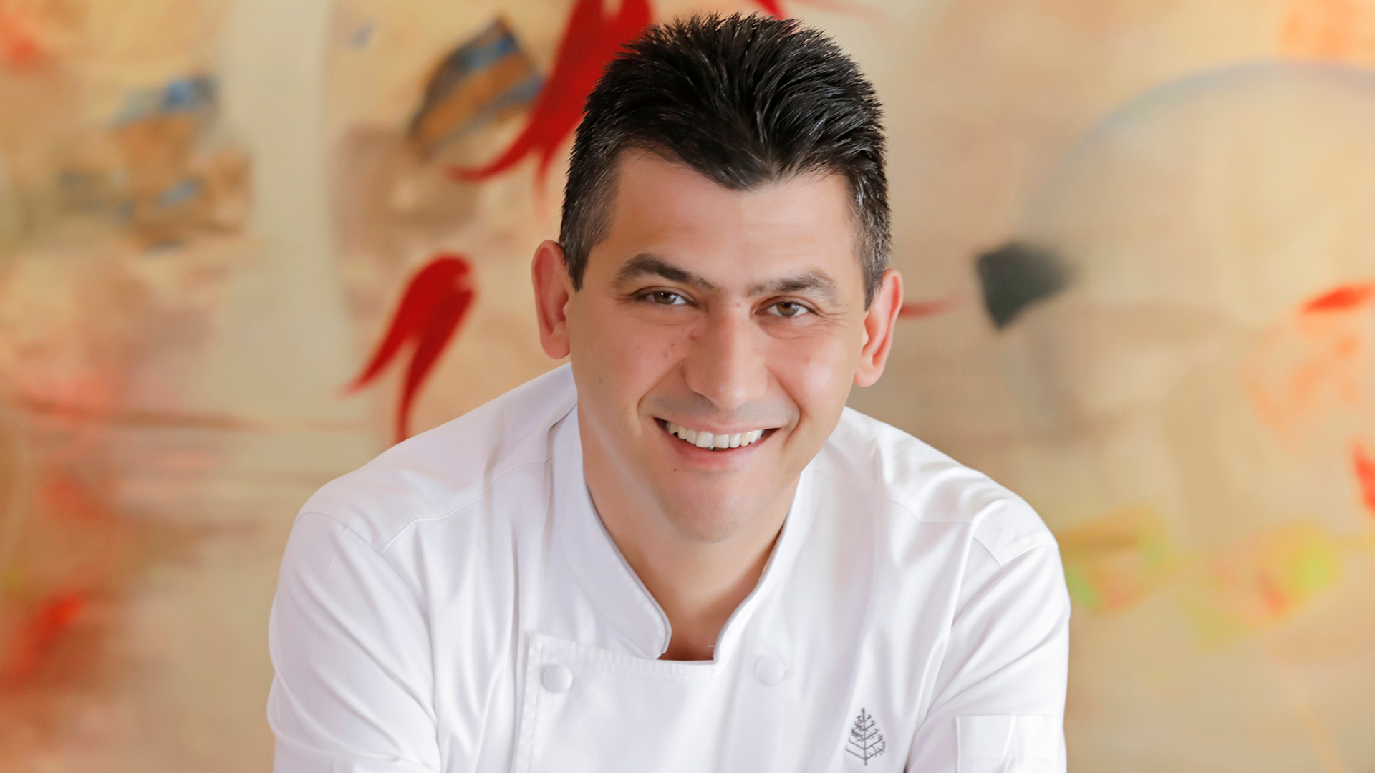
With the warm and relaxed atmosphere of a traditional Turkish meyhane, Anason 34 offers the essence of summer eating in Istanbul, outdoors by the edge of the Bosphorus at Four Seasons Hotel Istanbul. Meyhane culture dates back to the Byzantine era. By the early twentieth century many meyhanes also became exclusive places of entertainment, where today’s establishments tend to serve familiar mezzes with a modern twist. The meyhane is more than a mere place for dining. It is where conversation takes centre stage and hearts are poured out. If one is to try rakı’ only once in a lifetime, it has to be in atmospheric Istanbul, on the shores of Bosphorus.
Named after anise, the raw material of rakı, which is a must-drink for meyhane, Anason 34 also holds the plate number of Istanbul as 34.
Anason 34 is located by the pool on the terrace overlooking the Bosphorus. Led by Head Chef Savaş Aydemir, it offers a feast of flavours with tasty appetisers and mezes, seasonal fish varieties, meat options and desserts. Open from 8:00 pm to 12:00 midnight every day, Anason 34 will be the new favourite spot for those who wish to enjoy a slow, leisurely dining experience with great local food in an amazing setting.
The evening menu at Anason 34 starts with a variety of appetisers and mezes prepared with vegetables, seafood and yogurt, as well as butter-fried garlic shrimp, fried calamari, grilled octopus and paçanga pie. The main courses of sea bass fillet, veal medallion, meatballs and chicken thigh, all grilled, offer a feast for the palates as Anason’s must-try flavours. Every good meal ends with dessert and those with a sweet tooth will have a hard time in making up their mind. Semolina halva served with mastic ice cream, candied pumpkin served with tahini and walnuts, and profiteroles bring this journey of tastes to a perfect finale.
Delicious food prepared and served with impeccable Four Seasons service at Anason 34 is accompanied by a selection of 90s Turkish music in an entertaining atmosphere.
Four Seasons Hotel Istanbul at the Bosphorus invites its guests to toast against the spectacular Bosphorus sunsets at Anason 34.
For reservations, call +90 212 381 44 44.

RELATED

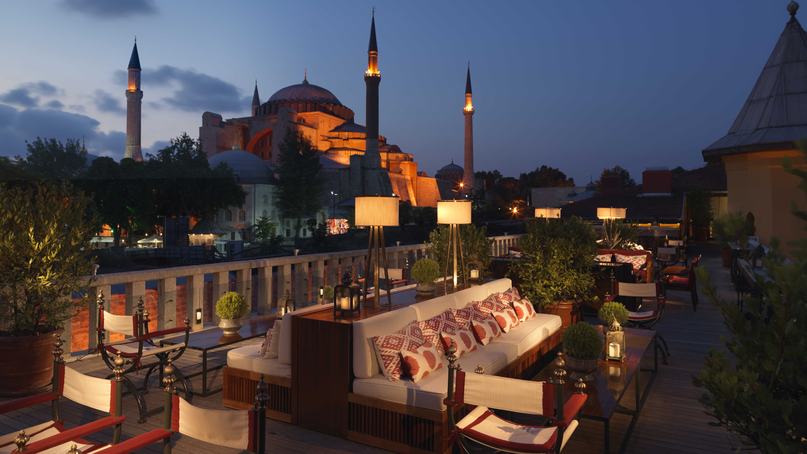 | June 20, 2019, Istanbul, Turkey  6 experiências em Istambul que você só vai ter nos hotéis Four Seasons  https://publish.url/br/bosphorus/hotel-news/2019/experiencias-em-istambul.html
May 30, 2019, Istanbul at the Bosphorus, Turkey
Four Seasons Hotel Istanbul at the Bosphorus Celebrates Global Wellness Day with Morning Activities on its Scenic Terrace
https://publish.url/bosphorus/hotel-news/2019/global-wellness-day.html

PRESS CONTACTS

Sibel Benli
Senior Director of Public Relations and Communications
Çırağan Cad. No. 28
Istanbul
Turkey
sibel.benli@fourseasons.com

90 (212) 381 41 35

