Al Meylas Lounge in Four Seasons Hotel Abu Dhabi at Al Maryah Island Unveils New Art-Inspired Pastries, Cakes, and Desserts to Welcome Sweet Tooth Guests

Luxury Abu Dhabi hotel celebrates the art of pastry with new pastries, cakes, and desserts in its signature lobby lounge to complement its celebrated afternoon tea experience
October 12, 2021, Abu Dhabi, U.A.E.

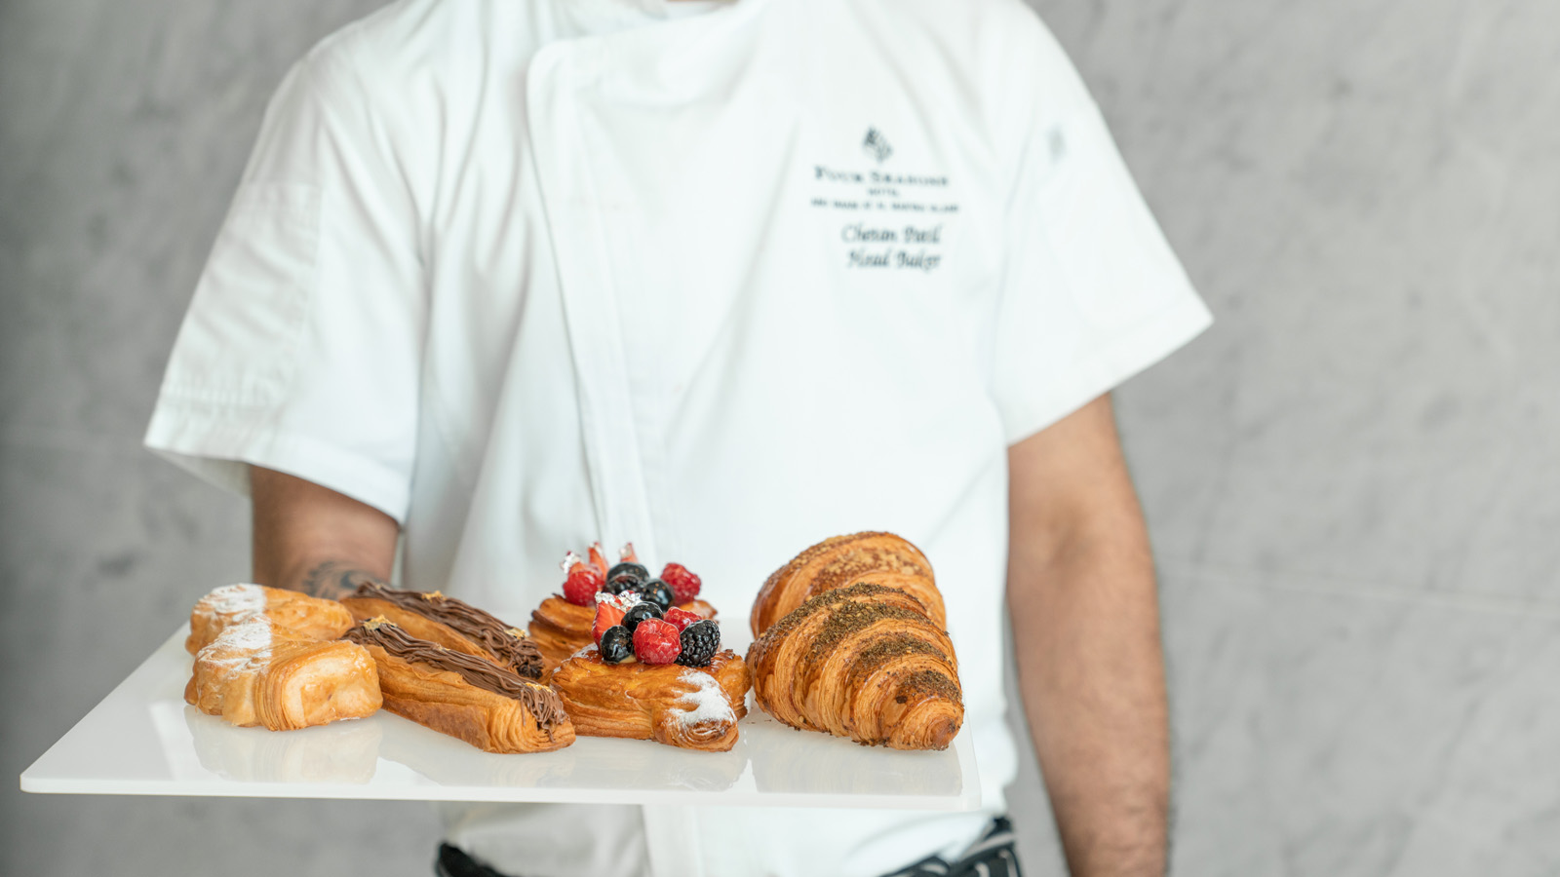
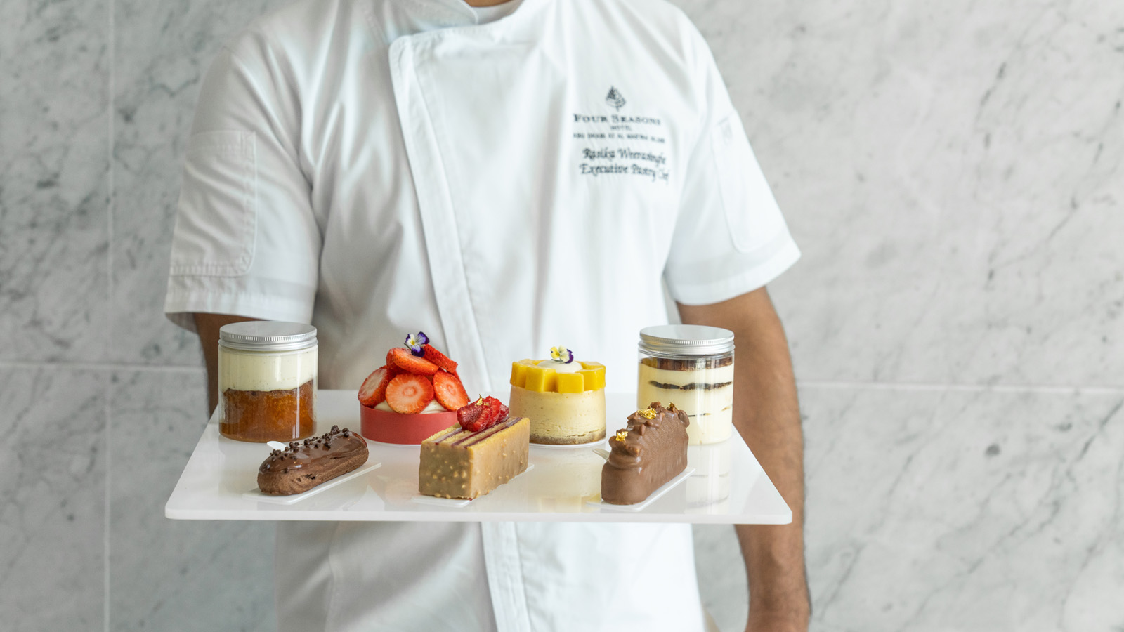 | 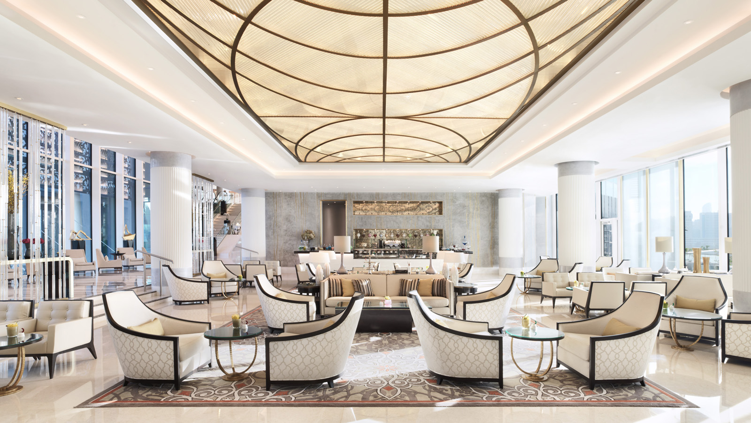 | 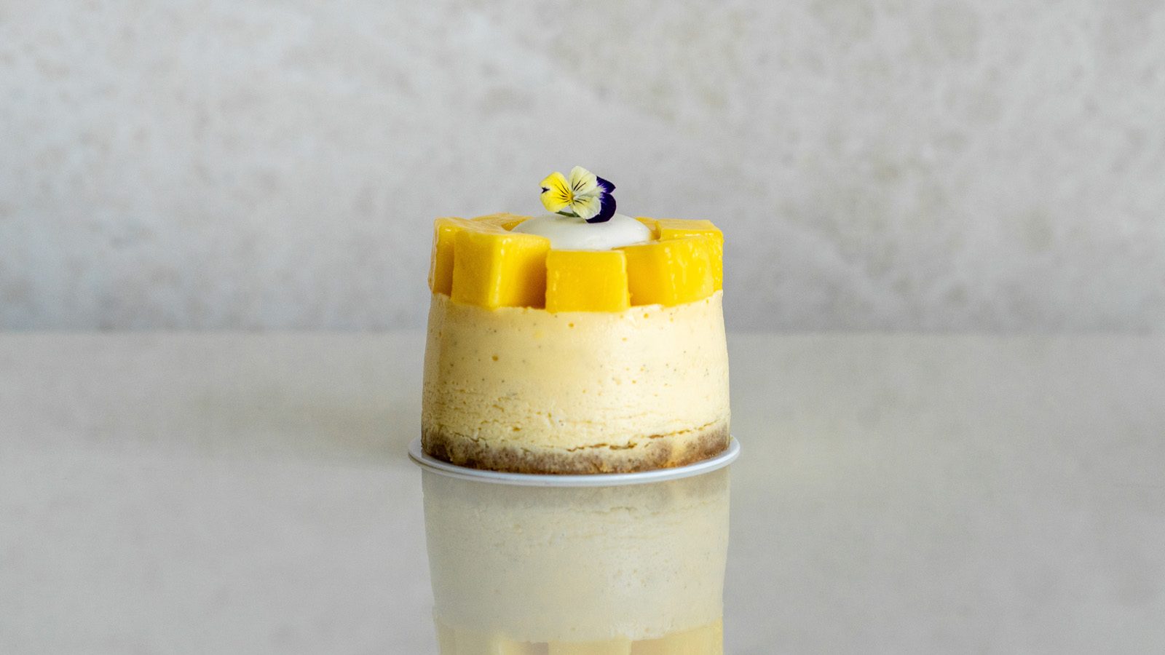
As Abu Dhabi’s high season kicks into gear, the focal point of Four Seasons Hotel Abu Dhabi begins to buzz with renewed vigour. Al Meylas lobby lounge is a natural meeting point, the modern majlis greeting local guests and international visitors alike with cuisine that brings people together. Having this in mind and with the opening of Dubai Expo 2020, Executive Pastry Chef Rasika Weerasinghe has carefully curated a symphony of sweets and pastries to connect hearts and minds. Providing modern interpretations developed through chef’s graphic design background, Al Meylas’ sterling reputation for pastries and desserts only enhances going into the city’s fall season. Offering something for every occasion, guests will not only discover Four Seasons artistry through its latest creations, but will also be able to connect over the Hotel’s renowned Arabian and English Afternoon Tea experience.
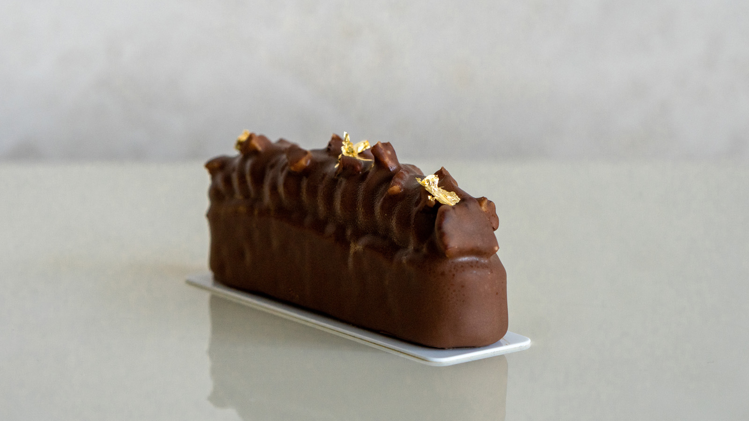 | 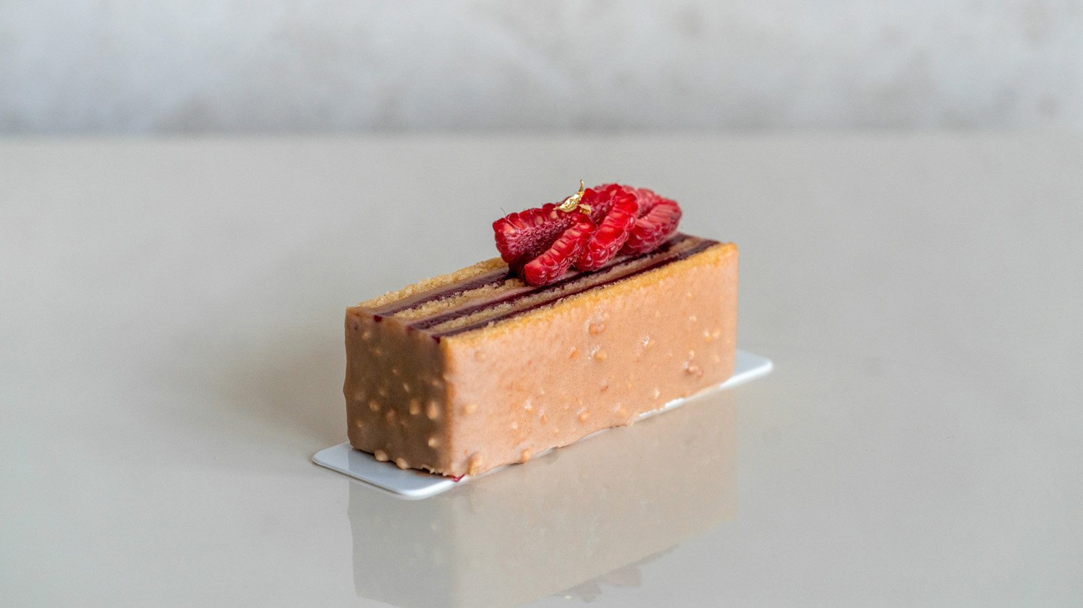 | 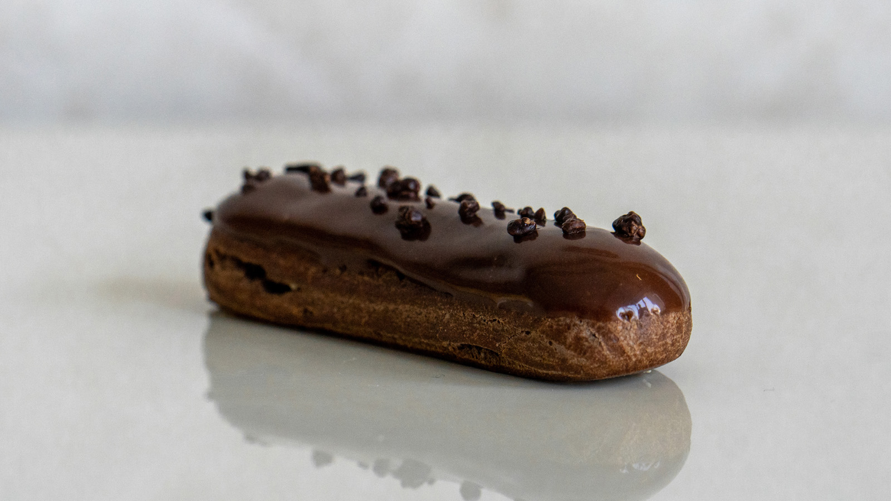
Rise and Shine with New Breakfast Pastries
Arriving to work daily at 4:00 am, Head Baker Chetan Patil works around-the-clock to ensure Four Seasons guests receive a selection of light and airy croissants, muffins, and more ahead of a busy schedule at neighbouring Abu Dhabi Global Market. Shining like the morning sunrise passing through the lobby’s mashrabiya design is Patil’s rediscovered pain au chocolat, which features a daring presentation with two types of Valrhona chocolate and a decorative gold leaf.
- Signature Highlights: Pain au Chocolat
- Prices start from AED 20 per pastry
Sample Art-Inspired Treats with a Brewed Beverage
Thoughtfully curated to complement the lobby lounge’s extensive selection of freshly brewed coffees and teas, Al Meylas’ latest art-inspired treats are the purest expression of Four Seasons culinary creativity. Blending a penchant for design with a curator’s mind, Executive Pastry Chef Rasika Weerasinghe has developed a selection of tarts and cakes to envelop the senses. Offering something for everyone, contrast was his aim when creating the fall 2021 menu. Behind the gallery-style glass of the lounge’s counter, fruit meets chocolate, levity meets indulgence, and classics meet the cutting-edge. If asked to select two favourites, the chocolate-loving Executive Pastry Chef hailing from Sri Lanka would select the mango cheesecake and caramelo for new guests.
- Signature Highlights: Mango Cheesecake, Caramelo
- Prices start from AED 40 per counter dessert
Have the Cake and Eat it Too
Guests can have their cake and eat it too with a selection of scrumptious cakes available by the slice and as a whole cake for life’s special occasions. Working with the inspiration of childhood nostalgia, Executive Pastry Chef Rasika Weerasinghe elevates the art of cake making with effortless Four Seasons style. Headlining the selection of Al Meylas’ fall 2021 cakes are the “hazelnut symphony” and “100% chocolate,” which feature bold presentations inspired by Weerasinghe’s time spent as a graphic designer. Guests craving more classical cakes will be delighted to sample the indulgent carrot and red velvet cakes, which receive a refreshed presentation.
- Signature Highlights: Hazelnut Symphony, Carrot Cake
- Prices start from AED 50 per slice; AED 320 per cake
- Custom cakes are available for order with 48 hours advance notice
Make Time for an Abu Dhabi Tradition: Al Meylas’ Afternoon Tea
A time-honoured ritual in Abu Dhabi, Al Meylas’ quintessential afternoon tea seamlessly blends modern Arabian culture and international flavours through two distinct afternoon tea experiences. Guests are invited by Restaurant Manager Daria Savelyeva to rediscover the gift of one another through the property’s interpretations of the quintessential English Afternoon Tea and Arabian Afternoon Tea.
- Afternoon Tea highlights: savoury eclair, truffle egg mayo sandwich, Scottish salmon sandwich, matcha roll, chocolate cream lichu
- AED 250 for two people
- Available daily, between 3:00 and 7:00 pm
Learn more about Al Meylas’ fall 2021 pastries by calling +971 2 333 2222, emailing reservations.abudhabi@fourseasons.com, or chatting on the Four Seasons App.

RELATED

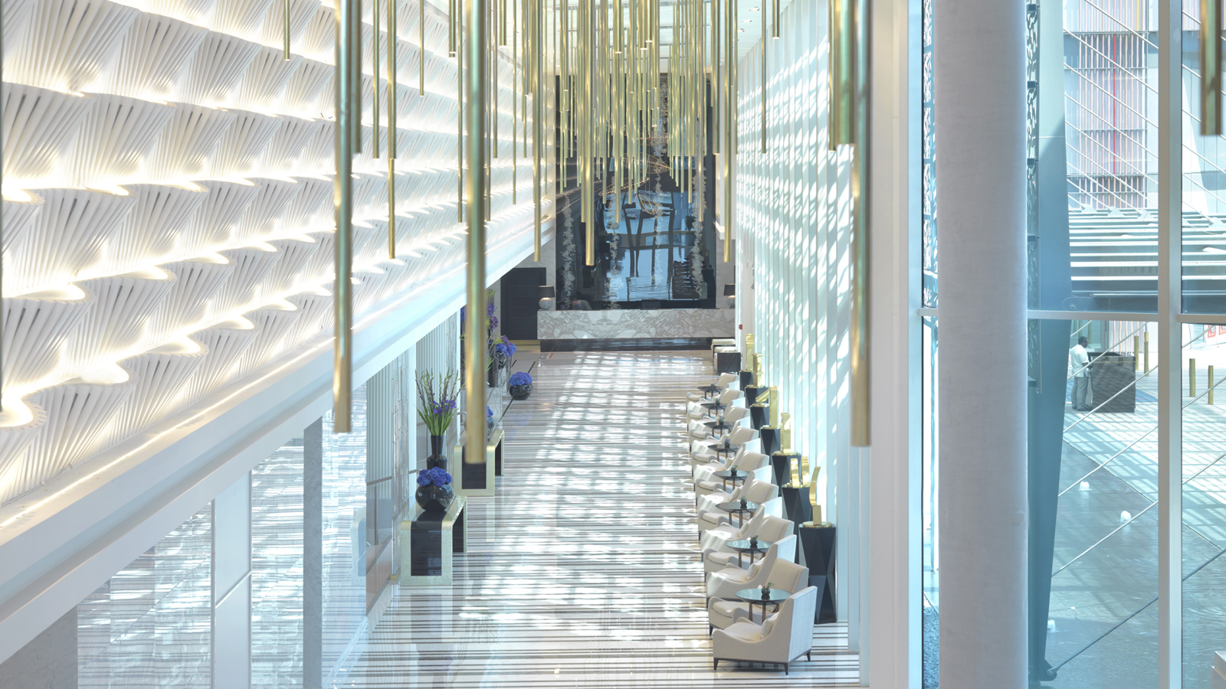 | September 20, 2021, Abu Dhabi, U.A.E.  Four Seasons Hotel Abu Dhabi Launches Two New Offers for Weekend Getaways and Extended Stays  https://publish.url/abudhabi/hotel-news/2021/new-offers-and-packages.html
September 20, 2021, Abu Dhabi, U.A.E.
Four Seasons Hotel Abu Dhabi Launches Two New Offers for Weekend Getaways and Extended Stays
https://publish.url/abudhabi/hotel-news/2021/new-offers-and-packages.html

PRESS CONTACTS

Veronika Szabo
Director of Public Relations and Communications
P.O.Box 107032, Al Maryah Island
Abu Dhabi
United Arab Emirates
veronika.szabo@fourseasons.com

+971 2 333 2222

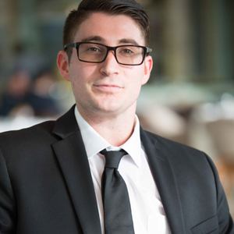 | Christopher Polys  Digital Marketing Executive  P.O.Box 107032, Al Maryah Island  Abu Dhabi  United Arab Emirates  christopher.polys@fourseasons.com  +971 2 333 2222

