Four Seasons Tented Camp Golden Triangle Introduces Forest Bathing

The Camp celebrates Global Wellness Day with a mindful virtual experience
May 25, 2020, Golden Triangle, Thailand

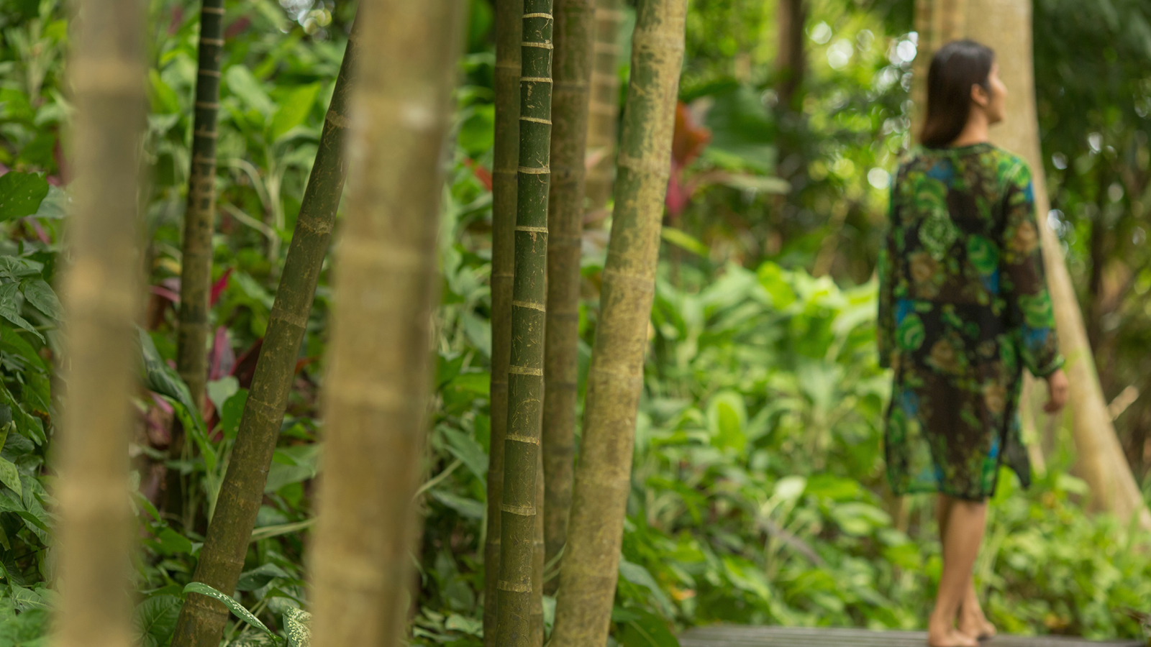
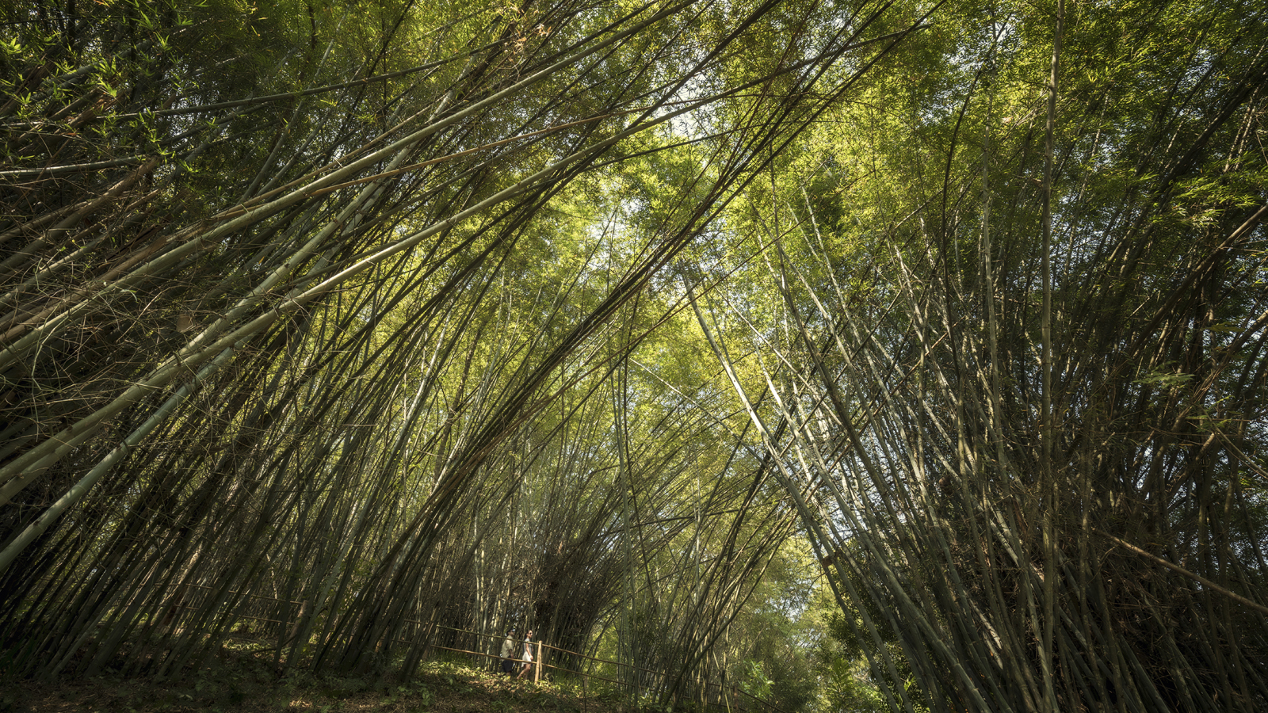 | 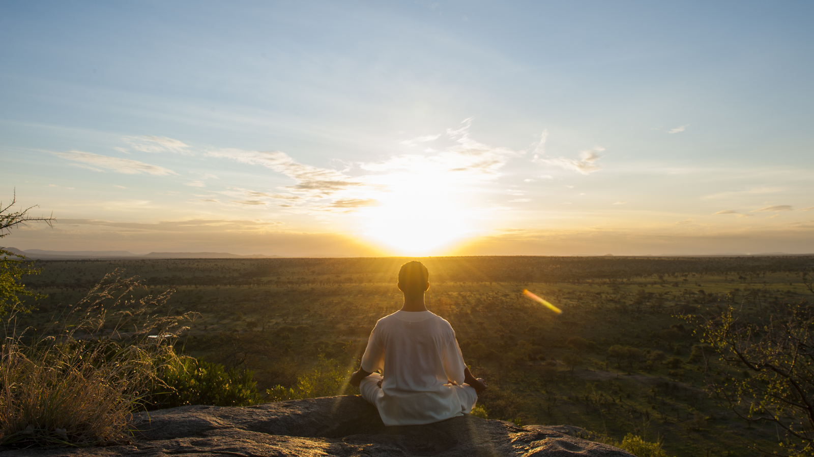 | 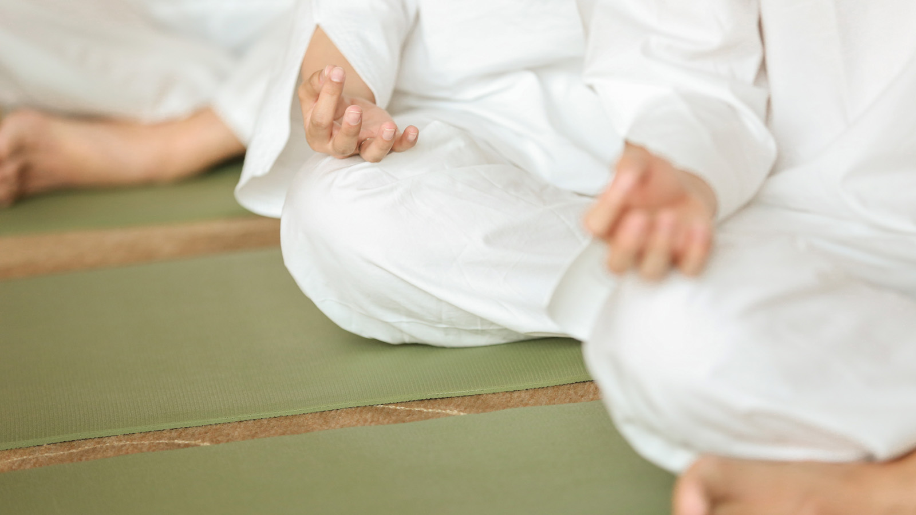
Nested in the bamboo jungles of Northern Thailand, Four Seasons Tented Camp Golden Triangle is a magical escape from reality, offering privacy, seclusion and an intimate encounter with nature that one craves for. “The healing power of nature’s embrace is much-needed – now more than ever!” shares Tobias Emmer, Camp Manager.
On June 13, 2020 for Global Wellness Day, the Camp will launch Forest Bathing - a therapy trail inspired by the jungles at the Golden Triangle. “Nature is a good medicine and being one with nature in times like these allows us to take our thoughts away from the daily routine and dream a little, of better times to come,” says Jutatip Sakulpanitcharuen, Spa Manager, who will lead the session.
Introducing this experience for the first time, guests will be transported to the beautiful jungle setting to partake in this mindful practice through a virtual tour broadcast on the Camp’s Instagram page. Ideal for those wanting to immerse in nature, the experience will inspire guests to connect with themselves and the serene atmosphere of the bamboo jungles at the Camp.
“This is not an exercise like hiking or jogging. It is simply being one with nature, connecting with trees, listening to birdsong, the breeze rustling through the leaves and being mindful of our senses. The experience aims to open up our senses and bridges the gap between us and the natural world,” shares Jutatip.
Besides reducing stress and blood pressure, Forest Bathing strengthens the immune and cardiovascular systems, boosts energy, mood, creativity, and concentration. “Once you have discovered the healing power of nature, you will able addicted – to immersing yourself in your surroundings, giving everyday stresses a break, and reaching a place of calm,” says Jutatip.
Guests who would like to join the 15-minute virtual tour at 9:00 am (GMT +7) on June 13, 2020 are requested to bring a potted plant to experience. “We may not be able to be with you during these times, but we wanted bring you here virtually, to our beautiful tented camp and live in the moment with us!” says Tobias.

RELATED

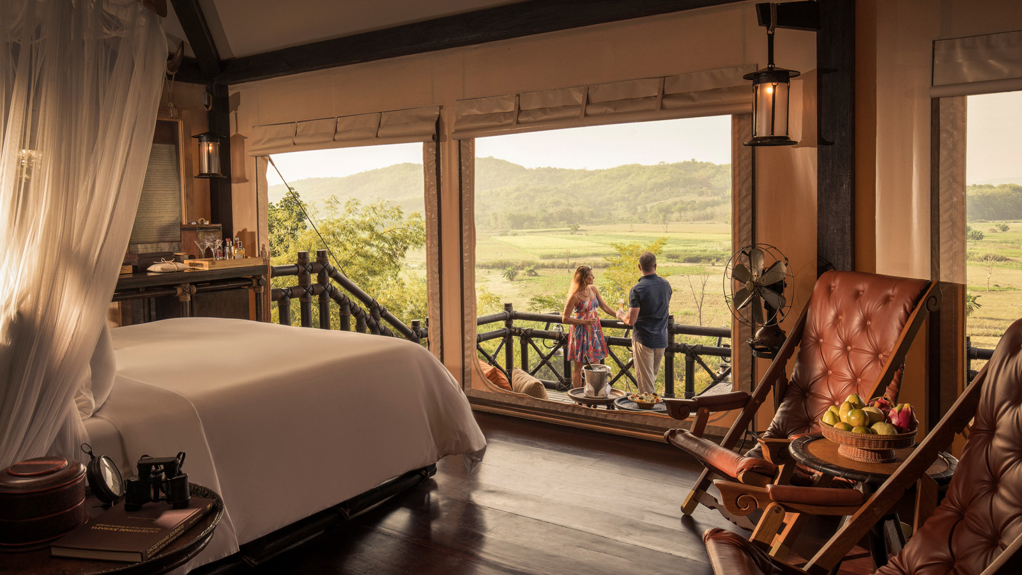 | March 3, 2020, Golden Triangle, Thailand  金三角四季帐篷酒店，天堂的掠影  https://publish.url/zh/goldentriangle/hotel-news/2020/glimpse-of-paradise-package-2.html
March 3, 2020, Golden Triangle, Thailand
A Glimpse of Paradise at Four Seasons Tented Camp Golden Triangle
https://publish.url/goldentriangle/hotel-news/2020/glimpse-of-paradise-package.html

PRESS CONTACTS

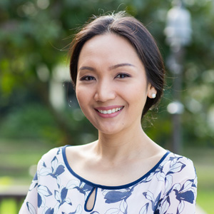 | Paphaon Suwannathamma  Assistant Public Relations Manager  502 Mae Rim-Samoeng (Old Road)  Chiang Mai  Thailand  paphaon.suwannathamma@fourseasons.com  +66 53 298 181
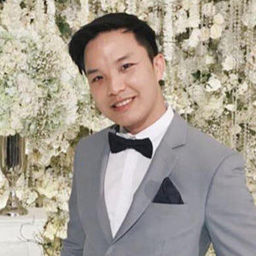 | Paponpat Sapsuwan  Assistant Public Relations Manager  3/F, 159 Rajadamri Road  Bangkok  Thailand  paponpat.sapsuwan@fourseasons.com  +66 02 207 8999
Chomploy Yavirach
Assistant Social Media Manager
3/F, 159 Rajadamri Road
Bangkok
Thailand
chomploy.yavirach@fourseasons.com

+66 02 207 8999

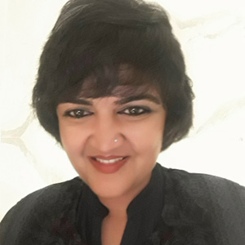 | Karuna Amarnath  Senior Director of Sales  3/F, 159 Rajadamri Road  Bangkok  Thailand  karuna.amarnath@fourseasons.com  +66 2207 8916

