Create Lifelong Memories at Four Seasons Hotel Gresham Palace Budapest with Luxurious Festive Celebrations

The most wonderful time of the year is around the corner; a season to celebrate timeless traditions, feast on festive delicacies, kiss under the mistletoe and create sparkling new memories
November 5, 2021, Budapest, Hungary

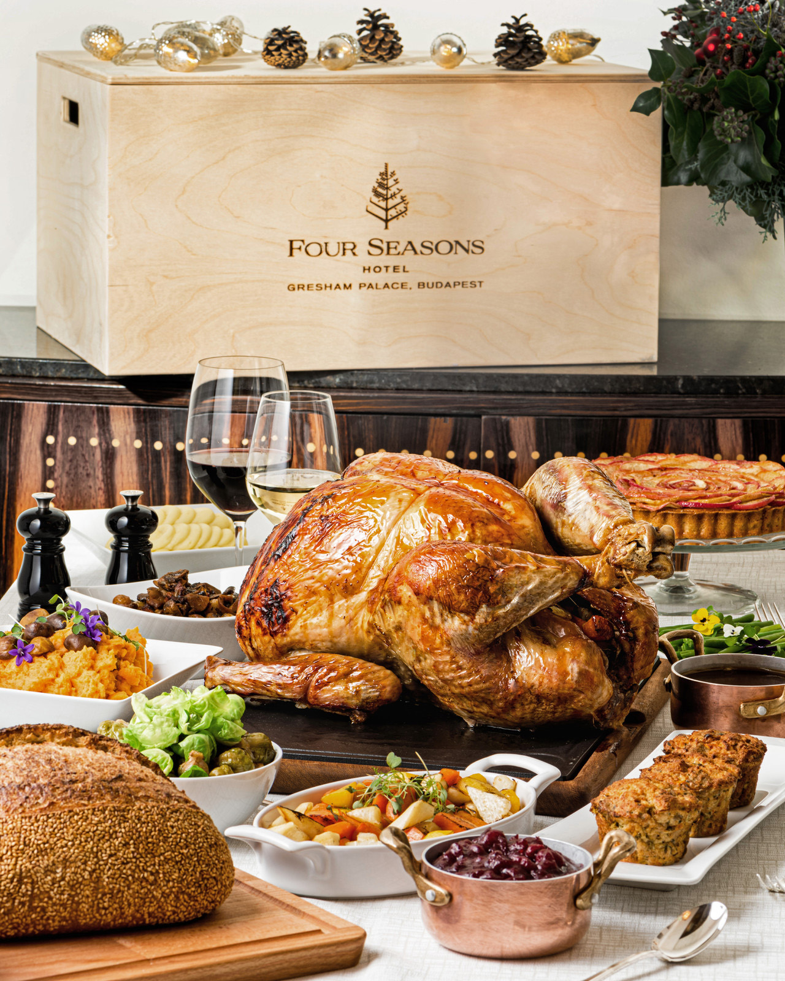 | 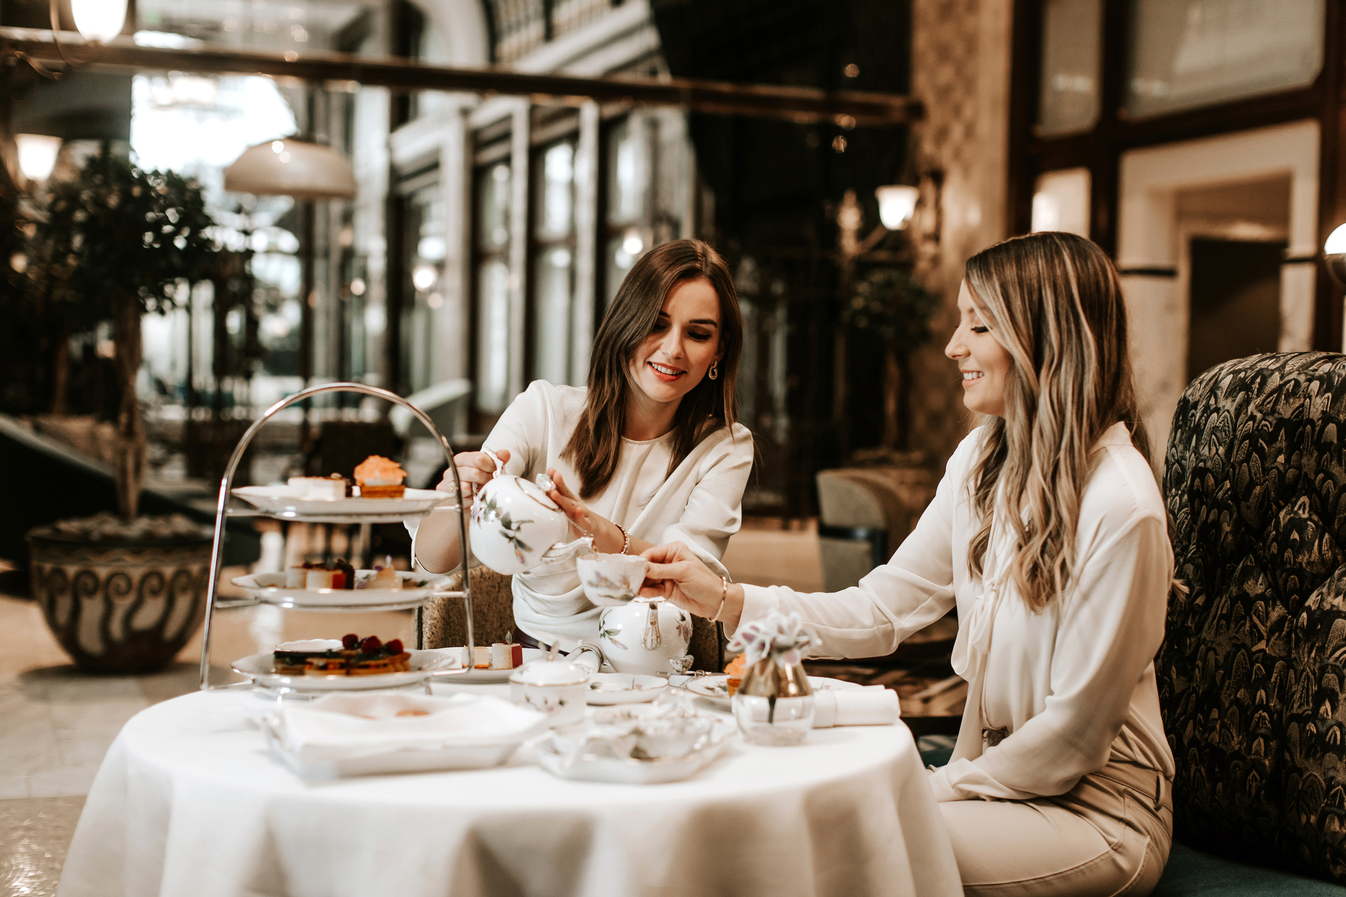 | 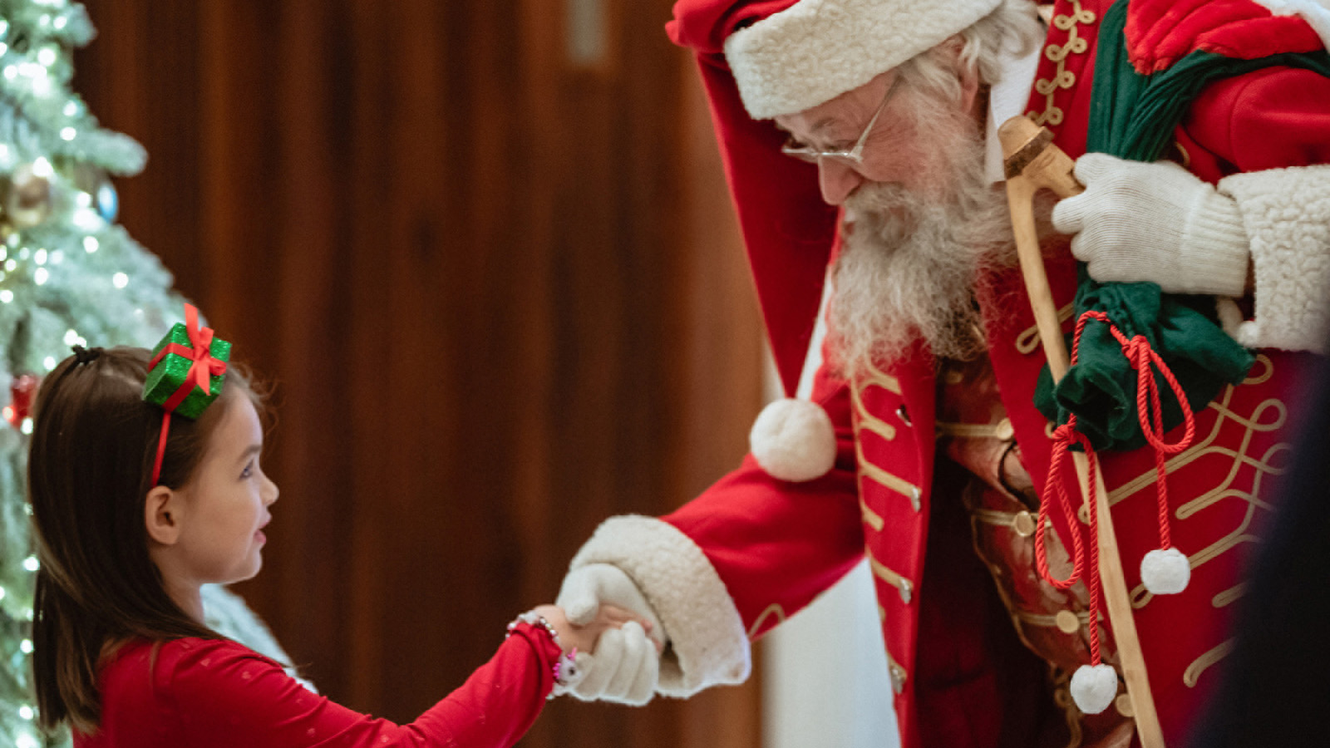
The festive season is the perfect time to gather loved ones and raise a toast to the most important treasure in life, time spent together. Four Seasons Hotel Gresham Palace Budapest invites guests to get into the holiday spirit with an unforgettable staycation at the majestic Gresham Palace dressed in its festive finest to get inspired by a handful of unique activities. From exquisite Christmas dinners and a Champagne countdown reminiscing Budapest’s Golden Era Glam to an indulgent spa treatment or a captivating local experience organised, there is something for everyone’s taste.
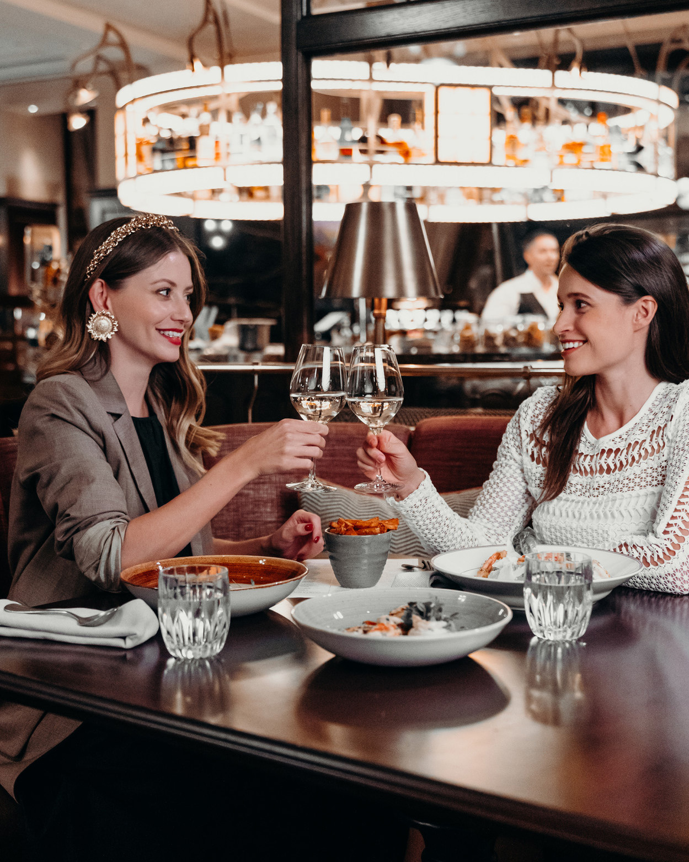 |  | 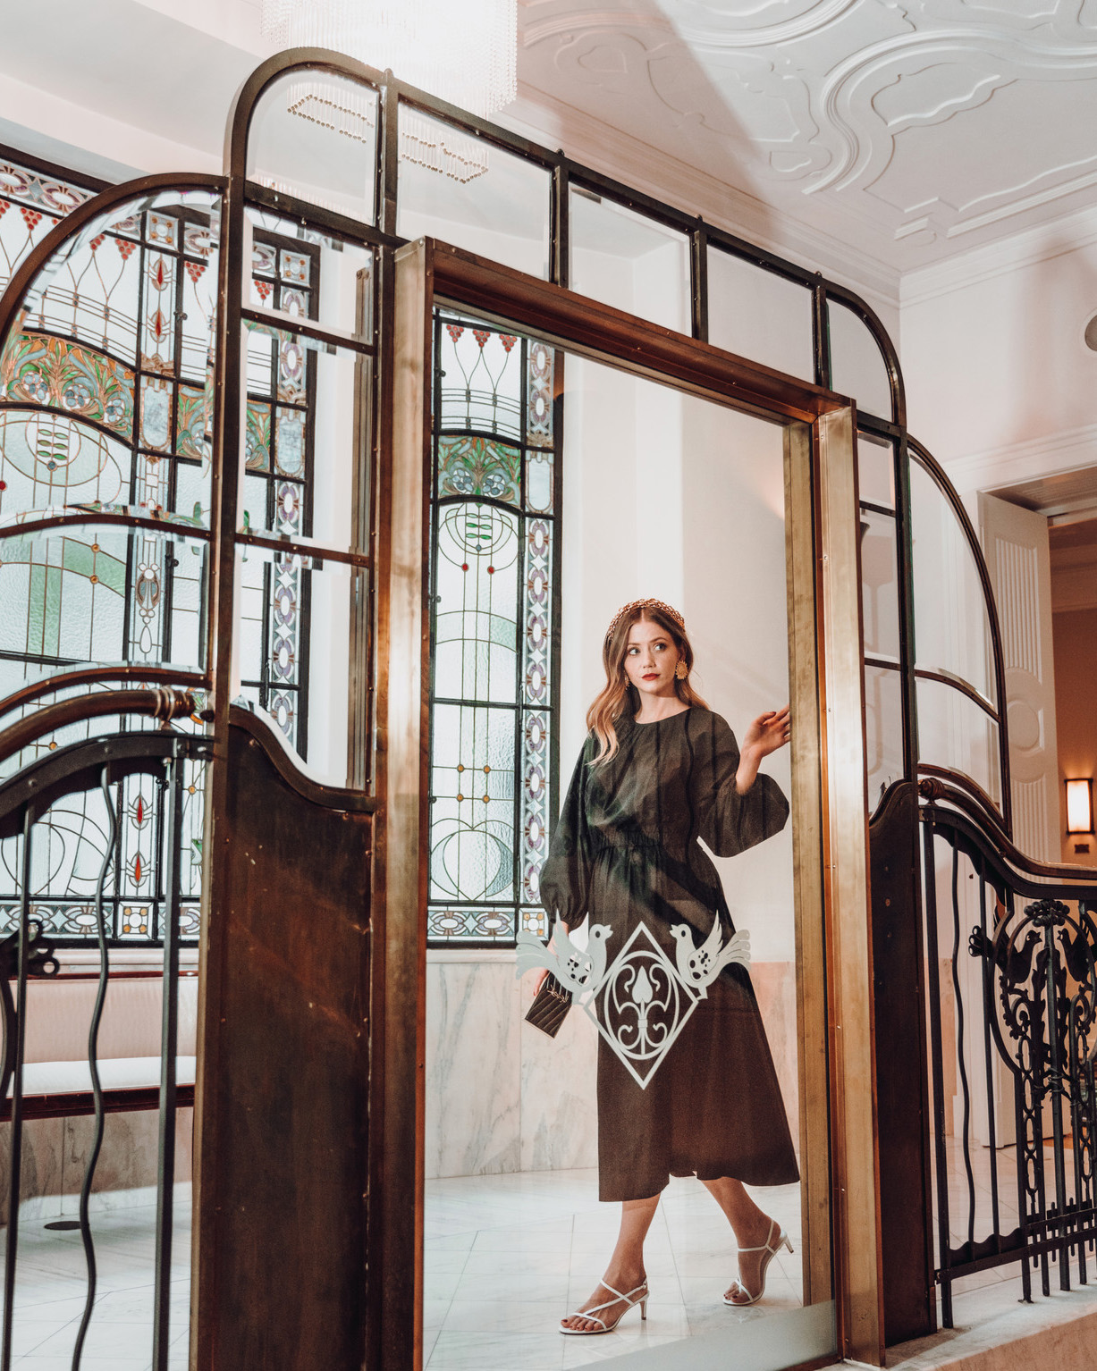
Fairytale Stay at the Gresham Palace
It’s the perfect time to spoil someone special with a stay at the majestic Art Nouveau Gresham Palace. From the moment of stepping in from the crisp winter air and walking through the iron peacock gates, guest will feel at home as they are welcomed by a festive atmosphere, the smell of pine and twinkling lights, combined with the legendary Four Seasons hospitality. Four Seasons Hotel Budapest offers different Festive Packages that include lavish culinary feasts and fun.
Hotel guests and locals alike are invited to enjoy wonderfully unique dining experiences during the festive season:
Holiday Turkey at Home
- November 24, 2021 – January 2, 2022
Christmas is simply not complete without the perfect roasted turkey. Four Seasons is offering a scrumptious Christmas Turkey Box to takeaway for the perfect family feast including roasted turkey with gravy, homemade cranberry marmalade, mashed potato, and apple-pear pie.
Winter Afternoon Tea
- Available every Saturday and Sunday between December 1 and 22, and available every day starting December 23, 2021 until January 2, 2022
A real festive royal feast at MÚZSA, the Hotel’s stunning Art Nouveau craft cocktail bar is awaiting Afternoon Tea enthusiasts. Exquisite teacakes and savoury delights are served in hand-painted Herend porcelain sets while evergreen melodies fill the air performed on piano, cymbal or harp.
Santa Brunch for Families with Little Guests
- December 5, 2021, 12:00 noon – 4:00 pm
Families with little guests can meet the Gresham Palace Santa Claus while enjoying live music and a feast of flavours at the buffet selection.
Dazzling Festive Dining at KOLLÁZS – Brasserie & Bar
- Christmas Eve and Day Dinners: December 24-25, 2021, 6:00-10:00 pm
- New Year’s Eve Dinner: December 31, 2021, 7:00 pm – 2:00 am
- Sunday Brunch, December 25, 2021 and January 1, 2022, 12:00 noon – 4:00 pm
KOLLÁZS – Brasserie & Bar, the Art Deco restaurant of Four Seasons Hotel Budapest prepares to welcome guests with a lavish feast of culinary delights for Christmas and during New Year’s Eve. The four-course dinner menus are each brimming with gastronomic treats crafted by Executive Chef Árp&aacute;d Győrffy, accompanied by live entertainment and optional wine pairing. The focus on festive favourites is big this year.
Post Christmas Eve and New Year’s Eve, leisurely brunches are here to remind all that the holidays are the perfect time to indulge.
Champagne Countdown at MÚZSA
- December 31, 2021, 8:30 pm – 2:00 am
MÚZSA, the stunning cocktail bar and lobby at the Gresham Palace will allow guests to get a unique glimpse into Budapest’s Golden Era Glam with a Champagne Countdown event on New Year’s Eve. A night of glamour, exquisite champagne selection, craft cocktails, Asian-Hungarian hors d'oeuvre, and spectacular live entertainment can be expected.
For more information, visit the Hotel's festive website; to know more about room packages, contact the reservations team via res.budapest@fourseasons.com or +36 1 268 6000. To receive more information about Christmas and New Year dining offers, contact the food & beverage team at festivity.budapest@fourseasons.com or chat through the Four Seasons App.

RELATED

December 12, 2022, Budapest, Hungary
Experience the Wonders of Herend Afternoon Tea This Festive Season with Four Seasons Hotel Gresham Palace Budapest
https://publish.url/budapest/hotel-news/2022/herend-afternoon-tea.html

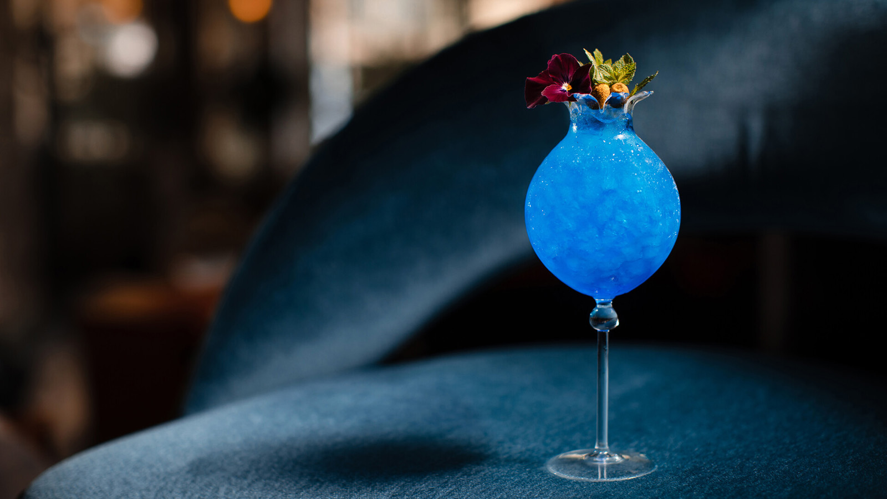 | November 18, 2022, Budapest, Hungary  MÚZSA Unveils New “Coloroid” Menu at Four Seasons Hotel Gresham Palace Budapest  https://publish.url/budapest/hotel-news/2022/new-coloroid-cocktail-menu-at-muzsa.html

PRESS CONTACTS

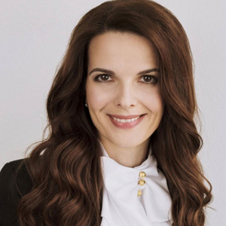 | Judit Esküdt  Director of Public Relations and Communications  Széchenyi István tér 5-6.  Budapest  Hungary  judit.eskudt@fourseasons.com  +36 1 268 5452
Fruzsina Otto
Assistant Public Relations Manager
Széchenyi István tér 5-6.
Budapest
Hungary
fruzsina.otto@fourseasons.com

+36 1 268 5419

