Four Seasons Los Angeles at Beverly Hills Announces Special Holiday Menus for Easter Brunch and Passover Dinner

March 8, 2023, Los Angeles at Beverly Hills, U.S.A.

 | 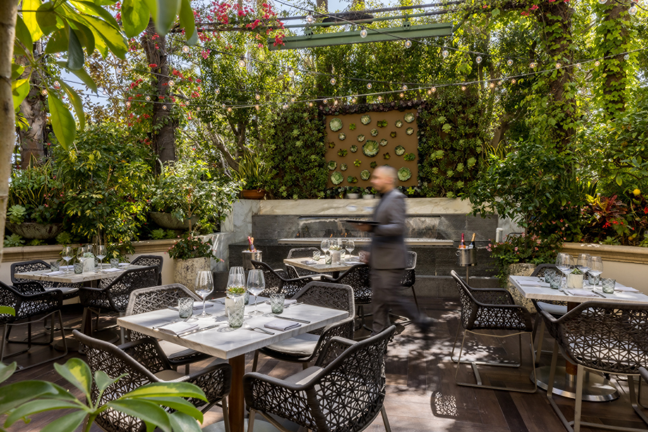 | 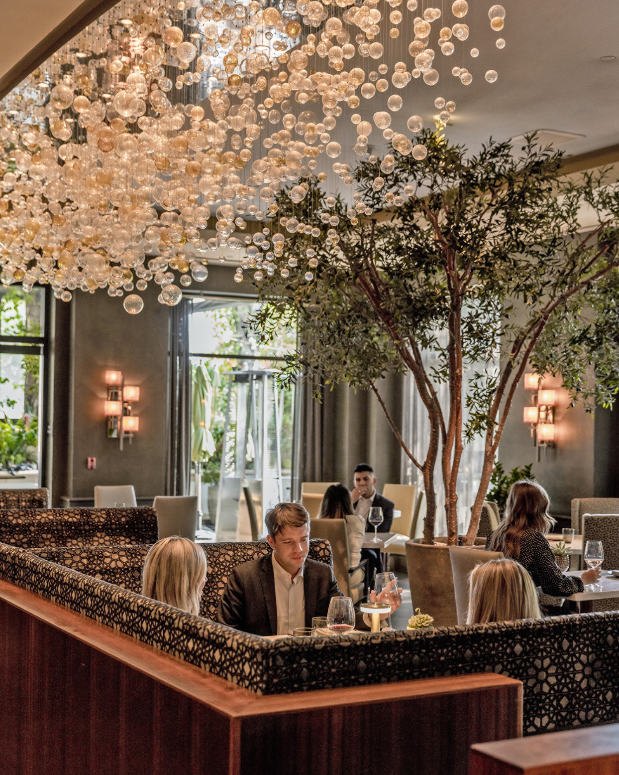
Four Seasons Hotel Los Angeles at Beverly Hills welcomes guests and local residents to celebrate Easter and Passover with special holiday menu offerings. Designed by Executive Chef Mitch Austin and the Hotel’s culinary team to offers selections for all ages, dietary preferences, and celebrations, both an abundant buffet-style Easter Brunch and curated three course Passover Dinner will be available. The Easter Brunch will also include an Easter Bunny and two egg hunts for children at 11:00 am and 2:00 pm.
Easter Brunch at Culina
- April 9, 2023
- USD 169 per person
- 10:00 am - 3:00 pm
Celebrate Easter at Culina with an extensive brunch prepared by Executive Chef Mitch Austin, along with an Easter Bunny and Easter Egg Hunt. The menu will feature brunch favourites including made-to-order eggs and omelets, vanilla Belgium waffles, and specialty pastries as well as savoury options including devilled eggs and artisanal salads. Additional appetizers include selections of California cheeses, nigiri sushi, rolls, king crab claws, oysters, shrimp cocktail, smoked and cold poached salmon, and more. A traditional carving station takes centre stage with roasted prime rib, carved spring lamb leg, maple glazed smoked ham, and honey mustard roasted organic salmon, with additional entrée selections include braised beef short ribs, Jidori chicken with creamy marsala sauce, miso glazed seabass, seared branzino, artichoke and ricotta ravioli, and more. A children’s buffet will also be available with fruit pops, finger sandwiches, mini corndogs, chicken tenders, tater tots and more. Decadent desserts will also be available including house made doughnuts, made-to-order cotton candy, petite carrot cakes, assorted gelato flavours, and more specialty desserts.
For bookings and inquiries, call the Hotel directly at 310 273 2222.
Passover Dinner at Culina
- Wednesday April 5, 2023 - Thursday April 13, 2023
- USD 79 per person
- 5:00-10:00 pm
In celebration of Passover, Culina’s culinary team has created a delectable three-course prix fixe dinner menu. The dinner will begin with appetizer options including a charoset salad, chicken liver p&acirc;té or matzo ball soup. Entrée options include a roasted Jidori chicken or braised Passover brisket. The meal concludes with a decadent dessert, coconut pannacotta.
For reservations, call 310 860 4000.

RELATED

January 18, 2023, Los Angeles at Beverly Hills, U.S.A.
Love is in the Air This Valentine’s Day at Four Seasons Hotel Los Angeles at Beverly Hills
https://publish.url/losangeles/hotel-news/2023/valentines-day.html

November 7, 2022, Los Angeles at Beverly Hills, U.S.A.
Four Seasons Hotel Los Angeles at Beverly Hills Celebrates the Holiday Season with Special Menu Offerings and Events
https://publish.url/losangeles/hotel-news/2022/festive-season.html

PRESS CONTACTS

Melanee Shale
Marketing and Communications Manager
300 South Doheny Drive
Los Angeles
USA
melanee.shale@fourseasons.com

+1 310 786 2217

