Our Concierge Picks of Bali's Best Annual Events

Our concierge team share their picks of the best annual events not to be missed in Bali.
March 20, 2019, Bali at Jimbaran Bay, Indonesia

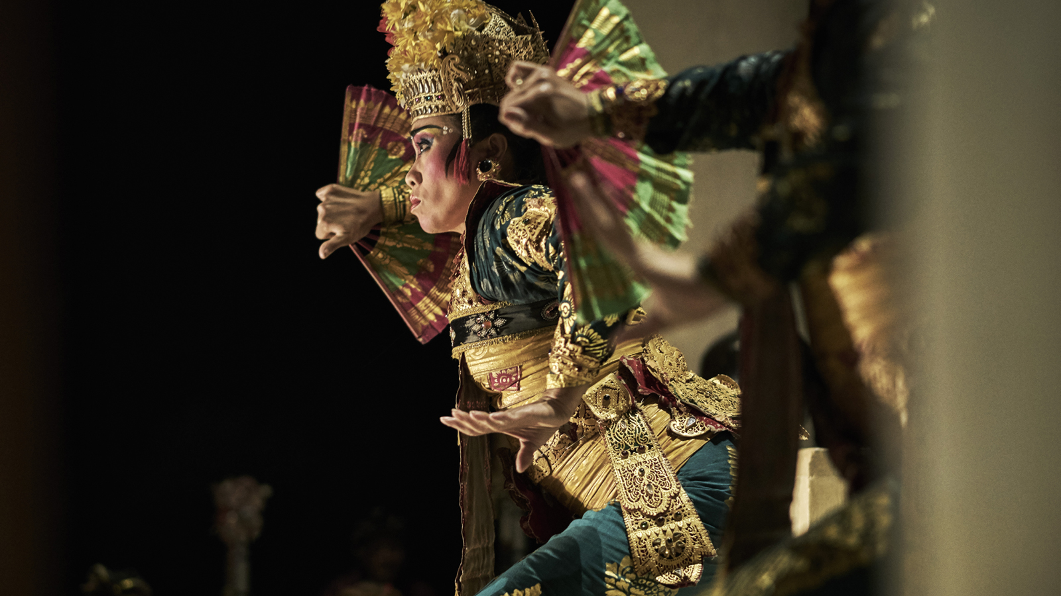
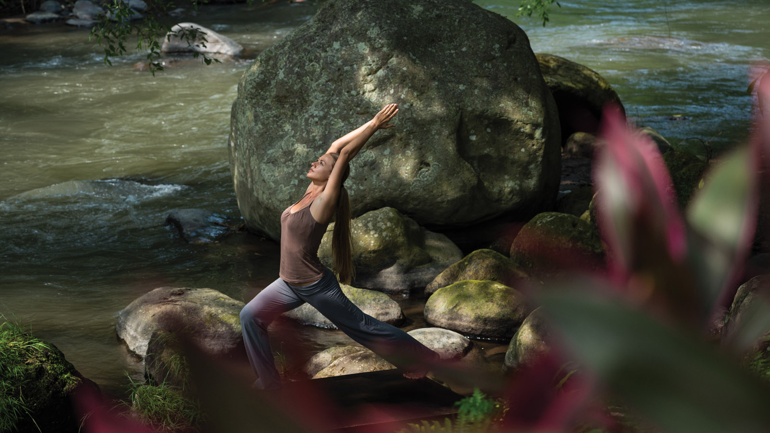 | 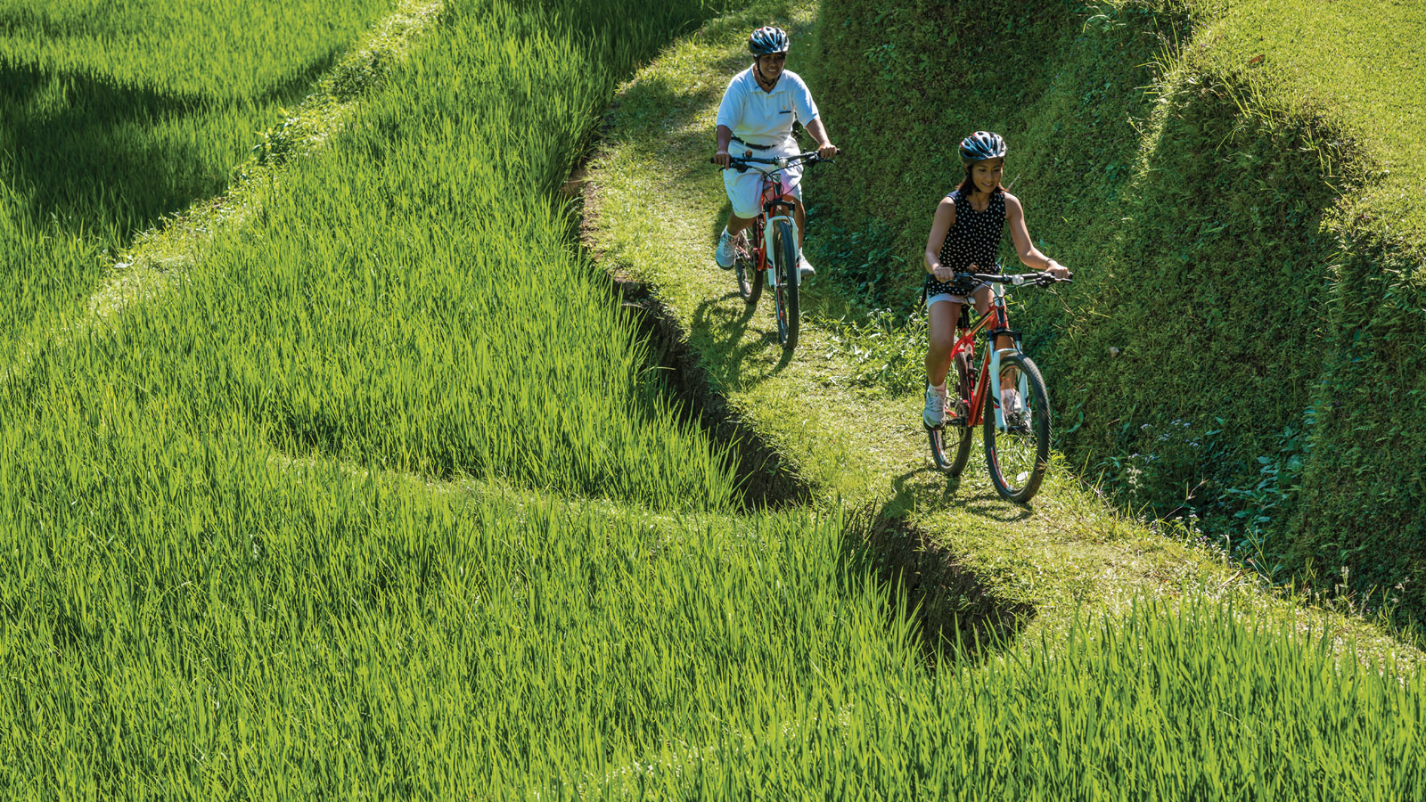 | 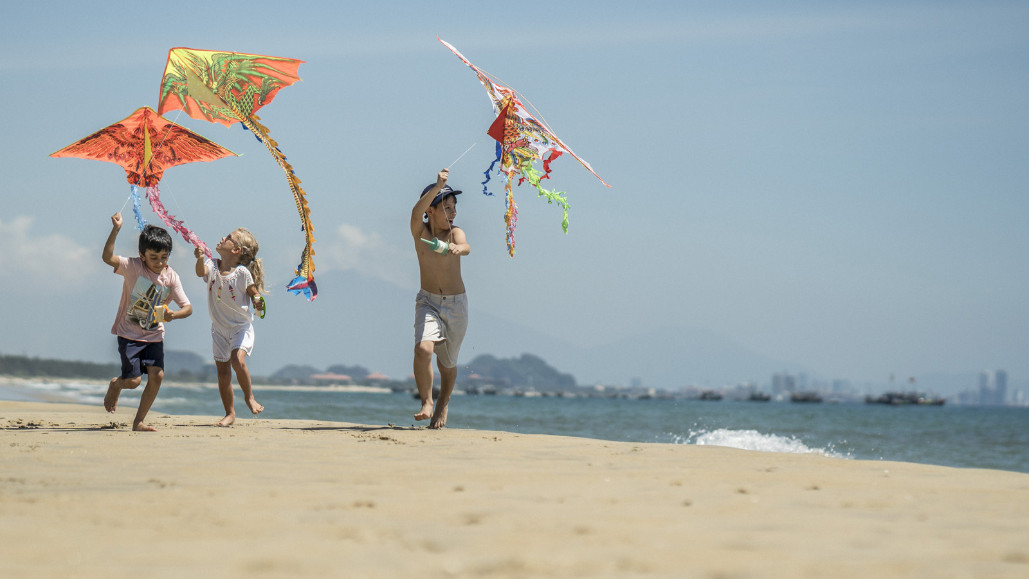
1 - Nyepi (March) - Many will say the best time to visit Bali is the ‘dry’ season April through October, but for cultural buffs, the best month is March to experience the unique Balinese-Hindu New Year, known as Nyepi or ‘Silent Day’. While most of the world marks a New Year with social gatherings and midnight fireworks, in Bali it’s a time to cleanse the spirit, meditate and give Mother Nature a full day of well-earned rest. Each village’s ‘ogoh-ogoh’ parade the night before is a fascinating display of art and engineering, while Four Seasons Resorts Bali at Jimbaran Bay and Four Seasons Resort Bali at Sayan curate special activities for guests to embrace this unique occasion. The date of Nyepi changes each year, following the lunar-based Balinese saka calendar. In 2020, Nyepi will fall on 25 March.
 | 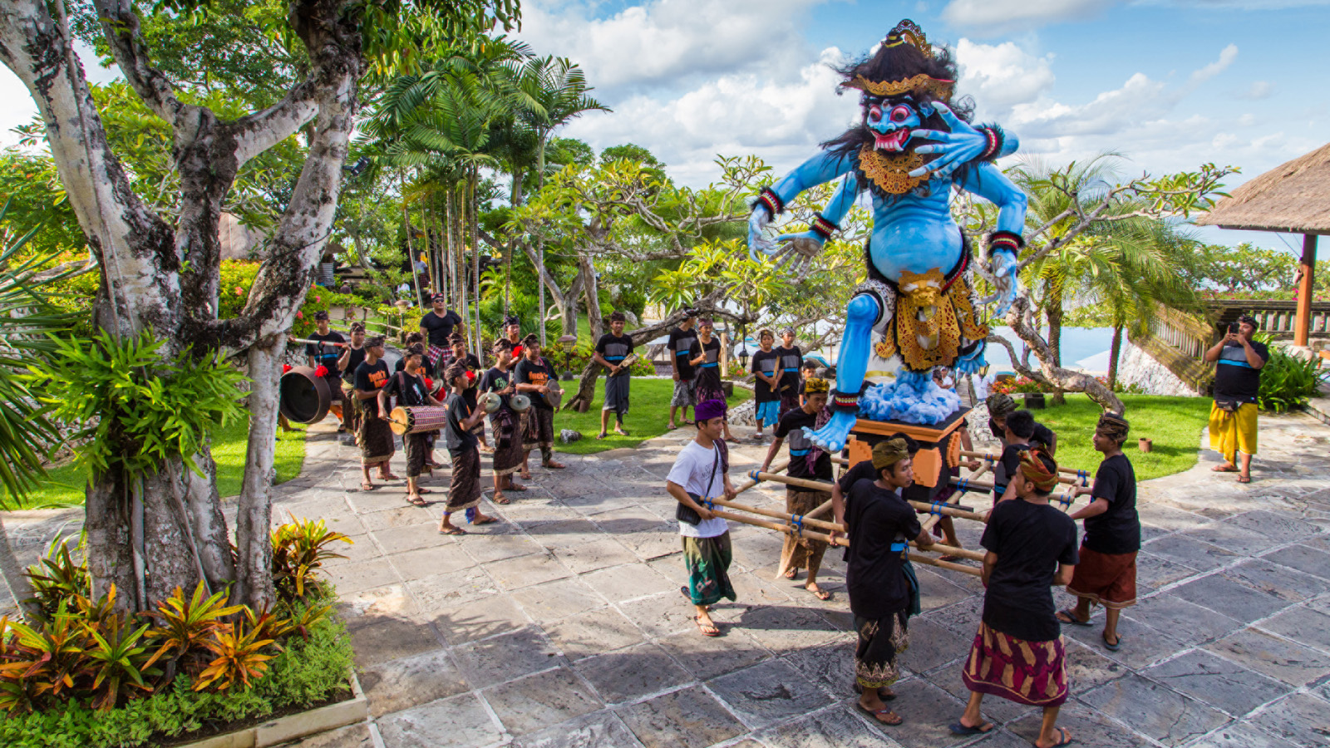 | 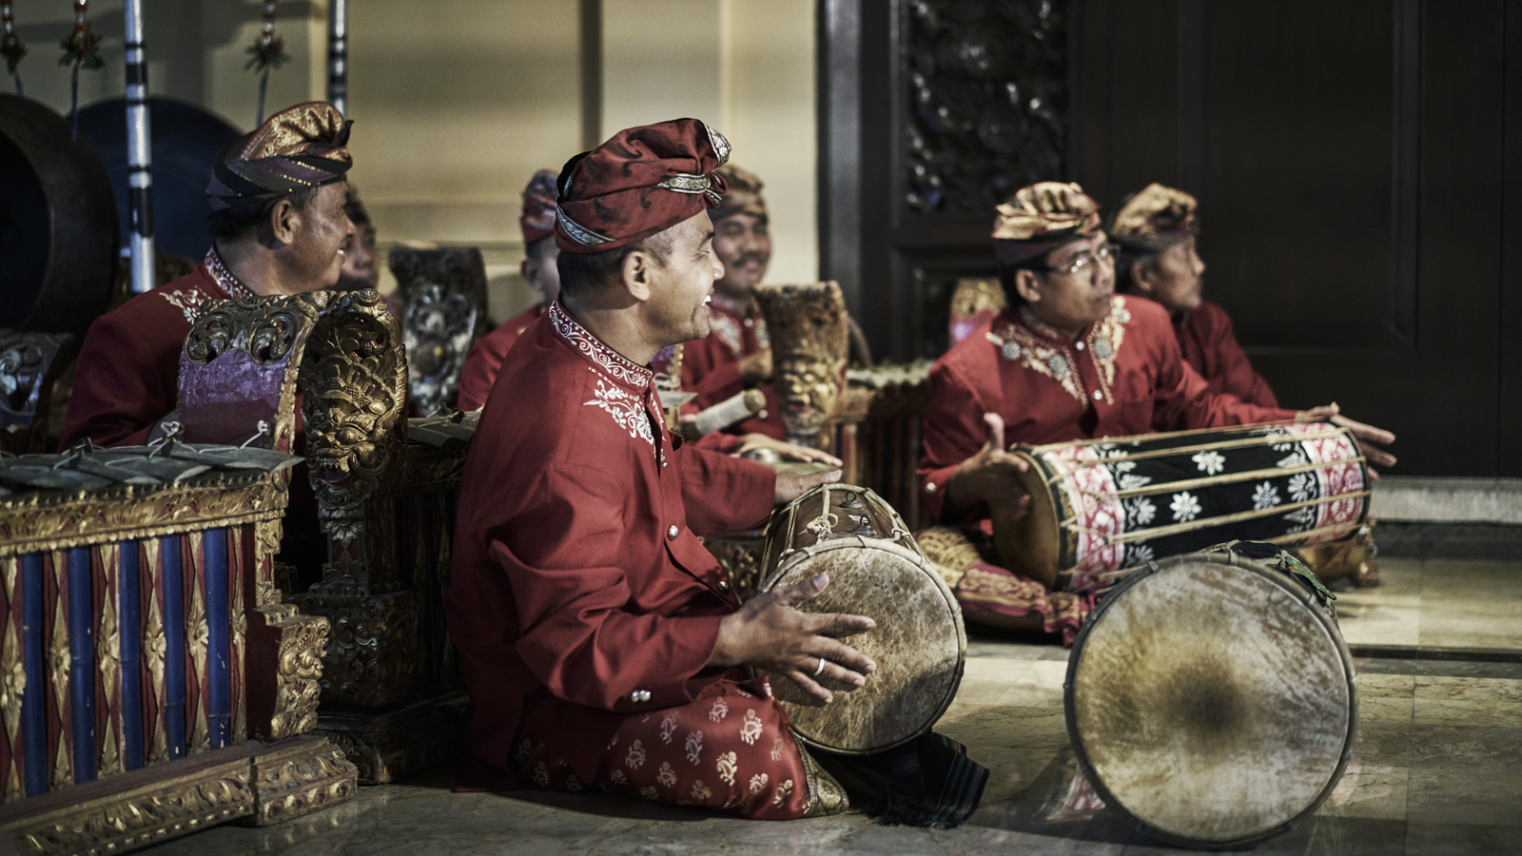
2 - Named after the Sanskrit word for medicine (‘ubad’), Ubud is a place for restoration of the soul, so it is no surprise that the Bali Spirit Festival (24-31 March 2019) is one of the world’s most inspiring yoga festivals. Celebrating global community, dance, world music and wellbeing, activities include interactive workshops & seminars, a lively community market and healing centre, children’s activity zone, and a variety of yoga classes.
3 - Ubud Food Festival (26-28 April 2019) – Since its launch five years ago, this Festival has grown into Indonesia’s leading food event, sharing diverse culinary cultures, unique local produce and top restaurants. Four Seasons Resort Bali at Sayan is participating this year with a guest chef collaboration. The resort’s renowned chef Wayan Sutariawan will partner with Ragil Imam Wibowo, named Chef of the Year at Jakarta’s Best Eats 2018, to present a seven course Indonesian Chef’s Table dinner at Ayung Terrace restaurant on 28 April 2019.
4 - More than 40 years old, the Bali Arts Festival (16 June – 14 July 2019) is an entire month dedicated to exhibitions of the many unique and dynamic aspects of Balinese culture, from the traditional to the contemporary. Artists from all regions of the island come together each year in Denpasar to showcase their craft, from gamelan orchestras and local handicrafts, to wayang kulit shadow puppets and epic dances.
5 - Having set a MURI world record for the largest number of dancers to perform together, the annual Tanah Lot Arts Festival (20 July 2019) will once again amaze with an opening show performed by some 1800 traditional dancers. The Rejang Sandat Ratu Segara is a Balinese sacred dance dedicated to the Mother of the Earth, and is incredible to see at this iconic sea temple, one of Bali’s most popular tourist attractions.
6 - Sanur Village Festival (21-25 August 2019) is held in the coastal village of Sanur (just 40 minutes from both Four Seasons Sayan and Four Seasons Jimbaran Bay). This festival celebrates the arts, great food, culture and the environment – eco-activities include planting corals and exotic and endangered plant species. You will also find fashion shows, photography exhibitions, golf and fishing tournaments, a cycling tour and family friendly events such as body painting, kite flying, beach games and fun run.
7 - Bali Kite Festival (29 August 2019) started out as a colourful way to thank the gods for bountiful harvests and fertility. This high-flying event has since grown into one of the most remarkable on Bali’s calendar. Prizes are awarded to the most distinct and creative kites, bringing out friendly rivalry between participants. If you head down to the beach to watch or take part, you will see a sky filled with kites of all shapes, sizes and colours soaring above the crowds.
8 - Ubud Writers & Readers Festival (23-27 October) has established itself as an annual pilgrimage for lovers of literature and conversation. Taking place over five days, the festival brings together some of the world’s most powerful voices in a melting pot of artists, authors, thinkers and performers, to provide a platform for meaningful exchange and cross-cultural dialogue.
9 - Bali International Triathlon (October) is one of the main events on Bali’s sporting calendar and attracts high-calibre athletes from around Indonesia and the world. The swimming part of the race begins at sunrise followed by the bike leg and finally a road race through the streets of sleepy villages. The event includes Sprint and Olympic distance courses, as well as a fun run. The event is held around 40 minutes’ drive from both Four Seasons Jimbaran Bay and Four Seasons Sayan.
10 - Perang Pandan War Dance Ceremony is a mass coming-of-age ritual, held annually and dedicated to the Hindu god of war and the sky, Indra. This age-old tradition is unique to Tenganan, a well-preserved old Balinese village in East Bali (Karangasem regency), and follows the village’s own calendar. In friendly duels, male villagers will battle each other armed with a small rattan shield in one hand and a packet of thorny 'pandan' leaves in the other.

RELATED

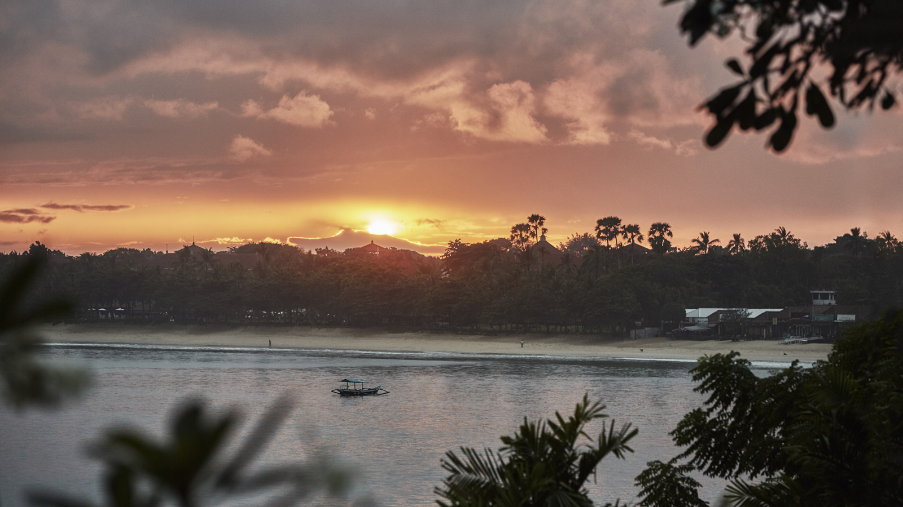 | February 25, 2019, Bali, Indonesia  Four Seasons Resorts Bali: Why Bali’s Annual “Silent Day” Needs to Be on Everyone’s Bucket List  https://publish.url/jimbaranbay/hotel-news/2018/nyepi-silent-day.html
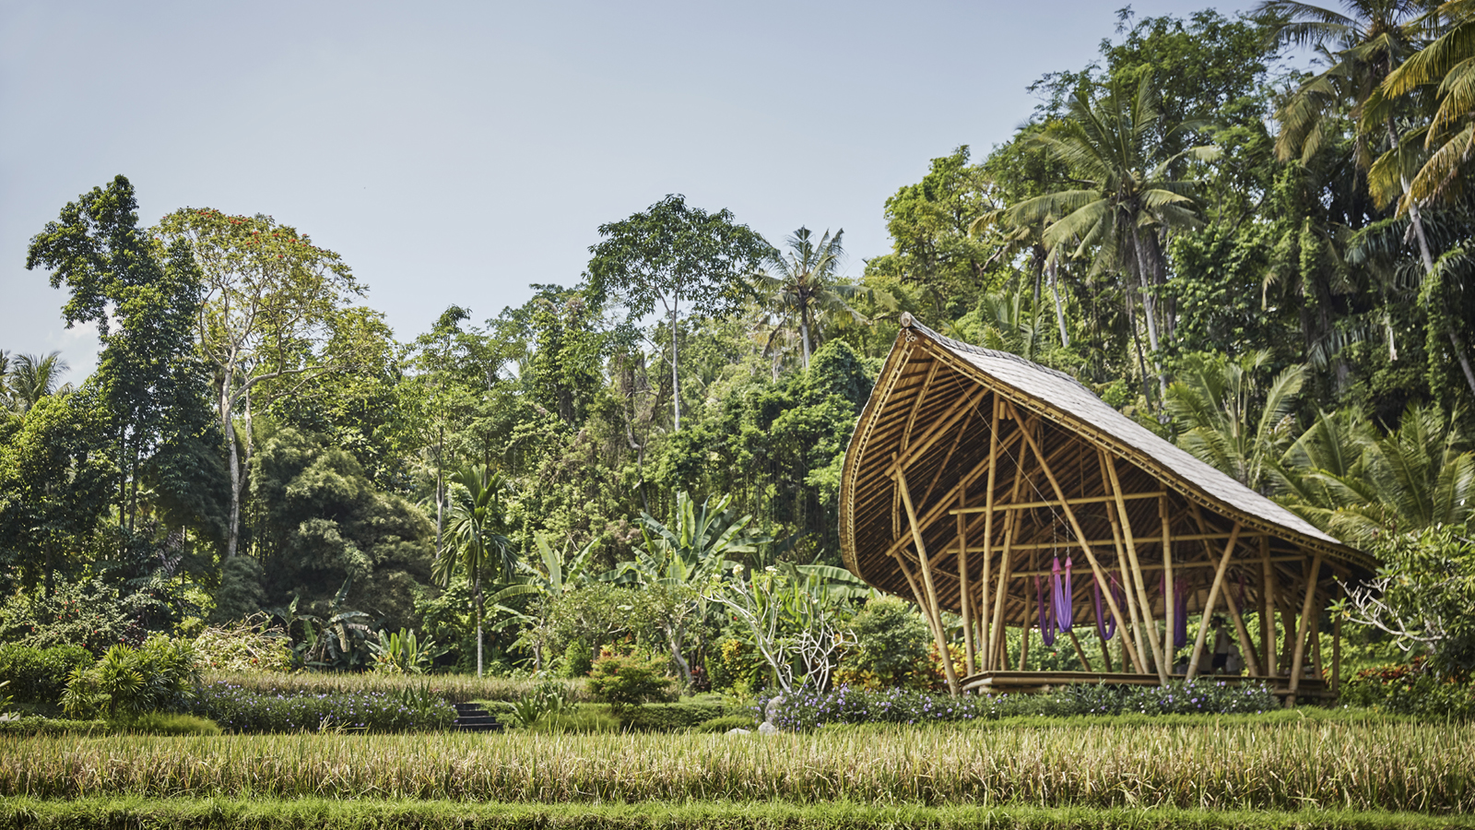 | January 30, 2019, Bali at Sayan, Indonesia  Guided by Gratitude: Four Seasons Resort Bali at Sayan Launches Destination’s First Year-Round Wellness Retreat  https://publish.url/sayan/hotel-news/2019/guided-by-gratitude-wellness-retreat.html

PRESS CONTACTS

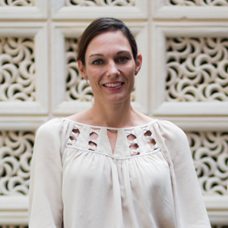 | Marian Carroll  Director of Public Relations  Jimbaran  Indonesia  marian.carroll@fourseasons.com  +62 (361) 701010

