Four Seasons Hotel Sydney Blooms with Fleurs de Villes FEMME

A floral high tea and a bathtub fit for a goddess creating an ethereal Sydney getaway
August 2, 2022, Sydney, Australia

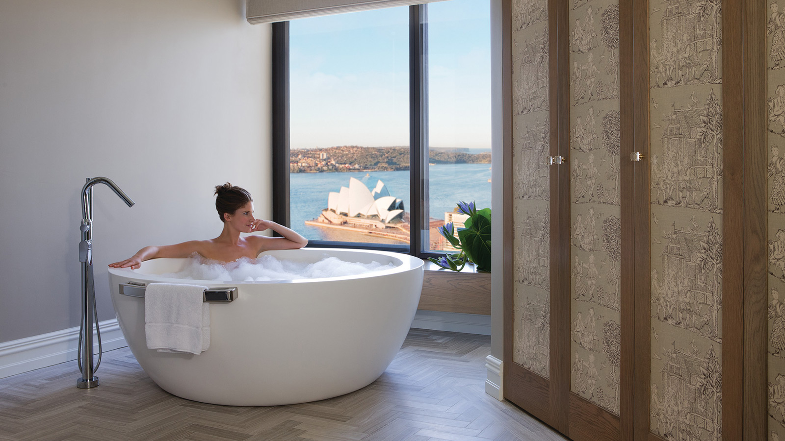
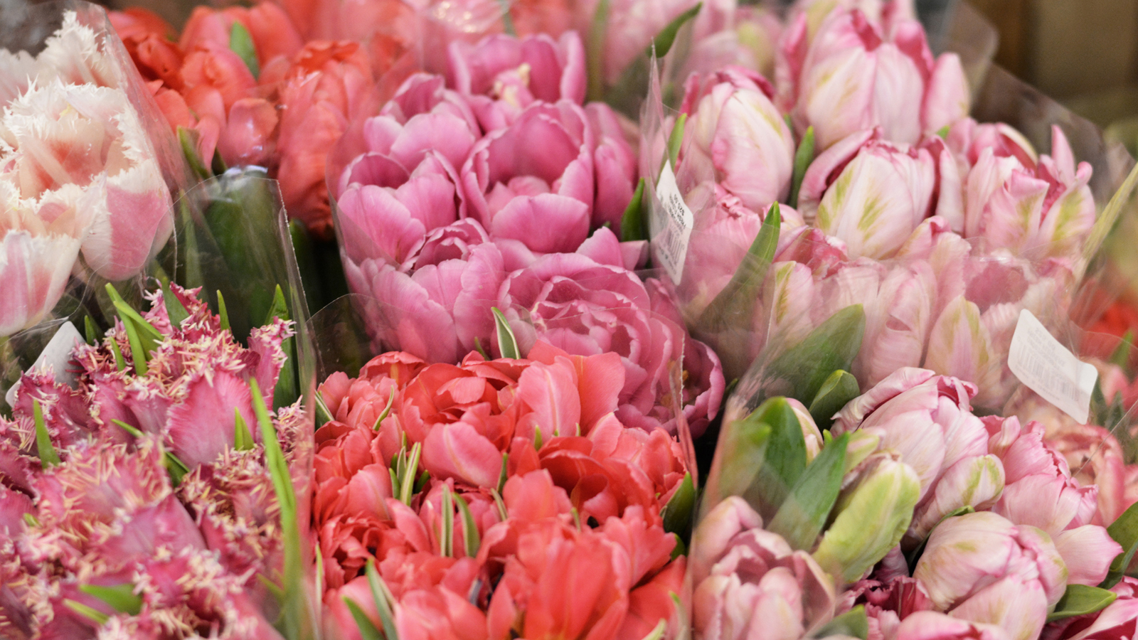
Four Seasons Hotel Sydney invites guests to stop and smell the roses during Sydney’s Fleurs de Villes FEMME exhibition featuring sensory experiences fit for a goddess. Guests can respite in the most indulgent suite surrounded by flowers or spend the afternoon with a floral-themed high tea and a leisurely stroll to the Royal Botanic Gardens, available August 19-28, 2022.
The Presidential Suite will bloom into a garden providing an oasis for all gods and goddesses. Unwind in a rose petal-filled bath surrounded by a cascading flower wall while looking over the sparkling Sydney harbour. What is more luxurious than a bath with a view? A bath with a glass of rosè or perhaps a customised cocktail prepared in the new in-room trolley by Grain. The feminine fragrance Delina by Parfum de Marly enhances the bath amenities, providing an overall sensory experience.
Inspired by the Greek goddesses of the seasons, two local florists have crafted a beautiful artistic pair: Demeter, the goddess of grain and agriculture, and her daughter Persephone, better known as the creator of the seasons. Persephone returns to the world each spring, and flowers instantly bloom wherever she steps, which creates an ethereal experience.
The unique exhibition of Fleurs de Villes FEMMES blends luxury floral couture and fresh blooms with bespoke floral-dressed mannequins appearing in the Royal Botanic Garden. At the same time, the Goddess Persephone is perched in the Hotel lobby.
Guests can enjoy any of the following sensory experiences starting from August 19, 2022.
The Garden Goddess Suite
The Garden Goddess suite is available for booking for any goddess looking for a quiet respite in the clouds. The one-bedroom Presidential Suite commands the ultimate view of the harbour, overlooking the Sydney Harbour Bridge and Sydney Opera House in a full panoramic view.
- Luxurious one-bedroom suite
- Garden bathroom with rose petal bath
- Delina perfumes and bath amenities (valued at AUD 1,200)
- Cocktail Trolley by Grain
Suite reservations are available by calling the Hotel directly at +61 2 9250 3100, rates from AUD 5,200 per night.
Fleurs Escape
Enjoy a Sydney getaway with a night in a luxury hotel, spend the day at the Royal Botanic Gardens, and be mesmerised by the beauty. Fleurs de Villes FEMMES guests are invited to stay at a special rate, including a rose bath amenity and two botanical cocktails, by entering the promo code: FLEURS here.
Fleurs de Thé at Mode Kitchen & Bar
The pastry team is taking floral inspiration from Fleurs de Villes and enhancing the afternoon tea, available from Friday through Sunday from 2:00 to 4:00 pm.
Guests can imbibe on floral-inspired sweets from Pastry Sous Chef Quentin Zerr, such as edible floral tartlet, chocolate delice and pink pavlova, all carefully hand-crafted. For savoury options, the team presents gourmet bites, such as egg and truffle tea sandwiches, tiger prawn rolls, gougères au Comté and gorgonzola and radicchio tarts, paired perfectly with a selection of teas featuring whole flowers.
For AUD 99 per person, guests can enjoy the above menu paired with a floral rosé cocktail; for AUD 109 per person, the flower tea will be paired with rosé champagne.
Reservations are required for Fleurs de Thé by clicking here or calling +61 2 9250 3100.
Enchanted Rose and Rosé Bath Soak
Suite guests can make the most of their deep-soaking tubs with a luxurious bath pack crafted with soothing Australian botanicals, bath salts and dried rose petals. Available for a limited time from August 19 to 28, 2022 for AUD 50 per person, this indulgent experience includes a glass of rosé.
Cocktail Class by Grain at the Calyx
An experience at Grain is not just about the delicious cocktail but also customising cocktails around guests’ taste buds. Join this masterclass where the Hotel’s talented craftsmen will walk guests through the art of cocktail making featuring Australian botanicals.
Adam Lau will lead a masterclass at The Calyx at The Royal Botanic Gardens on Monday, Augus 22, 2022 at 5:00 pm. For more information, click here.
About Fleurs de Villes
Fleurs de Villes is an international luxury experiential brand that creates bespoke floral events with top local floral designers to showcase each city’s world class talent and create stunning displays of art. From August 19 to 28, 2022 visitors to The Calyx at Royal Botanic Garden Sydney are invited to enjoy Fleurs de Villes FEMMES – a fresh floral celebration of remarkable women. The spectacular 10-day floral extravaganza will feature 17 floral mannequins celebrating remarkable women around the world, created by some of Sydney’s favourite florists. The local florists will create these fresh floral tributes based on an inspirational photograph or painting of each woman.

RELATED

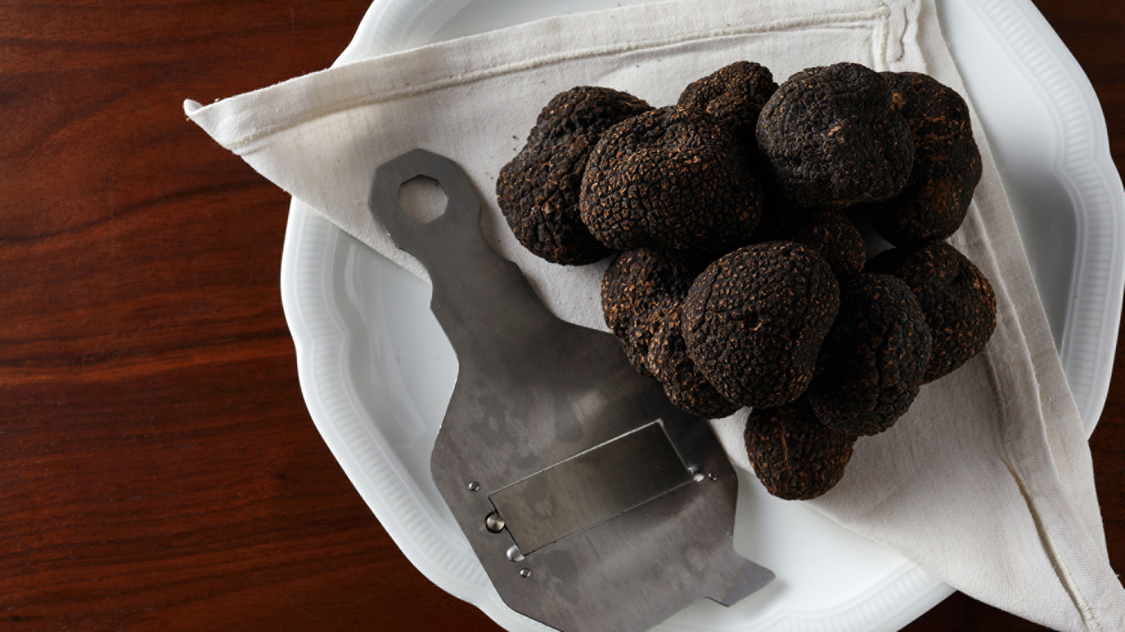 | June 27, 2022, Sydney, Australia  MODE Kitchen & Bar Launches Winter Menu Topped with Black Truffle Delicacies at Four Seasons Hotel Sydney  https://publish.url/sydney/hotel-news/2022/mode-kitchen-and-bar-truffle-menu.html
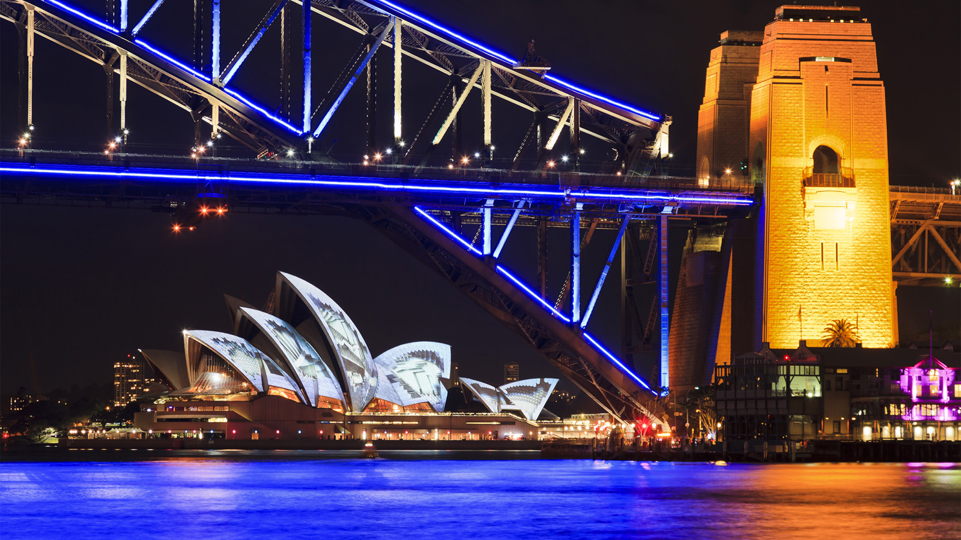 | May 18, 2022, Sydney, Australia  View the “Soul of the City” from Four Seasons Hotel Sydney During Vivid  https://publish.url/sydney/hotel-news/2022/vivid-sydney.html

PRESS CONTACTS

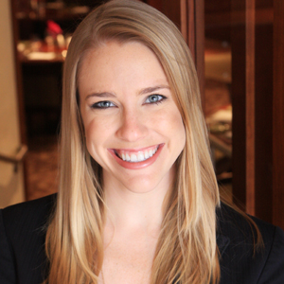 | Elysia McEwen  Director of PR and Communications  199 George Street  Sydney  Australia  elysia.mcewen@fourseasons.com  +61 2 9250 3315

