Four Seasons Resort Bora Bora Named #1 Hotel in French Polynesia by TripAdvisor

Acclaimed island resort also named top hotel for luxury and service
January 30, 2019, Bora Bora, French Polynesia

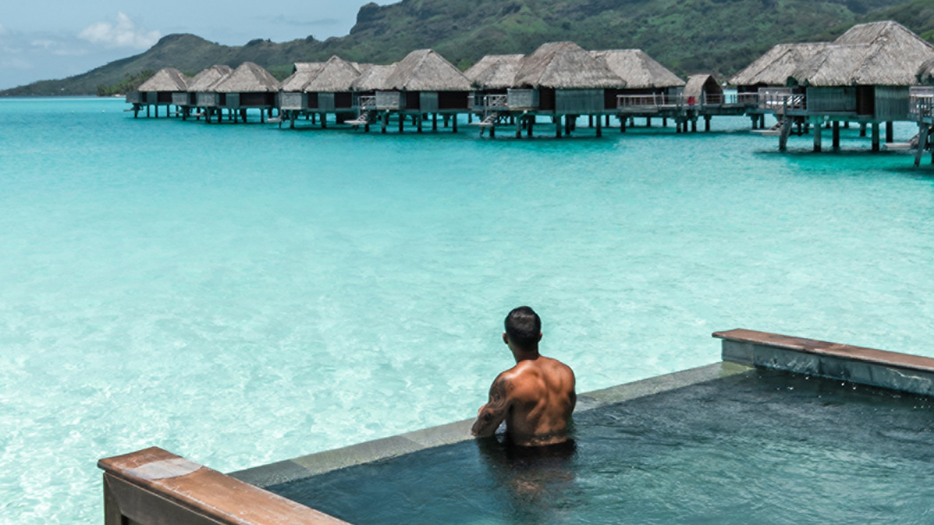
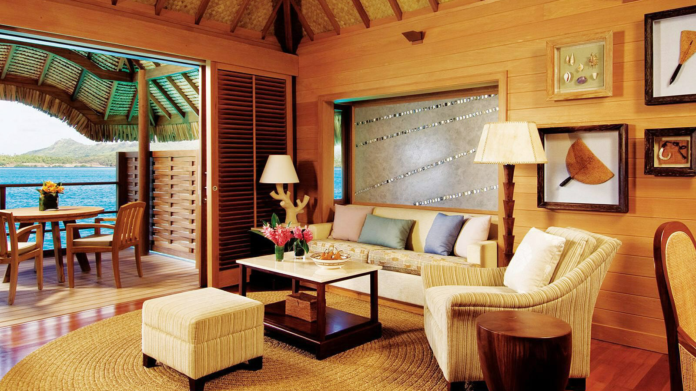 | 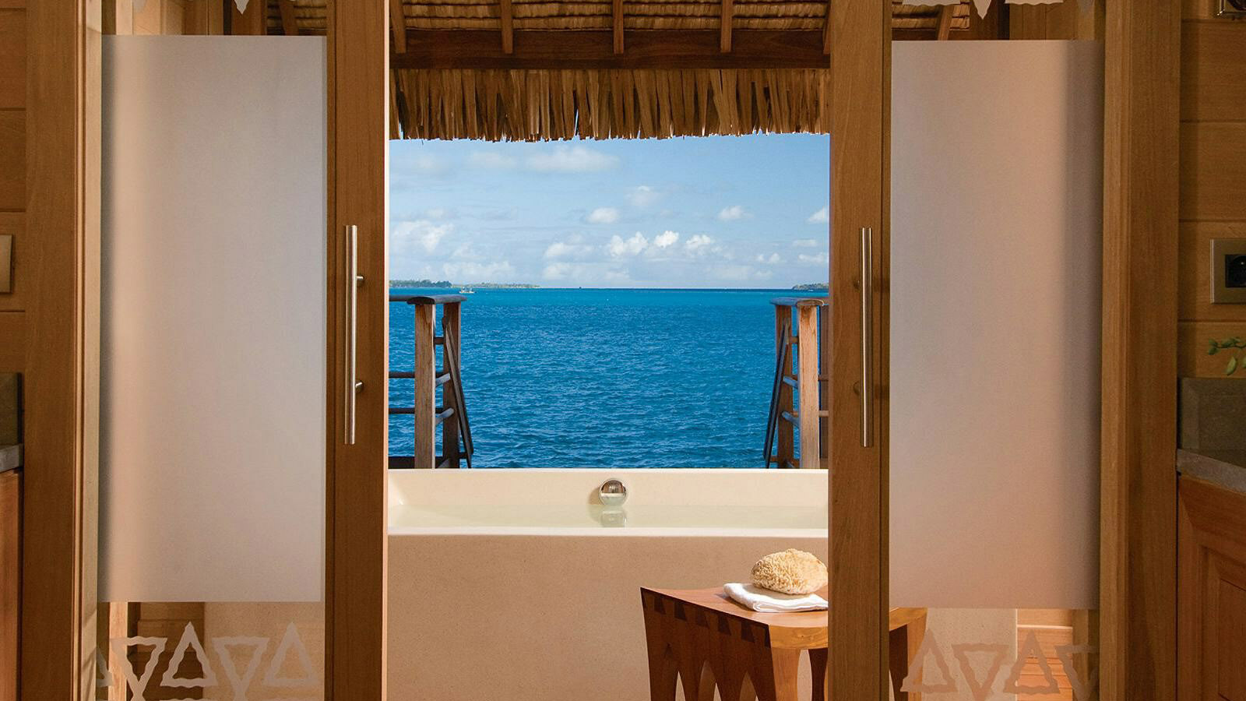 | 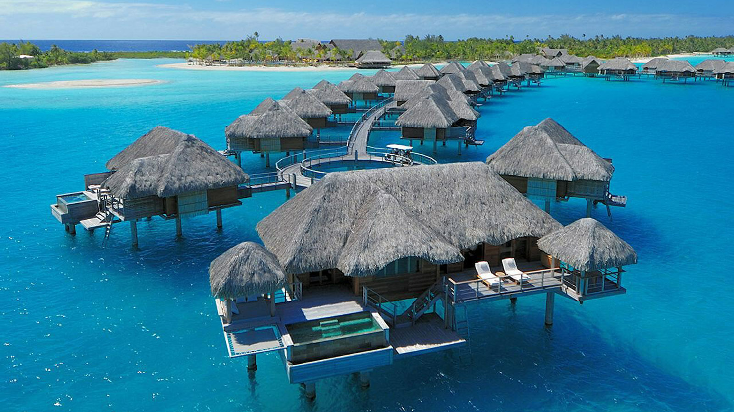
Four Seasons Resort Bora Bora was named the #1 Hotel in French Polynesia in the 2019 TripAdvisor Travelers’ Choice Awards.
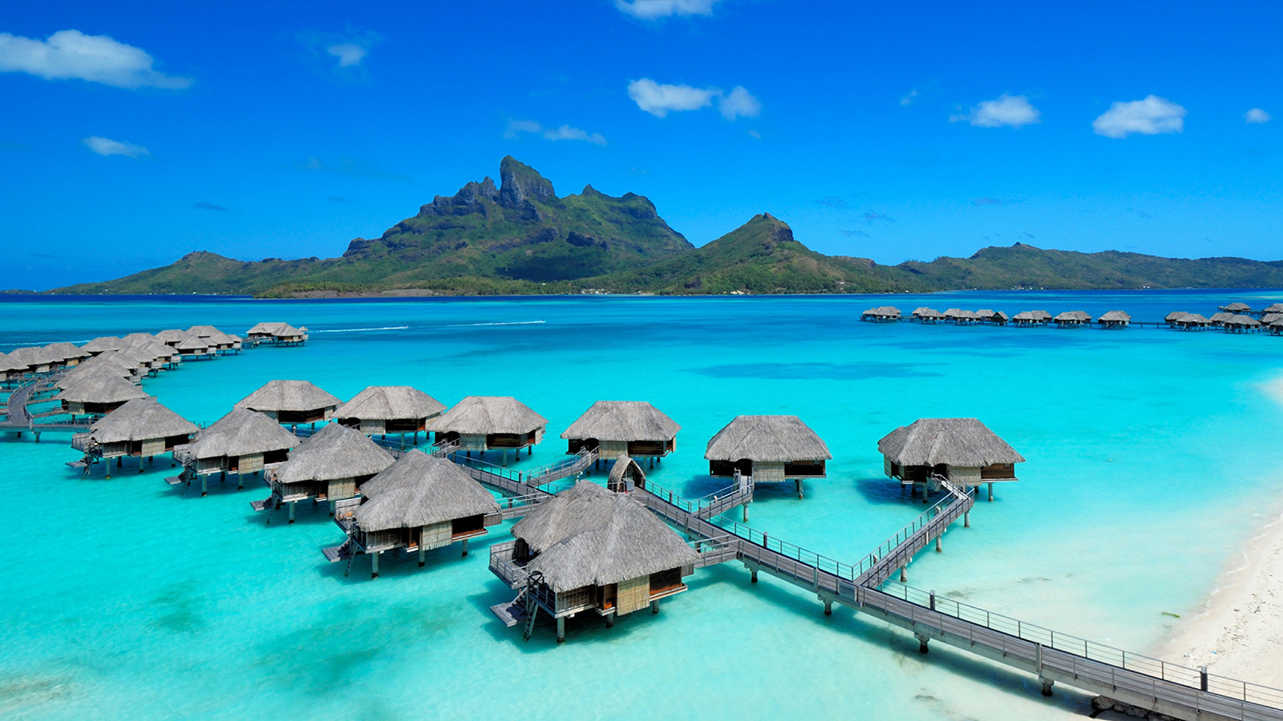 | 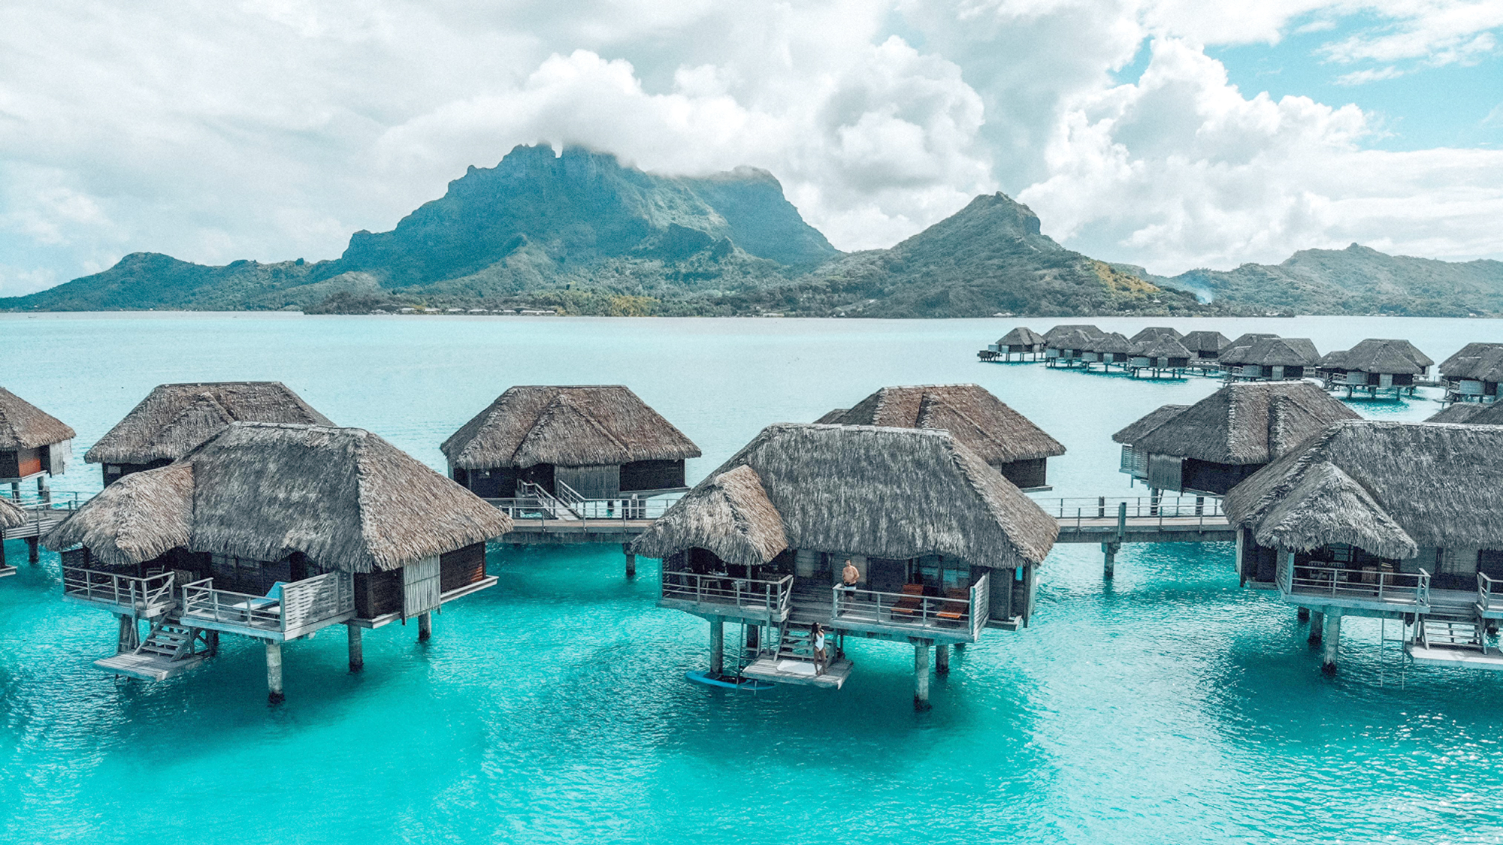 | 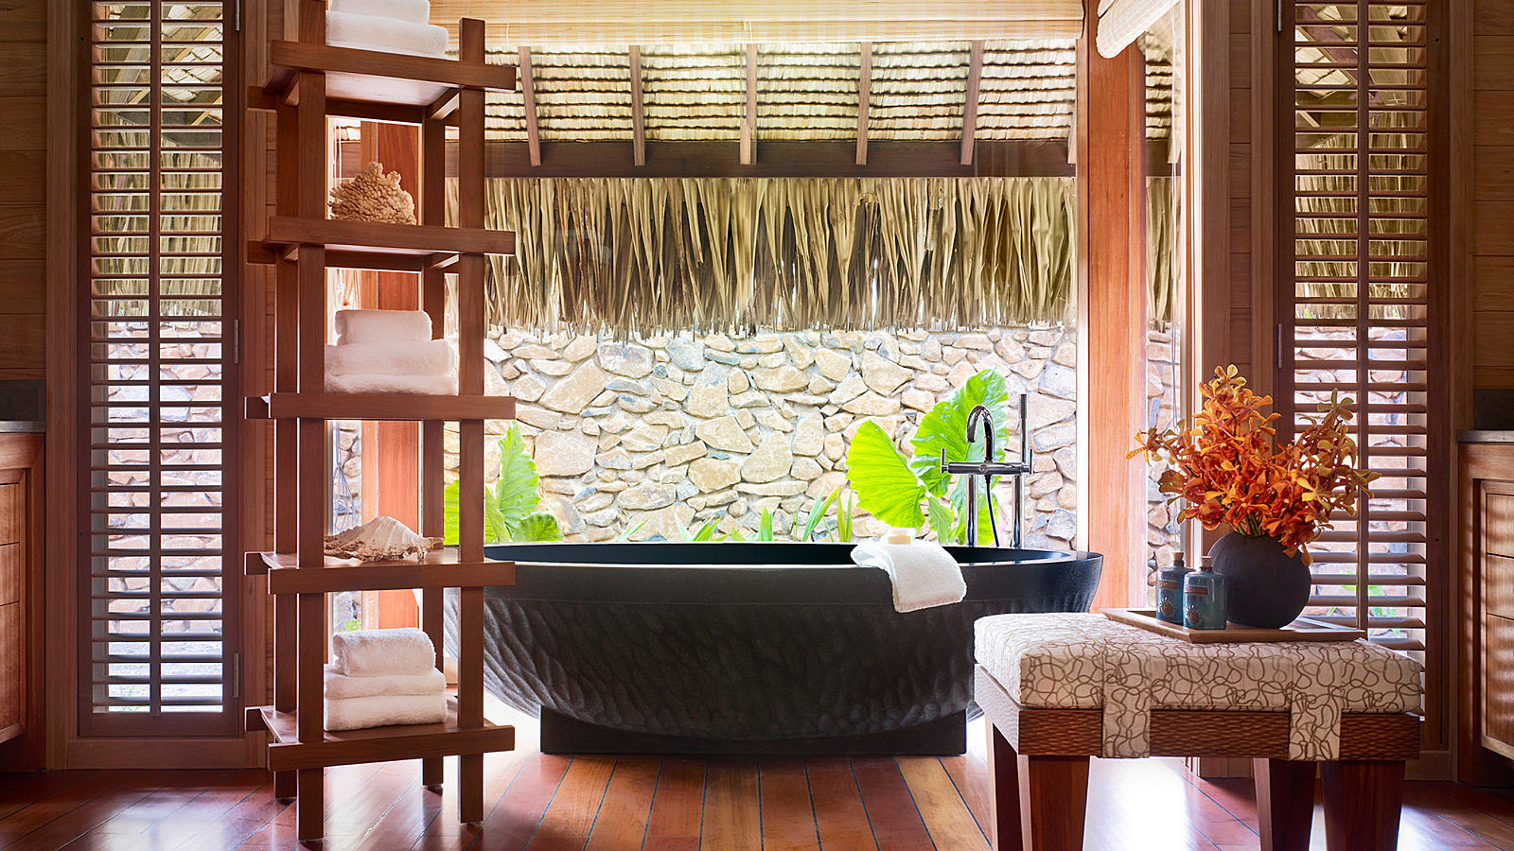
Based on the reviews and opinions submitted by the website’s millions of international users over the past year, the Travelers’ Choice Awards are recognised as a direct reflection of guest opinion and sentiment.
The Resort was also named the Top Luxury Hotel and Top Service Hotel in French Polynesia.
"It’s always an honour to be recognised by the TripAdvisor community, whose valuable first-hand reviews share the true experience of travel,” says Maria Jagla, General Manager of Four Seasons Resort Bora Bora. “As we bring the Resort to a new level of excellence this year, we look forward to welcoming guests to make even more memories in paradise.”
Four Seasons Resort Bora Bora is currently offering the Stay Longer - Fourth Night Free package, which includes accommodations in an overwater bungalow or beachfront villa and daily breakfast buffet for two. One complimentary night is offered for every three consecutive paid nights.
To make reservations, call toll-free 800 819 5053 or direct at 011-689-603-170, contact your travel professional (Chain Code FS) or book online.

RELATED

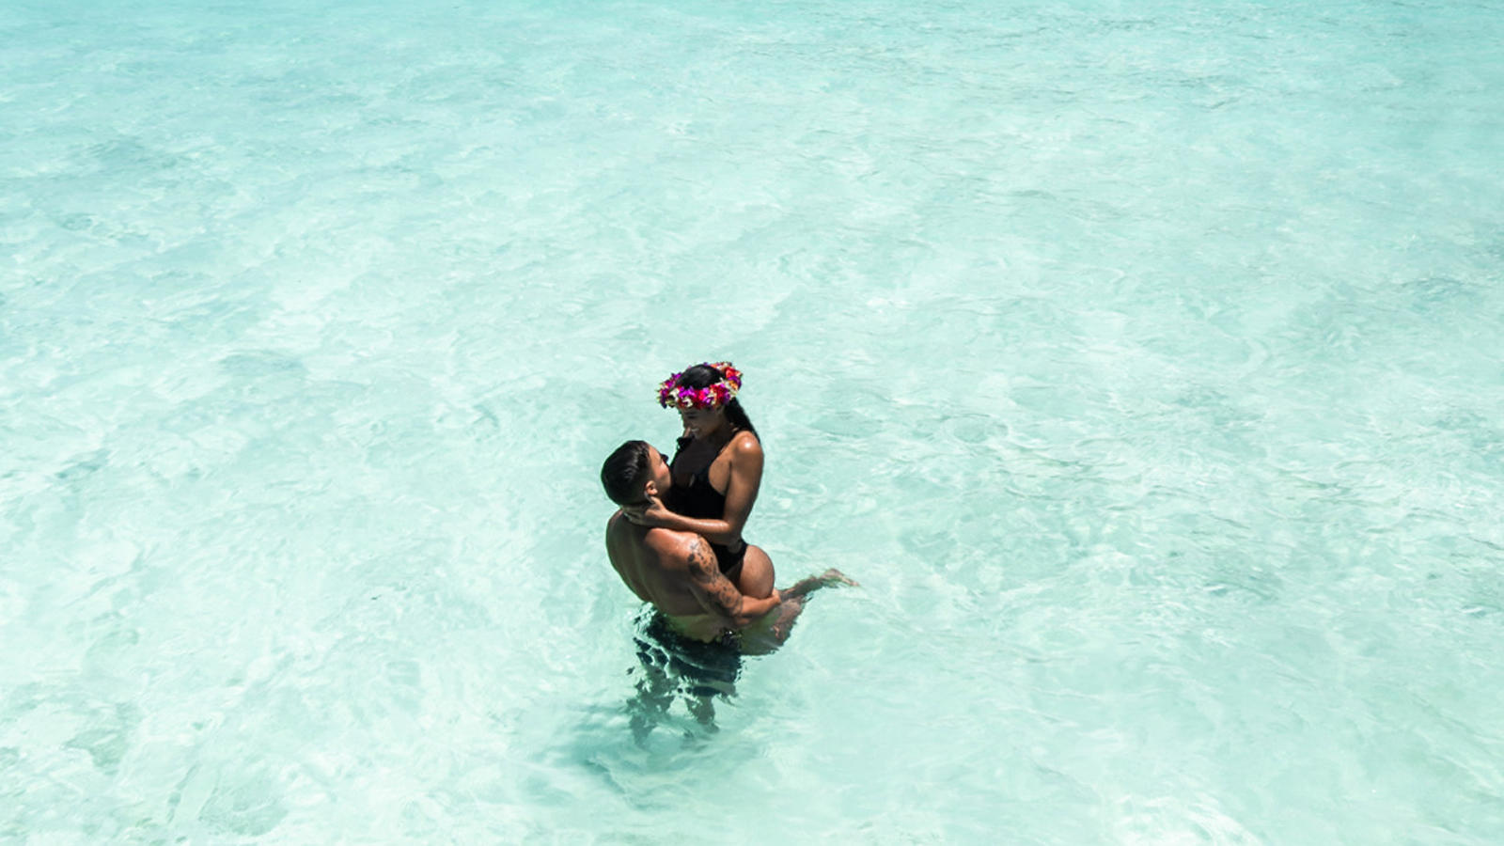 | January 17, 2019, Bora Bora, French Polynesia  Four Seasons Resort Bora Bora Named One of Elite Traveler’s Top 100 Hotels  https://publish.url/borabora/hotel-news/2019/elite-traveler-top-100-hotels.html
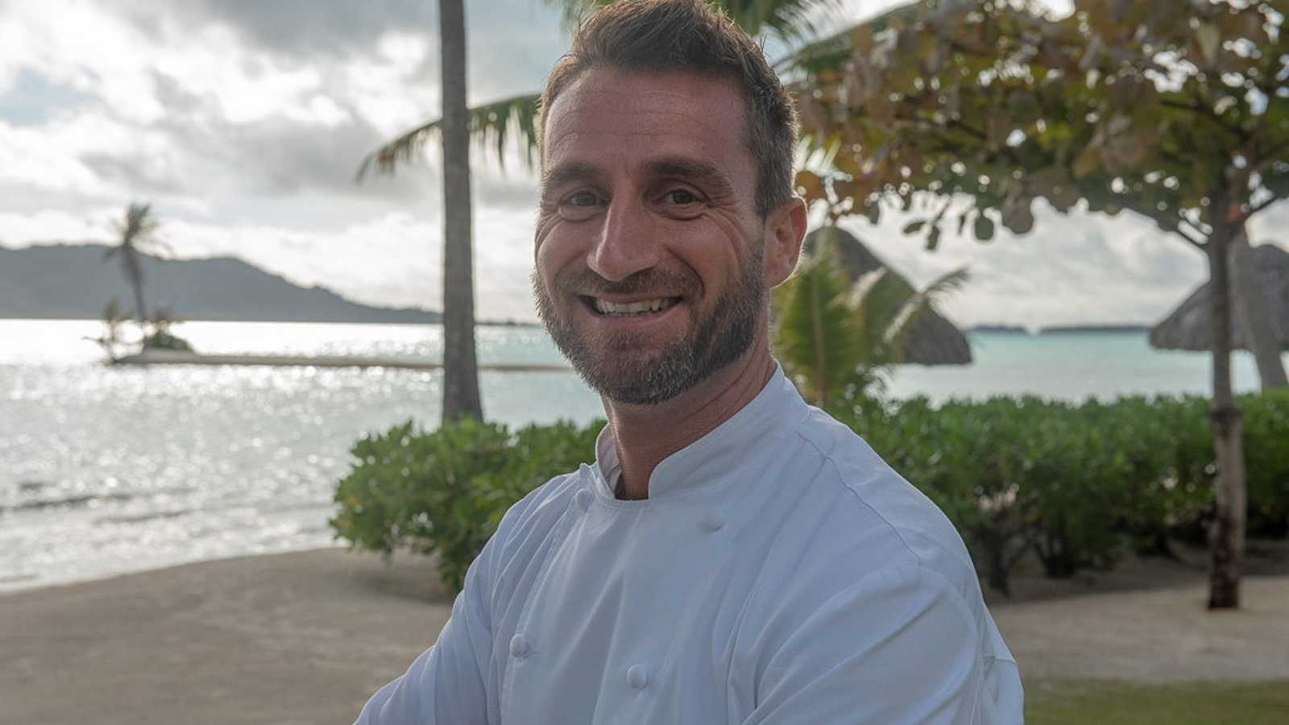 | October 11, 2018, Bora Bora, French Polynesia  Stefano Attardi Appointed Executive Chef of Four Seasons Resort Bora Bora  https://publish.url/borabora/hotel-news/2018/new-executive-chef-stefano-attardi.html

PRESS CONTACTS

Brad Packer
Director of Public Relations
350 South Beverly Drive, Suite 100
Beverly Hills
U.S.A.
brad.packer@fourseasons.com

(310) 712-1493

