Bar Trigona at Four Seasons Hotel Kuala Lumpur Partners with Local Farm to Launch Tree-Volution Project

Renewing Malaysian forestland, one cocktail at a time
December 21, 2020, Kuala Lumpur, Malaysia

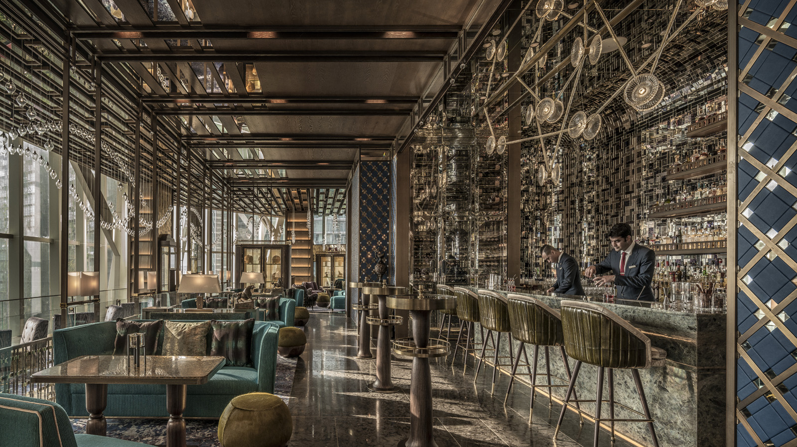
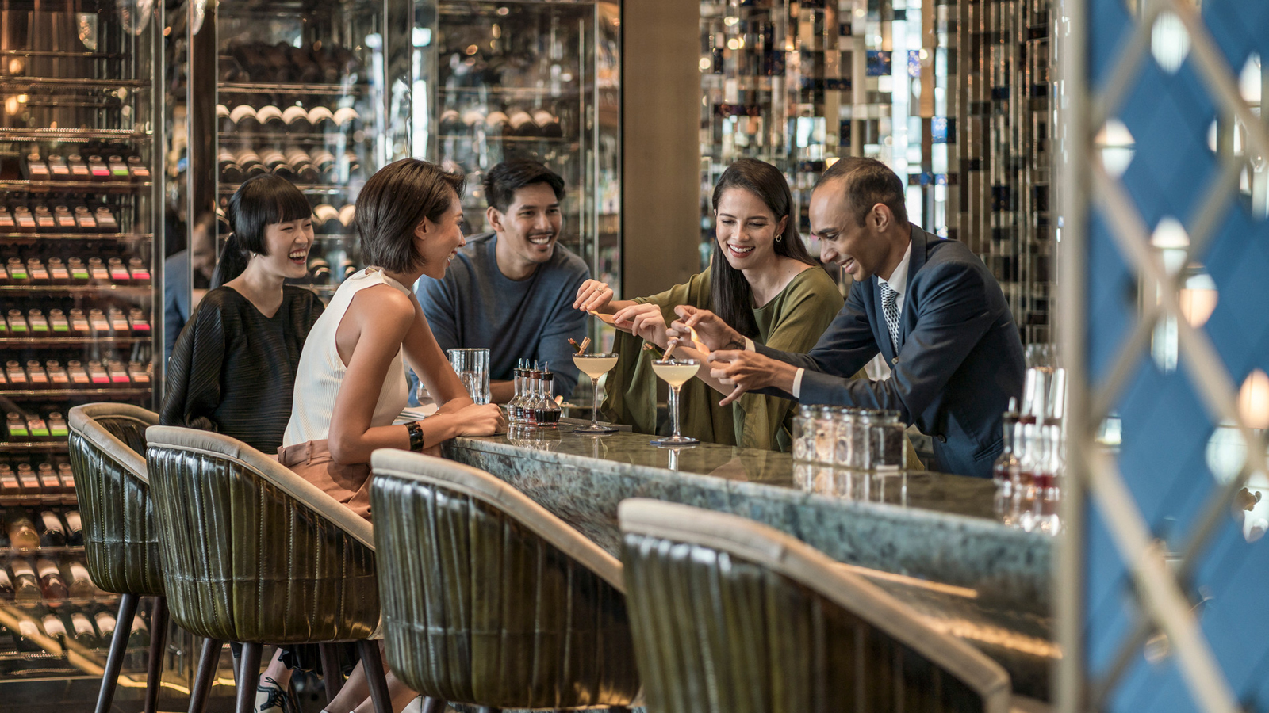 | 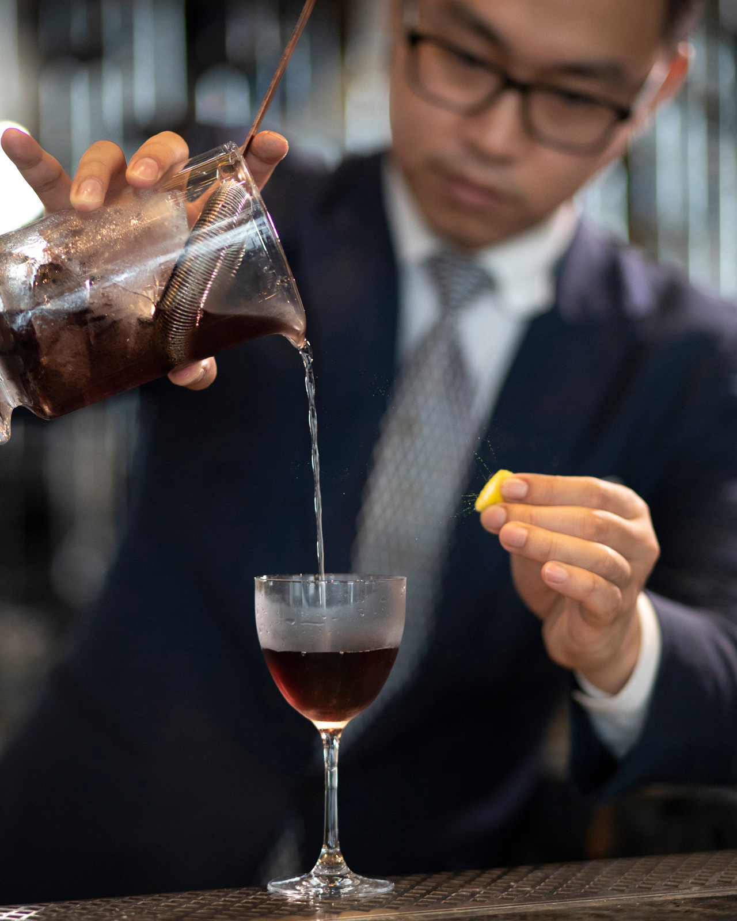
Combining a passion for great cocktails with a commitment to restore the local forestland, Bar Trigona at Four Seasons Hotel Kuala Lumpur has launched a long-planned project – A Tree Today, A Forest Tomorrow. Bar Trigona, recently recognised among World’s 50 Best Bars by The World’s 50 Best Bars 2020, has initiated yet another sustainability project to support the transformation of Malaysian forestland, while also bolstering local farming communities.
Sip Craft Cocktails to Grow New Forests
Every time guests order one of four selected cocktails at Bar Trigona, MYR 5 goes towards planting fruit trees around local farms. “We’re focusing on mangifera and citrus species, which grow quickly and begin giving fruit within just a few years. This will encourage local wildlife to return, restoring the area’s biodiversity,” explains Head Bartender Ashish Sharma, the driving force behind the initiative. Expanding forest cover also helps farmers by controlling flooding and erosion, and replenishing the soil with vital nutrients.
To pull off this ambitious goal, Bar Trigona has teamed up with long-time partner Ong Ning-Geng, whose cacao farm in Pahang forms the backbone of his bean-to-bar company, Chocolate Concierge. Ning and his team will use the proceeds for seed collection, planting and protection of the farm. A kitchen garden is also in the works, with Bar Trigona planning to set up its own herb farm – a supplement to sourcing ingredients from local cultivators.
Say Cheers and Join the Tree-Volution
Guests can support the project by sampling selected cocktails, each one showcasing a different local fruit. Discover Mandarin Way, a complex blend of spiced vermouth, gin, gula melaka and mandarin, or savour Mango Overloaded, which combines the intensity of serious spirits with the vibrancy of tropical fruit. Judgment brings together unexpected tastes such as aged rum, jackfruit and milk, while Sunset Margarita offers a refreshing watermelon twist on a classic.
Several of the spirits used are in collaboration with Wholly Spirits, a Bar Trigona partner and exclusive distributor for some of the most acclaimed spirits in the industry. Other Bar Trigona partners including EcoSpirits, Michter’s, and Diplomatico are also strong supporters of the tree-volution program.
Contributions of MYR 200 or more get a tree named after the donor, as well as the chance to harvest its fruits in the future. Once the tree begins fruiting, donors receive a jar of homemade mead, jam or kombucha. Bar Trigona also invites local clubs, societies and companies to join plantation drives at the farm. As Ashish notes, “It’s a great way to spend a day out in nature and do something meaningful with your colleagues.”
Protect the Ecosystem’s Tiny Guardians
Alongside tree plantation, proceeds from cocktail sales will go towards establishing new beehives. These tiny pollinators support the growth of trees, wildflowers and crops, playing a crucial role in maintaining our delicately-balanced ecosystem. “Sadly, climate change is putting honeybees at great risk,” says Ashish, noting Bar Trigona’s longstanding efforts to protect local bee populations. Continuing with an earlier initiative, the bar invites patrons to adopt their very own beehive at the farm. A contribution of MYR 500 funds the care of the hive for an entire year, as well as a gift of five jars of artisanal honey for patrons.
Simple Steps to Solve Big Problems
With fast-depleting tropical cover around the world, the renewal of forests is an increasingly urgent need. Ashish, Ning and their teams aim to plant a minimum of 500 trees every year by 2022. Along with all the benefits for biodiversity, the project is also set to provide employment opportunities to local communities – from planting and caring for trees, to training as beekeepers. As Ashish sums up, “We’re focusing on small actions with big impact.”

RELATED

November 30, 2020, Kuala Lumpur, Malaysia
Glittering Celebrations at Four Seasons Hotel Kuala Lumpur
https://publish.url/kualalumpur/hotel-news/2020/festive-season.html

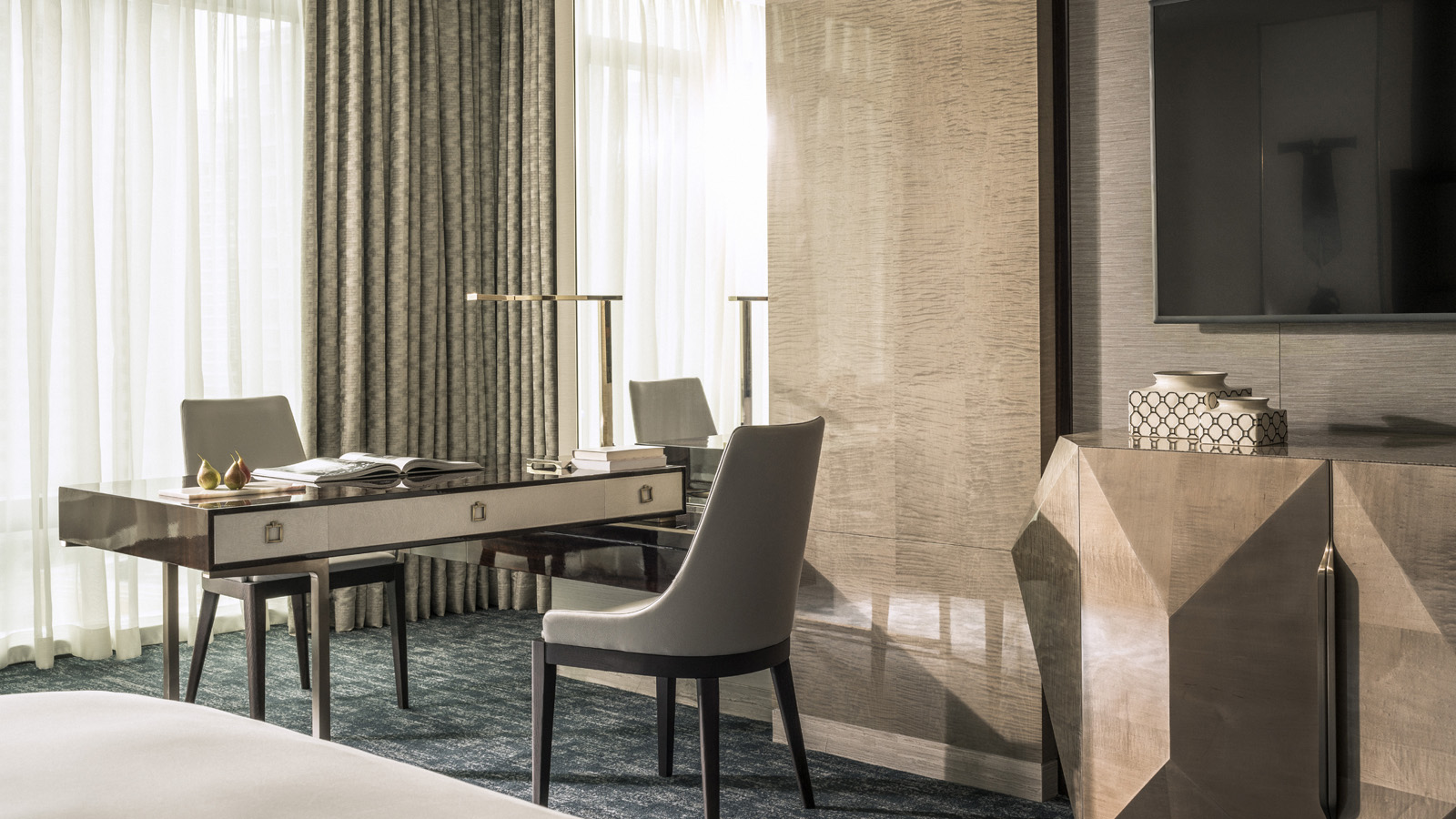 | November 25, 2020, Kuala Lumpur, Malaysia  Inspiring Workspaces at Four Seasons Hotel Kuala Lumpur  https://publish.url/kualalumpur/hotel-news/2020/work-from-hotel-packages.html

PRESS CONTACTS

Kanchana Ganglani
Director of Public Relations
145 Jalan Ampang
Kuala Lumpur
Malaysia
kanchana.ganglani@fourseasons.com

+6(03) 2382 8740

