Four Seasons Hotel Abu Dhabi Fires Up Its Brand-New Butcher & Still Food Truck for the New Year

Innovative restaurant experience brings the spirit of the iconic 1920s Chicago Steakhouse to the UAE
January 2, 2020, Abu Dhabi, U.A.E.

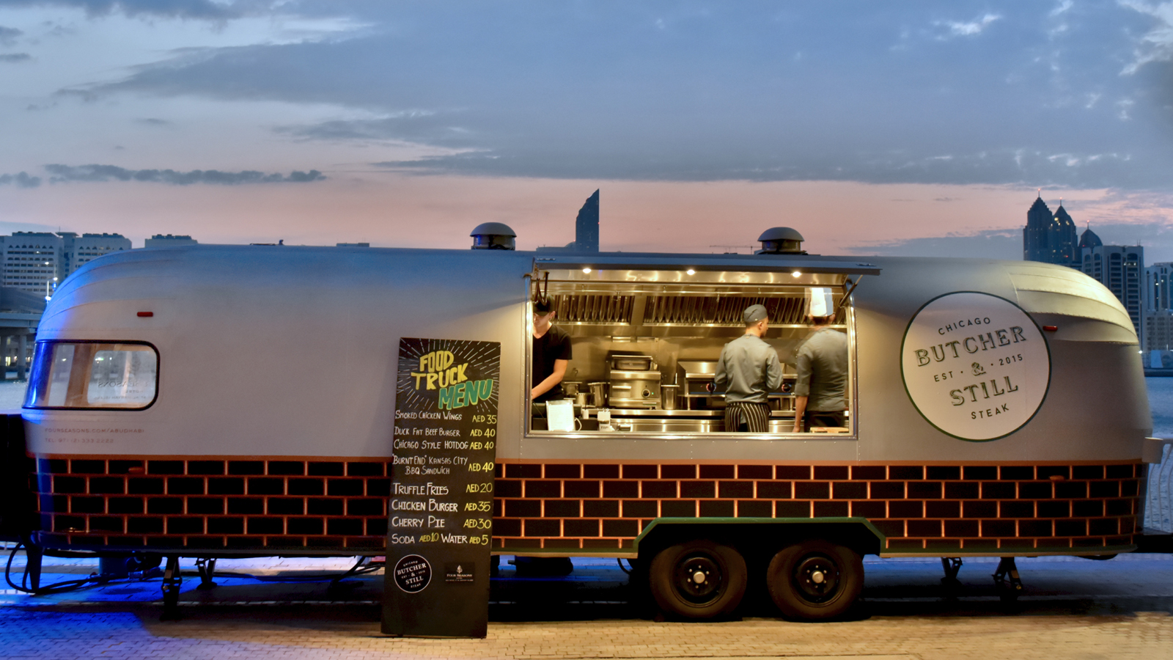
Is there anything that captures quintessential Americana than the hitting the open road? Scenic vistas, comfort food, and no particular place to be but in the moment, connecting with others, embracing life. Butcher & Still’s food truck delivers that feeling in abundance, bringing the spirit of the iconic 1920s Chicago Steakhouse at Four Seasons Hotel Abu Dhabi to the UAE. Premium yet approachable, the concept brings an innovative chef-driven concept to the country’s luxury restaurant and bar space.
The Concept: Bringing the Spirit of Butcher & Still to the UAE
A true master of his craft, Director of Food and Beverage Carlo Laiso and his team always choose the road less taken when creating something for Four Seasons guests. “We are always eager to innovate in the market, to push the boundaries and create bold and unexpected concepts in a way that only Four Seasons can. What guests see is the result of more than two years of collaboration and hard work. In the food truck space we are first movers, offering an experience that will capture the imagination of our clients. What is most exciting however, is the paradox of creating something humble and seamlessly infusing our identity as a premium, 1920s Chicago Steakhouse.”
The shell of the new Butcher & Still Food Truck is a nostalgia-invoking Airstream trailer, the stuff of legends in American touring culture. Rustic, yet elegant its silver patina is the definition of relaxed luxury. This sumptuous design is enhanced by cues taken from the restaurant’s most recognisable details including a rich leather chef’s table reminiscent of the plush banquettes clients have come to know and love, as well as the infamous AK-47 bullet print skirting the perimeter of the truck. However, one of the greatest details is the reinterpretation of the outlet’s signature show kitchen, which breaks down the barrier between chefs and guests, allowing them to connect. Laiso reiterates, “Each detail is selected with purpose to convey what makes Butcher & Still truly extraordinary from the concept, the menu, and most importantly, the people.”
The Cuisine: Crafting Chef-Centric Food
Deeply comforting and supremely satisfying the menu of Butcher & Still’s food truck is all about refining all-American classics, offering a premium experience while retaining the essence of those democratic and widely-loved dishes. A long-held ambition of American Restaurant Chef Marshall Roth, crafting this menu has been a passion project, as these dishes are a part of his identity and universally loved. He states, “Our job as chefs is to connect people, to conjure up memories of meals spent with friends and families, of life’s special occasions by sharing our passion. With each dish we are trying to get to the core of what we all love about these dishes and elevate them through the power of our products. For example, our signature cheeseburger features a homemade toasted brioche bun, rich Creekstone Farms beef, a high-quality cheddar cheese, and fresh greens. It’s simple but it is exactly what you picture when that burger craving hits.” The food truck’s other signature dishes include the Chicago dog, a Kansas City burnt ends sandwich, chicken wings and truffle fries.
The Community: There for All of Life’s Great Moments
Returning guests of Butcher & Still Restaurant are fiercely loyal, stopping by for every occasion from casual afternoon beverages to birthdays, graduations and anniversaries. With its new food truck, the Butcher & Still culinary team keeps its approach relaxed, welcoming more and more guests to discover what makes the concept so special. By dishing up mobile delights at key events around the UAE and being available for private catering functions, the restaurant is creating a community that celebrate life’s special moments big and small.
To bring the Butcher & Still experience to a corporate or social event, email catering.abudhabi@fourseasons or call +971 2 333 2222.

RELATED

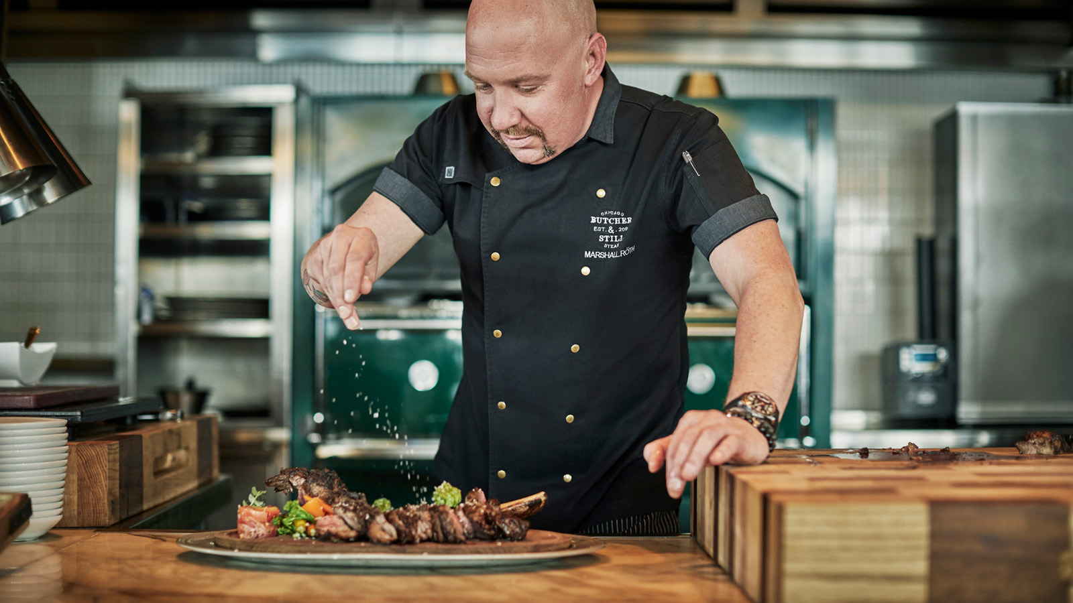 | November 13, 2019, Abu Dhabi, U.A.E.  Six Ways to Enjoy Butcher & Still at Four Seasons Hotel Abu Dhabi at Al Maryah Island  https://publish.url/abudhabi/hotel-news/2019/weekly-events-at-butcher-and-still.html
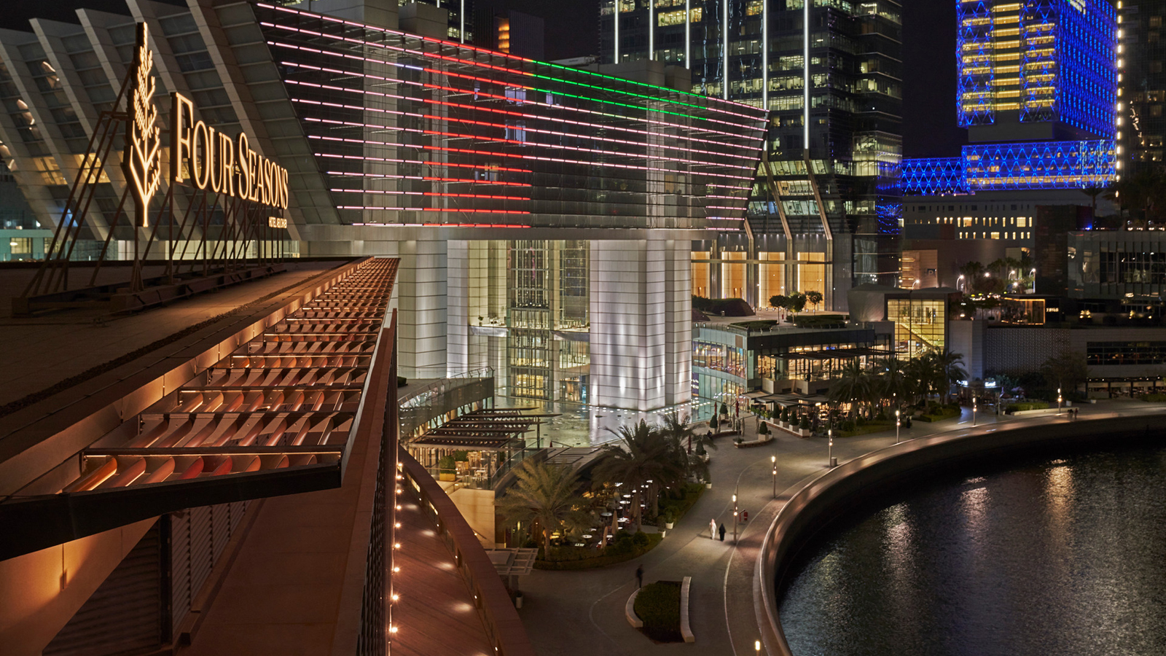 | October 24, 2019, Abu Dhabi, U.A.E.  A Quintessential Festive Experience Among Desert Dunes at Four Seasons Hotel Abu Dhabi at Al Maryah Island  https://publish.url/abudhabi/hotel-news/2019/festive-season.html

PRESS CONTACTS

Veronika Szabo
Director of Public Relations
P.O.Box 107032, Al Maryah Island
Abu Dhabi
United Arab Emirates
veronika.szabo@fourseasons.com

+971 2 333 2222

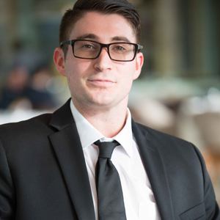 | Christopher Polys  Digital Marketing Executive  P.O.Box 107032, Al Maryah Island  Abu Dhabi  United Arab Emirates  christopher.polys@fourseasons.com  +971 2 333 2222

