Celebrate the Power of Love This Valentine’s Season with a “Riviera Rendezvous” at Four Seasons Astir Palace Hotel Athens

January 24, 2023, Athens, Greece

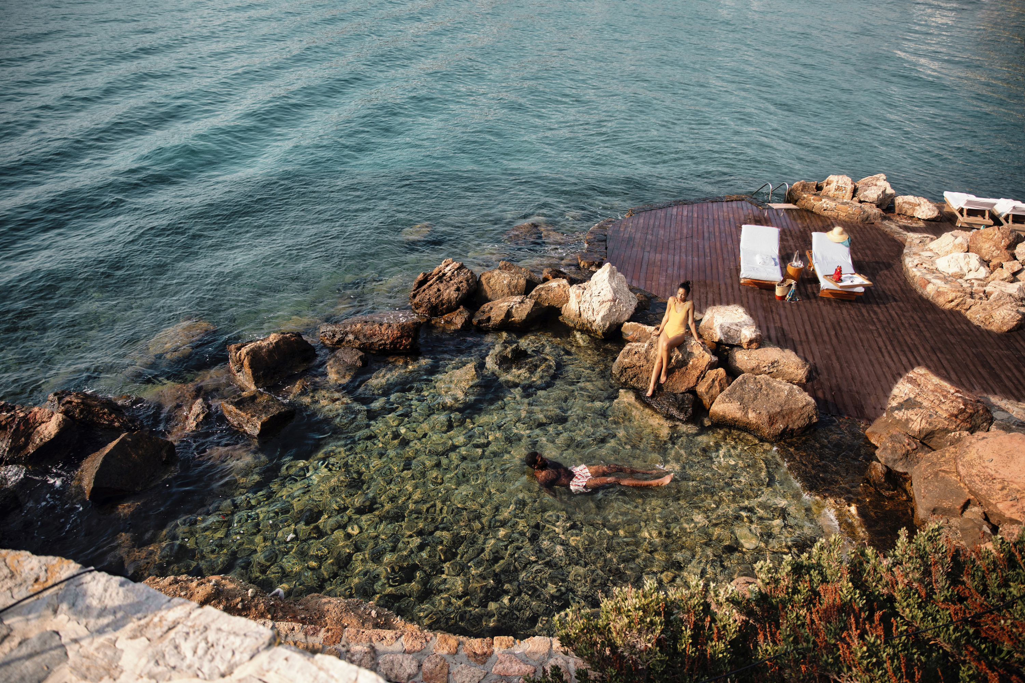
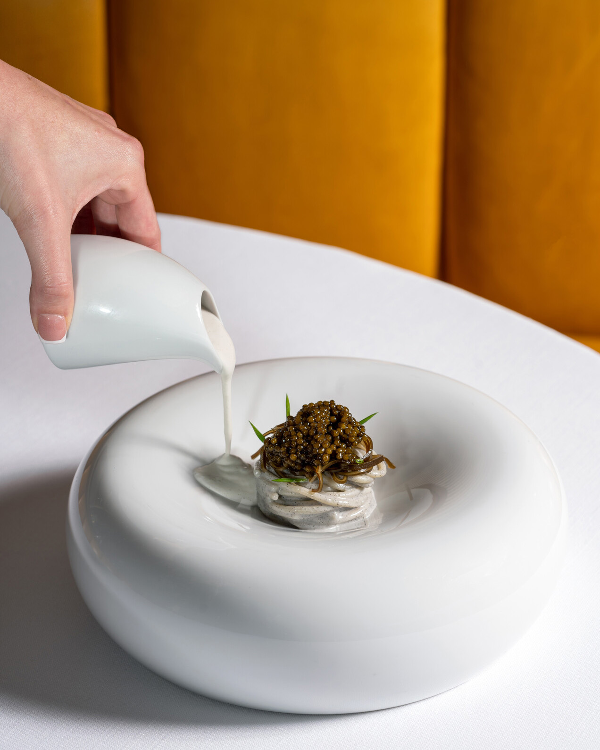 | 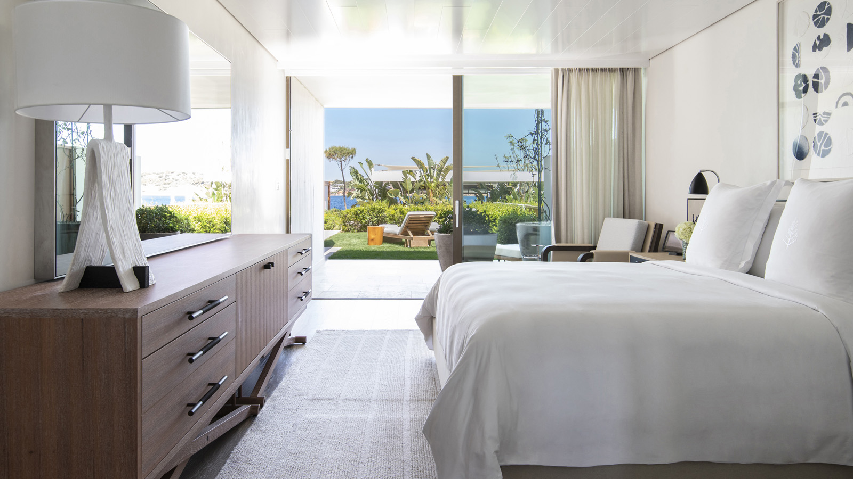 | 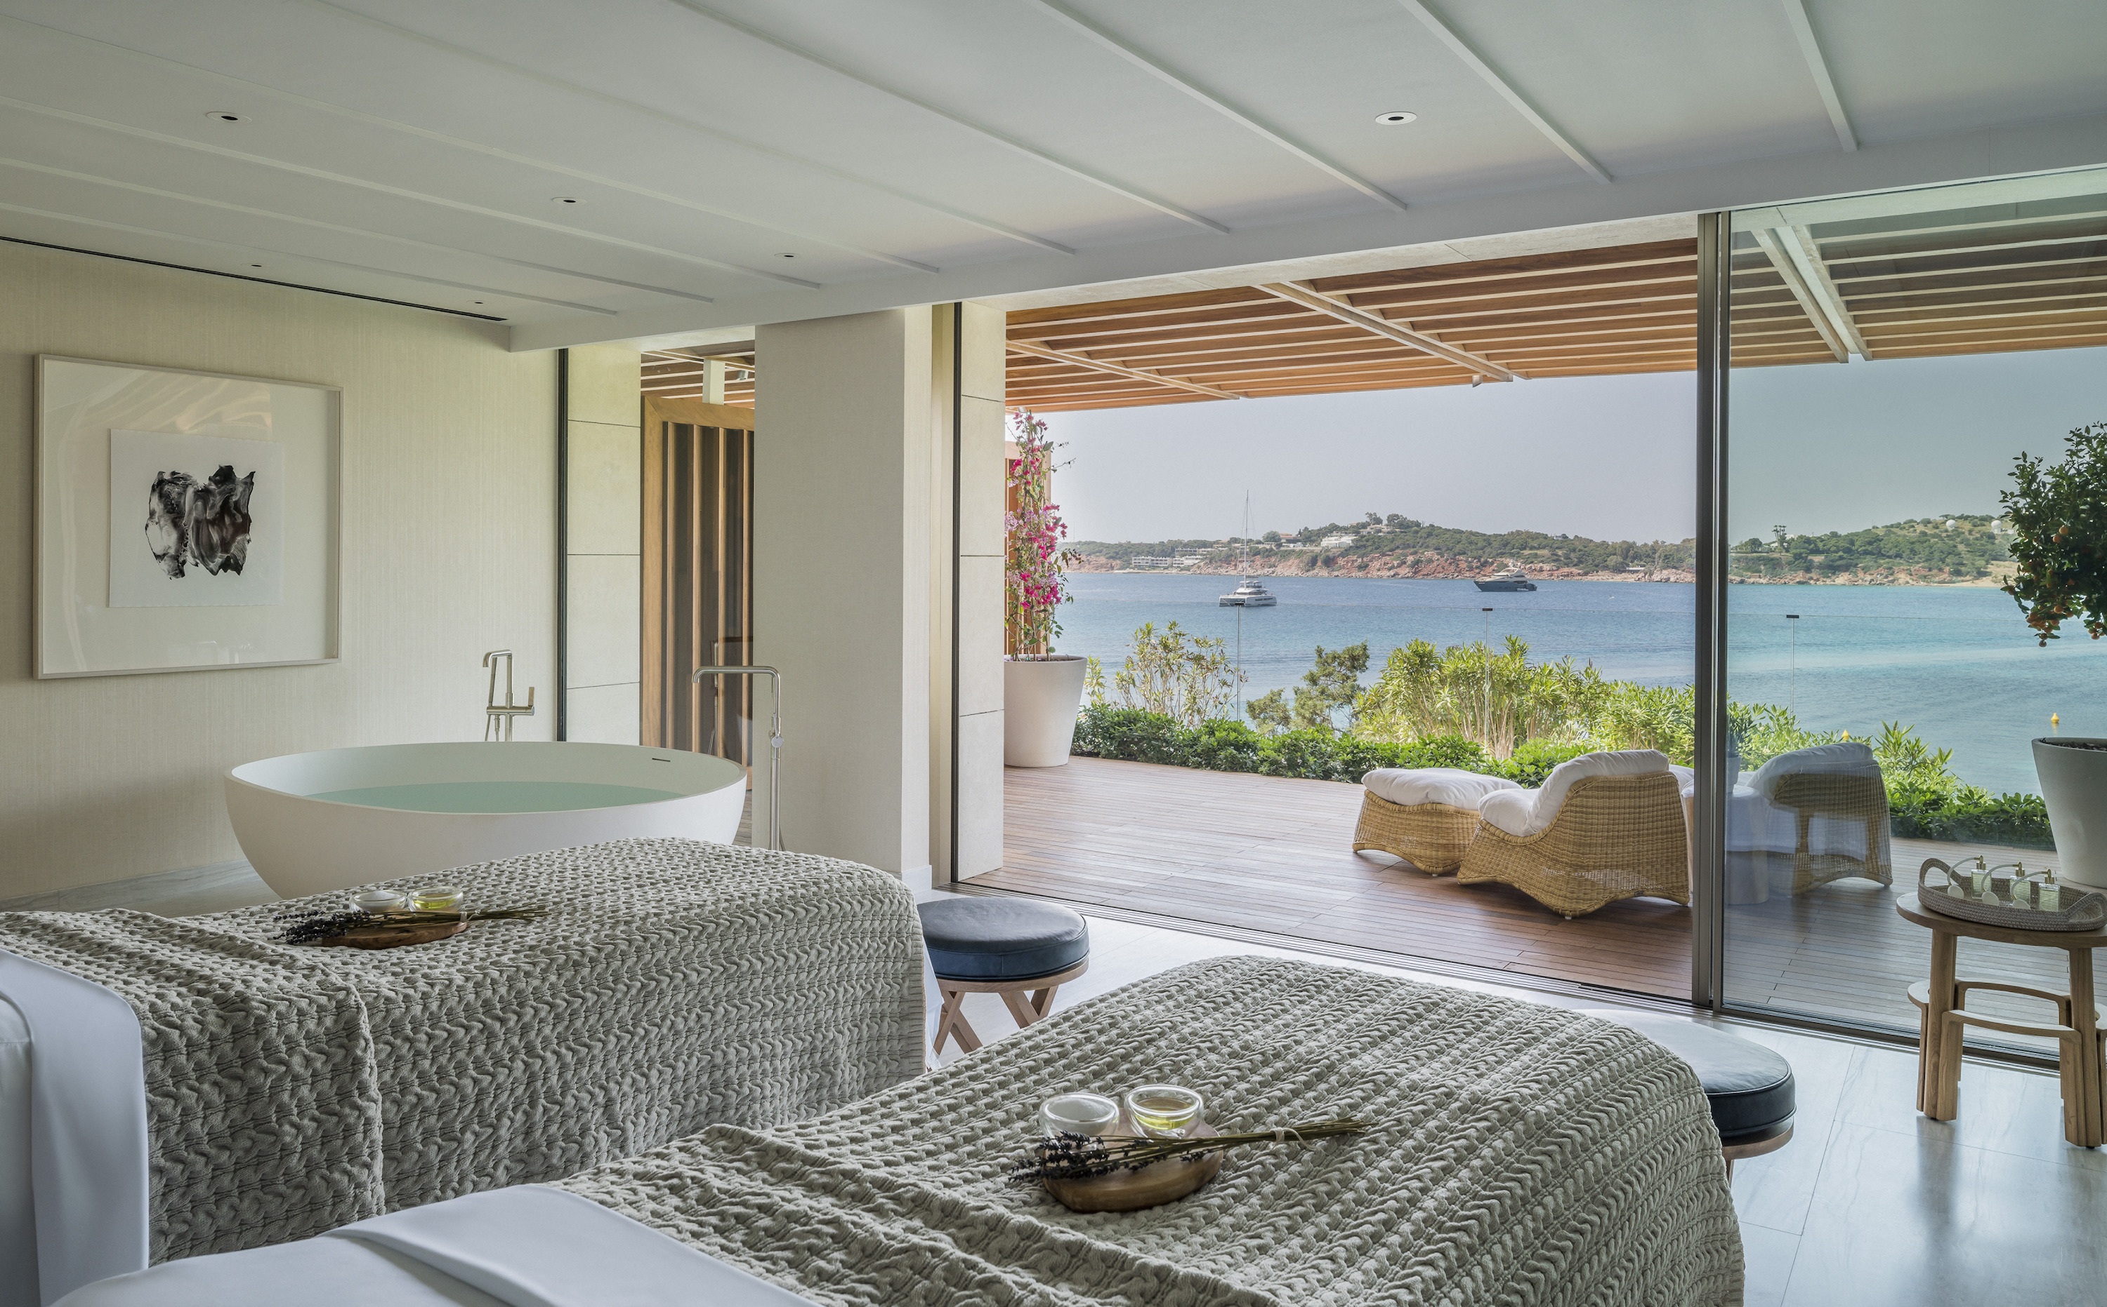
With hushed sea-view rooms that let the outside world slip far away, heart-soaring dining and spa experiences, and a roll call of some of the world’s most famous couples, Four Seasons Astir Palace Hotel Athens is ready for Valentine’s Day.
Guests wishing to make this year’s season of romance an occasion to remember are invited to indulge in the ultimate demonstration of lavish love: a Riviera Rendezvous for two at the Hotel’s iconic romantic retreat on the pine-studded Astir Peninsula.
Available across any dates and any room from February 3 to April 2023, Riviera Rendezvous includes a minimum one night stay, maximised by an early midday check-in and late 2:00 pm check-out (subject to availability). A heart-shaped cake will await all couples in their room upon arrival, with bespoke floral arrangements (available on request) for a scene-stealing welcome. Riviera Rendezvous also includes a cutting-edge four-course meal for two at Chef Luca Piscazzi’s Michelin-starred restaurant Pelagos, plus Twilight Treats for Two: a unique sunset tea featuring the signature patisserie delights at atmospheric Avra Bar overlooking the Saronic Sea.
Valentine’s on the Athens Riviera
Thanks to its secluded forested location embraced by the Aegean Sea, the glittering Four Seasons Astir Palace Hotel Athens has played host to some of the world’s most in-love couples, including Aristotle Onassis and Jackie Kennedy. Follow in their footsteps by taking a romantic ramble through the surrounding forest, stroll along the Hotel’s private sandy beach as moonlight sparkles upon the sea, or simply connect as a couple more deeply, away from everyday concerns, in The Fountain House hydrotherapy haven.
If a proposal is part of the plan during a Riviera Rendezvous stay, the Hotel’s creative staff can be relied upon to offer imaginative suggestions and discreet assistance at every turn.
Sharing Food: A Great Act of Love
In Mediterranean cultures, there’s perhaps no greater act of love than the sharing of food. With an emphasis on decadent celebratory dining throughout the season of love, the expert chefs at Four Seasons Astir Palace Hotel Athens - led by Sergio Favata - pour endless passion into menus and experiences with heart.
At upscale Mercato, a special brunch menu on Sunday, February 12, 2023 will showcase Valentine’s highlights alongside a stunning selection of Italian favourites - the perfect opportunity to gather family, friends and loved ones to celebrate connection and togetherness in a spirit of gratitude while enjoying the salt-kissed Riviera setting.
On Valentine’s Day itself, Mercato’s Chef Sergio Favata will present a set dinner menu of sharing delights: Roso di Mazara, the traditional Italian Carnaroli with beetroot, Champagne and Red Prawns; a selection of Duck or Cod Roulade; and a mouth-watering Chocolate Cream Brule, served with Rose Champagne in an atmosphere of refined rustic romance.
Alternatively, at Pelagos, Chef Luca’s boundary-pushing innovation will continue with a six-course Valentine’s Night dinner, showcasing his playfully transformative approach to locally sourced produce in delights such as the new version of the iconic Caviar Pasta and a Chocolate Souffle to share.
And for the “morning after” of Wednesday, February 15, 2023, Mercato’s bountiful buffet breakfast will serve up a few special Valentine’s additions of its own (Red Velvet Pancakes, anyone?) - a final culinary reminder of the sensory pleasures afforded by Astir Palace life on the beautiful Athens Riviera.

RELATED

January 23, 2023, Athens, Greece
Heed the Oceanic Call of Pelagos This February: Three Reasons to Visit the Michelin-Starred Restaurant at Four Seasons Astir Palace Hotel Athens
https://publish.url/athens/hotel-news/2023/february-events-and-menus-at-pelagos.html

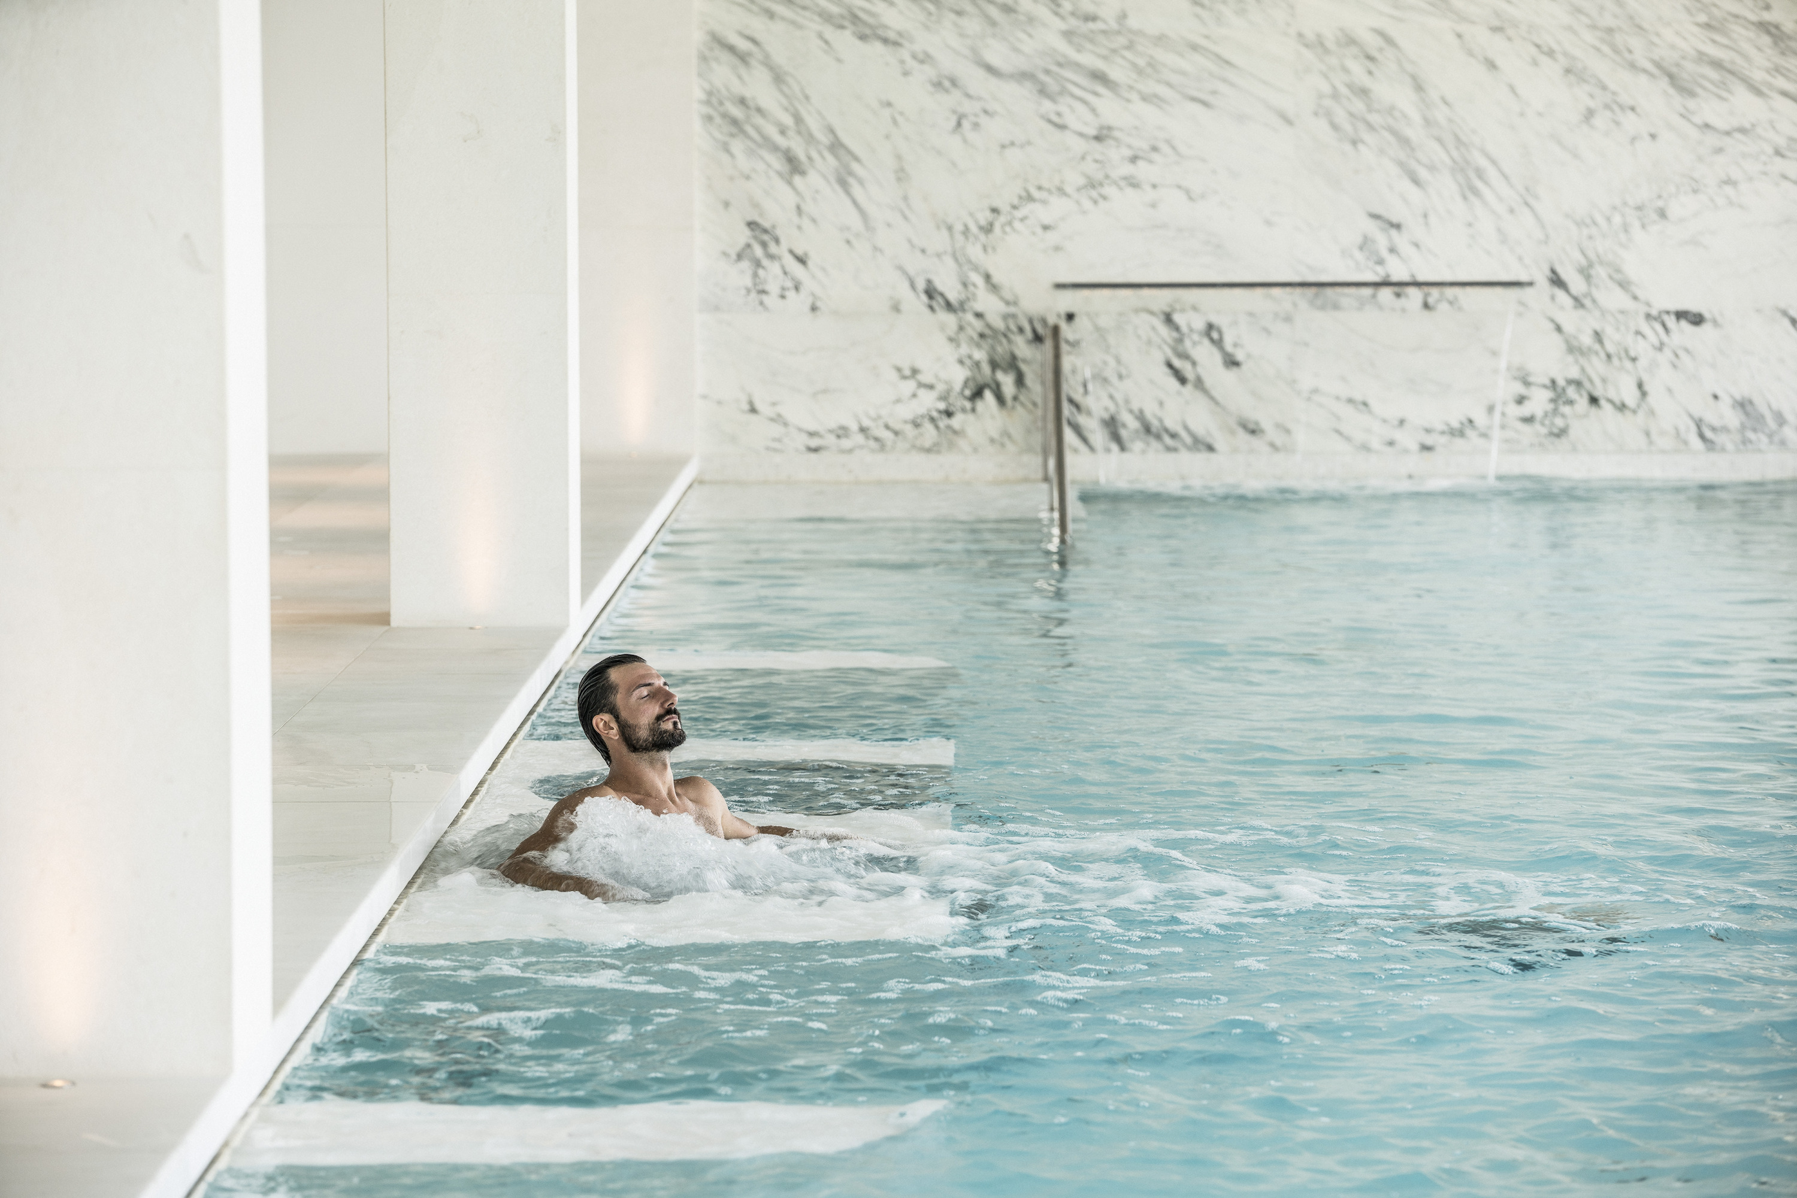 | January 12, 2023, Athens, Greece  Ease into the New Year with the “Precious Pampering Moments” Offer at Four Seasons Astir Palace Hotel Athens  https://publish.url/athens/hotel-news/2023/precious-pampering-moments-spa-offer.html

PRESS CONTACTS

Elia Kentrota
Director of Public Relations
40 Apollonos Street
Vouliagmeni, Athens
Greece
elia.kentrota@fourseasons.com

+30 210 8901077

