Now Open: Four Seasons Astir Palace Hotel Athens Defines Modern Luxury in a Relaxed Setting on the Athenian Riviera

A legend is reborn with every consideration for today’s traveller in the newest Four Seasons experience, and its very first in Greece
March 29, 2019, Athens, Greece

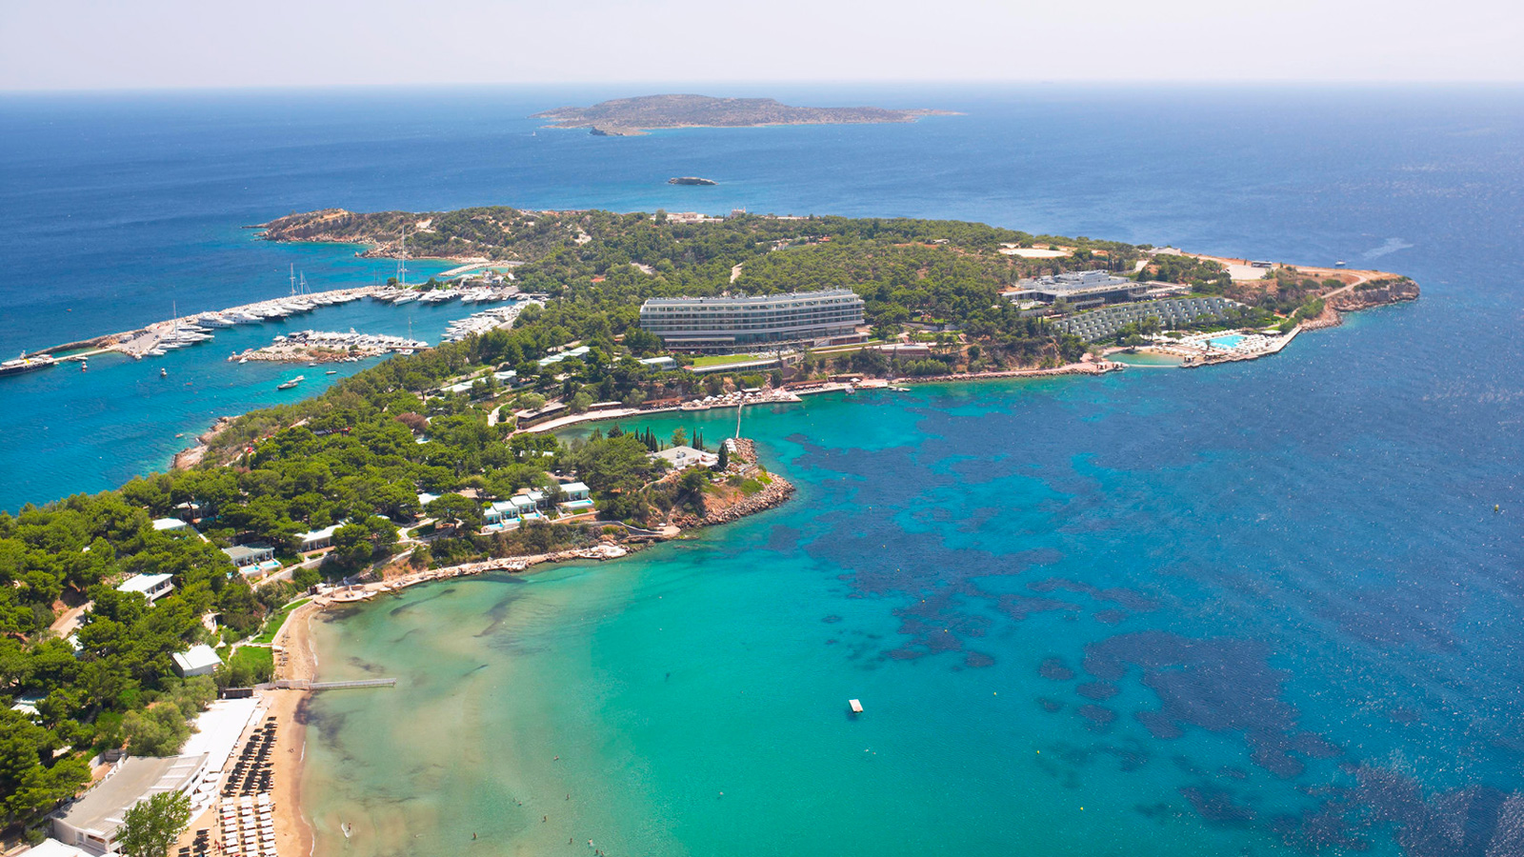
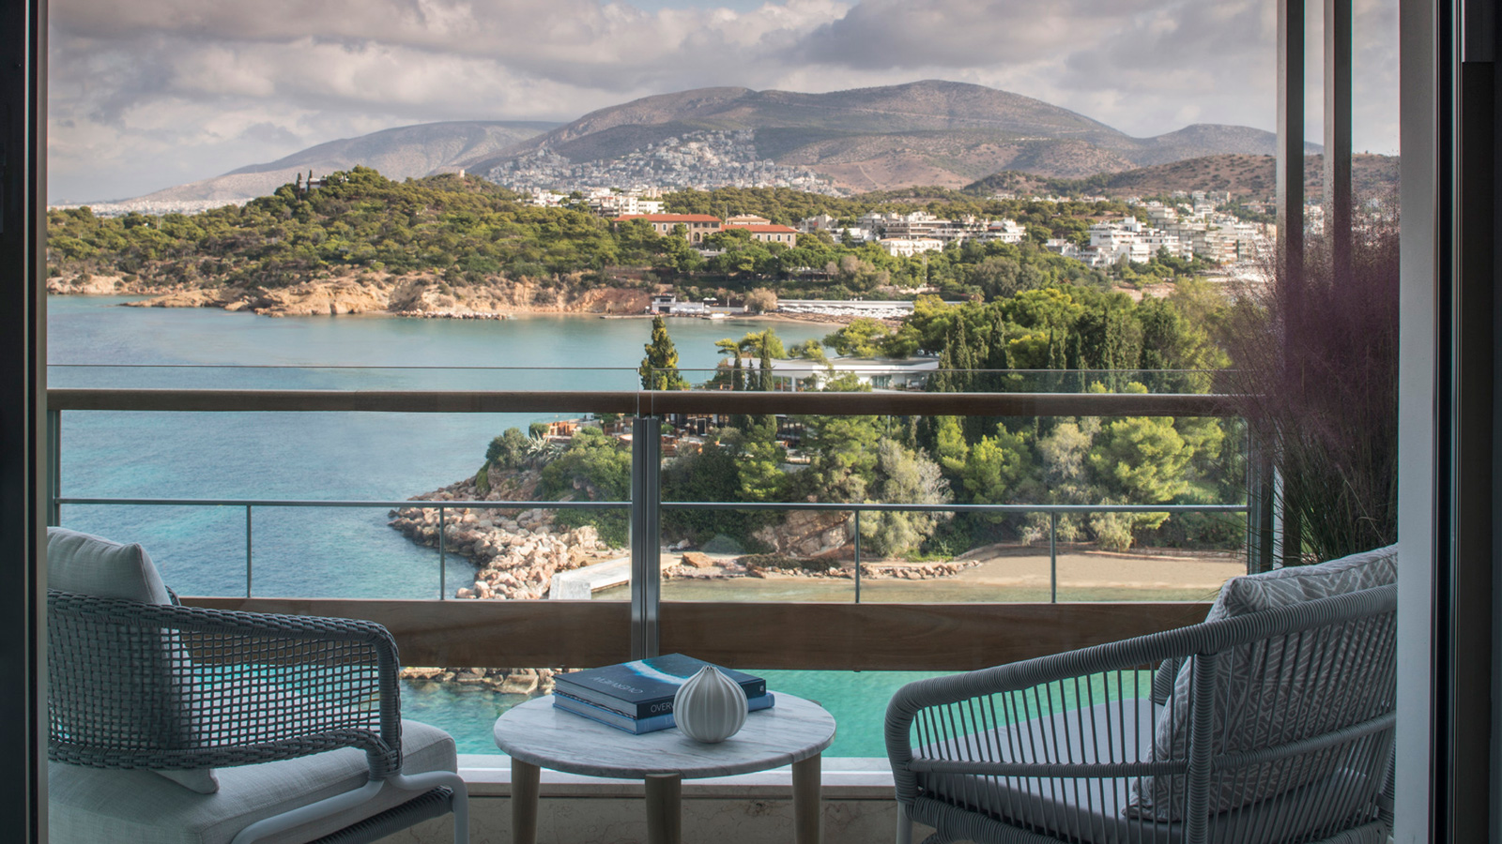 | 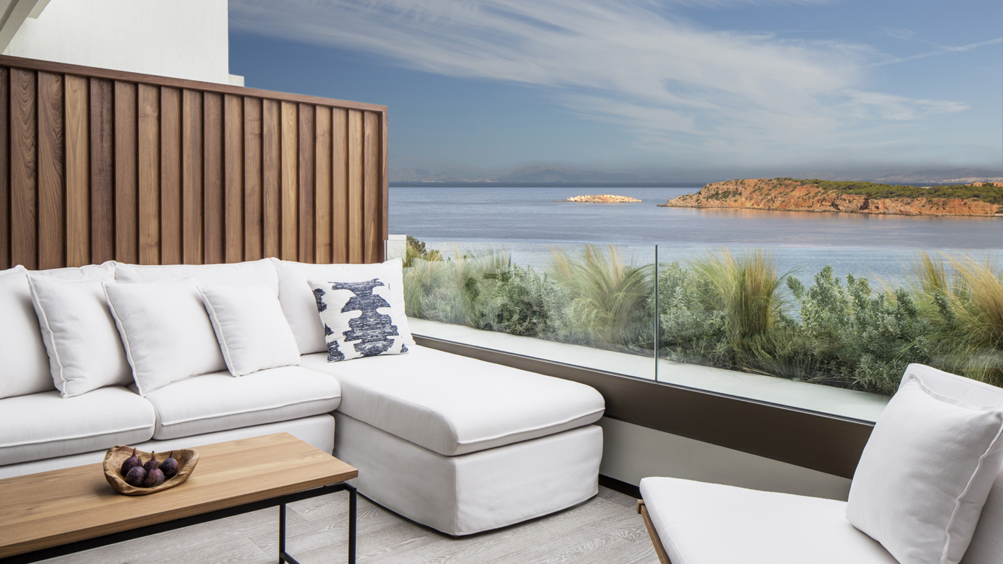 | 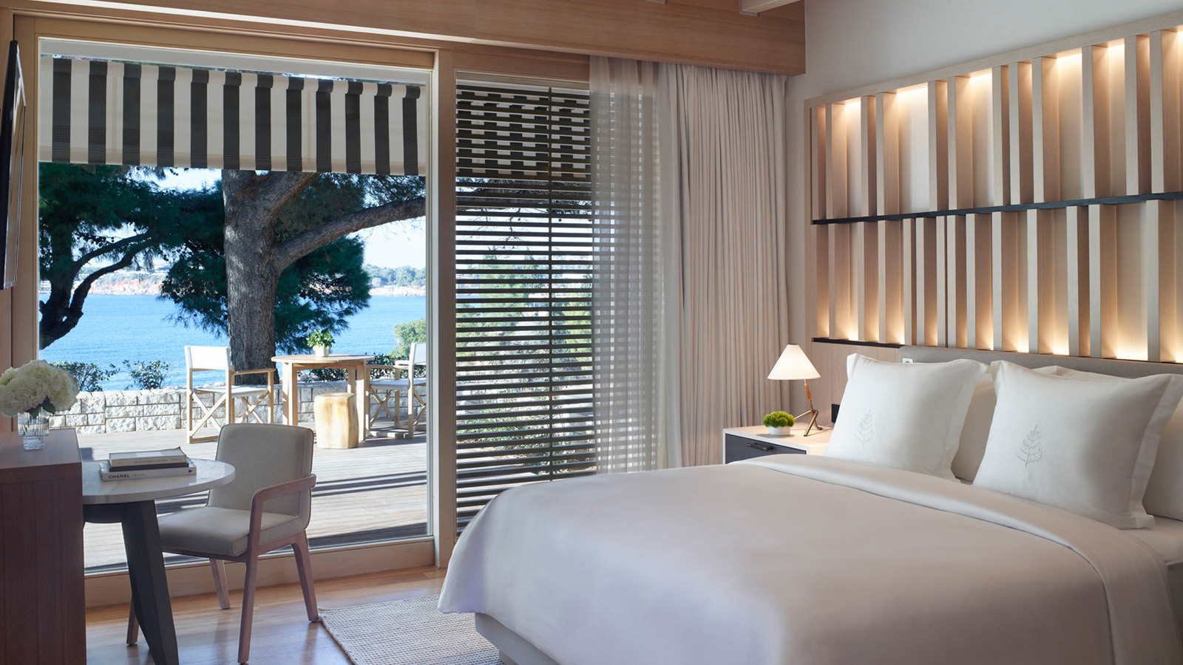
Heralding in a new era in a storied history and an exciting new chapter for a global brand, Four Seasons Astir Palace Hotel Athens is now open. Inspired by the historic glamour of the original Astir Palace Hotel, the fully updated 300-room hotel nestled amid 74 acres (30 hectares) of lush seaside landscape on the shores of the Athenian Riviera is also the first Four Seasons in Greece.
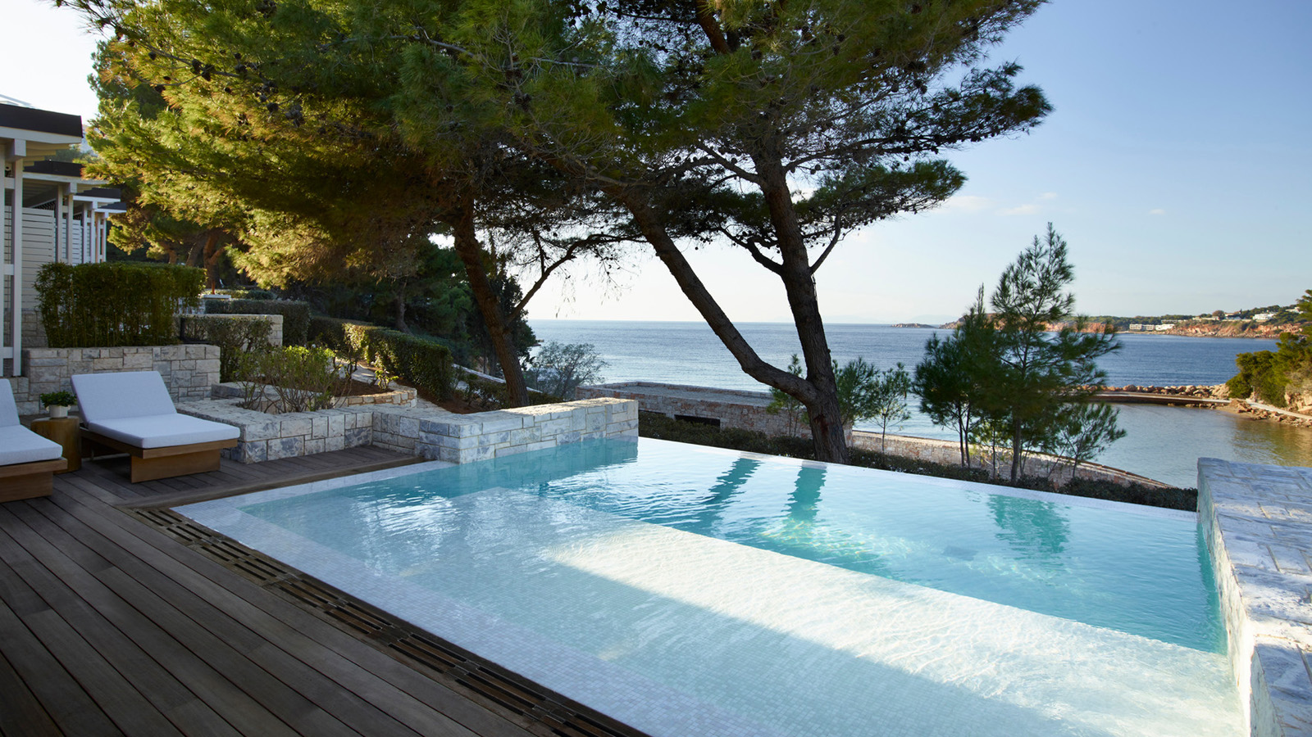 | 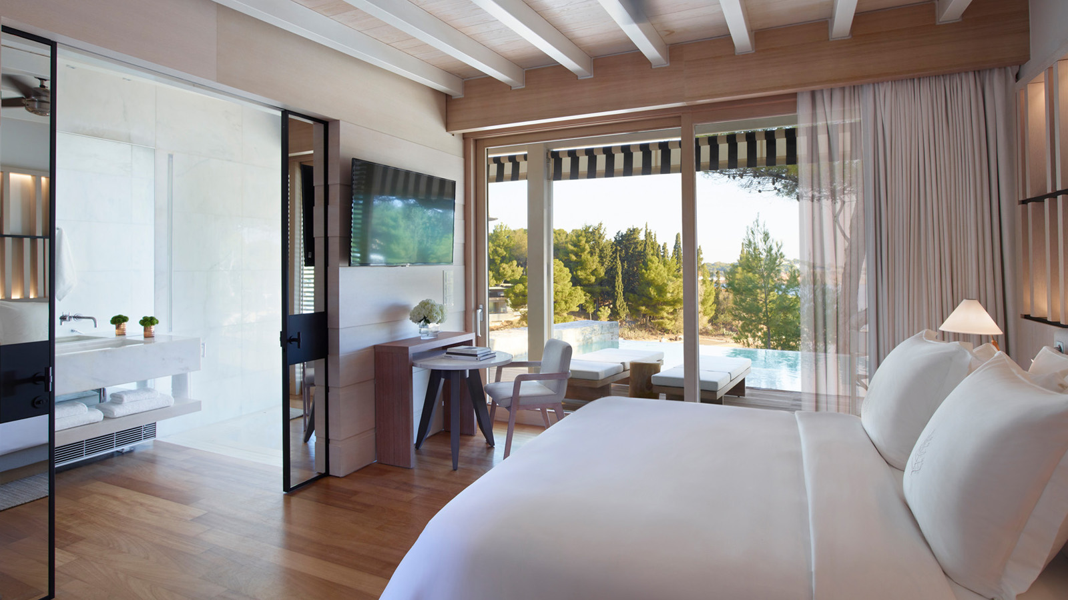 | 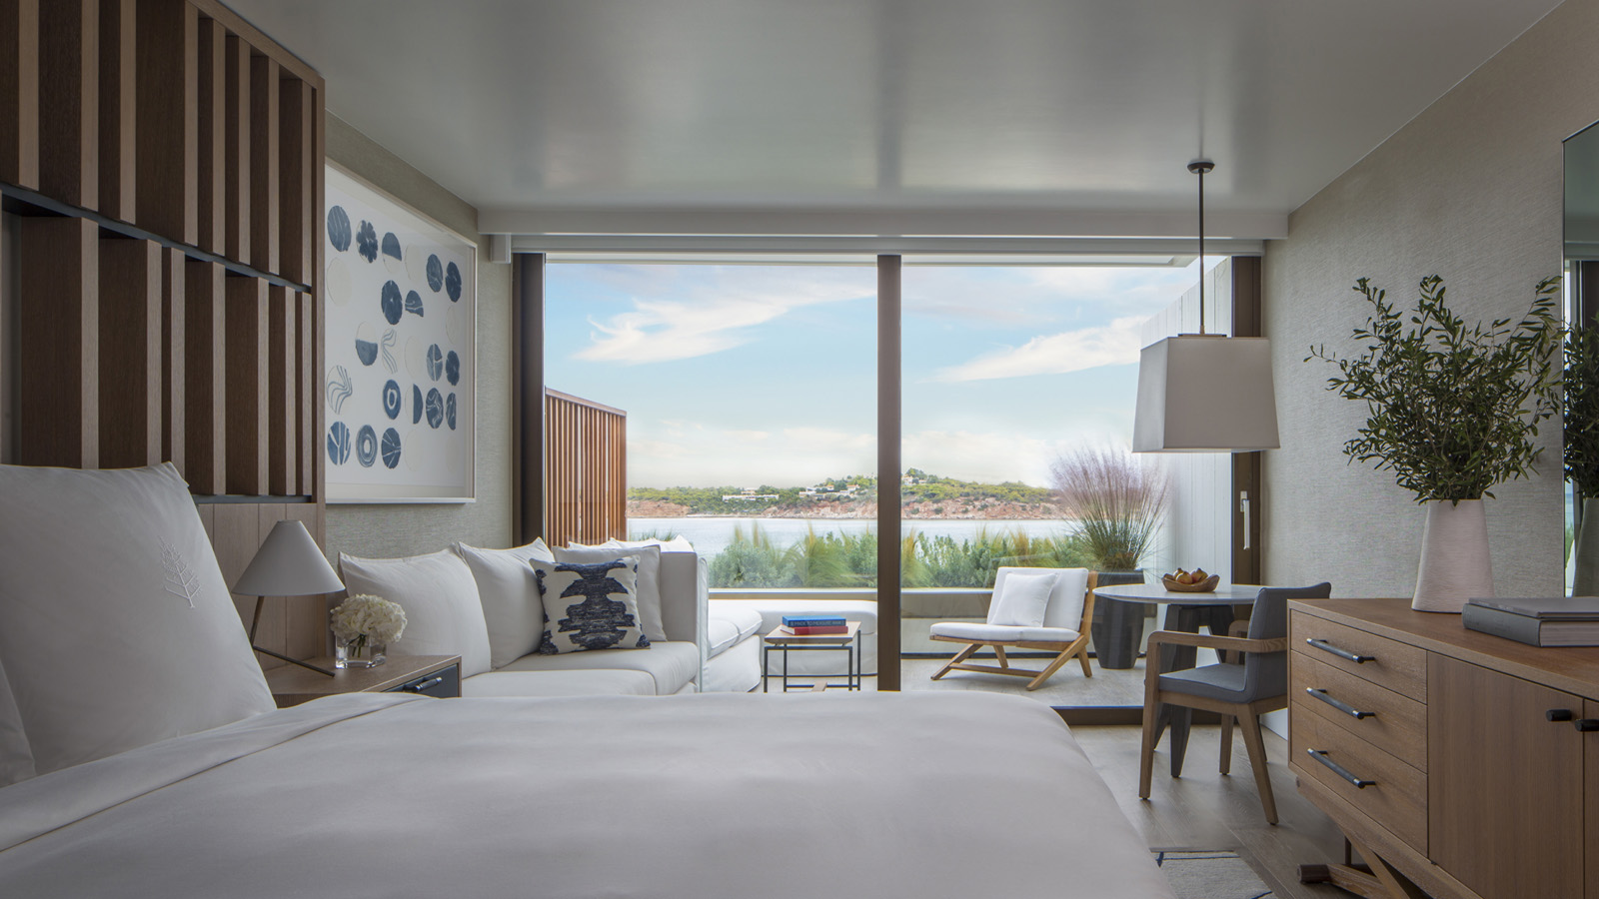
“It’s a landmark day in so many ways as we welcome our first guests to the new Four Seasons Astir Palace Hotel Athens,” enthuses General Manager Sam Ioannidis, a 27-year Four Seasons veteran who leads a team of 700 handpicked and highly trained staff. “So many of our people are locals or native-born Greeks returning to their homeland from around the world, or people who have deep roots in this culture and finally have the opportunity to live and work here. This heritage makes us even more excited to share it all with our guests – whether it’s your first time in Greece or you’ve been here many times before, we promise that we’ll give you an experience that only Four Seasons can deliver.”
Located on a peninsula just 30 minutes from the city centre and a half hour from Athens International Airport, Four Seasons Astir Palace Hotel is the ideal choice for travellers who want to experience the best of ancient and modern Greece, weekenders from Athens or the region, families looking for a holiday that can be both fun-filled and educational, and couples who are beginning or renewing their lives together in one of the world’s most romantic destinations.
This Year in Athens
“Everyone is aware of the wealth of ancient history to be found in Greece, but savvy travellers know there are also many other reasons to fall in love with Athens now,” says Chef Concierge George Vournazos. “In addition to helping guests plan the best ways to make the most of their time at the Acropolis and other major museums, the summer calendar is filled with performing arts, from the Release Athens music festival throughout June to orchestral, opera and dance events at the Athens Concert Hall and Stavros Niarchos Foundation Cultural Center.”
For art lovers, the Benaki Museum is currently featuring works by artists who were influenced by Yiannis Moralis, one of Greece’s greatest 20th century icons. “Guests can also enjoy our in-house collection of close to 2,000 works by mostly contemporary Greek artists, and we are very pleased to collaborate with the Benaki Museum in hosting an on-site museum shop within the Hotel.”
Be among the first to stay at the new Four Seasons Astir Palace Hotel Athens and re-experience Athens in an entirely new way: The Grand Opening Offer featuring 20 percent savings on the room rate plus daily breakfast is extended through the end of 2019, and travellers are also invited to take advantage of the Stay Longer – Sixth Night Free package offering a complimentary night with each five nights paid.
Best of Both Worlds: A Plethora of Seaside Fun Just Minutes from the City Centre
Three private beaches strung together by a thousand foot (300 metre) boardwalk, three pools (free-form family pool, sleek infinity pool and indoor lap pool), five tennis courts, myriad watersports from windsurfing to sea kayaking plus a sunset sail every evening, an onsite basketball court and a golf club just steps away, extensive trails for jogging and walking, a fully-supervised complimentary Kids for All Seasons program housed in its own facility, boat access and even a helipad … in the words of Hotel Manager Panagiotis Sopiadis, “need we say more?”
“If you’ve ever had to make the tough decision between staying in Athens or going to an island resort, Four Seasons Astir Palace has it covered in one seaside destination.”
Dining at Four Seasons: An International Tour Begins with Contemporary Greek Cuisine
Helmed by Executive Chef Bertrand Valegeas who brings more than a quarter century’s experience in kitchens all over the world, the Hotel’s culinary offering is as diverse as Greek culture. Director of Food and Beverage Sotiris Ananiadis explains:
“Within the Hotel we are offering eight unique concepts, with easy access to other marquee restaurants on the Astir Peninsula including Nobu’s Matsuhisa Athens. Here at Four Seasons Astir Palace, guests can tuck into the trattoria-style Italian specialties at Mercato; share beloved Greek favourites at the beachside Taverna 37; chill poolside with tapas and cocktails at our Latin American grill Helios; or – and this is my personal recommendation – enjoy a more sophisticated dining experience at Pelagos, where we are featuring the day’s best Aegean fish and seafood prepared to order.”
Four Seasons Astir Palace Hotel Athens also offers the lobby gathering place Astron Lounge and Terrace for light fare, afternoon tea and cocktails; the elegant Avra Lounge and Terrace; and the Hotel’s homage to the Astir Palace’s golden age at Aristotle’s cigar and cognac lounge. Four Seasons also offers chairside food and beverage service at its outdoor pools and beaches.
Please note that outdoor dining experiences Taverna 37 and Helios will open at a later date.
Holistically Inspired: The Spa at Four Seasons
Taking to heart the sage words of Hippocrates - “Cure sometimes, treat often, comfort always” – The Spa at Four Seasons offers a comprehensive menu of treatments and services attuned to modern life.
“The Fountain House is our hydrotherapy zone inspired by ancient Greek traditions updated in state-of-the-art facilities that include an aroma steam grotto, hammam, vitality pool and chill showers,” says Spa Director Elodie Lefebvre. “Experienced spa goers will delight in our innovative, results oriented treatments, while those in serious need of relaxation and pampering will be very well taken care of.”
Signature treatments created especially for the new spa include the two-hour Iremia Stillness Recovery Ritual (“a blissful, nurturing treatment for physically or emotionally exhausted souls,” recommends Lefebvre); the 90-minute Epanorthosi Green Caviar Repair that addresses issues of ageing and environmental damage to the skin; and the Frodida Body Ritual (60, 90 or 120 minutes), which is carefully tailored to individual wants and needs by the Spa’s caring therapists.
Your Greek Home Away from Home
Housed in two distinct buildings and a collection of private bungalows, accommodations options at Four Seasons Astir Palace Hotel range from light-filled rooms and suites to ultra-exclusive garden cottages.
At Arion with its modernist architecture and retro-chic design, guests will find a laid back vibe expressed in breezy rooms and suites. Four of the Hotel’s restaurants and lounges are also here, along with the Spa and indoor pool.
At Nafsika, azure sea views dominate every room and suite – including some with private pool. The social hub Avra Lounge and Terrace is here along with two other restaurants, the fitness centre and several luxury boutiques.
For guests seeking more space and privacy, and perhaps a little nostalgia, Four Seasons offers The Bungalows, originally built in the early 1960s, and now reborn with a fresh look and up-to-date amenities for today’s travellers.
Meetings, Events and Special Occasions at Four Seasons
With a broad selection of indoor and outdoor function spaces accommodating guest lists from 70 to 700, Four Seasons continues the Astir Palace tradition of hosting productive business meetings and memorable social occasions with the added attraction of seaside accommodations for participants and guests, not to mention myriad opportunities for fun for everyone. The expert team at Four Seasons assists planners and wedding couples from the earliest creative ideas to flawless, worry free execution. To get started, contact +30 210 8901000.

RELATED

March 29, 2019, Athens, Greece
Four Seasons Astir Palace Hotel Athens é inaugurado e define novo conceito de luxo na Riviera Ateniense
https://publish.url/br/athens/hotel-news/2019/now-open-4.html

March 29, 2019, Athens, Greece
Apre oggi Four Seasons Astir Palace Hotel Athens la nuova definizione di ospitalità di alto livello nello scenario della riviera ateniese
https://publish.url/it/athens/hotel-news/2019/now-open-5.html

PRESS CONTACTS

Elia Kentrota
Director of Public Relations
40 Apollonos Street
Vouliagmeni, Athens
Greece
elia.kentrota@fourseasons.com

+30 210 8901077

