Six Reasons Couples Love Four Seasons Resort Anguilla

January 15, 2019, Anguilla, West Indies

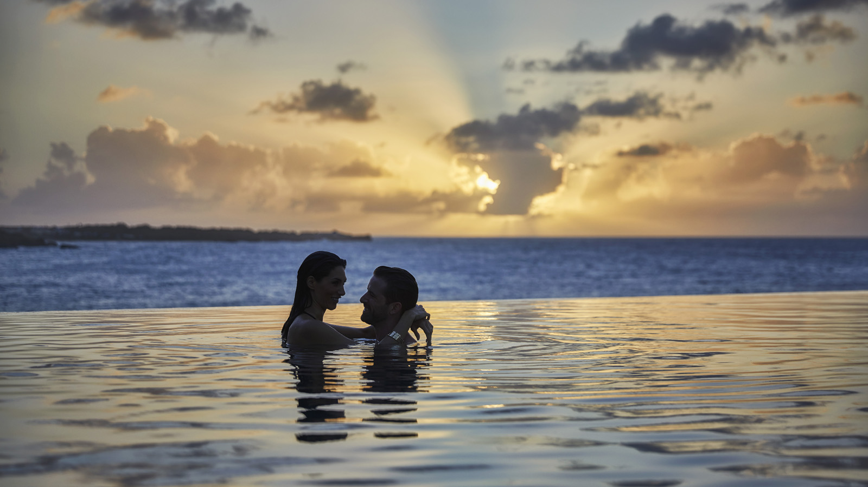
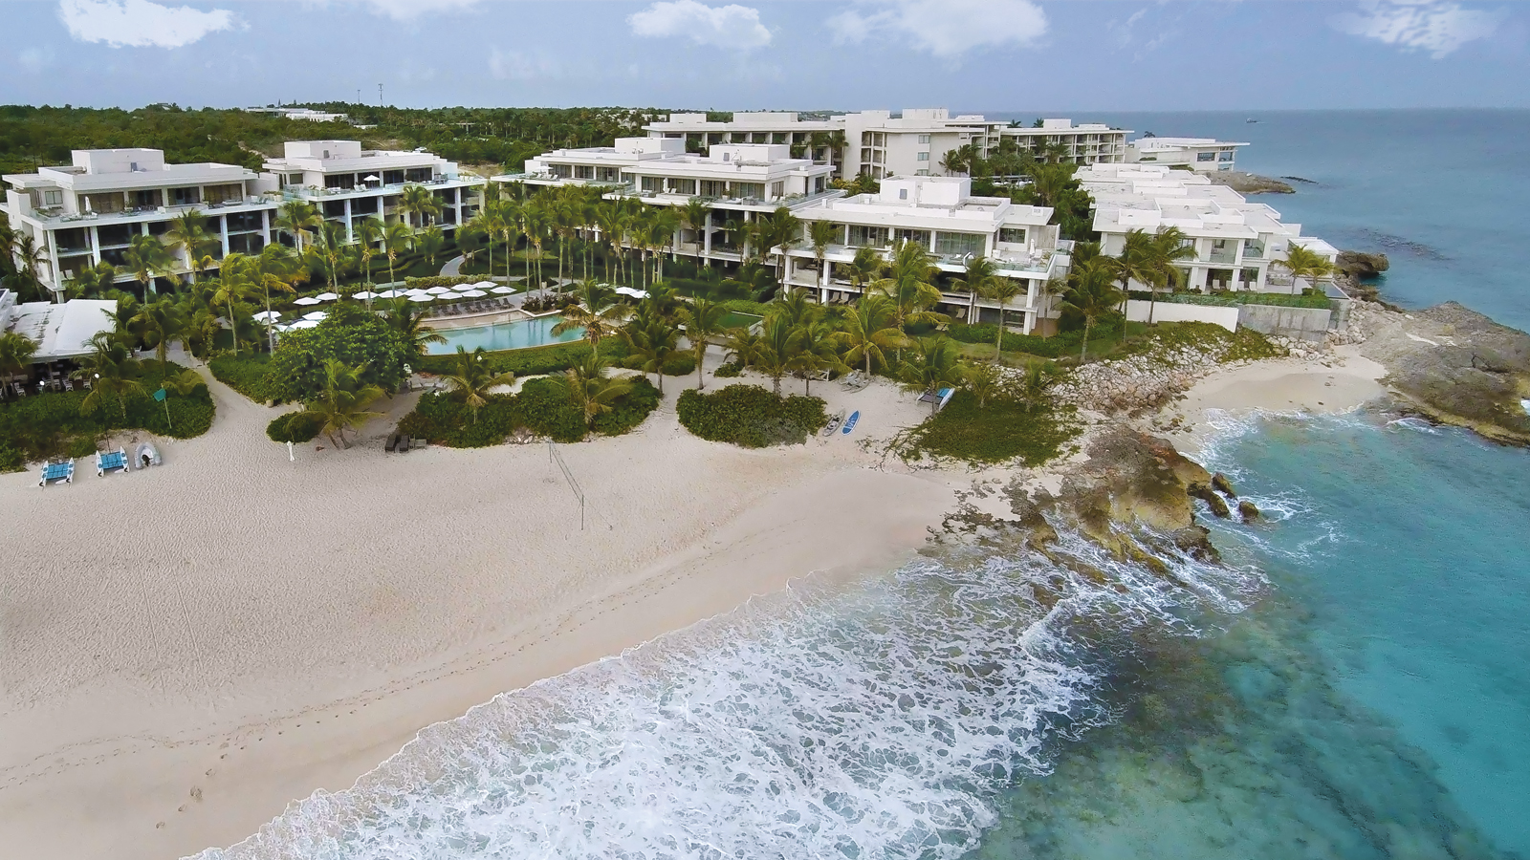 | 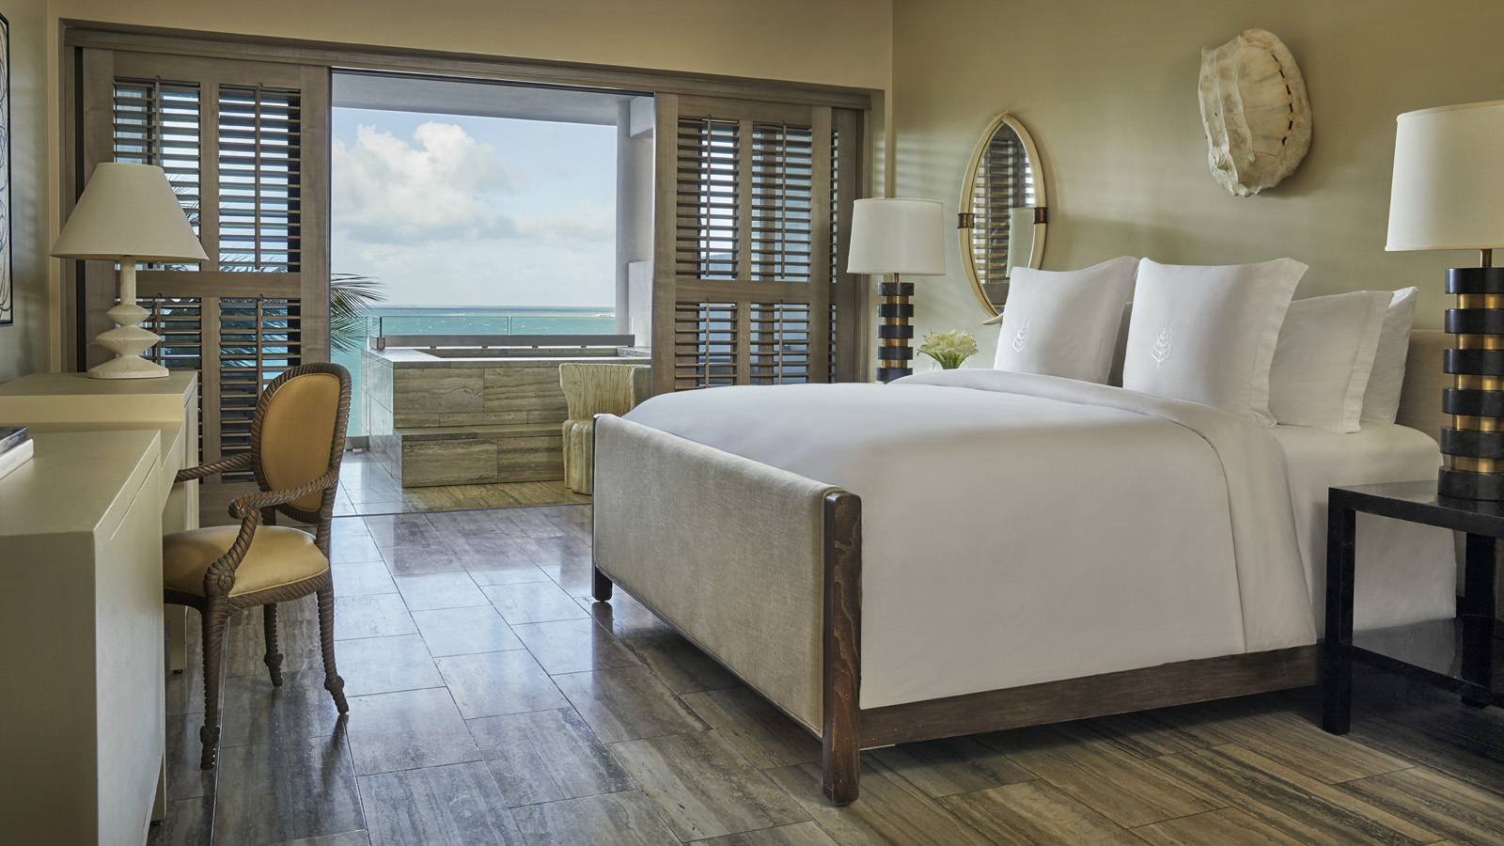
For a honeymoon, Valentine’s Day or simply any day of the year, the island of Anguilla is an established destination for romance. In fact, it was the chosen location for shooting the dating TV series, Coupled, produced by Mark Burnett.
Dial up the romance at Four Seasons Resort and Residences Anguilla, where couples will be spoiled with luxurious services and amenities such as:
- Adults-Only Pool: Our Sunset Pool is considered one of the sexiest pools in the Caribbean. Soak in Mother Nature’s daily sunset show from the sleek infinity edge pool, which is located on a 150-foot (46 metre) bluff overlooking Barnes Bay. Delicious rum punches, Mojitos and other poolside favourites are brought to guests in the pool or served on a floating bar.
- Stylish Rooms: All accommodations were designed by internationally acclaimed designer Kelly Wearstler. One-bedroom suites feature marble bathrooms with double sinks, a deep soaking tub and an oversized walk-in shower. Enjoy the ocean view from your outdoor balcony, private plunge pool or from the lounges chairs for two.
- Private Islands: Imagine arriving by boat to a stretch of beach where the only things seen for miles are palm trees, blue waters and swaying palms. Anguilla is blessed with many nearby islands just waiting to be discovered: Sandy Island, Prickly Pear, Dog Island and more.
- Waterfront Couples Massages: The Romance Cabana at The Spa offers a view of the Caribbean Sea if you choose to keep your eyes open during the massage. With eyes closed, the only sound you’ll hear is the lull of waves while therapists provide either a Blue Tranquility or Deep Sea massage.
- Dining on a Private Beach: Dinner for two under the stars is very romantic. Add a beachfront location with a private server and it’s guaranteed to be unforgettable. Jack’s Cove is a hidden gem at the Resort. It’s only available when the stars are aligned and the tides are right, but if it’s not available, Meads Bay (named the top 10 beaches in the Caribbean and best beach on Anguilla by 10Best in USATODAY), or Barnes Bay are equally romantic.
- Play Together: They say that couples who play together, stay together and Four Seasons Anguilla provides myriad activities on land and at sea: from tennis in the morning and kayaking in the afternoon to paddle-boarding and one-on-one on the Resort’s NBA regulation basketball court.
Romantic Resort
Spread over 35 acres (14 hectares), Four Seasons Anguilla is the only resort on Anguilla situated on two beaches. Guests may enjoy multiple dining options, a full-service spa, complimentary water activities, more than 100 private pools, three Resort pools plus two of the island’s most esteemed beaches.

RELATED

February 6, 2019, Anguilla, West Indies
Love is Easy to Celebrate at Four Seasons Resort Anguilla with the Anguilla Love Package
https://publish.url/anguilla/hotel-news/2019/anguilla-love-package.html

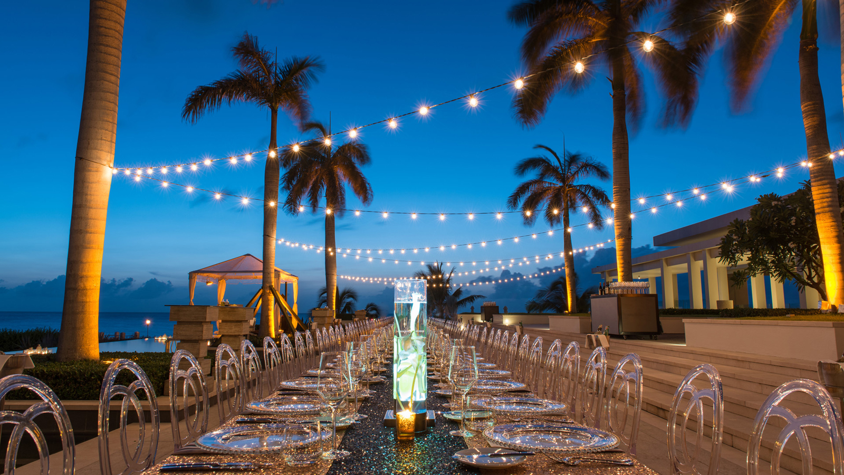 | December 5, 2018, Anguilla, West Indies  Ring in the New Year with Friends and Family on the #1 Island in the Caribbean at Four Seasons Resort and Residences Anguilla  https://publish.url/anguilla/hotel-news/2018/new-year.html

PRESS CONTACTS

Suzanne Willis
Director of Public Relations and Communications
Barnes Bay, P.O. Box 8028
West End
Anguilla
suzanne.willis@fourseasons.com

+1 (239) 287-7070

