Four Seasons Resort Maui Presents Virtual Lei-Making Class

In partnership with lei artist Lauren Shearer of Hawaii Flora + Fauna, the tropical resort offers step-by-step instructions to gift Mom with aloha this Mother’s Day
May 1, 2020, Hawaii, Maui, U.S.A.

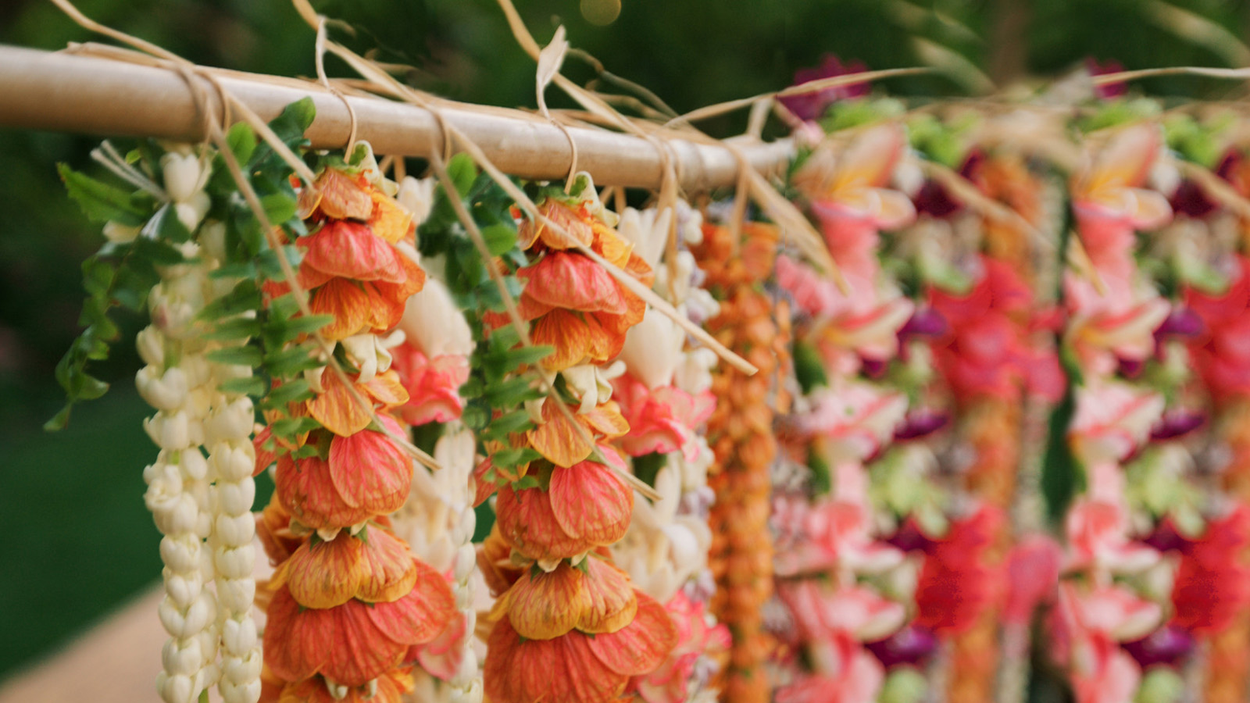
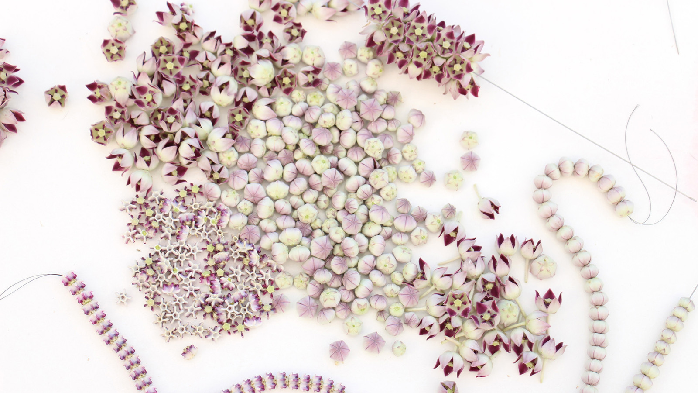 | 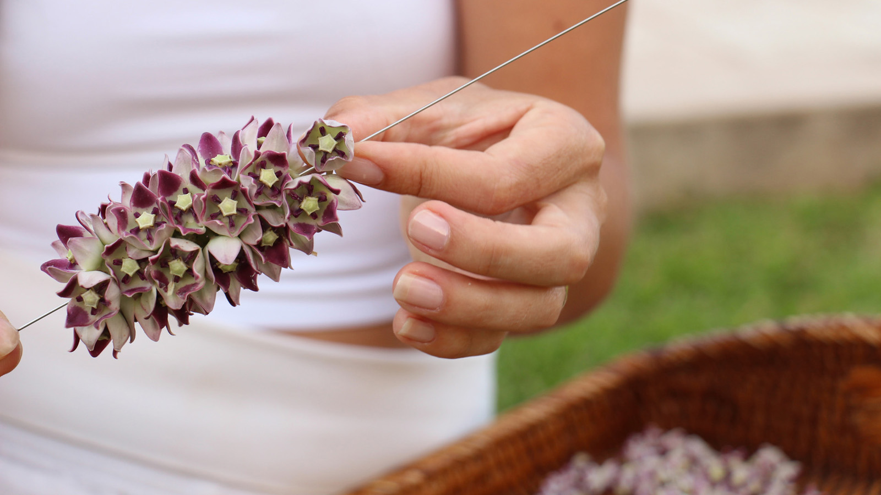 | 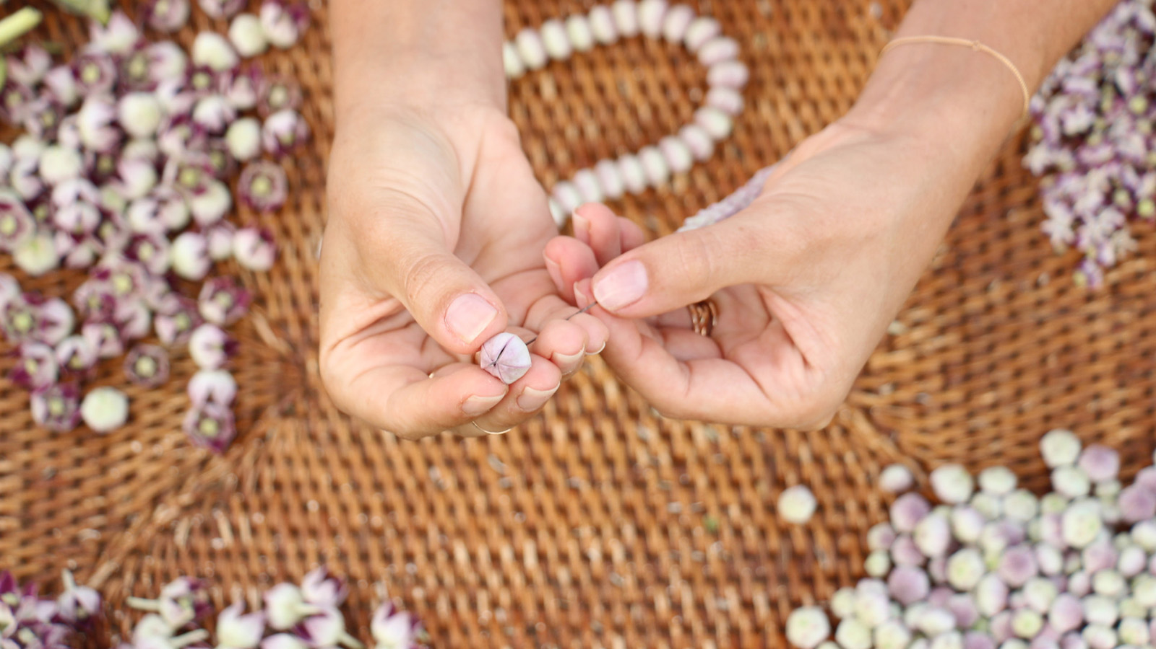
Four Seasons Resort Maui at Wailea announces a virtual lei-making class in collaboration with island expert and longtime partner Lauren Shearer, owner of Hawaii Flora + Fauna, in time for Mother’s Day and beyond.
Internationally recognised as a symbol of aloha, in Hawaii, lei are given for many reasons: ceremonies, gifts, beautification and, of course, greeting island visitors. But no matter what the purpose, gifting a lei leaves an indelible impression on its recipient.
“There is an inexplicable mana (power) in both giving and receiving lei,” says Shearer, whose fresh designs and unexpected materials have gained her notoriety as a “modern” lei artist. However, she pays homage to the craft by constructing lei with not only flowers but leaves, seeds, fruit and more that she forages locally, just as early Polynesians did.
“Each lei can be a gift that honours the beauty of your natural environment, wherever you are,” she advises. “My mission is to connect humanity back to the roots of their surroundings, so they can appreciate that life is ever-changing and ephemeral, just like lei.”
Flower Lei Making How-To
Purchase a lei kit with (or without) fresh flowers from Hawaii Flora + Fauna in time for Mother’s Day here.
Lei-gredients and supplies:
- Flowers (and/or leaves, seeds, and more if desired - almost anything can be made into a lei!)
- Lei needle - a regular needle can be used if necessary
- Thin string - or anything from fishing line to dental floss or sewing thread
Stringing styles:
- Kui pololei (straight stringing) – lengthwise through the centres of the flowers
- Kui poepoe (round stringing) – crosswise through the stems or ovaries of the flowers, arranging as spokes in a wheel
- Kui lau (flat stringing) – crosswise through the stems or ovaries, arranging them alternating from side to side of the string
Instructions:
- Step 1 – Be creative and remember that mana will pass through to the lei and on to its recipient.
- Step 2 – Gather the flowers chosen to assemble into a lei.
- Step 3 – Thread string through the eye of the lei needle. (The string may need to be doubled up depending on the weight of the flowers.)
- Step 4 – Determine stringing style and pattern.
- Step 5 – Pierce flowers with the lei needle and gently pull them down the string, continuing until the lei is about 36 to 42 inches (90-105 centimetres).
- Step 6 – Tie off the two ends with a few simple knots.
Four Seasons Resort Maui regularly shares virtual aloha on Instagram. Tune into @FSMaui on Saturday, May 9, 2020 to discover more lei-making tips during @HawaiiFloraFauna’s Instagram takeover.

RELATED

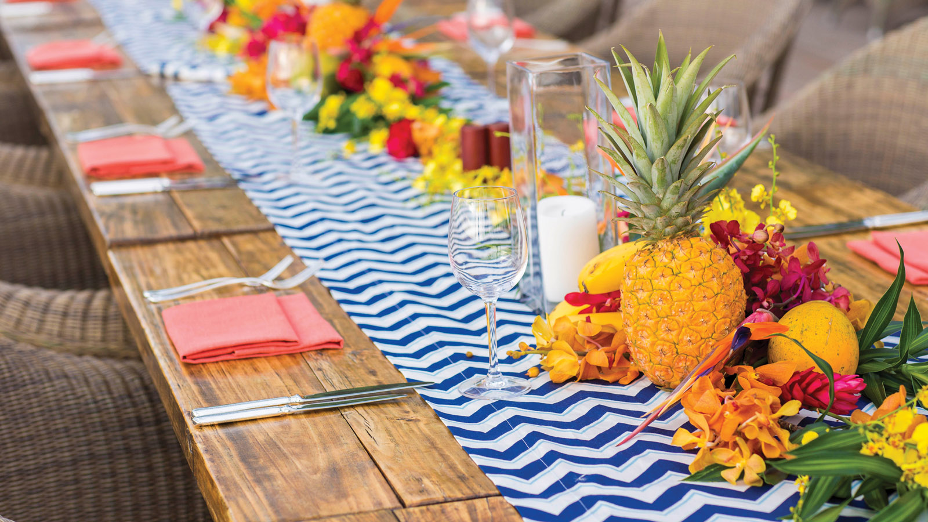 | April 27, 2020, Hawaii, Hualalai, U.S.A.  Four Seasons Resort Hualalai Creates Luxe Mother’s Day Experience at Home  https://publish.url/hualalai/hotel-news/2020/mothers-day.html
April 23, 2020, Hawaii, Lanai, U.S.A.
フォーシーズンズ リゾート ラナイ、自宅で体験できる「おうちでラナイ」シリーズを開始
https://publish.url/jp/lanai/hotel-news/2020/lanai-at-home-social-media-series-2.html

PRESS CONTACTS

Crissa Hiranaga
Director of Public Relations
3900 Wailea Alanui Drive
Wailea, Maui
U.S.A.
crissa.hiranaga@fourseasons.com

+1 (808) 891-4115

