Changing the World, One Girl at a Time: Four Seasons Hotel Beijing Celebrates 5th Year Sponsoring Educating Girls of Rural China

October 25, 2018, Beijing, China

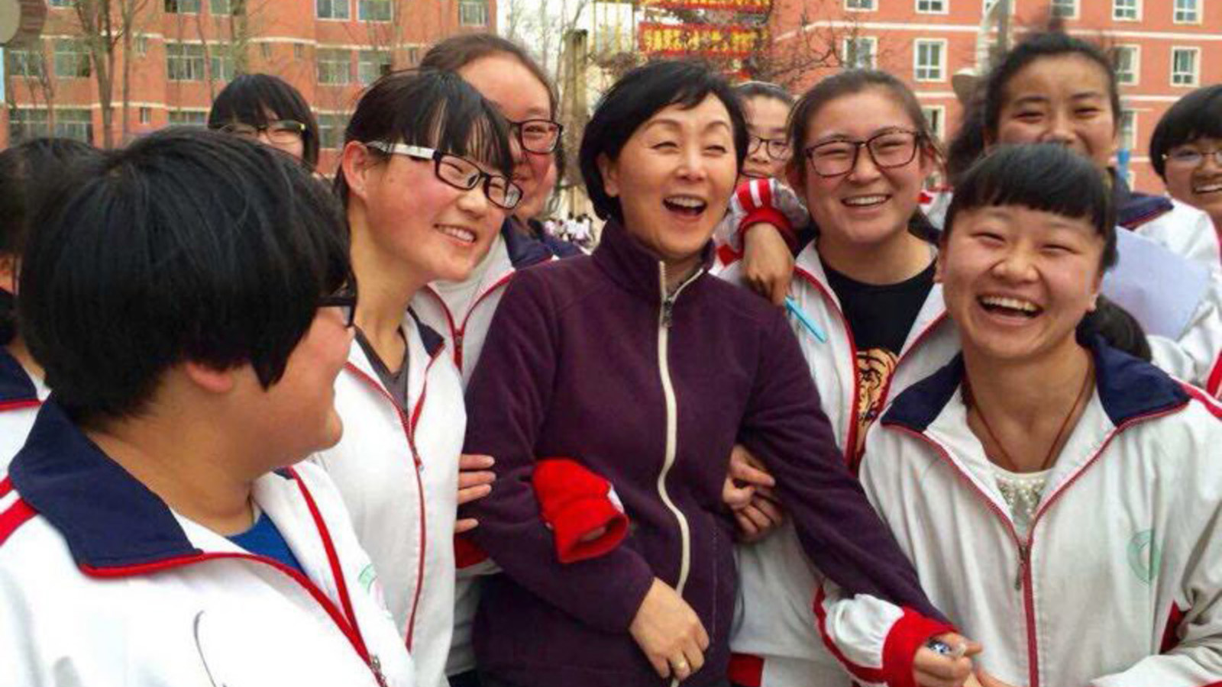
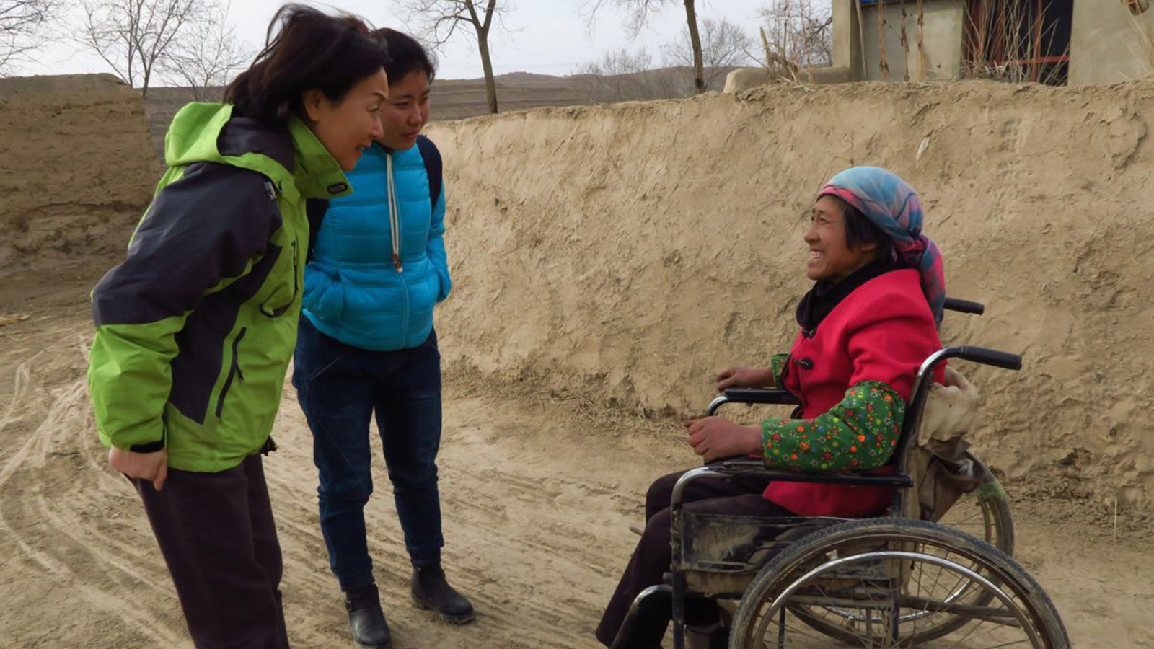 | 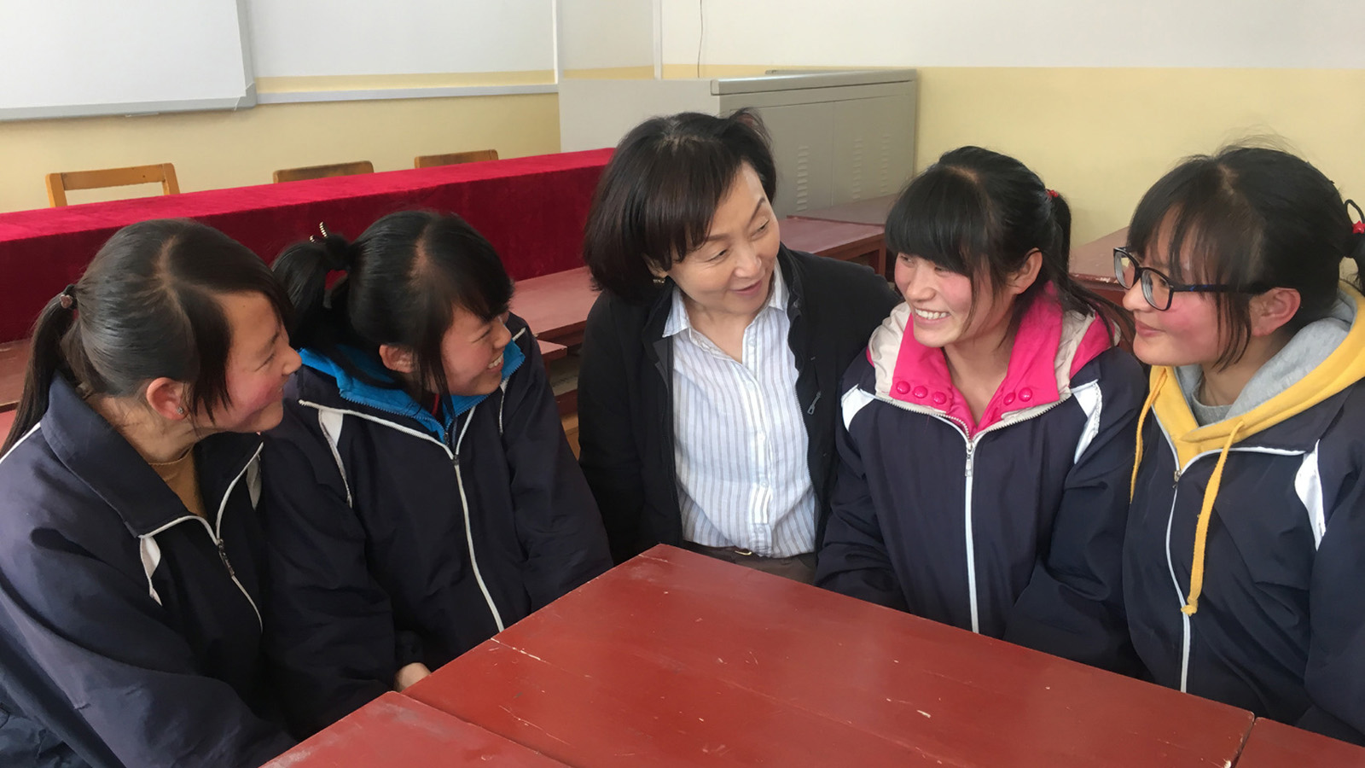 | 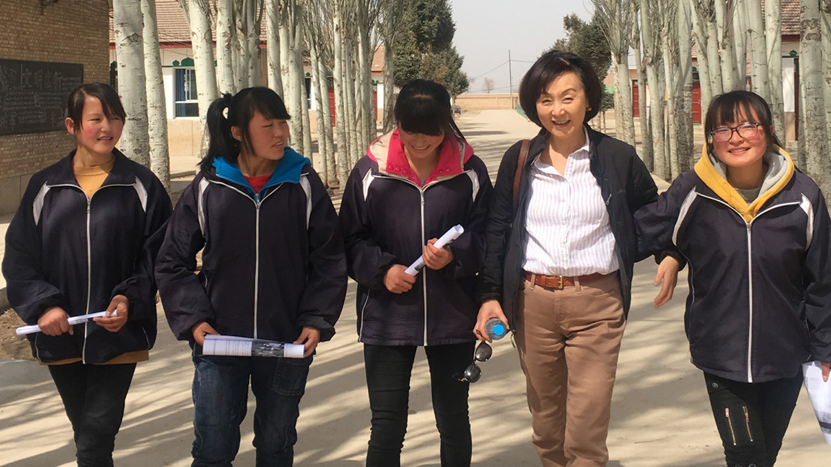
Empowering young women, sending a message of hope, and championing a lifelong love of learning, Four Seasons Hotel Beijing has been a proud sponsor of EGRC – Educating Girls of Rural China – since shortly after its opening in 2012.
Through funds gathered from annual mooncake sales, charity balls, festive events, Chi Fan for Charity (CFFC) program, and a thriving artist-in-residence program, the Hotel has, to date, helped 15 girls finish high school.
Andrew De Brito, the General Manager of Four Seasons Hotel Beijing comments, “We are dedicated to improving the living conditions of girls in rural China. We view our partnership with EGRC as more than financial support – it’s about empowering a generation of young women to see that their future is bright and they can make a real difference.”
It has been said that to educate a girl is to educate a nation, but with the odds stacked against them, girls in rural China often don’t have the funds or family support to pursue an education. This is where EGRC comes in: an organisation dedicated to helping some of the country’s poorest young women gain qualifications that will change their lives, and the lives of those around them.
Ching Tien founded EGRC in 2005, sponsoring 24 girls to pursue an education in the first year. Thirteen years on, EGRC has sent more than 1,000 girls to school, with a 99 per cent graduation rate. During that time, the organisation has expanded to provide English language training, a mentorship program and a Future Leader scholarship among other programs and events.
It’s an inspiring project where funding is just the start. “My vision for these girls is more than just survival,” explains Ching Tien. “Education is just one part of it. Moral support, encouragement and confidence-building are equally as important as paying a girl’s tuition. And we are grateful to supporters like Four Seasons Hotel Beijing for helping us realise this vision.”

RELATED

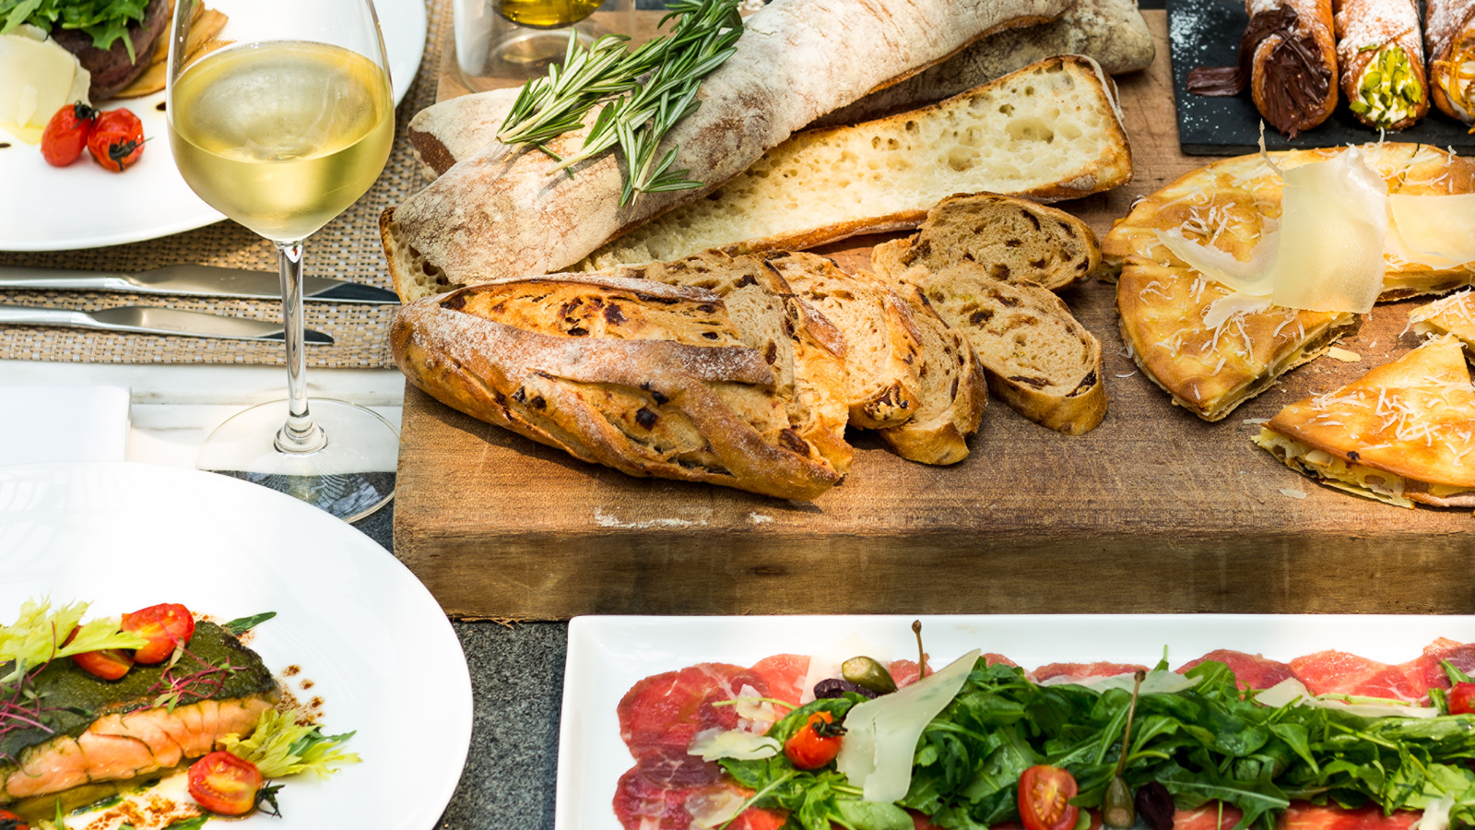 | October 12, 2018, Pudong, Shanghai, China  A Lively and Luxurious Italian Saturday Brunch in Lujiazui at Four Seasons Hotel Pudong, Shanghai  https://publish.url/pudong/hotel-news/2018/saturday-italian-brunch.html
October 12, 2018, Pudong, Shanghai, China
Camelia周六早午餐
https://publish.url/zh/pudong/hotel-news/2018/saturday-italian-brunch-2.html

PRESS CONTACTS

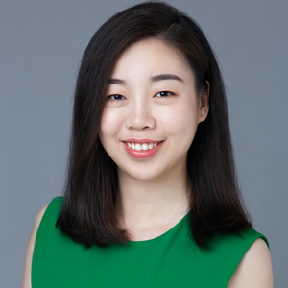 | Emilie Zhang  Assistant Director of Public Relations  48 Liang Ma Qiao Road Chaoyang District  Beijing  China  emilie.zhang@fourseasons.com  +86 10 5695 8706
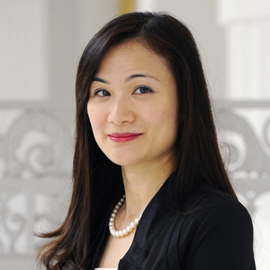 | Vivian Koh  Director, Public Relations and Content, Asia-Pacific  Tourism Court, 1 Orchard Spring Lane #04-01  Singapore  Singapore  vivian.koh@fourseasons.com  +65 6739 5806

