Four Seasons Hotel Singapore Appoints Gabriel Carlos as Bar Manager of One-Ninety Bar

January 1, 2021, Singapore

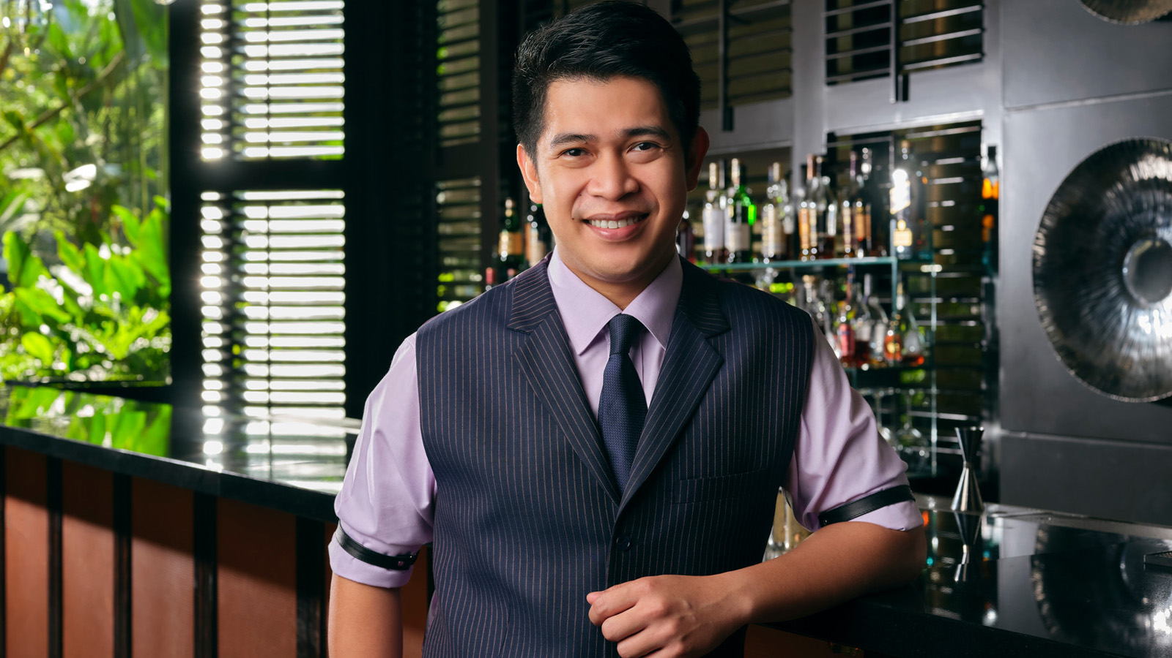
Passionate about the art of bartending and a familiar face at guest shifts, bar conventions and trade seminars around the world, Gabriel Carlos now lends his effervescent personality as Bar Manager of One-Ninety Bar at Four Seasons Hotel Singapore.
Better known as Gab, his passion for the trade started when he had a brush with bartending as part of his school curriculum in college. He has since impressed at global platforms including Tales of the Cocktail, Bar Convent Brooklyn and Bar Convent Berlin.
Most recently, Gab oversaw the entire spirit collection and the "American Whiskey Embassy" program as assistant bar manager at Manhattan, ranked world’s 14th best bar and Asia’s 8th. It was here that he had grown in his knowledge, craft and role after joining the opening team as bartender in 2014 and being promoted to senior bartender and then to assistant bar manager in 2016.
Prior to Manhattan, Gab was bartender at La Dolce Vita Restaurant, Mandarin Oriental Singapore after moving to Singapore from Philippines in 2011.
An outgoing, attentive and charismatic individual who is knowledgeable and passionate about spirits and cocktails, Gab has developed a strong reputation in the local bar community as being a highly competent, creditable, positive person with an intense work ethic and has a history of exceeding guest expectations by providing them with an exemplary service.
“We are very excited to welcome Gab and to have him on our team in Singapore. We are certain that with his inspirational leadership, One-Ninety Bar will continue to elevate and excite both guests and the bartending scene in Singapore,” says Giovanni Speciale, Director of Food & Beverage and Culinary Operations at Four Seasons Hotel Singapore.

RELATED

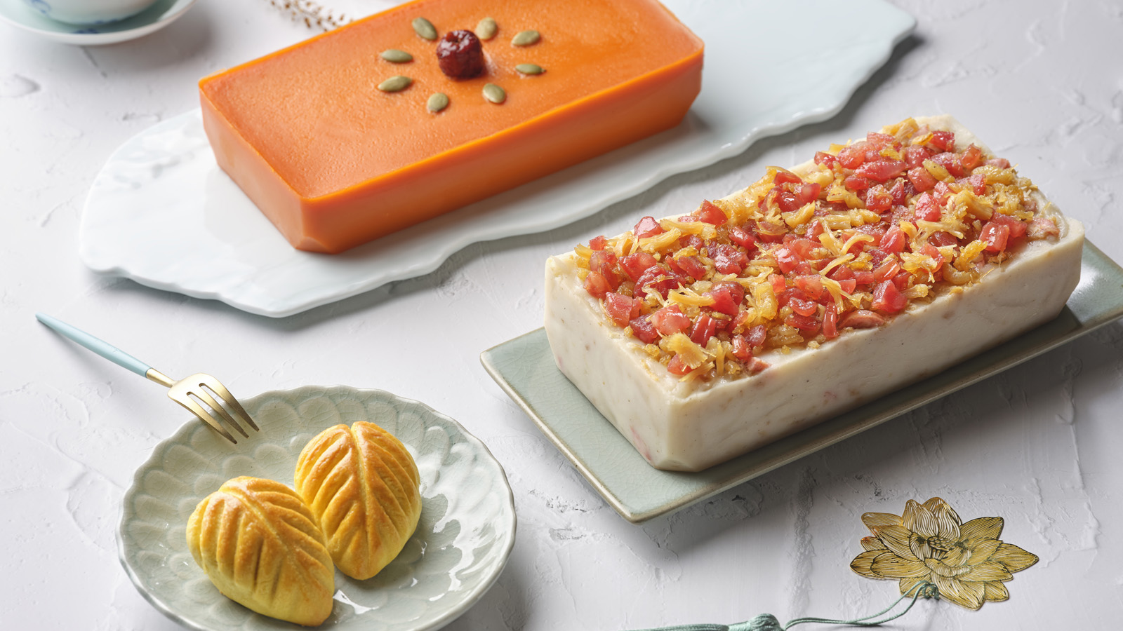 | January 13, 2021, Singapore  Auspicious Celebrations This Lunar New Year at Four Seasons Hotel Singapore  https://publish.url/singapore/hotel-news/2021/lunar-new-year.html
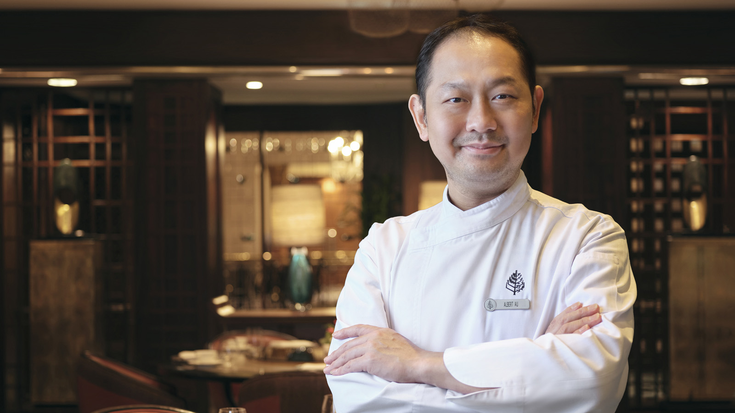 | January 12, 2021, Singapore  Four Seasons Hotel Singapore Appoints Chef Albert Au as Chinese Executive Chef at Jiang-Nan Chun  https://publish.url/singapore/hotel-news/2021/new-chinese-executive-chef-albert-au.html

PRESS CONTACTS

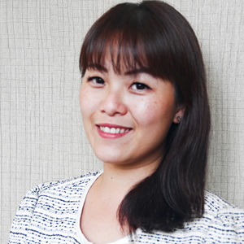 | Valerie Loy  Director of Public Relations and Communications  190 Orchard Boulevard  Singapore  Singapore  valerie.loy@fourseasons.com  (65) 6831 7130

