Four Seasons Resort The Biltmore Santa Barbara Reopens June 1

Iconic beachside Resort welcomes guests for the summer season
May 16, 2018, Santa Barbara, U.S.A.

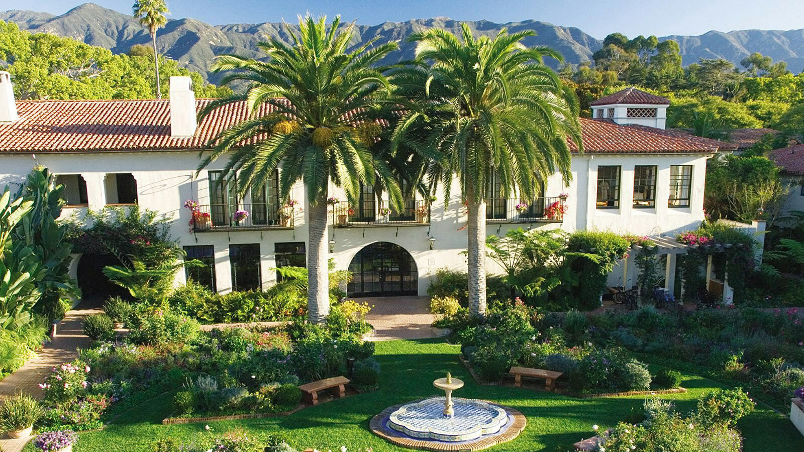
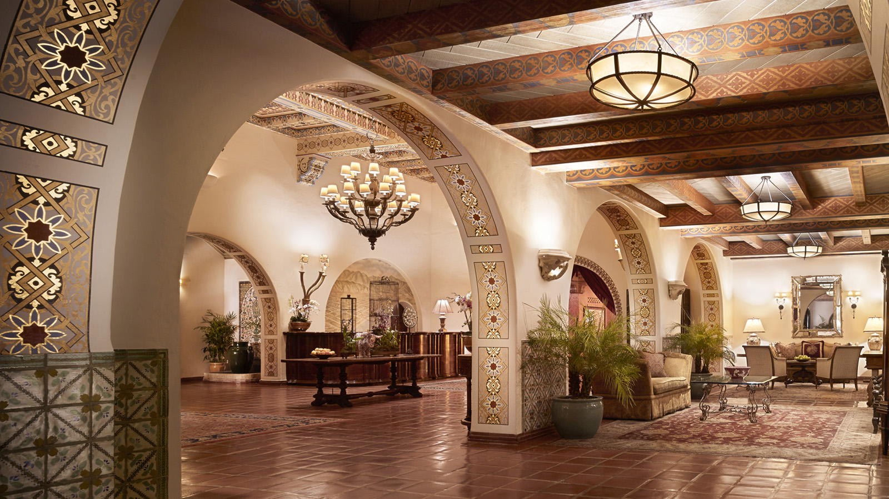 | 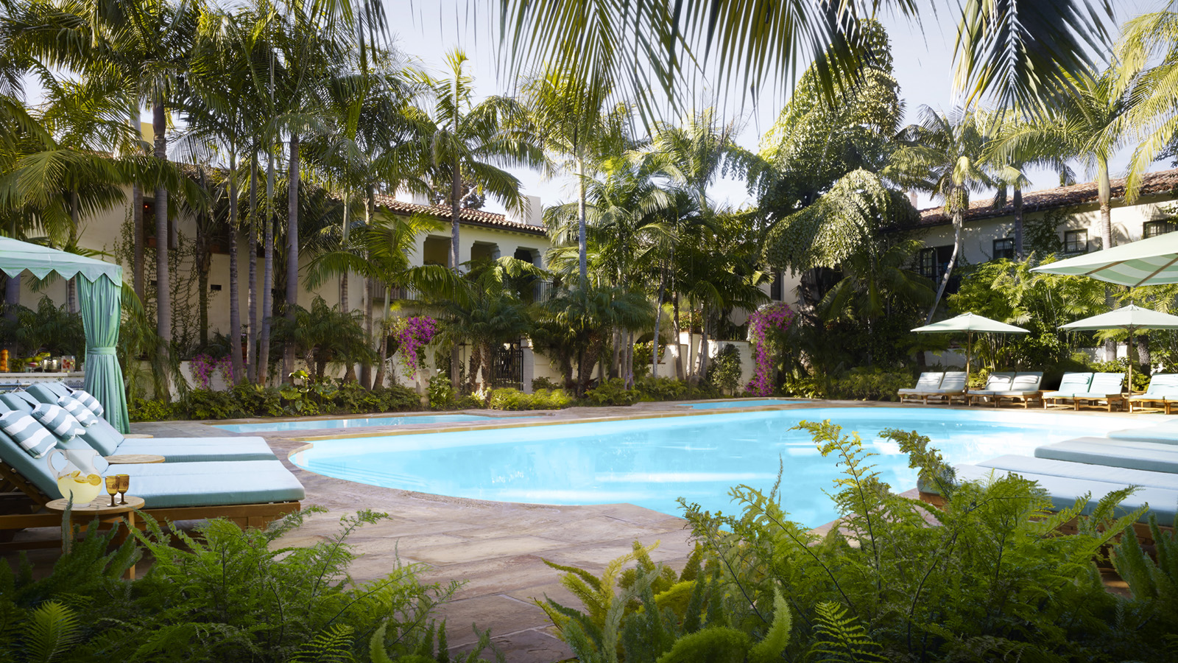 | 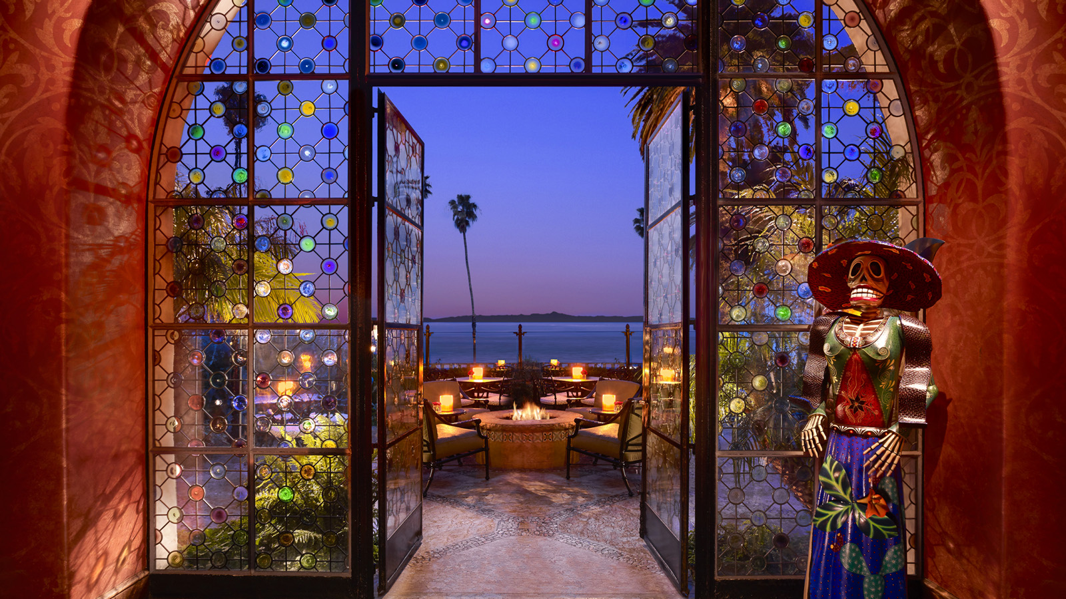
Four Seasons
Resort The Biltmore Santa Barbara, an AAA Five-Diamond award recipient and California’s premier
Four Seasons
resort, announces it will reopen June 1, 2018.
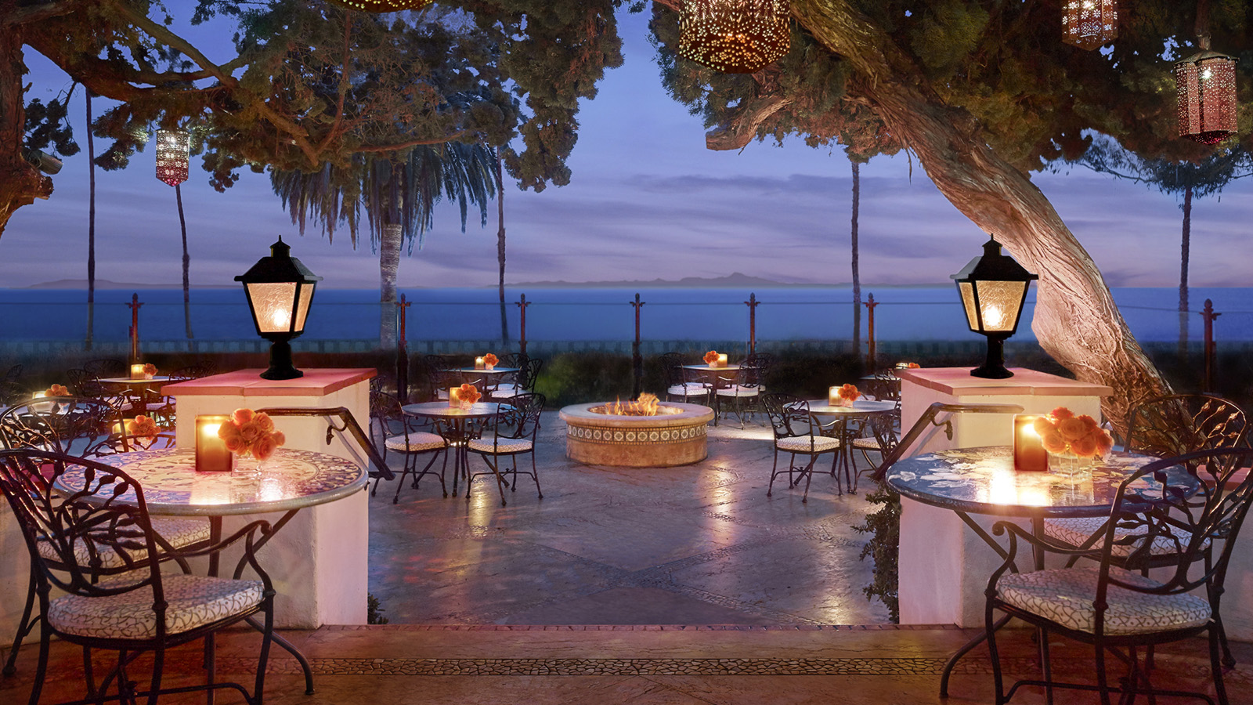 | 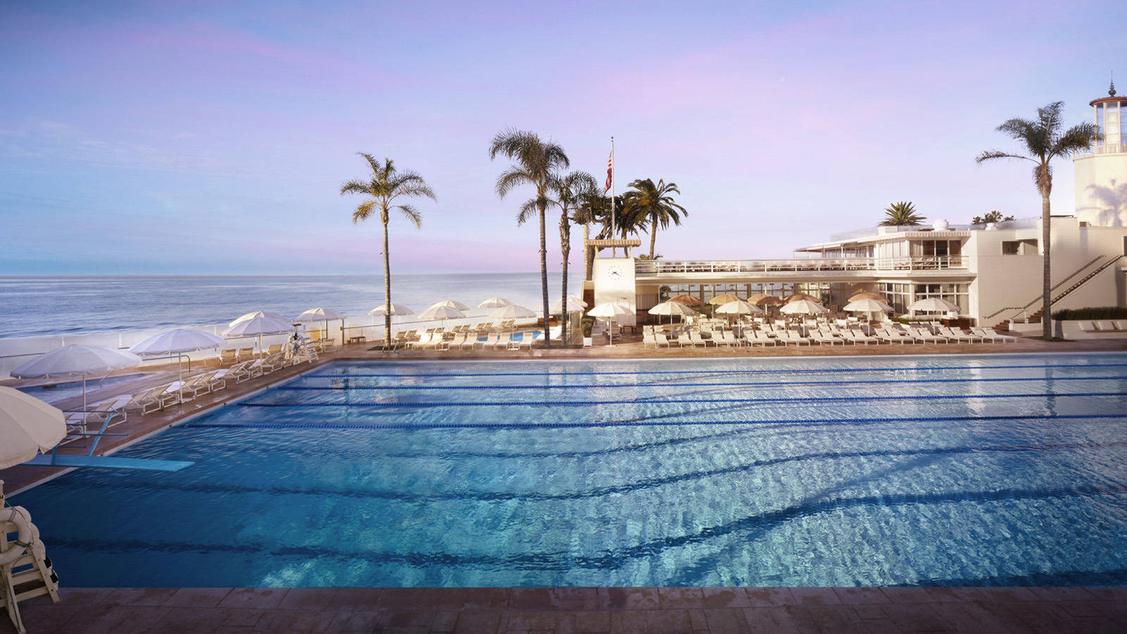 | 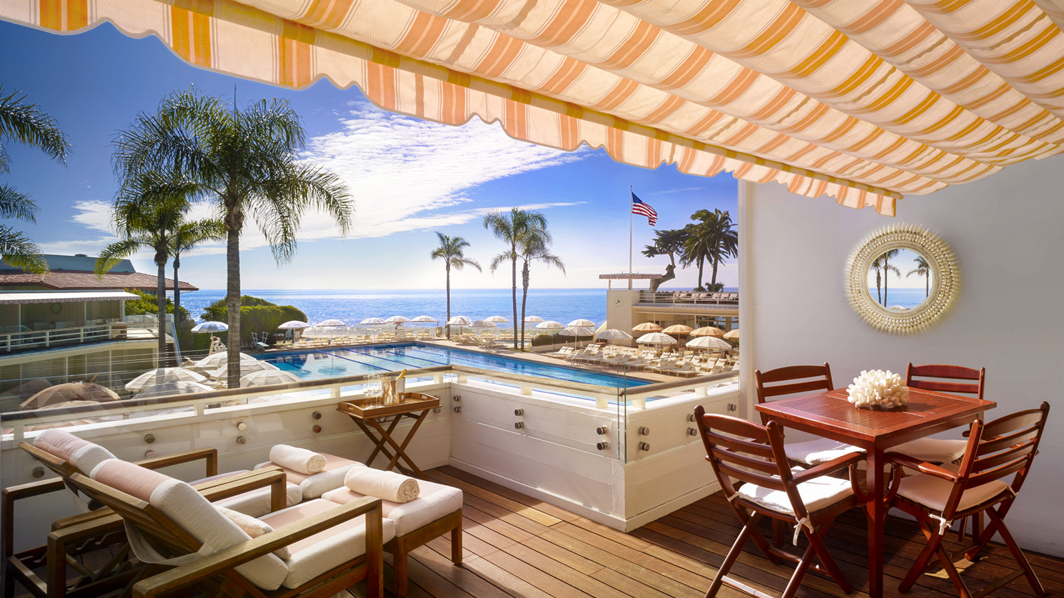
The reopening of the Resort’s 22 oceanfront acres (9 hectares) follows a nearly five-month closure caused by the California mudslides. A team of experts worked diligently to restore the Resort to its original radiance, which included extensive landscaping and restoration of some back-of-house areas and guest rooms. Originally built in 1927 by architect Reginald Johnson, the Resort is known for its authentic Spanish Colonial splendour, picturesque oceanside location and exemplary service.
New this year, the Resort’s new Anacapa Suite will open in fall, offering guests 2,000 square feet (232 square metres) of interior and exterior livable luxury overlooking the Pacific Ocean and Butterfly Beach. Adding to the selection of specialty suites and bungalows, the Anacapa Suite will feature a 15 by 17 foot (4.6 by 5.1 metres) plunge pool, fire pit and private driveway, and includes complimentary access to the private-membership Coral Casino Beach and Cabana Club.
Also this year, the Resort's popular Summer Tasting Series returns with a new lineup of the best local purveyors, distillers and winemakers. Guests are invited to experience the bounty of Santa Barbara via three tasting events set within several of the Resort's standout venues. Additionally, new culinary and spa offerings are being introduced, further enhancing the guest experiences already available.
"On behalf of our 600 passionate and dedicated employees, I am thrilled to announce that our iconic Resort is back – and better than ever,” says Karen Earp, General Manager of
Four Seasons
Resort The Biltmore Santa Barbara. “We look forward to welcoming our guests ‘home’ to experience the best of the American Riviera, beginning with our prime summer season.”
In celebrating its reopening, along with its 90th year,
Four Seasons
Resort The Biltmore Santa Barbara is currently offering the Experience More – Resort Credit Package, which includes luxurious accommodations and a Resort credit of up to USD 300. Guests may use their credit to experience more of the Resort – from scenic oceanfront dining at Bella Vista and handcrafted cocktails and sunset tapas at Ty Lounge, to tennis lessons, spa treatments and more. For reservations, book online, call 805 969 2261 or contact your travel professional (chain code FS).

RELATED

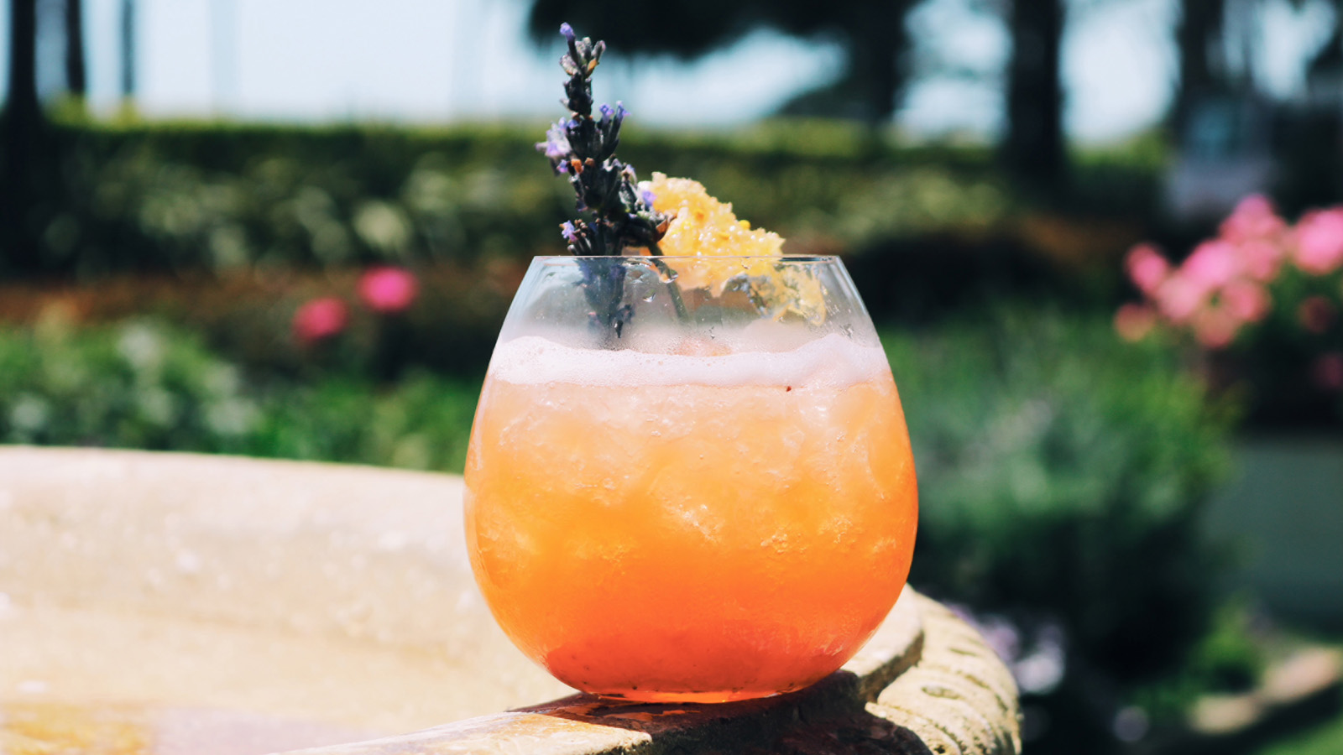 | June 28, 2018, Santa Barbara, U.S.A.  Four Seasons Resort The Biltmore Santa Barbara Wins the Official Drink of Santa Barbara Cocktail Contest  https://publish.url/santabarbara/hotel-news/2018/official-cocktail-of-santa-barbara.html
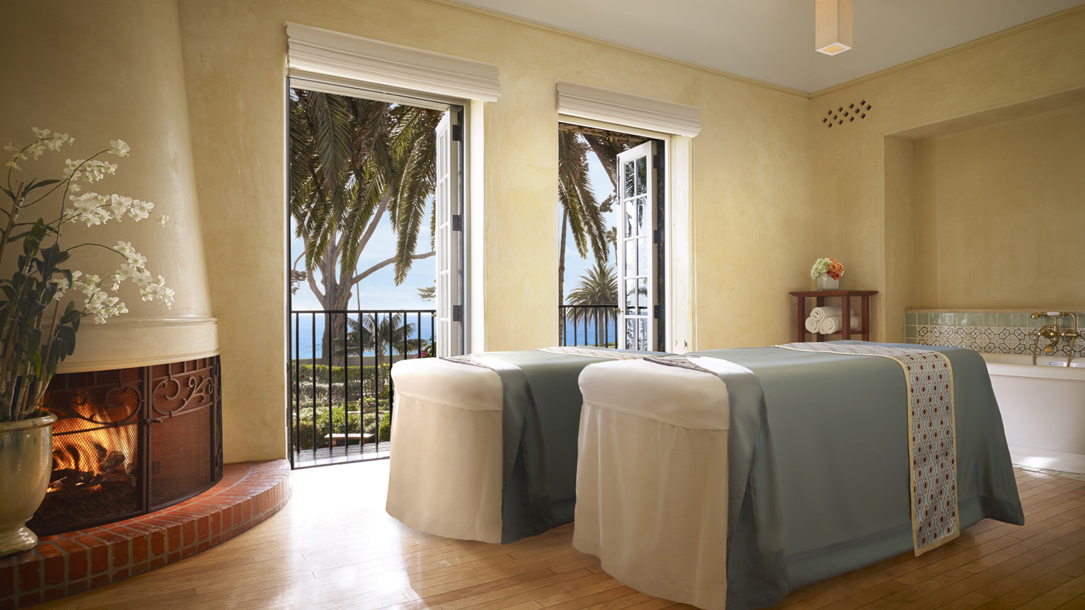 | June 1, 2018, Santa Barbara, U.S.A.  Four Seasons Resort The Biltmore Santa Barbara Enhances Wellness Offerings with New Treatment and Amenities  https://publish.url/santabarbara/hotel-news/2018/new-spa-offerings.html

PRESS CONTACTS

Emilie Plouchart
Director of Public Relations
1260 Channel Drive
Santa Barbara
U.S.A.
emilie.plouchart@fourseasons.com

+1 (805) 565-8270

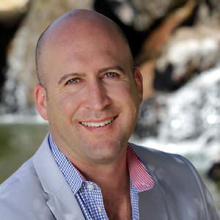 | Brad Packer  Director of Public Relations  350 South Beverly Drive, Suite 100  Beverly Hills  U.S.A.  brad.packer@fourseasons.com  (310) 712-1493

