Four Seasons Mountain Collection Embraces Wellness Through Transformative Travel Experiences

May 8, 2018, Toronto, Canada

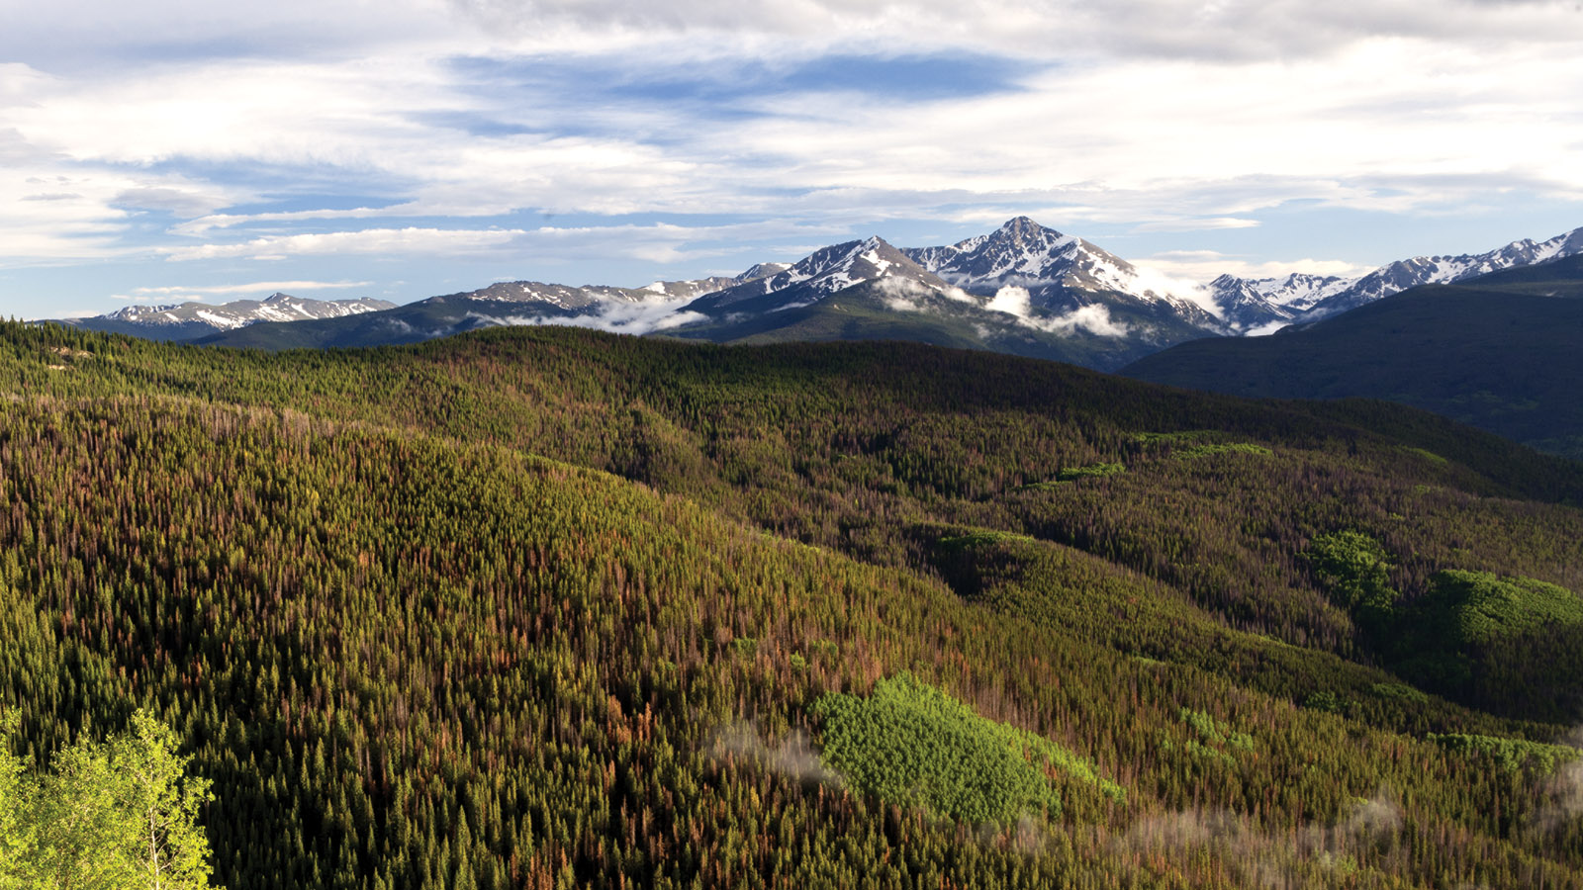
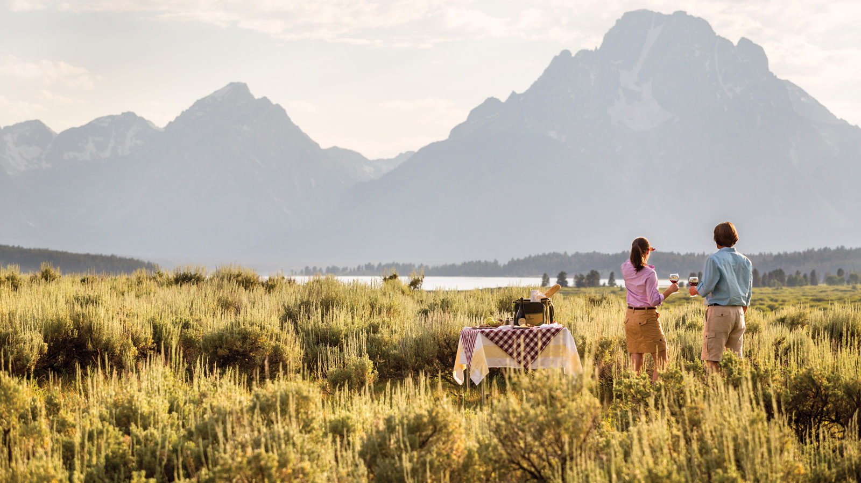 | 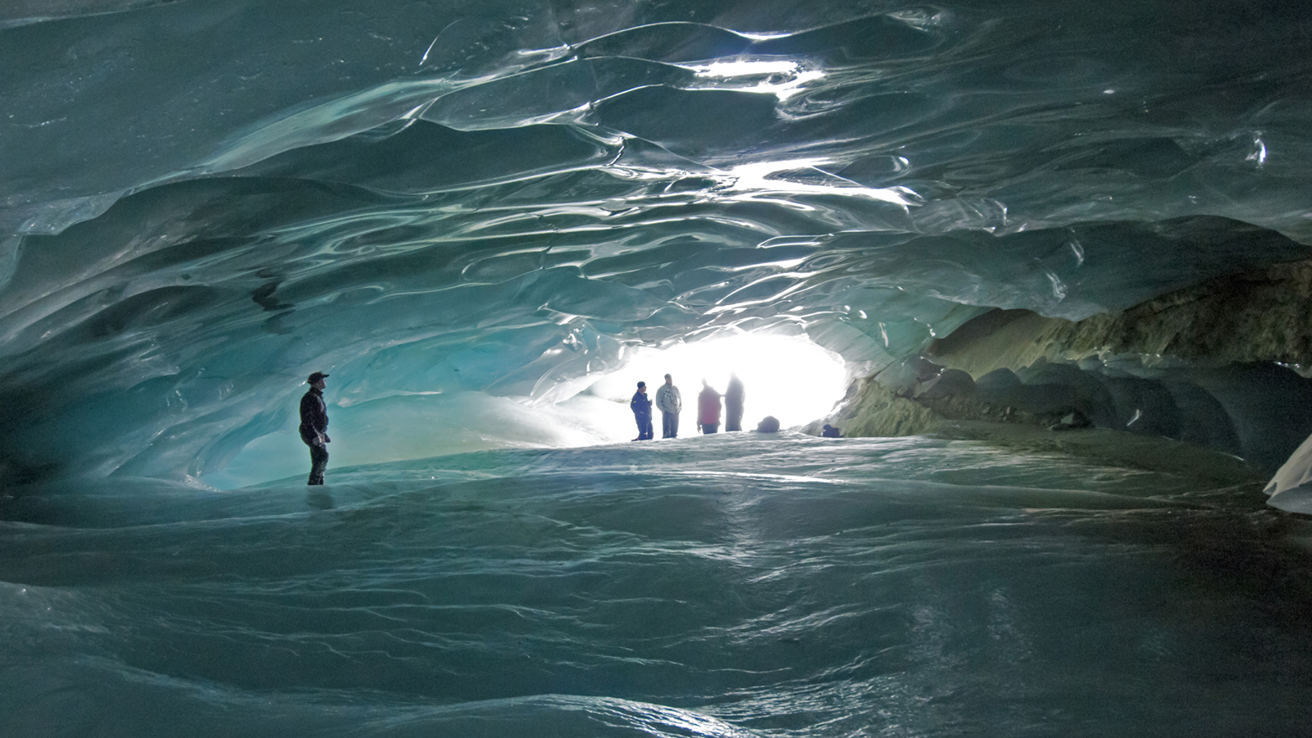 | 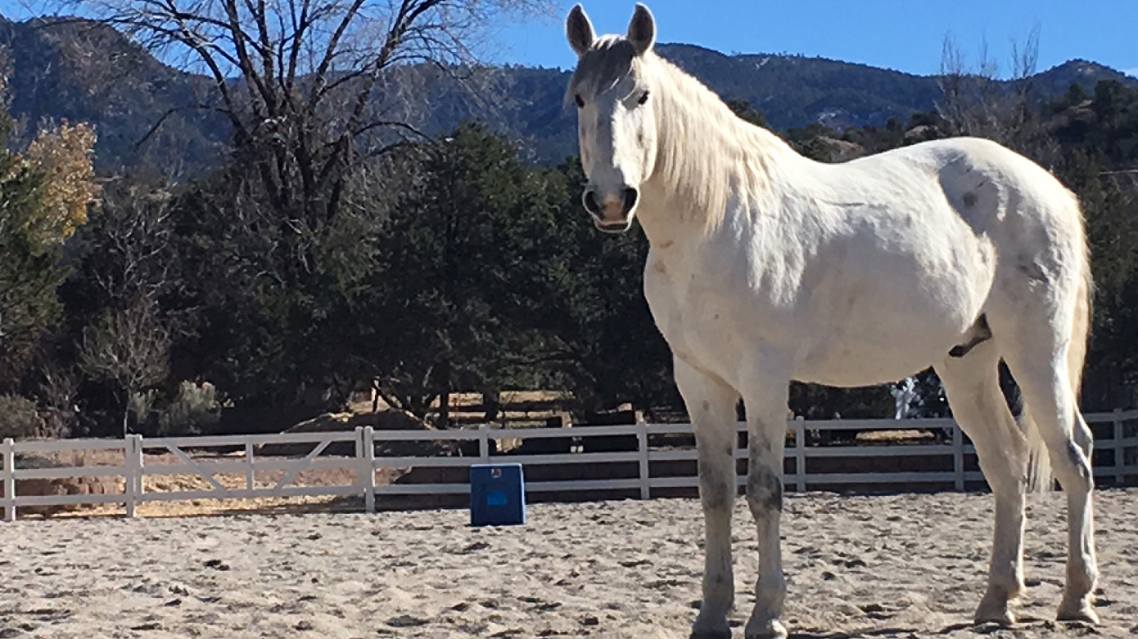
With the increasing individuality of the modern luxury traveller,
Four Seasons
Mountain Collection including
Four Seasons
Resort and Residences Jackson Hole,
Four Seasons
Resort Rancho Encantado Santa Fe,
Four Seasons
Resort and Residences Vail and
Four Seasons
Resort and Residences Whistler offers a variety of immersive ways to experience the world’s most breathtaking mountain resorts through transformative travel.
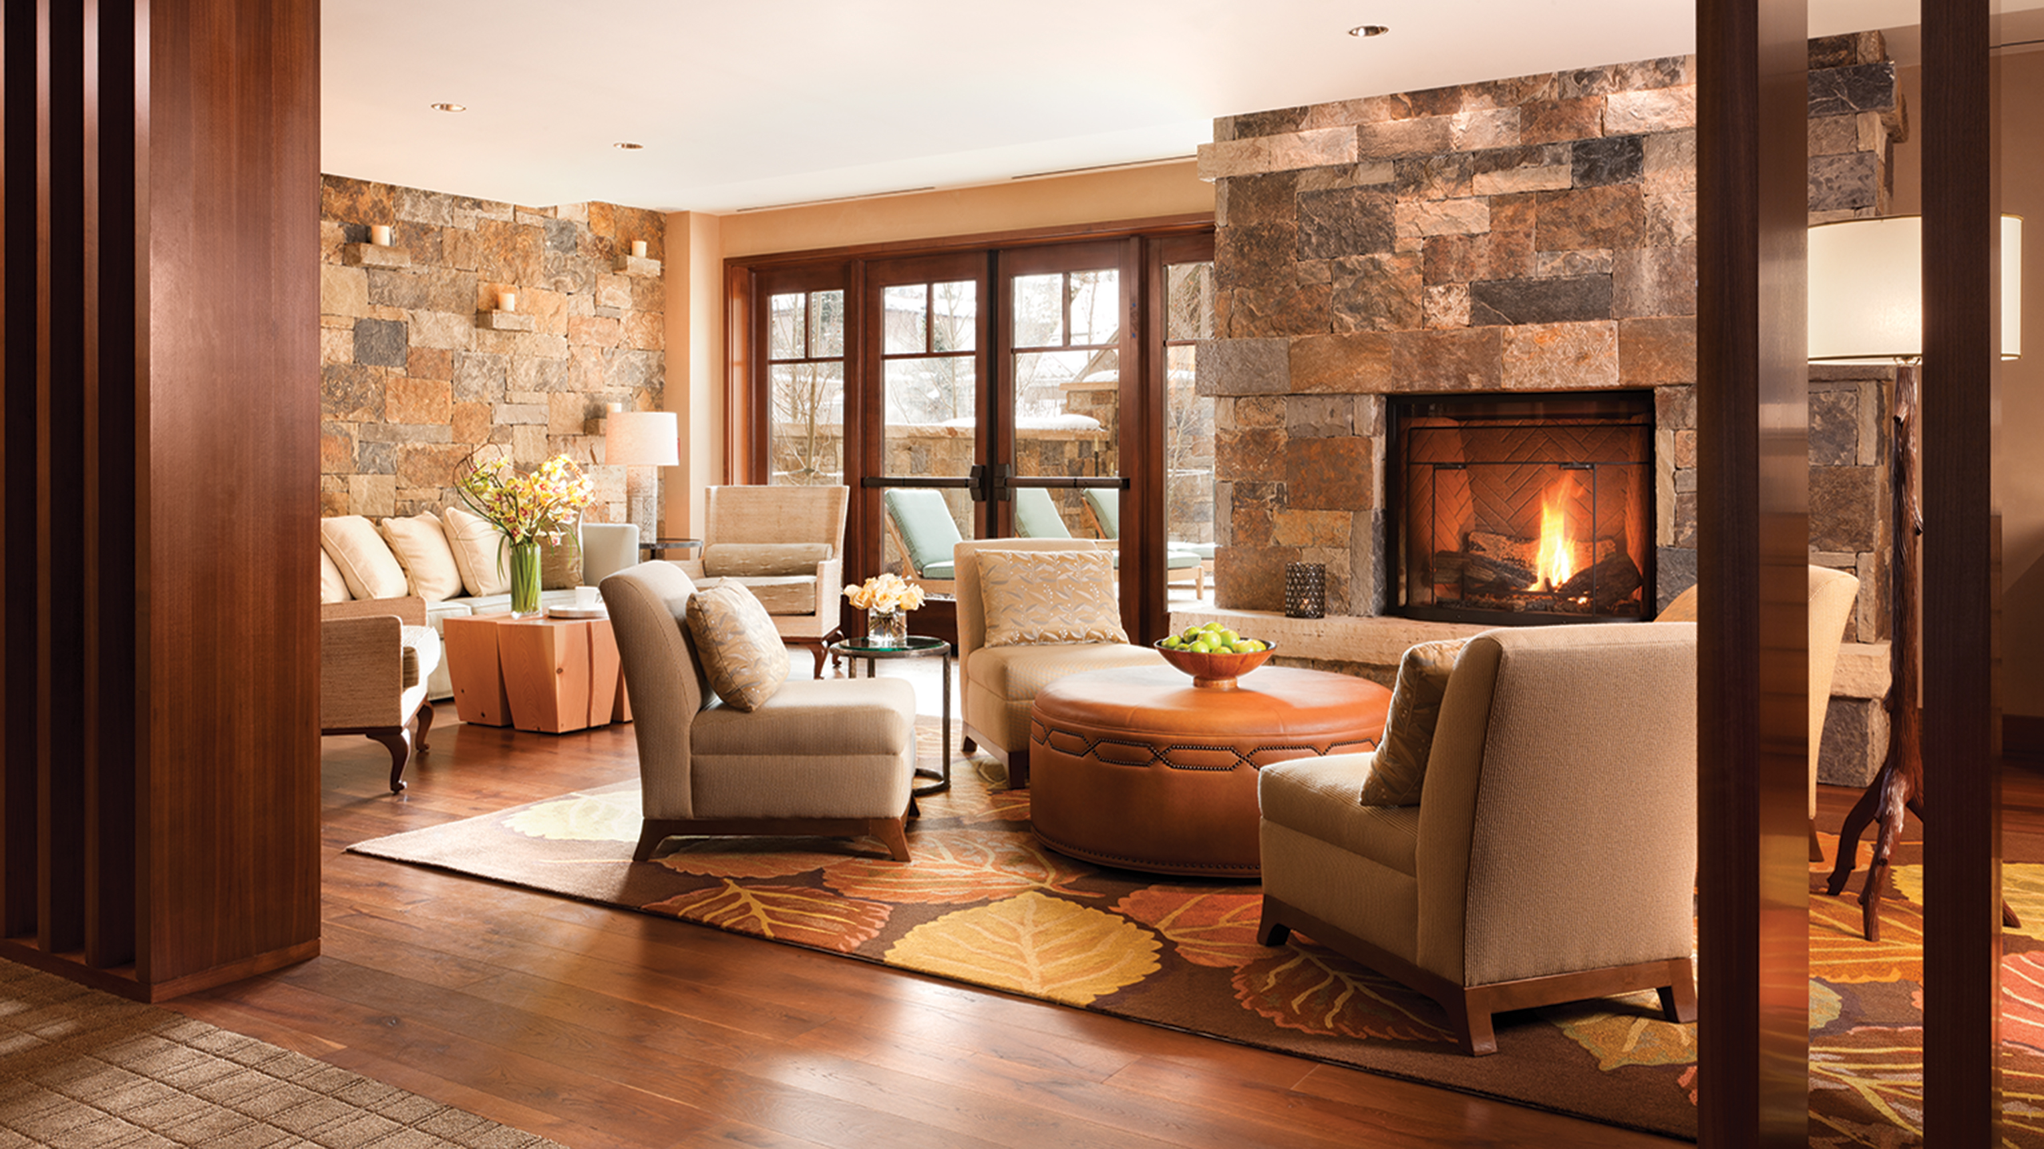
Listed as one of the 2018 global wellness trends by the Global Wellness Summit, transformative travel is described as “travel that challenges people on a deeply personal level, creating emotion through the powerful medium of storytelling.” From wildlife safaris to equine therapy, “mountain cures” and wellness wilderness, the Collection’s transformative experiences allow guests to explore what wellness means to them, in an awe-inspiring mountain setting.
Four Seasons
Resort and Residences Jackson Hole: Wildlife Safari
Practice the art of stillness on a wildlife safari in what’s considered America’s Serengeti. Led by the dedicated naturalist team at
Four Seasons
Resort and Residences Jackson Hole, experience a customised full or half day expedition in Grand Teton or Yellowstone National Park. Safely and comfortably view magnificent creatures in their natural habitat, beyond the highways and in remote areas. Along the way, learn about the flora and fauna, geology and history of this significant ecosystem, and have the opportunity to view elk, moose, mule deer, bison, bears, wolves, bighorn sheep, bald eagles, river otters, trumpeter swans, owls and other rare birds.
Four Seasons
Resort Rancho Encantado Santa Fe: Year of You
The Year of You retreat at
Four Seasons
Resort Rancho Encantado offers a unique and experiential journey designed for couples and individuals that want to transform the way they live, love and lead. The retreat combines the Resort’s indulgent and rejuvenating amenities with the immersive EQUUS Experience, an innovative and award-winning program that engages horses to support powerful learning and self-discovery for participants. Designed and facilitated by personal development and leadership mentors Kelly Wendorf and Scott Strachan, the experience can lead to lasting breakthroughs for individuals and couples, as they learn how to create safety and trust, the art of being present, and the power of thoughts, beliefs and intention.
Four Seasons
Resort and Residences Vail: Mountain Cures
As the only Forbes Five-Star Spa in the Vail Valley, the Spa at
Four Seasons
Resort and Residences Vail offers guests the opportunity to relax, renew and restore well-being. Results-oriented and organic treatments focus on preserving the delicate balance of hydration and nourishment – especially important in this alpine climate. The Resort’s Mountain Cures, a series of Colorado and mountain-inspired treatments, are certain to aid in sleep, altitude adjustment and boosting energy while in Vail.
Four Seasons
Resort and Residences Whistler: Wellness Wilderness
Lift off from Whistler in a helicopter and fly over Canada’s largest, southernmost ice cap to explore an evolving world of ice and snow. Enchanting natural ice sculptures, ice flows and gentle slides will transport guests from one grand hall to the next. Be lead through a labyrinth of chambers of aqua-blue magnificence, then sit for a moment to take-in the natural blue ambient light. This fully guided ice cap interpretive tour will leave guests wanting more as the experienced, informative guide explains glacier dynamics and introduces the Resort’s project, the “Ice Cap Research Initiative,” and how Head-Line Mountain Holidays is working to better understand and impart knowledge of these ice fields to the broader community.
About
Four Seasons
Mountain Resorts
In addition to world-class skiing and epic summer adventures, each
Four Seasons
Mountain Resort offers the ultimate wellness getaway in an enviable location, as well as fine dining, luxurious spa retreats, après ski offerings, and new, one-of-a-kind experiences. With the Resorts’ signature amenities and renowned personalised service,
Four Seasons
Resort and Residences Vail,
Four Seasons
Resort Rancho Encantado Santa Fe,
Four Seasons
Resort and Residences Whistler and
Four Seasons
Resort and Residences Jackson Hole are in a class of their own among mountain destinations.

RELATED

May 7, 2018, Vail, U.S.A.
Four Seasons Resort and Residences Vail Announces New General Manager Meredith Macfarlane
https://publish.url/vail/hotel-news/2018/new-gm-meredith-macfarlane.html

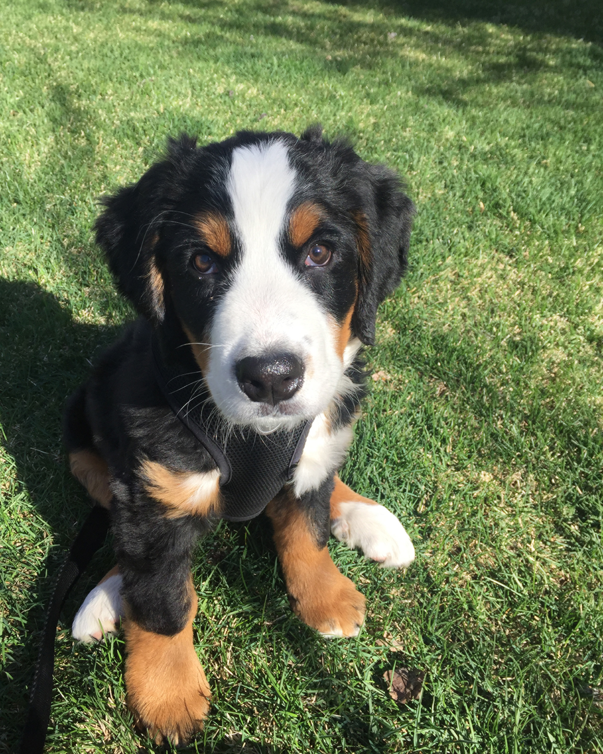 | May 4, 2018, Jackson Hole, U.S.A.  Four Seasons Resort and Residences Jackson Hole Welcomes New Four-Legged Team Member  https://publish.url/jacksonhole/hotel-news/2018/introducing-tillie-the-resort-dog.html

PRESS CONTACTS

Kiersten Dunn
Director of Public Relations and Communications
One Vail Road
Vail
U.S.A.
kiersten.dunn@fourseasons.com

+1 (970) 477-8687

Nina Braga
Public Relations Director
7680 Granite Loop Road, P.O. Box 544
Teton Village
U.S.A.
nina.braga@fourseasons.com

+1 (307) 732-5062

Christine Kim
Public Relations and Communications Manager
4591 Blackcomb Way
Whistler
Canada
christine.kim@fourseasons.com

+1 (604) 966-2666

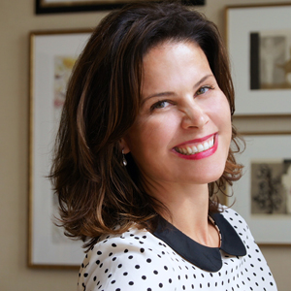 | Kate Colley  Director of Public Relations and Communications  4591 Blackcomb Way  Whistler  Canada  kate.colley@fourseasons.com  +1 (604) 844-6769
Morgan Moore
Glodow Nead Communications
1700 Montgomery Street, Suite 203
San Francisco
U.S.A.
RanchoEncantadoPR@glodownead.com

+1 (415) 394-6500

