Mid-Autumn Elegance by Four Seasons Hotel Singapore

July 6, 2022, Singapore

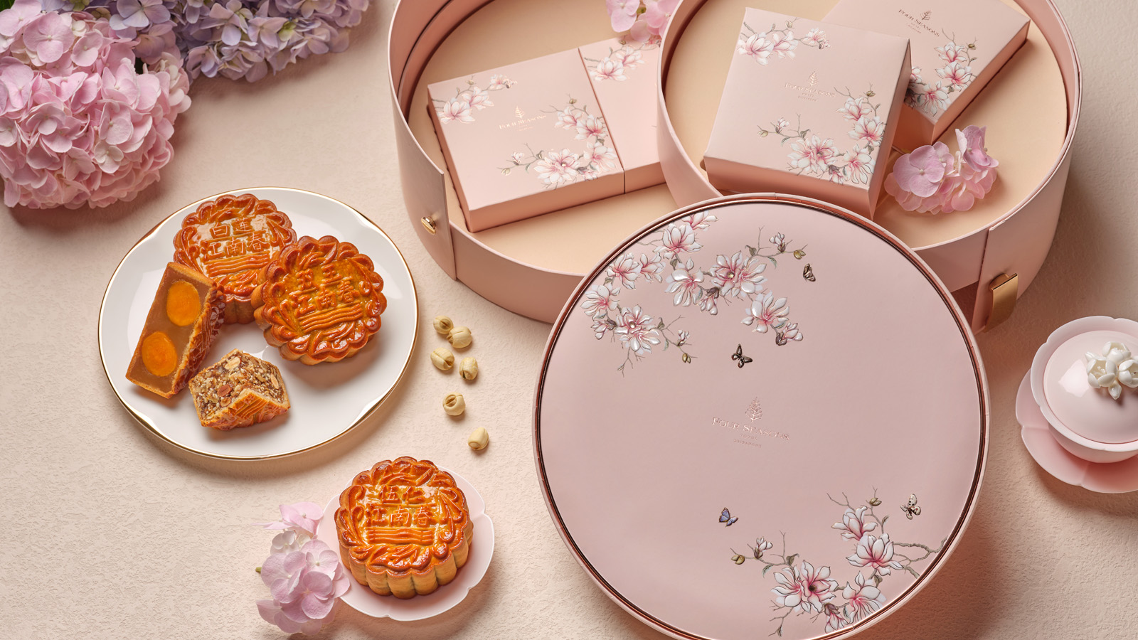
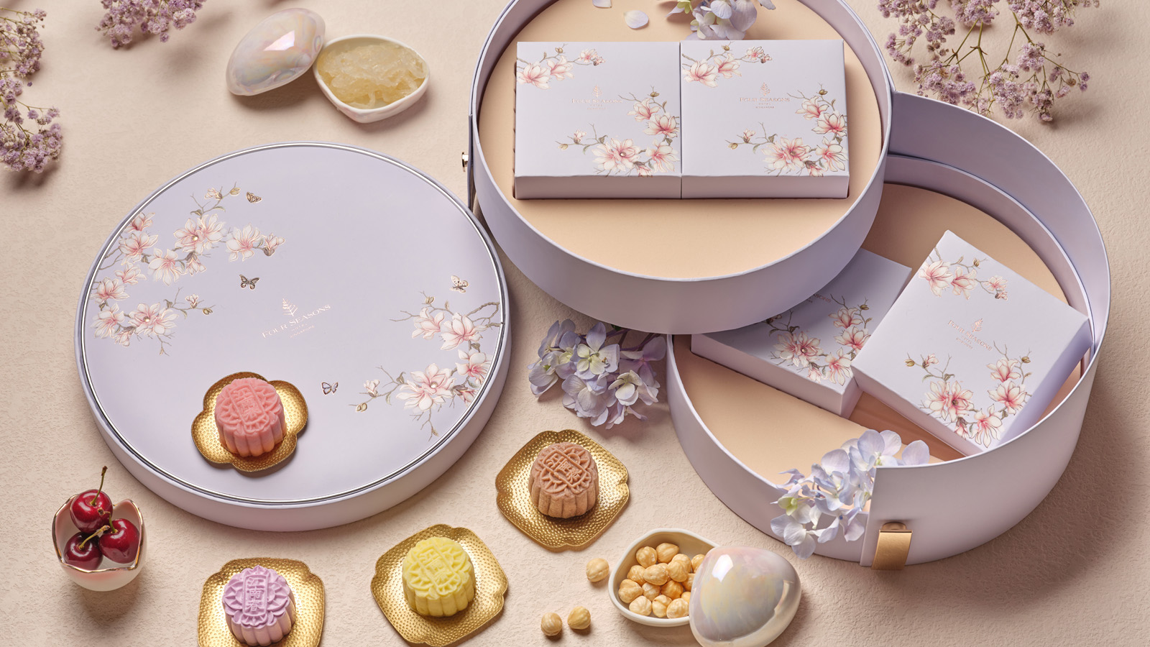 | 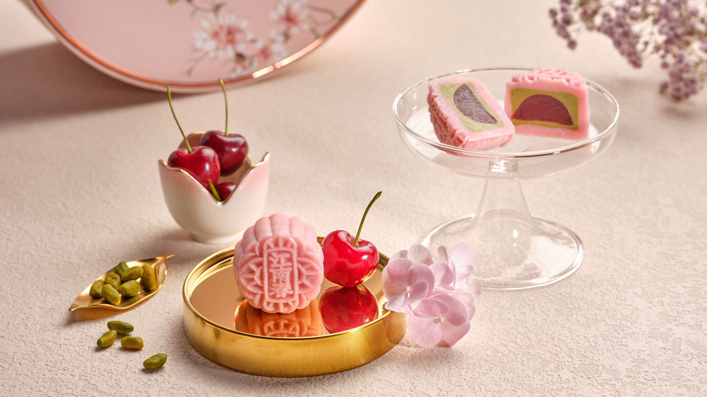
Embrace the beauty of Mid-Autumn with elegant, handcrafted mooncakes by award-winning authentic Cantonese restaurant Jiang-Nan Chun at Four Seasons Hotel Singapore. Carefully crafted, the storied collections feature perennial favourites and new, limited edition snowskin mooncakes. Encased in exquisite gift boxes graced with intricate blossoms, these delicacies are created with exceptional ingredients and skill.
Luxurious Gifting
Freshly made mooncakes encased in rose gold blush or silver pastel lilac jewellery boxes make for a coveted gift this Mid-Autumn season. With plum blossom flora that reflect the ethereal beauty of the botanical sanctuary of the Hotel, the thoughtfully-designed case exudes stylish sophistication and delights the most discerning.
Baked Collection
With a focus on classics, the baked selection sees the return of the signature Smoked Duck with Assorted Nuts and Lime inspired by Jiang-Nan Chun’s signature Peking duck, prepared in a mesquite wood-fire oven. Also on the menu are perennial favourites Silver Lotus Paste with Macadamia, Silver Lotus Paste with Single Yolk and Silver Lotus Paste with Double Yolk.
Each baked mooncake spotlights the natural flavour of top quality ingredients including premium silver lotus - lotus that is young and fresh. Requiring a lower quantity of oil and sugar to create the paste, silver lotus paste is a healthier option for all ages. If variety is desired, Four Seasons Medley will surely delight with one of each flavour.
Snowskin Collection
Debuting this year is the flavour of the season – Cherry and Sicilian Pistachio. Gloved in a soft, Mandarin snowskin, a cherry gelée gem lies shrouded in a Sicilian pistachio pastry cream, a genteel surprise for a refined delight.
Traditionally known for its attributes such as enhancing one’s complexion, the exquisite Bird’s Nest with Custard mooncake is itself a work of art where velvety custard gently envelopes and complements the bird’s nest centre. Lovers of the “king of fruit” will also be thrilled by the aromatic, smooth and creamy Mao Shan Wang Durian snowskin mooncake.
An indulgence for all ages, the Hazelnut Royaltine Chocolate delights with its blend of the crunchy Jivara chocolate praline base combined with fragrant hazelnut, a creative rendition the Hotel’s well-loved hazelnut royaltine cake.
COPENHAGEN Organic Sparkling Tea
Elevate the season and pair the exquisite mooncakes with organic sparkling teas by COPENHAGEN, a Danish label developed by award winning sommelier Jacob Kocemba and business partner Bo Sten Hensen. Enjoy the dry and delicate taste of LYSERØD made with white silver needle tea for a nice and soft mouthfeel, crisp notes of jasmine and chamomile of BLÅ, a blend of 13 different organic teas, or indulge with GRØN (5 percent), an alcoholic sparkling tea with a strong green tea persona while bearing significant notes of citrus.
Price List*
Baked Collection
- Silver Lotus Paste with Double Yolk SGD 88
- Silver Lotus Paste with Single Yolk SGD 86
- Silver Lotus Paste with Macadamia SGD 88
- Smoked Duck with Assorted Nuts SGD 88
- Four Seasons Medley (one of each flavour) SGD 92
Snow Skin Collection
- Mao Shan Wang Durian SGD 118
- Bird’s Nest with Custard 98
- Hazelnut Royaltine Chocolate SGD 88
- Cherry with Sicilian Pistachio SGD 88
- Jiang-Nan Chun Medley (two of each flavour) SGD 98
COPENHAGEN Organic Sparkling Tea
- LYSERØD SGD 88
- BLÅ SGD 88
- GRØN (5 percent) SGD 98
Early Bird
Enjoy 25 percent off baked mooncakes from now until August 14, 2022 and 10 percent off baked mooncakes from August 15 until September 1, 2022.
To Order
Available for orders now, these treasured treats will be ready for collection or delivery from August 1 until September 9, 2022.
To order, speak with the Hotel at (65) 6831 7253, email festiveseason.sin@fourseasons.com or visit Four Seasons Hotel Singapore Mooncake 2022 for online orders.

*Prices are in SGD and are at nett price.

RELATED

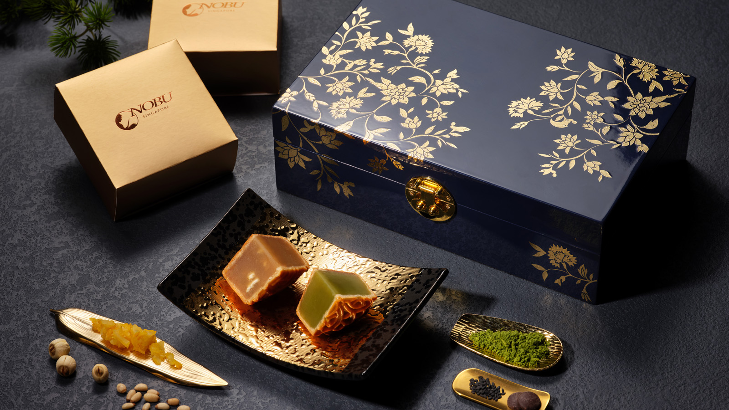 | July 6, 2022, Singapore  Nobu Singapore at Four Seasons Hotel Singapore Launches Mid-Autumn Gifting  https://publish.url/singapore/hotel-news/2022/nobu-mooncakes.html
June 13, 2022, Singapore
A Fantastic Father’s Day with Four Seasons Hotel Singapore
https://publish.url/singapore/hotel-news/2022/fathers-day.html

PRESS CONTACTS

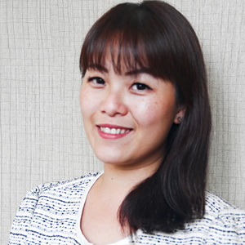 | Valerie Loy  Regional Director of Public Relations and Communication  190 Orchard Boulevard  Singapore  Singapore  valerie.loy@fourseasons.com  (65) 6831 7130

