An Itinerary for a Summer's Day in the City by the Sea

September 14, 2016, Alexandria, Egypt

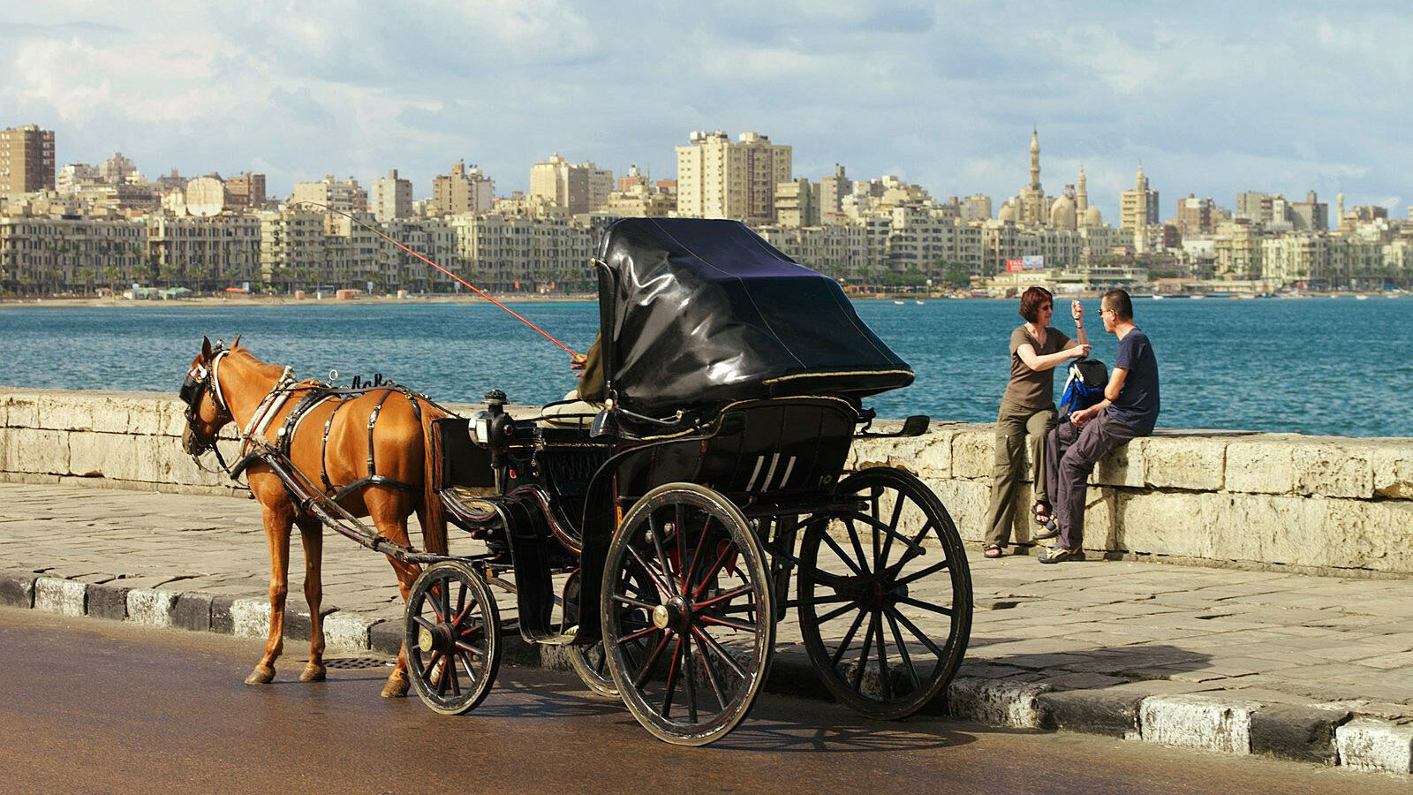
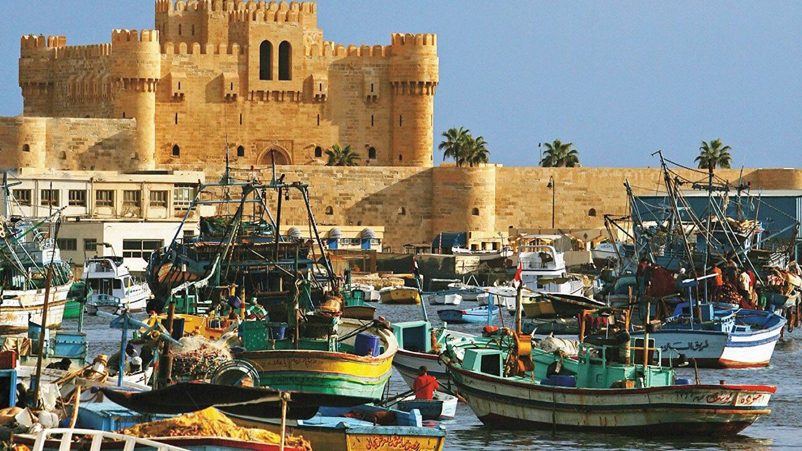 | 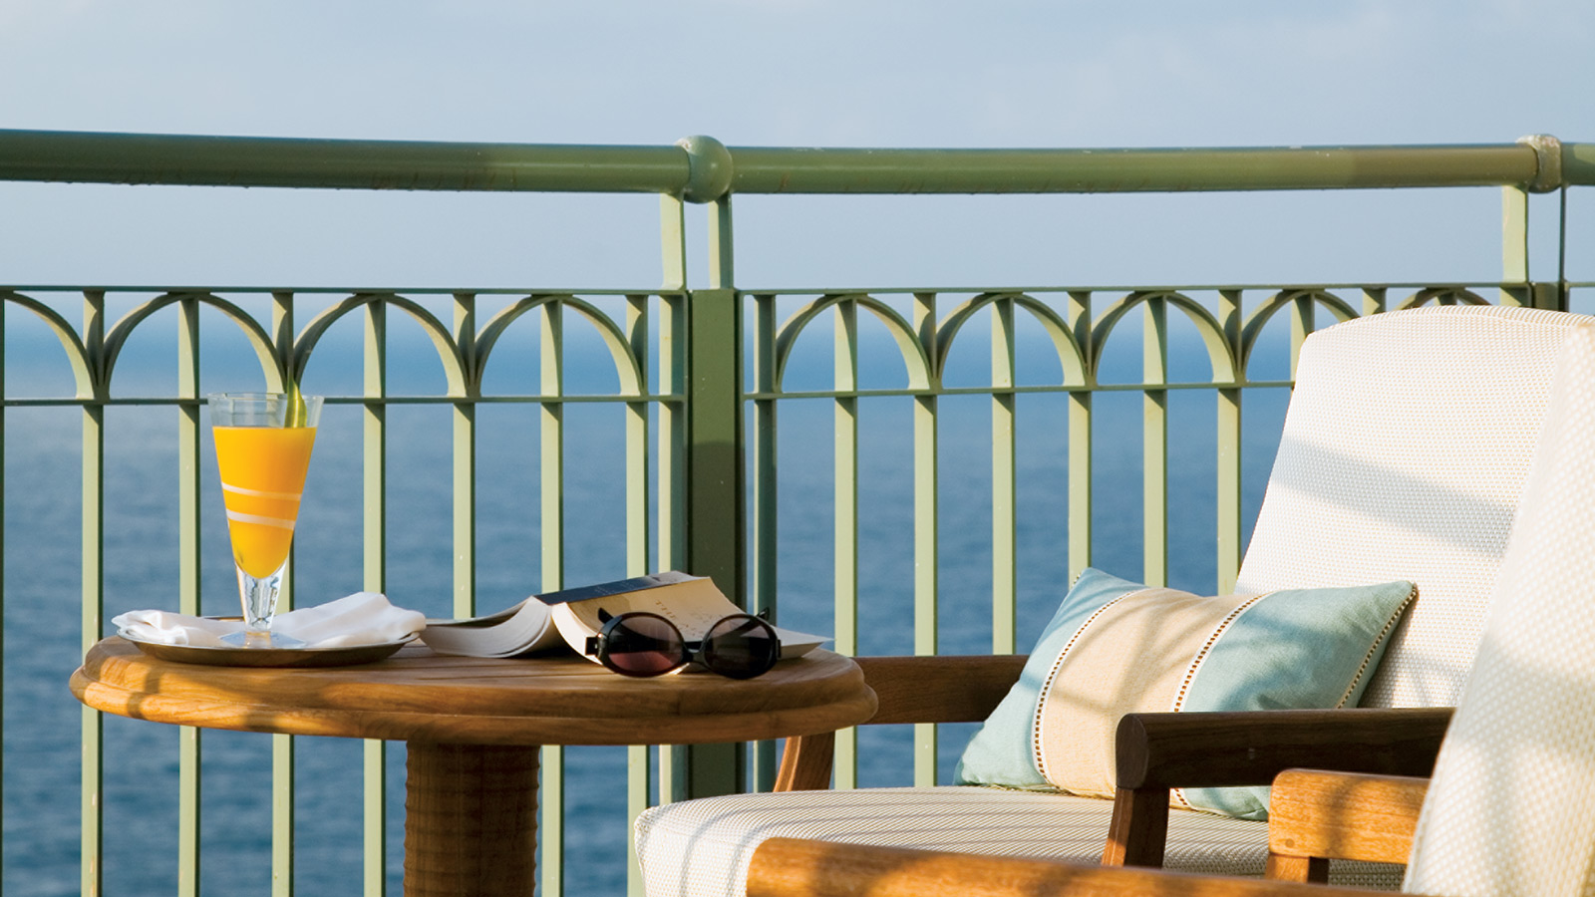 | 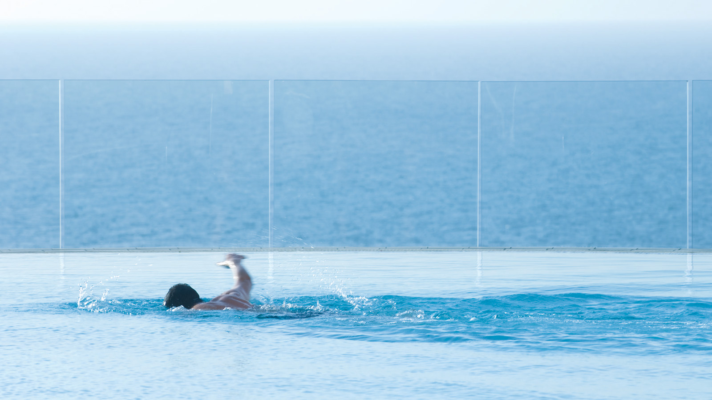
Alexandria combines a proud history, impressive architecture and fine dining with scenic beaches along the Mediterranean coast, all of which could be experienced in one day if need be. The concierge team at
Four Seasons
Hotel Alexandria recommends a perfect summer's day here.
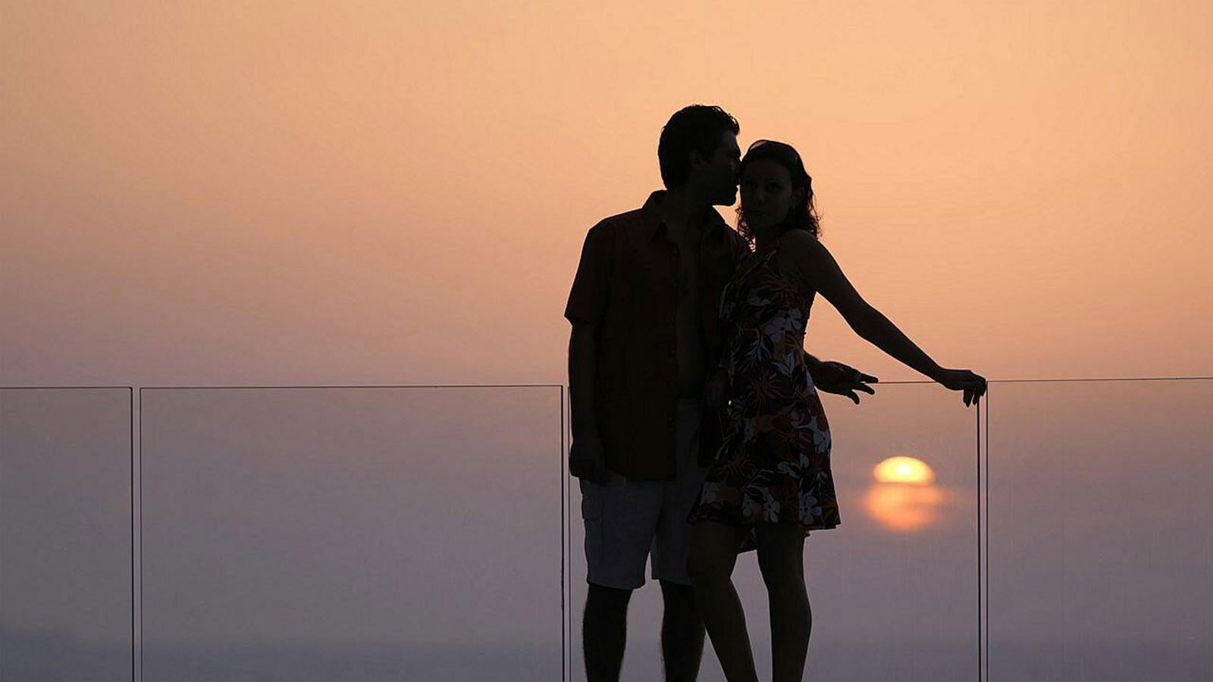
Start off your day by heading down to San Stefano, a stretch of sand also known as the Alexandria Riviera and one of Egypt’s most exclusive coastal addresses. Once you have basked in the warm sun and cooled off in the waters of the Mediterranean, one may then proceed to explore the city.
Wander through Souk El-Attarine, a network of alleys where you can find everything from traditional antiques to flavourful spices as you browse the countless shops and merchants selling their goods along the pedestrian streets. You’re also bound to work up an appetite as you pass restaurants serving up fresh-caught fish.
After visiting one of Alexandria’s many mouth-watering fish restaurants, head to Montazah palace for a calm break from the lively city streets. Set among acres of rolling gardens and full of beautiful flowers and trees, it was initially a former king’s summer residence ensuring sights fit for royalty. For a contrast, visit the ultra-modern Bibliotheca Alexandrina; the library contains and symbolises the learning that the city has represented for centuries.
Watch the sun set from Fort Qaitbay to experience one of the best views in Alexandria. Then round off your day by a relaxing night stroll on the Corniche that runs along the eastern beachfront of Alexandria.
All of which is only a small glimpse of the plethora of magnificent locations to enjoy when in Alexandria.

RELATED

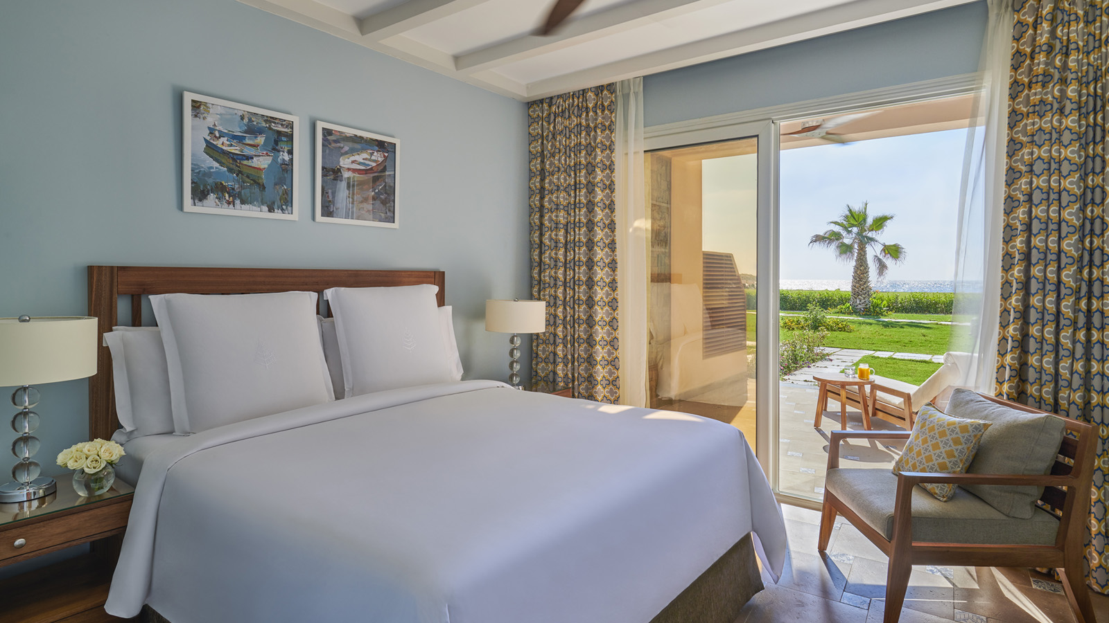 | March 14, 2019, Alexandria, Egypt  Four Seasons Hotel Alexandria at San Stefano Offers a Unique Resort Experience in the City on the Beach  https://publish.url/alexandria/hotel-news/2019/new-beach-features-and-experiences.html
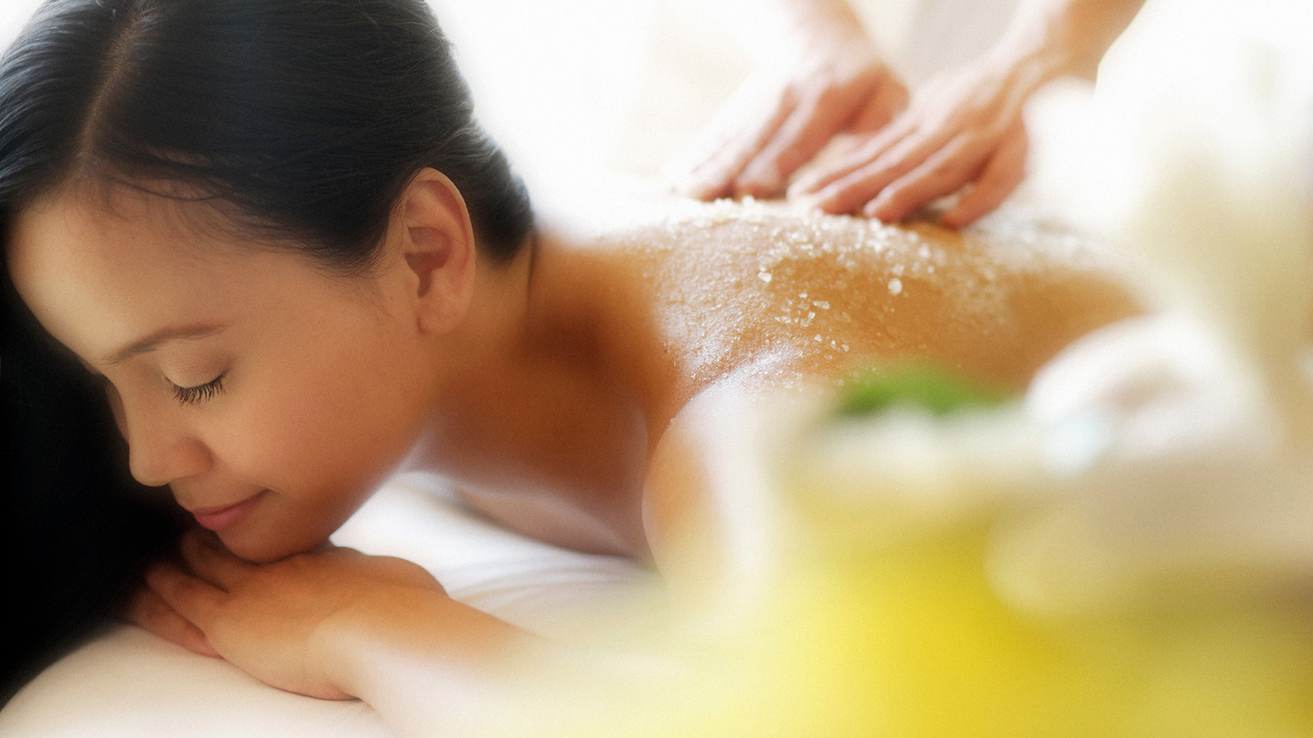 | March 1, 2019, Alexandria, Egypt  Four Seasons Hotel Alexandria Unveils a New Spa Journey  https://publish.url/alexandria/hotel-news/2019/new-spa-journey.html

PRESS CONTACTS

Sarah Nabil
Director of Public Relations
399 El Geish Road
Alexandria
Egypt
sarah.nabil@fourseasons.com

20 3 581 8000

