Four Seasons Resort and Residences Vail Completes Phased Resort Enhancement Project

Luxury mountain resort completes multi-year, multi-million dollar renovation
July 14, 2021, Vail, U.S.A.

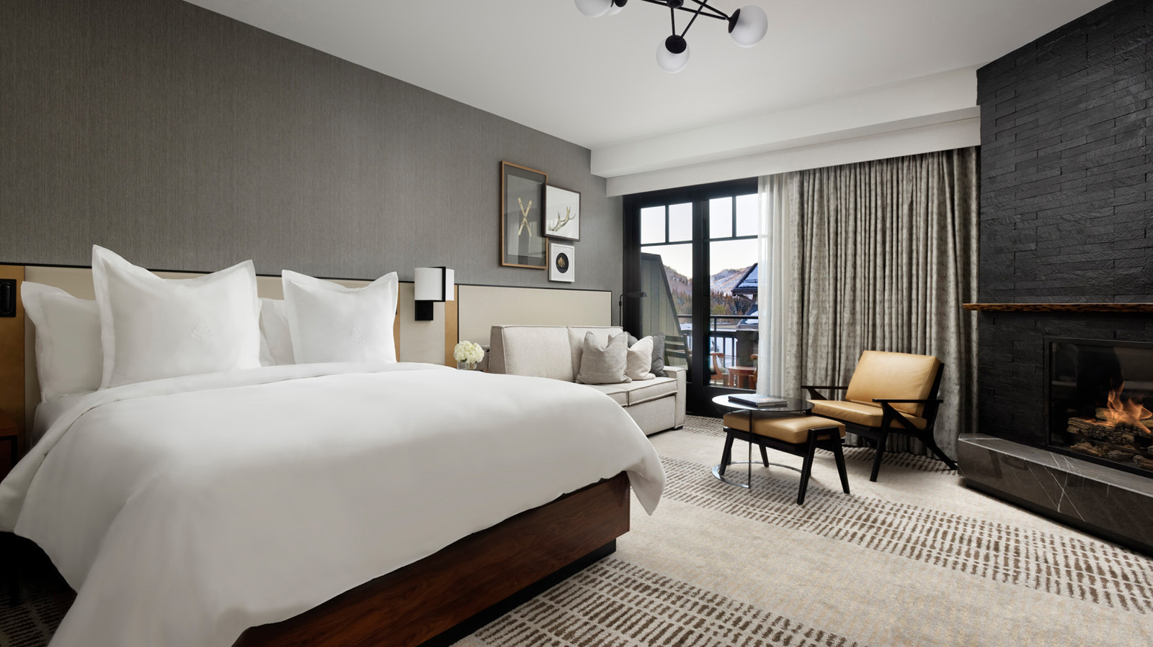
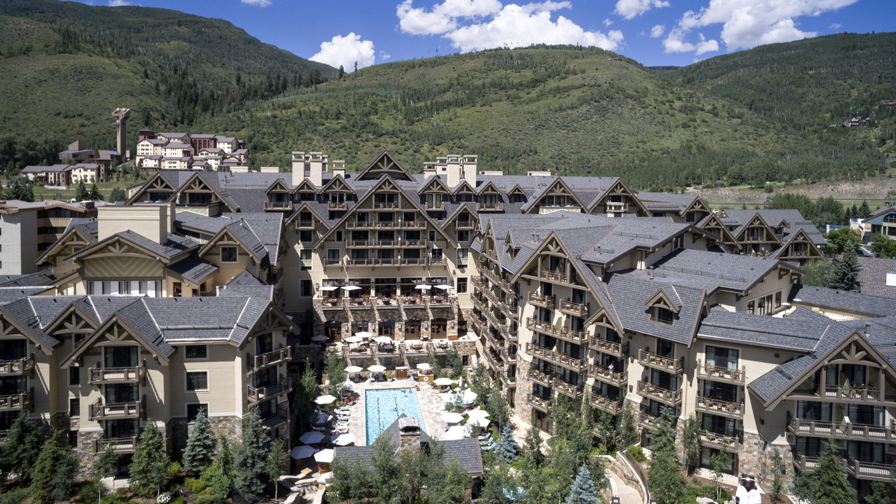 | 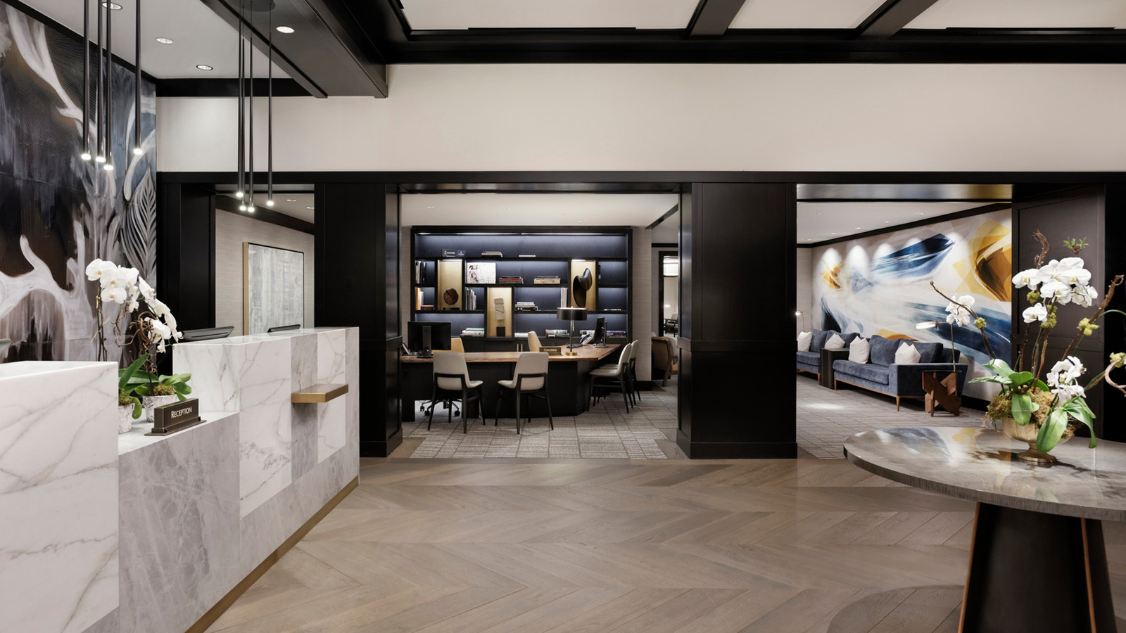 | 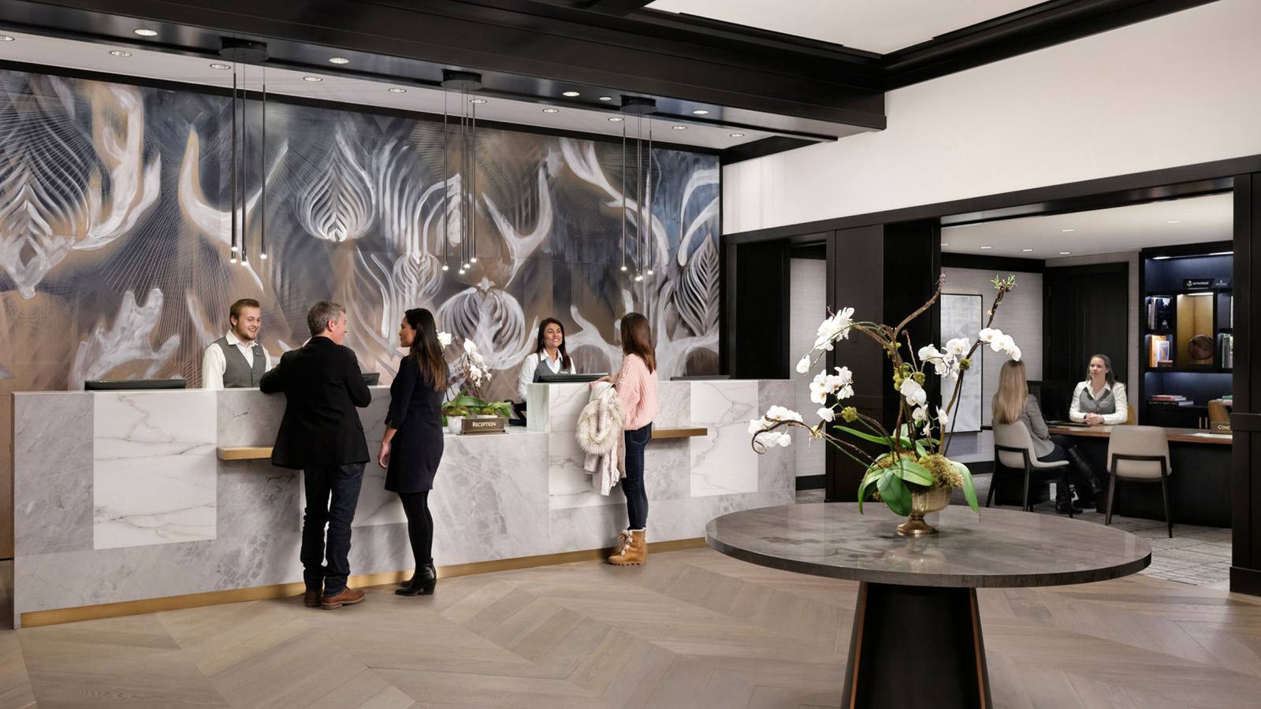
The luxury hospitality leader in the Vail Valley, Four Seasons Resort and Residences Vail will complete its highly anticipated Resort enhancement project in mid-summer 2021. The premier year-round property has been completely reimagined, creating a fresh interpretation of the grand alpine resort, with a refined, contemporary finish. The Resort will continue to be the place for both locals and visitors alike seeking the sophistication of the Four Seasons brand while enjoying the legendary setting in Vail Village.
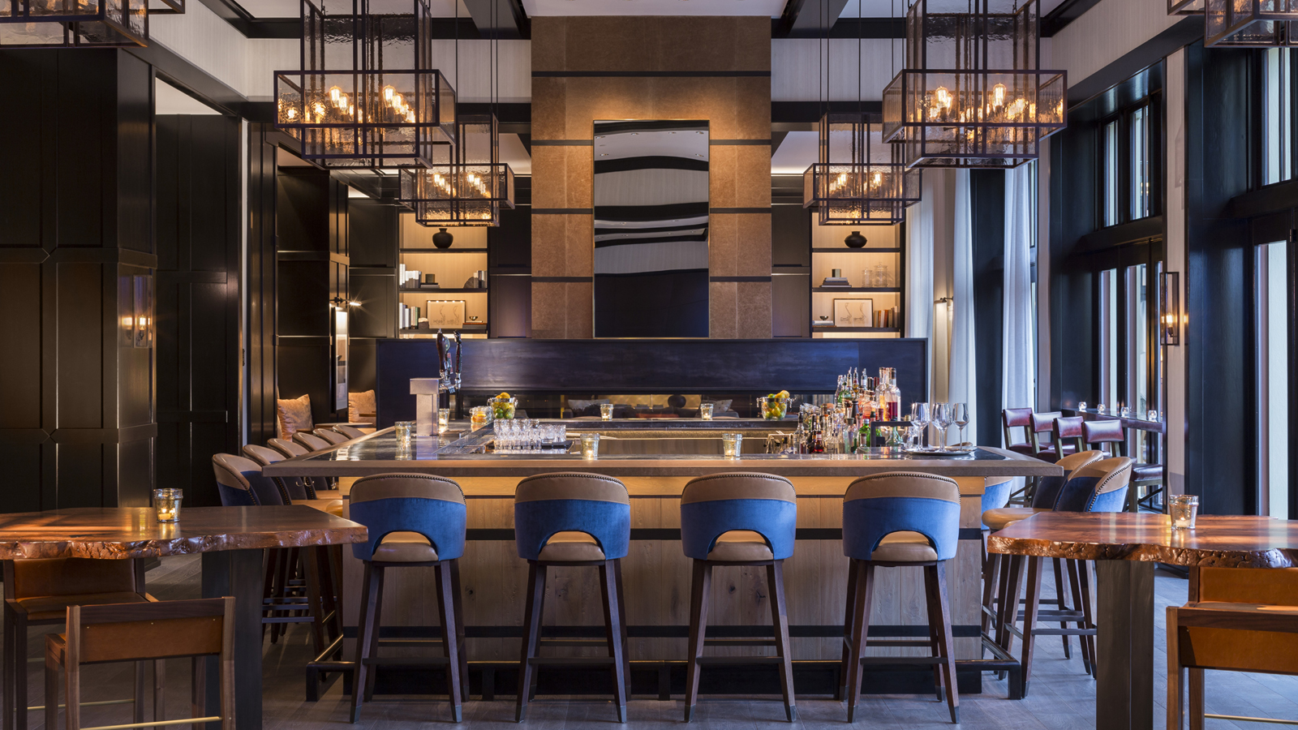 | 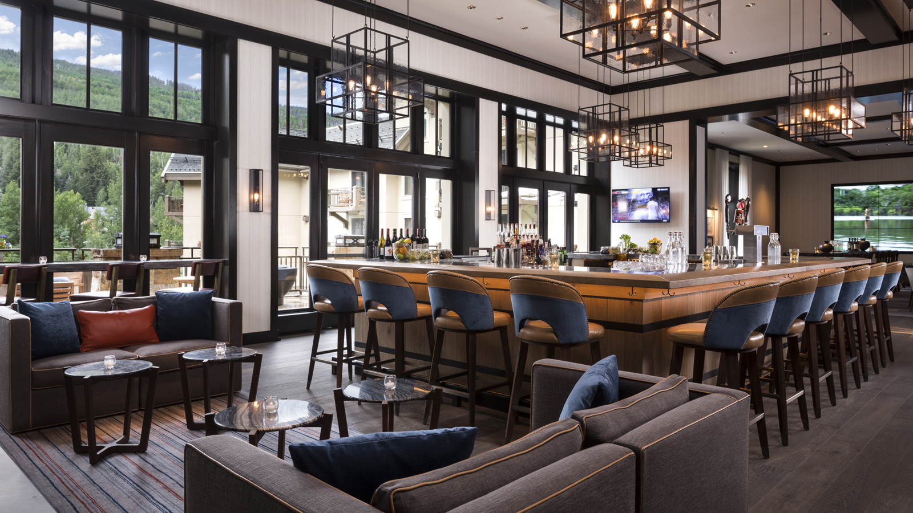 | 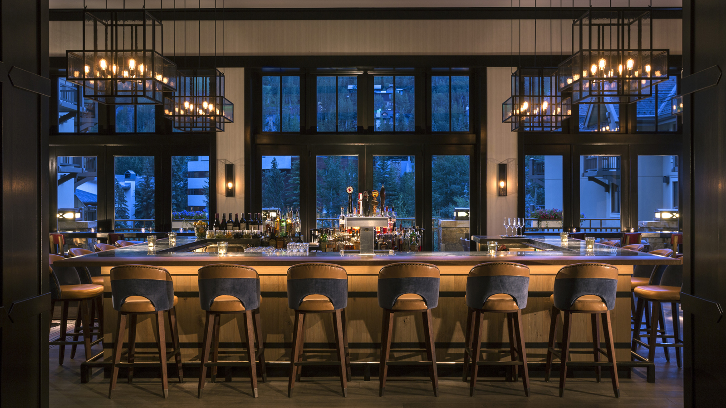
“We are delighted with how the results of our enhancement project – it has truly elevated our Resort and will further position us among the premier luxury mountain resorts in North America,” says Four Seasons Resort and Residences General Manager Meredith Macfarlane. “While the renovations have offered us the opportunity to reimagine our Resort from an aesthetics and design standpoint, the primary element that makes Four Seasons Vail like no other remains our talented team. I am honoured to have an amazing, passionate team who pride themselves on creating memorable experiences for our guests and owners – which truly sets us apart from other mountain resorts the world over.”
The multi-million-dollar complete renovation of Four Seasons Resort and Residences Vail, phased over the past three years, marks the most significant investment the Resort has undergone since its inception in 2010. Enhancements includes a refresh and remodel of all hotel guest rooms, suites and corridors; conversion and remodelling of several private residences; refreshed meeting space; and a redesigned lobby and all public spaces.
The building’s design elements have transformed the Vail property with a stylish, cool, mountain-chic makeover. The tailored mountain modern design has incorporated clean, contemporary lines paired with organic textures and colours, complementary of Vail’s breath-taking mountain landscape. Local stone and wood have added mountain-chic touches to all of the fireplaces while nature-inspired carpet, leathers, and textured fabrics have been combined to create a sophisticated resort feel.
In addition to a complete makeover of all guest rooms and suites, many of the individually-owned private residences in Four Seasons branded Private Retreats portfolio have been renovated as well. Boasting twenty-four private residences ranging from two- to six-bedrooms, each uniquely designed and beautifully appointed, Four Seasons Residences Vail is the ideal location for families, multi-generation travel and groups of friends seeking comfortable, luxurious accommodation while enjoying the limitless adventure of Vail Mountain – located in the Resort’s very own backyard.
Located just thirty minutes from Eagle County Regional Airport (EGE) and Vail Valley Jet Center, and just under two hours from Denver International Airport (DEN), the Resort is easily accessible for travellers.
Nestled at the base of Vail Mountain in the beautiful Colorado Rockies, Four Seasons Resort and Residences Vail offers guests the ideal location to take advantage of all the activities and adventure that the Vail Valley have to offer. Combined with award-winning Four Seasons service provided by the knowledgeable, inspirational staff at the Resort, guests find exactly what they’re looking for in this quintessential alpine destination.
Continue to experience legendary service at Four Seasons Resort and Residences Vail: Book a stay in one of the Resort’s beautifully appointed guest rooms or private residences by calling 1 303 389 3301 or book online.

RELATED

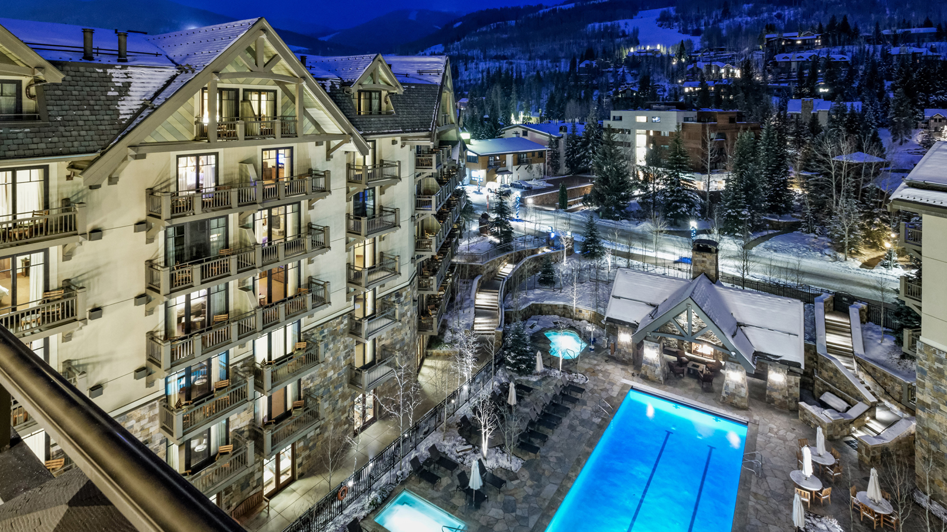 | March 2, 2021, Vail, U.S.A.  Four Seasons Resort and Residences Vail Named Best Hotel in Vail by U.S. News & World Report in 2021 Best Hotel Rankings  https://publish.url/vail/hotel-news/2021/best-hotel-in-vail.html
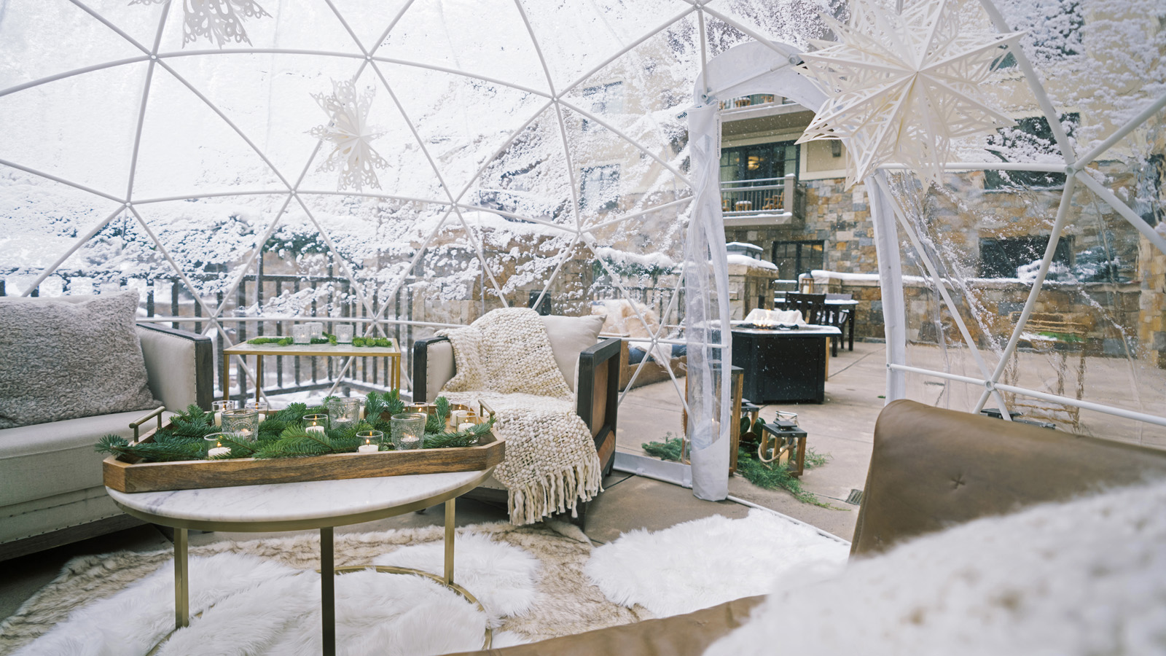 | February 19, 2021, Vail, U.S.A.  Four Seasons Resort and Residences Vail Announces Curated Private Dining Experiences  https://publish.url/vail/hotel-news/2021/new-dining-experiences.html

PRESS CONTACTS

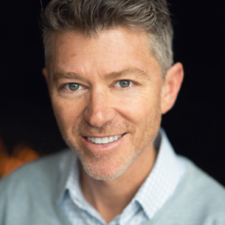 | Jonathan Reap  Director of Public Relations  One Vail Road  Vail  USA  jonathan.reap@fourseasons.com  +1 970 477 8687

