Billy Cueto Joins Four Seasons Resort Palm Beach as Resort Manager

20-year Four Seasons brand veteran continues career legacy at iconic resort destination
May 28, 2021, Palm Beach, U.S.A.

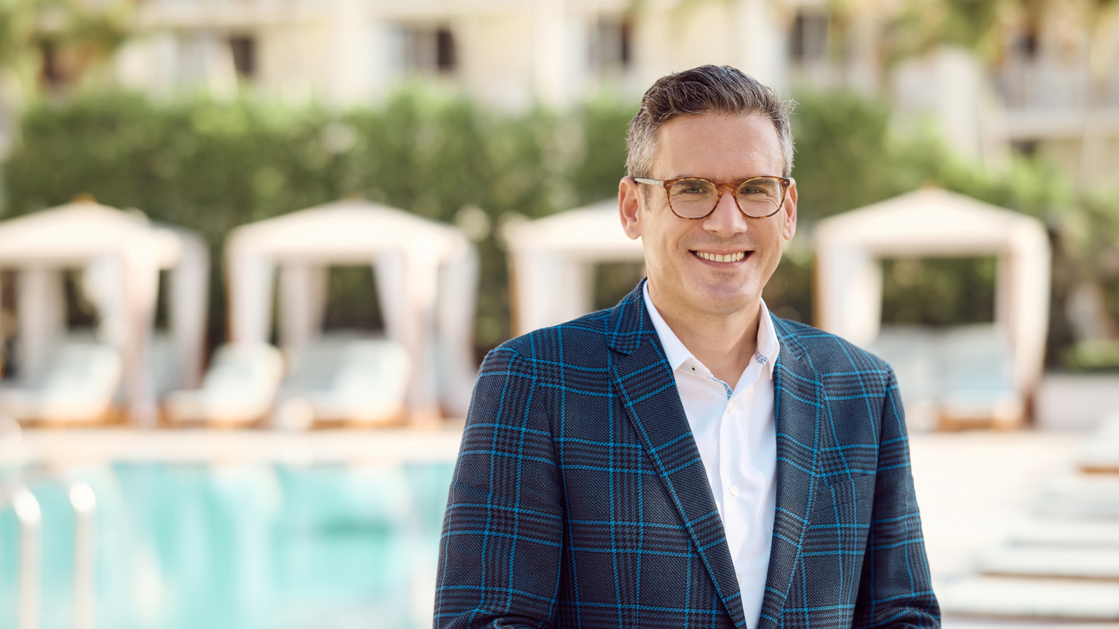
From one stunning oceanside oasis to another, Billy Cueto joins Four Seasons Resort Palm Beach as Resort Manager by way of Four Seasons Resort and Residences Anguilla. With him, Cueto brings a naturally personable demeanour, creative aptitude, and 20 years of Four Seasons brand experience to the Five-Star, Five-Diamond Resort on Palm Beach Island’s best beach.
“To join the leadership of a world-class Resort during a pivotal time in hospitality history is an honour,” says Cueto. “I am excited to embrace the spirit of Palm Beach Island and care for our guests with the same level of exceptional and gracious service that this Four Seasons team is known for.”
After a year of being privately reserved, Four Seasons Resort Palm Beach began welcoming new arrivals in April, presenting a host of exciting experiences for guests and locals alike including renovated specialty suites, new offerings at Florie’s, the Resort’s flagship restaurant and bar in partnership with three-Michelin-starred Chef Mauro Colagreco, new hyper-personalised treatments at the Five-Star Spa, and the introduction of the Resort’s official therapy dog, an Australian Labradoodle named Fort.
With the Resort primed for a successful year, Cueto is ready to once again make his mark. Not only is Cueto responsible for ensuring a smooth-running operation, one of his priorities is keeping employees engaged and motivated, requiring a lot of cheerleading and positivity, a trait that comes naturally to him. “The driving force behind keeping our guests happy is a contented team,” says Cueto.
A true brand ambassador, Cueto’s Four Seasons career began with the Front Desk team at Four Seasons Hotel Chicago in 2001. Cueto’s hotel skills grew with each new position from Concierge, Hotel Assistant Manager and Front Office Manager at Four Seasons Hotel Houston to Director of Rooms at Four Seasons Hotel Westlake Village followed by Four Seasons Hotel Los Angeles at Beverly Hills. His next destination would be Four Seasons Resort and Residences Anguilla as Resort Manager before arriving at Florida’s quintessential luxury resort destination, Palm Beach Island.
The warmth and care Cueto brings to his role also extends to his connections with Resort clientele. He looks forward to welcoming guests to the relaxed sophistication and easy-going pace of life by the water at Four Seasons Resort Palm Beach, especially during a time when so many are seeking a safe and welcome escape to re-connect with loved ones.

RELATED

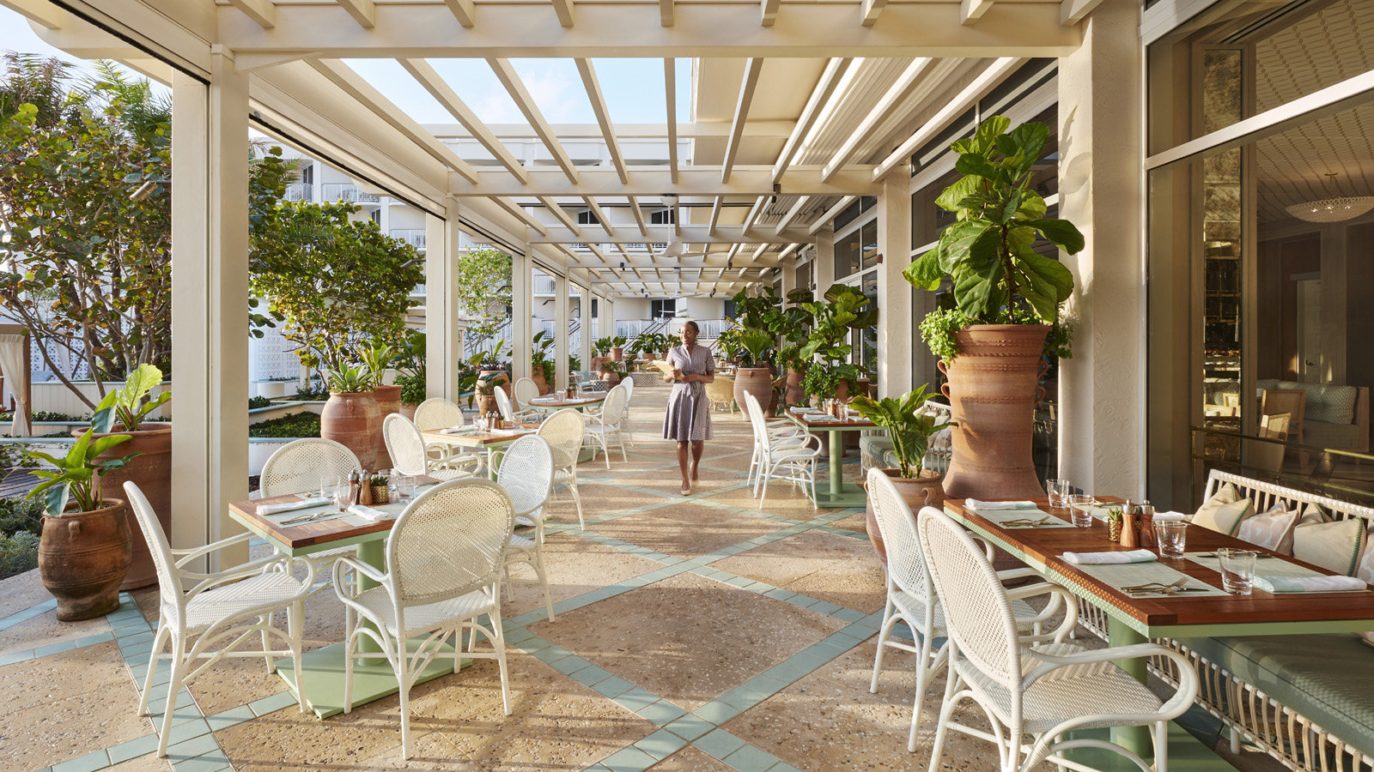 | April 12, 2021, Palm Beach, U.S.A.  Florie’s by Mauro Colagreco Welcomes New Guests and Locals Back to Its Home at Four Seasons Resort Palm Beach  https://publish.url/palmbeach/hotel-news/2021/flories-reopening.html
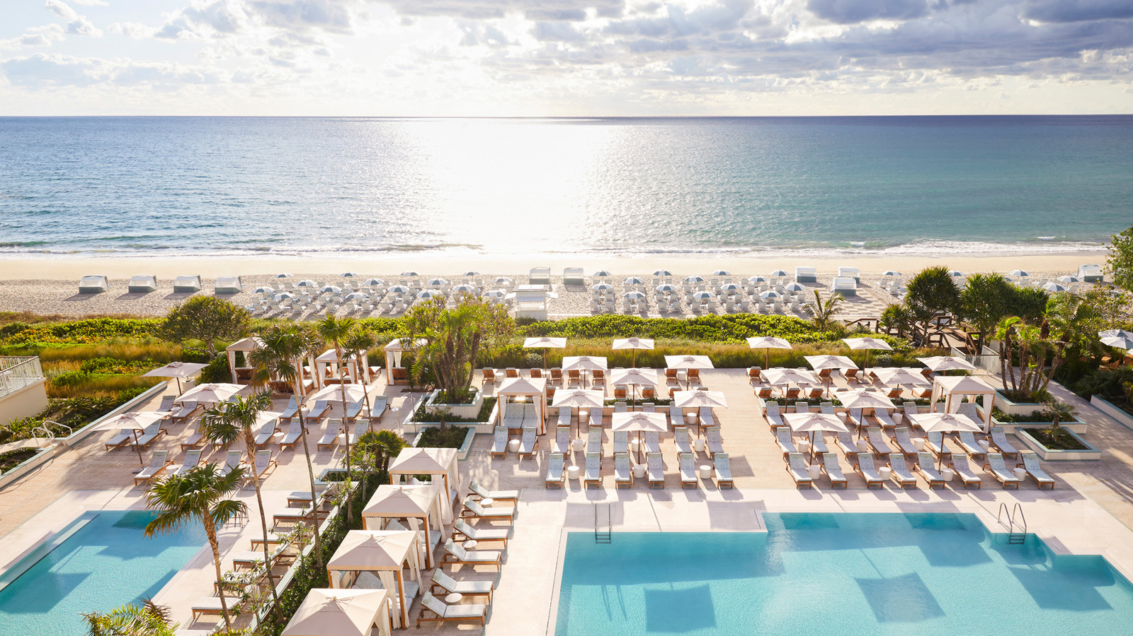 | April 2, 2021, Palm Beach, U.S.A.  Four Seasons Resort Palm Beach Opens for New Arrivals and Local Experiences  https://publish.url/palmbeach/hotel-news/2021/reopening.html

PRESS CONTACTS

Laurie Herrick
Regional Director of Public Relations and Communications
2800 South Ocean Boulevard
Palm Beach
USA
laurie.herrick@fourseasons.com

1 561 493 5549

