FOUR SEASONS Bogota
Tel: NOT_SETEmail: NOT_SET

OPENING DATE: April 2016
GENERAL MANAGER: Mark Bingle

Property Features
Total Accommodations: 63
- Guest Rooms: 34
- Suites: 29
Architects and Interior Designers
- Milena Vargas, architect
- Lauren Rottet, designer
- Saul Sasson, restaurant designer
Design Aesthetic:
- Sleek and stylish boutique hotel
Location:
- In the heart of the city's Zona T, a shopping and design district, and easily accessible to museums and other landmarks

Spa and Wellness
Spa
Treatment Rooms: 5, plus 1 Couple's Suite
Design Aesthetic: Inspired by "Emerald City" with a palette of gemstones: emerald and aquamarine, accented by tropical greenery and the sound and touch of water
Special Features:
- Spa boutique
Fitness
- Fully-equipped gym open 24/7

Dining
Restaurant: Biblioteca
- On the Menu: International and local breakfast specialities
- Indoor and Outdoor Seating: 43

Meetings and Events
Total Event Space: 559 sq. ft. / 52 sq. m.

PRESS CONTACTS
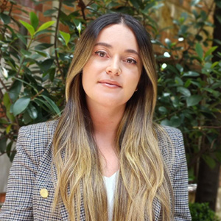 | Laura Quintana Niño  Cra 7 No. 69A-22  Bogotá DC  Colombia  laura.v.quintana@fourseasons.com  +57 310 5504082

