Win the Ultimate New Year’s Eve 2017 Experience at Four Seasons Hotel Seattle

The luxury hotel is ringing in the new year with a giveaway for two
December 5, 2017, Seattle, U.S.A.

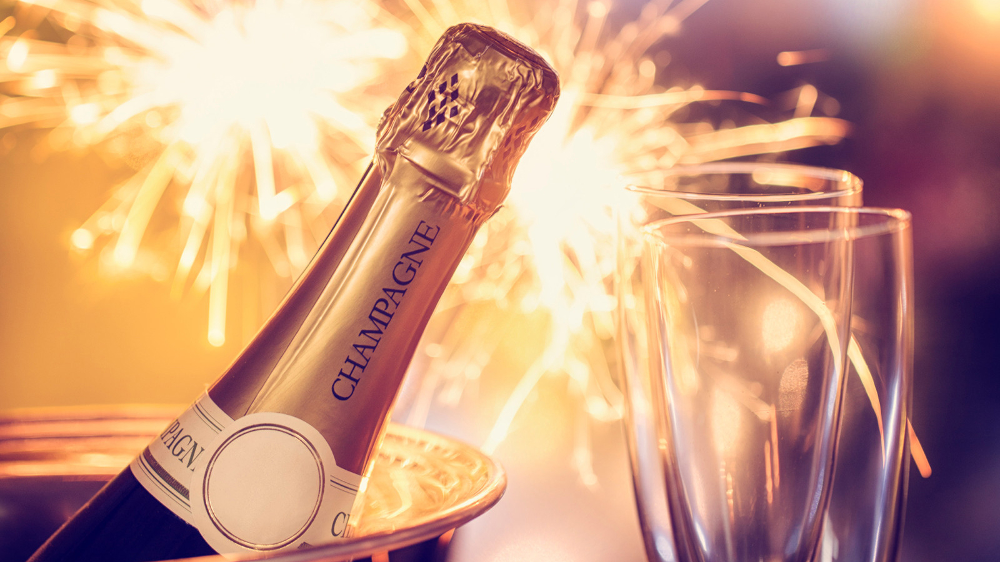
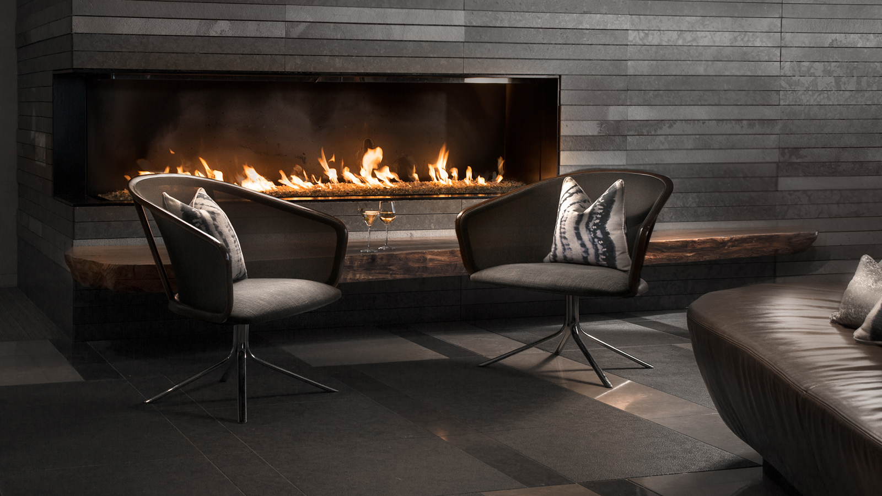 | 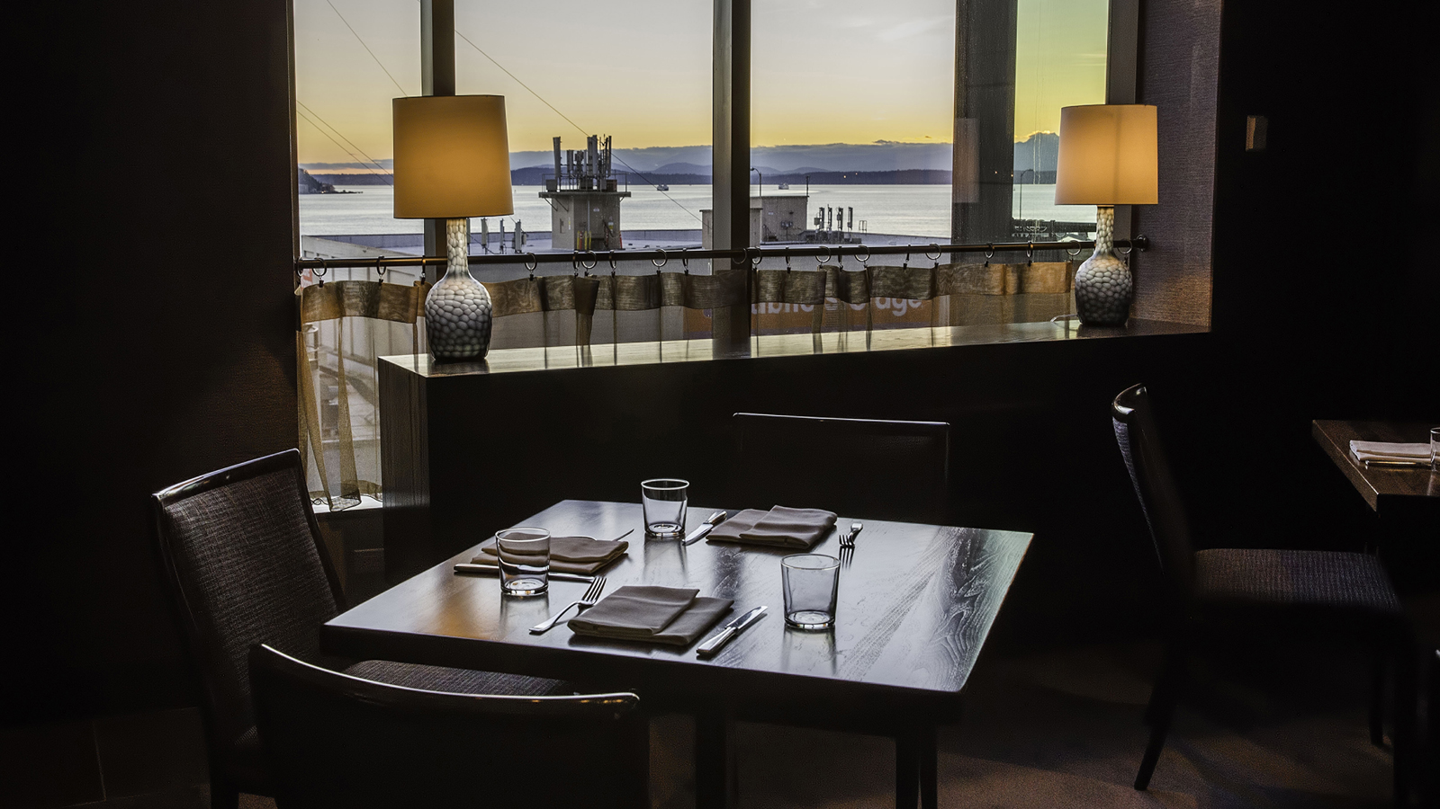 | 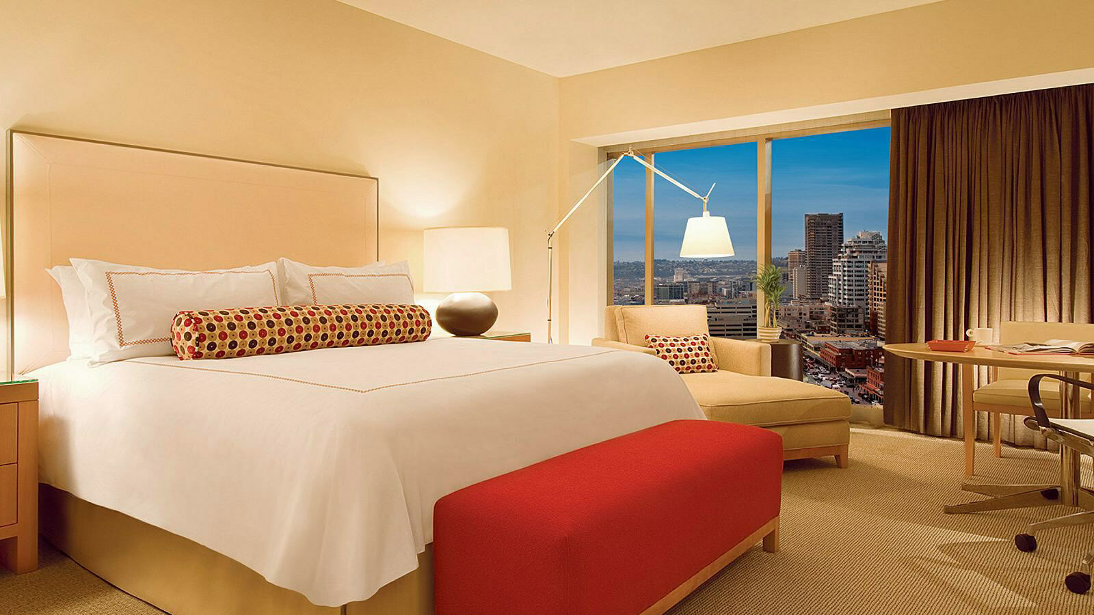
The place to see and be seen this holiday season,
Four Seasons
Hotel Seattle is celebrating the New Year by awarding one lucky winner and their guest with a lavish New Year’s Eve culinary and staycation experience. The contest is through the Hotel’s Facebook page.
Eligible entrants have the chance to win two tickets to the Moët & Chandon New Year’s Eve 2017 Bash at Goldfinch Tavern, an overnight night stay in a Seattle View guest room on December 31, 2017, and breakfast for two the next morning.
The contest is now live and will end on Friday, December 29, 2017 at 10:00 am PST. Fans and followers of the Hotel’s Facebook page can enter for a chance to win by liking the Hotel’s page and commenting with a .gif that describes how they would feel if they won.
The New Year’s Eve bash includes a five-course feast prepared by Chef Joe Ritchie and the team, champagne toast at midnight, party favours and beats by DJ Nelson Estrada. Guests can expect a great culinary evening paired with DJ Nelson’s passion to take the crowd to new heights of excitement and energy.
Choose from a selection of Goldfinch Tavern’s favourites, from king crab salad and hamachi crudo to spot prawn ravioli and the black truffle risotto. Entrée choices range from scallop and lobster; grilled rabbit; grilled wagyu beef; or a spiced crusted lamb loin. Save room for a decadent dessert before taking the elevator home to one of the Hotel’s spacious guest rooms, with views of nearby Seattle Art Museum.
For further contest information, review the official rules here. To follow
Four Seasons
Holiday posts around the world follow #FSHoliday.
To book a stay at the Hotel or make reservations to the Moët & Chandon New Year's Eve Bash, contact the Hotel at 206 749 7000.

RELATED

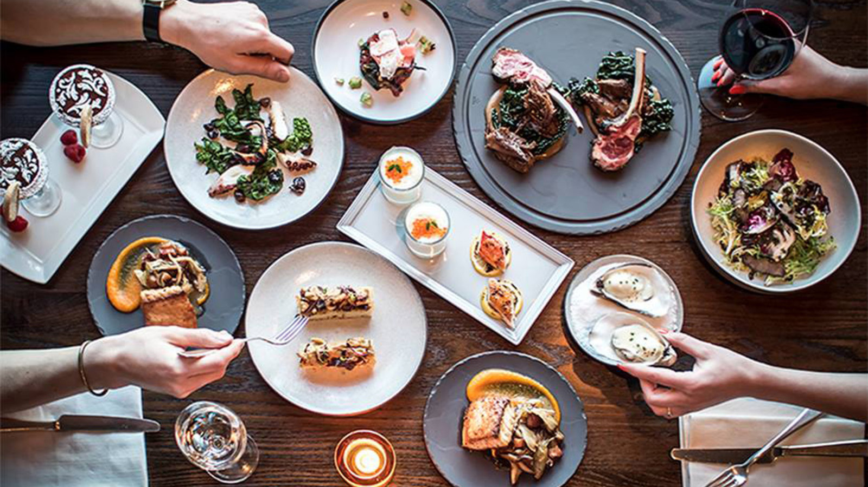 | October 24, 2017, Seattle, U.S.A.  Seattle’s Top Restaurants Collaborate to Showcase the “Best Chefs You’ve Never Heard Of” at Four Seasons Hotel Seattle  https://publish.url/seattle/hotel-news/2017/best-chefs-youve-never-heard-of-event.html
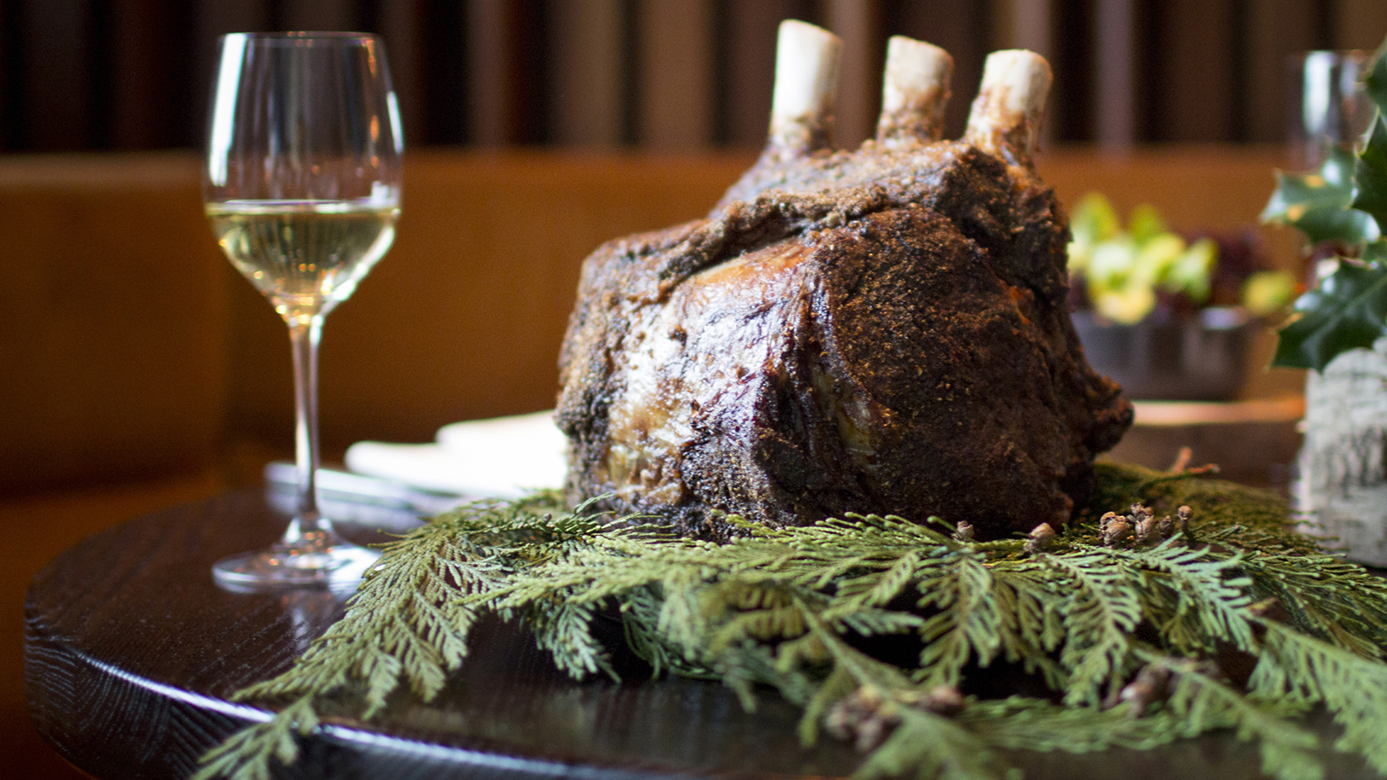 | October 10, 2017, Seattle, U.S.A.  Let it Glow: Holiday Events and Culinary Experiences Shine a Light on Craftsmen at Four Seasons Hotel Seattle  https://publish.url/seattle/hotel-news/2017/festive-season.html

PRESS CONTACTS

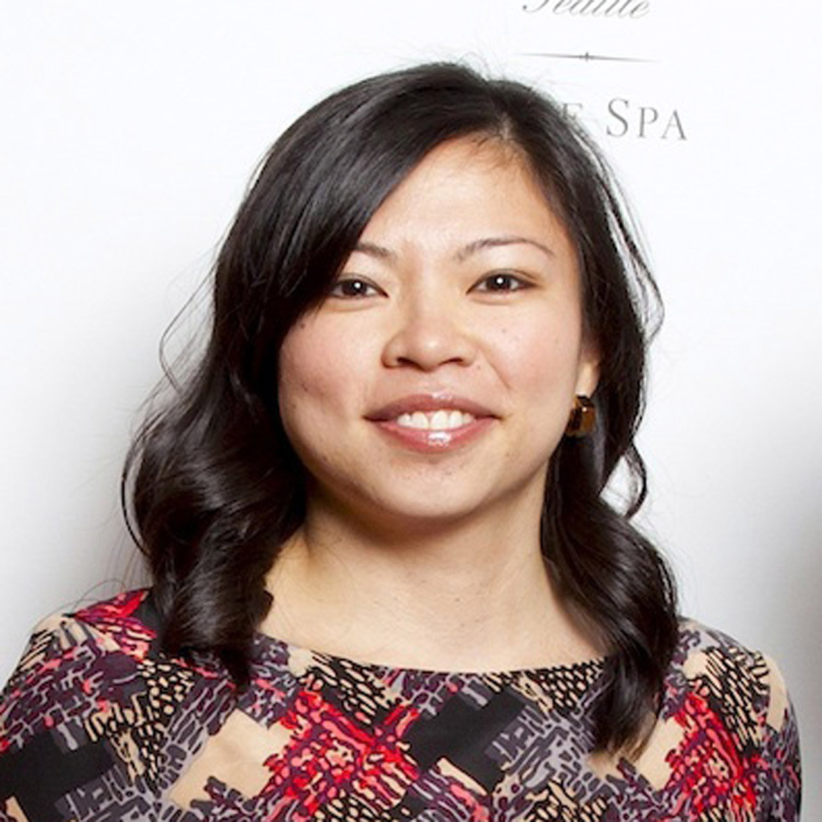 | Meg Paynor  PR Consultant  99 Union Street  Seattle  U.S.A.  meg@paynorpr.com  1 (206) 913-3848
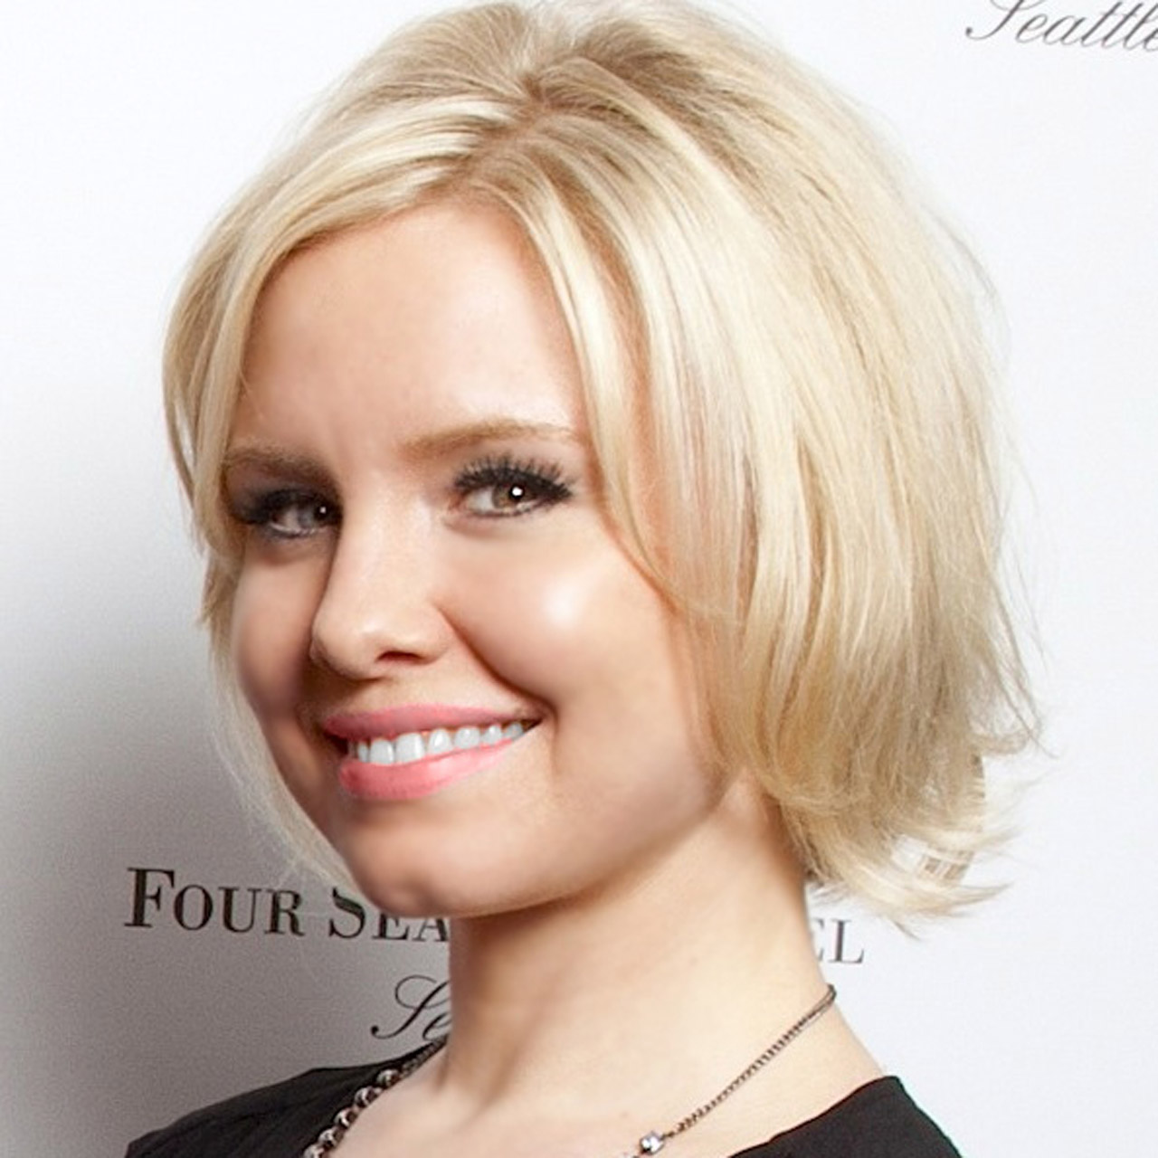 | Crystal Southcote  Digital Media Manager  99 Union Street  Seattle  U.S.A.  crystal.southcote@fourseasons.com  +1 (206) 749-3909

