Sip Rosé for a Cause This Summer at Four Seasons Hotel New York

June 21, 2019, New York, U.S.A.

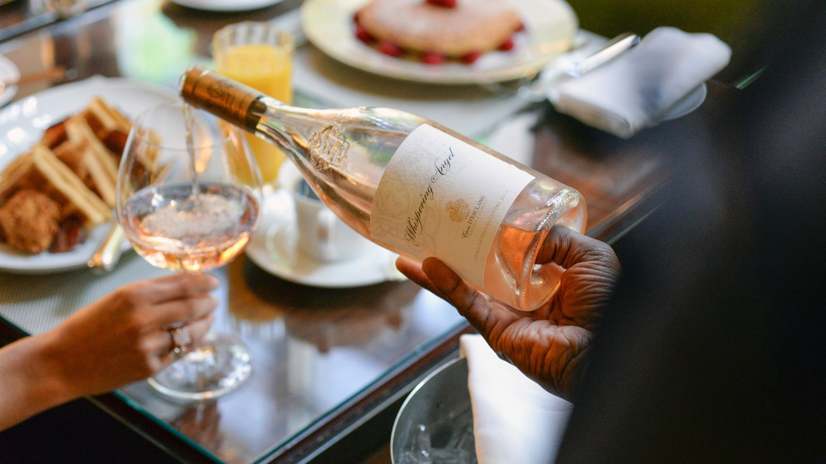
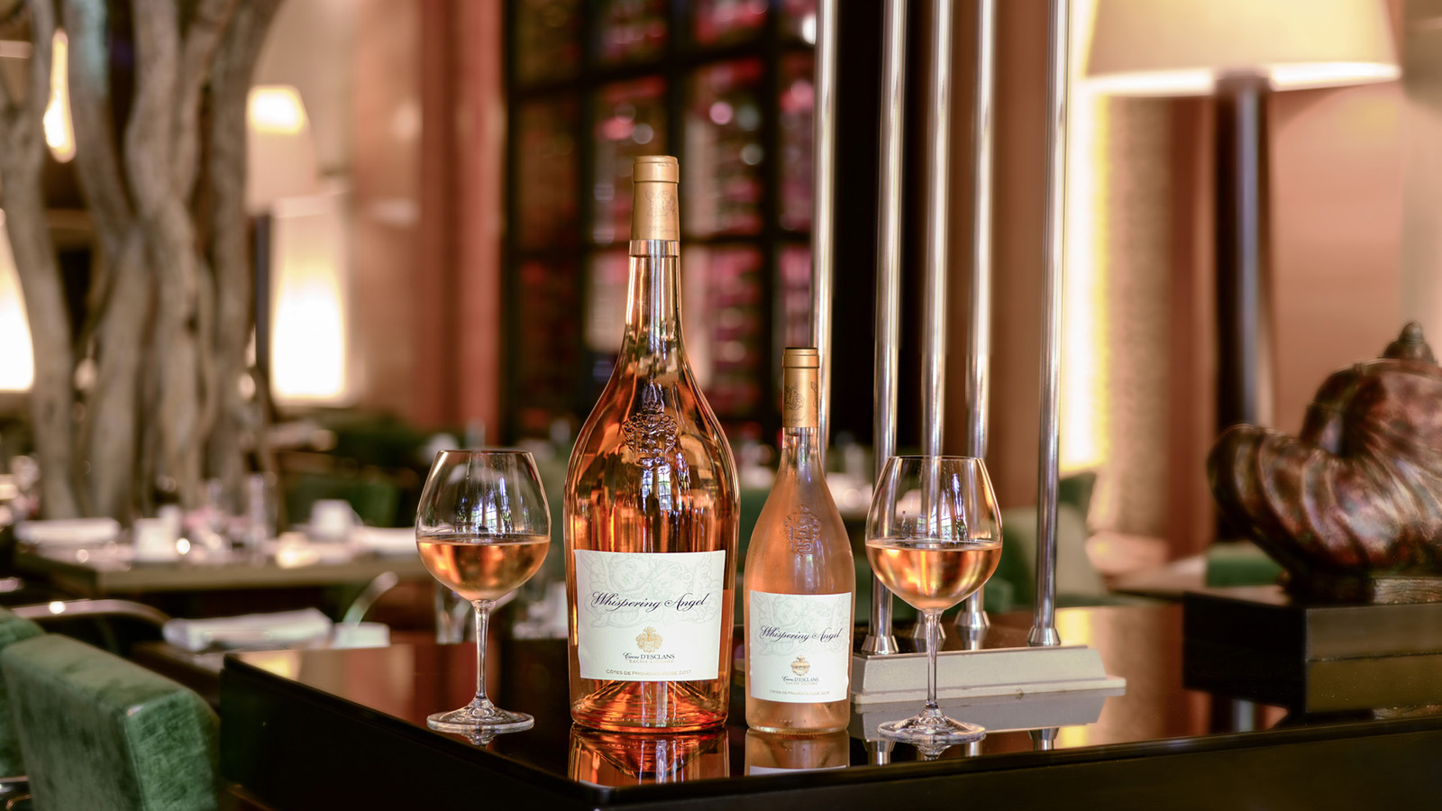 | 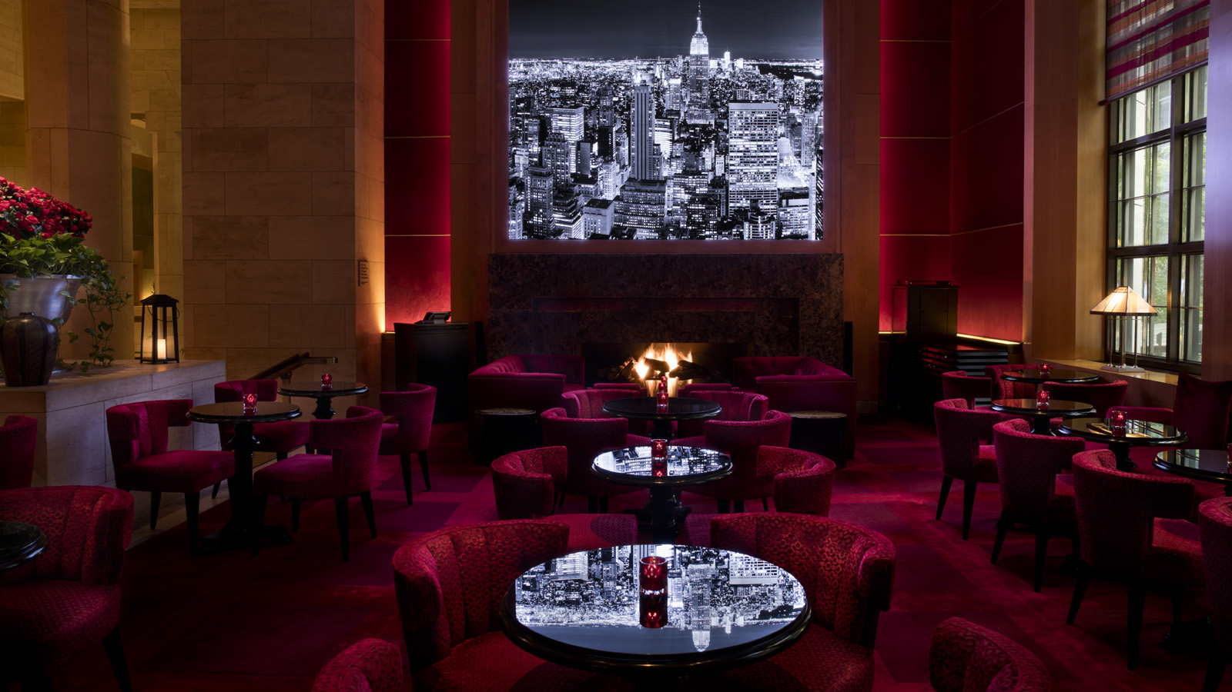 | 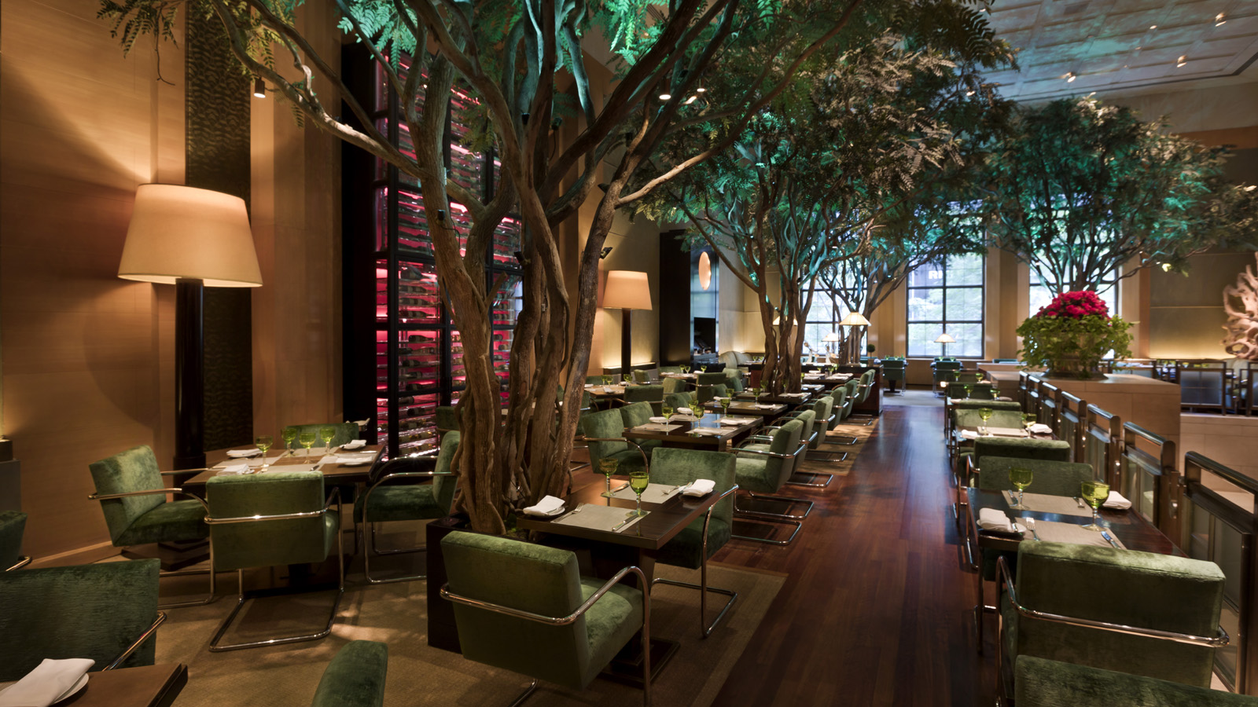
Four Seasons Hotel New York announces an exciting partnership with Whispering Angel. For the summer season, guests are invited to sip this rosé for a cause at Ty Bar and The Garden.
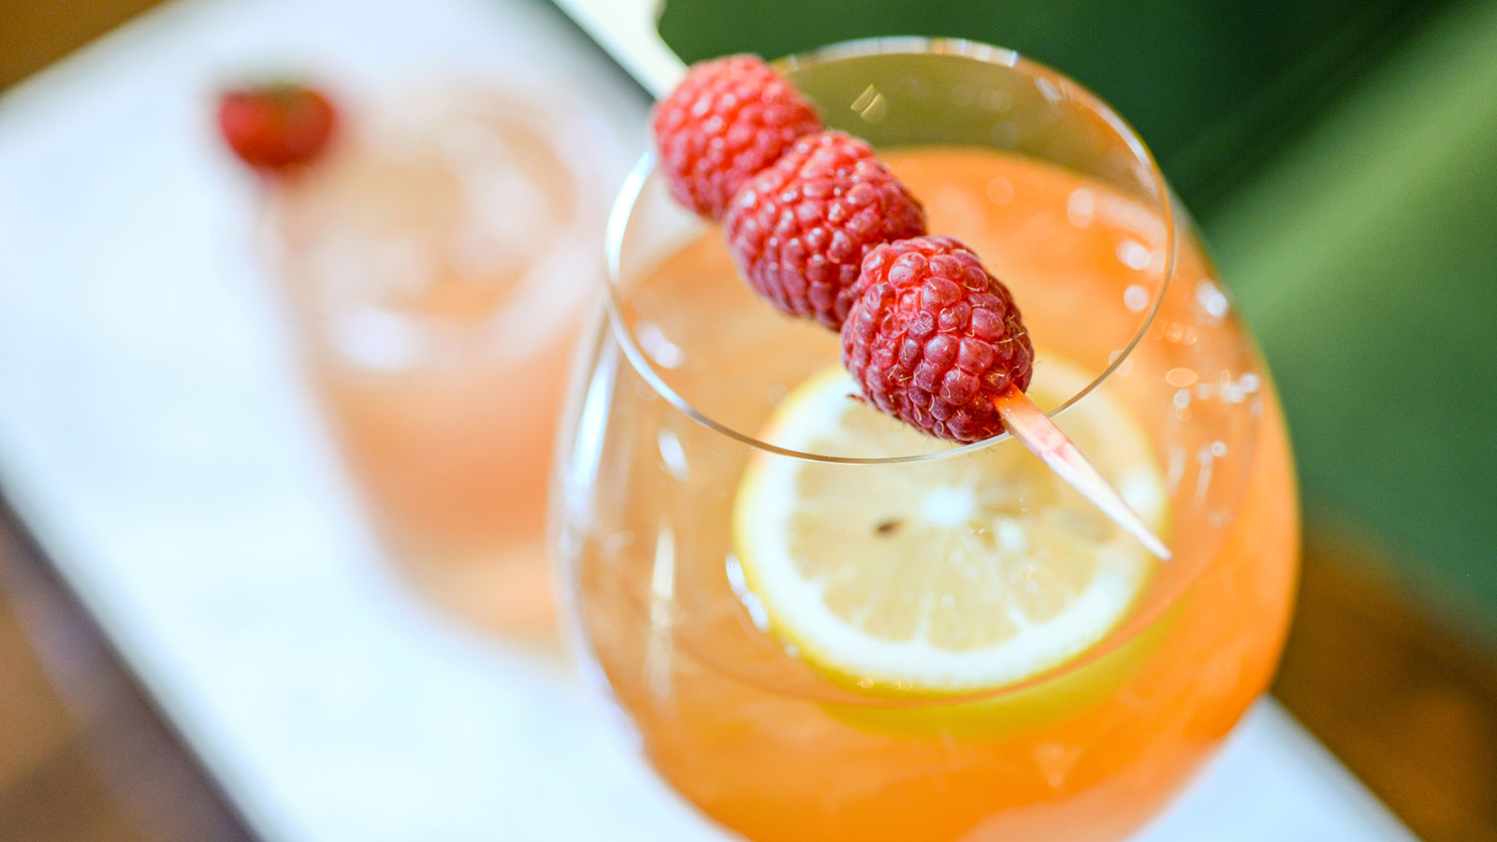 | 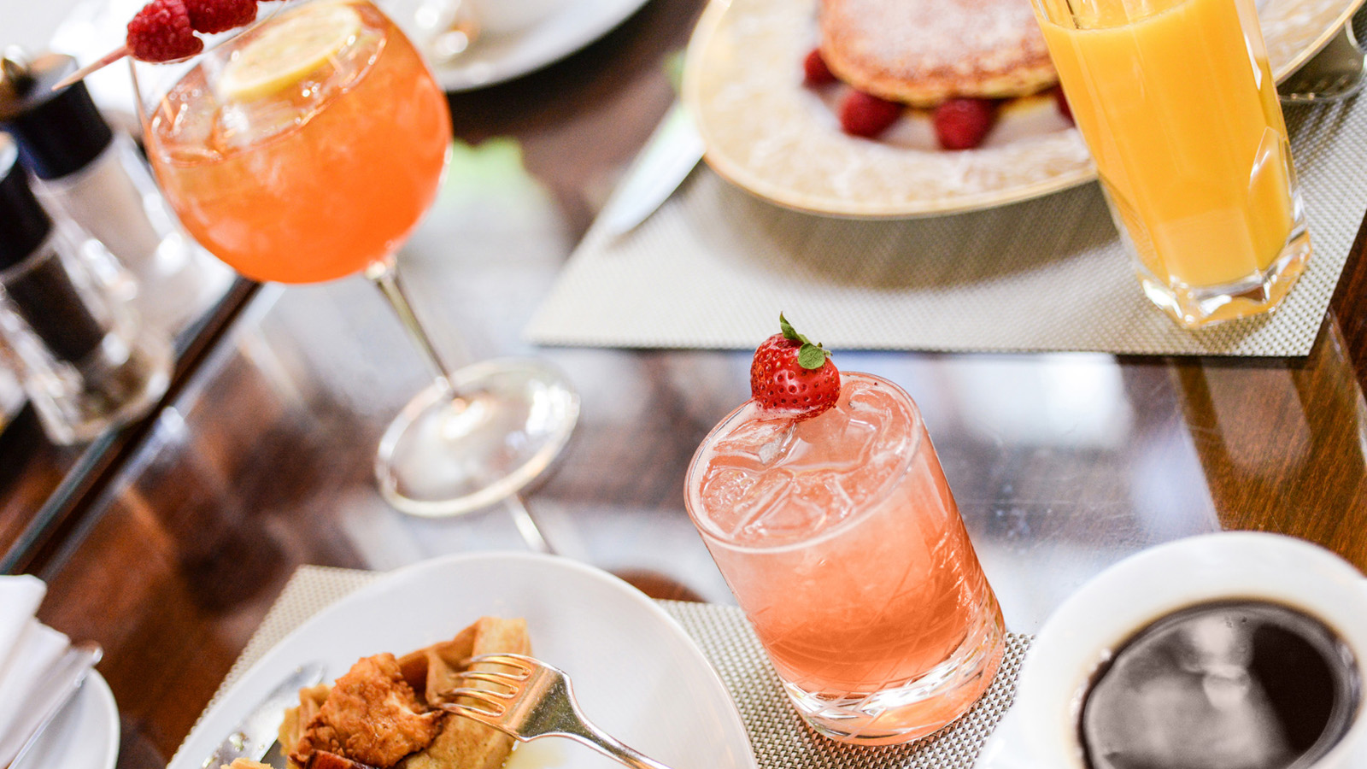
Because of Whispering Angel, Ty Bar’s menu just got a little pinker with the addition of the Côtes de Provence Rosé 2016 and the newly launched Rock Angel. Both selections can be enjoyed by the glass or bottle.
Guests may choose from the following rosé selections:
- Whispering Angel, Côtes de Provence Rosé 2016
- Rock Angel, Côtes de Provence Rosé 2016
Cocktails:
- The Garden Sangria - Whispering Angel, raspberry liquor and peach nectar
- Rosé Shortbread - Whispering Angel, plum gin, vanilla syrup, strawberry
Dining at The Garden is an experience like no other; it’s an enchanted forest-like restaurant setting in the heart of Midtown Manhattan. During brunch, guests can choose a rosé-infused cocktail to pair with their entrée.
Weekend brunch at The Garden is available from 12:00 noon to 2:30 pm on Saturdays and Sundays. A portion of the sales will be donated to a non-profit that provides support to cancer patients in New York City. To make reservations, call 212 758 5700.

RELATED

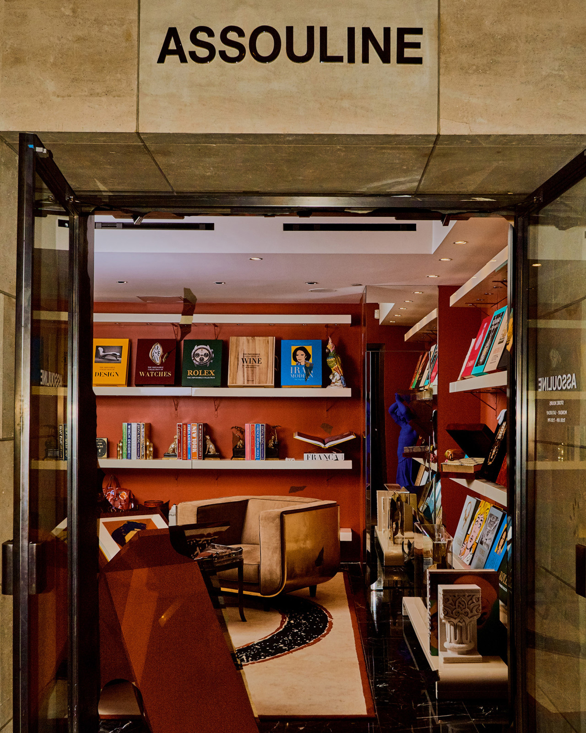 | May 28, 2019, New York, U.S.A.  Four Seasons Hotel New York Welcomes Assouline, the Global Luxury Brand in Culture  https://publish.url/newyork/hotel-news/2019/assouline-store.html
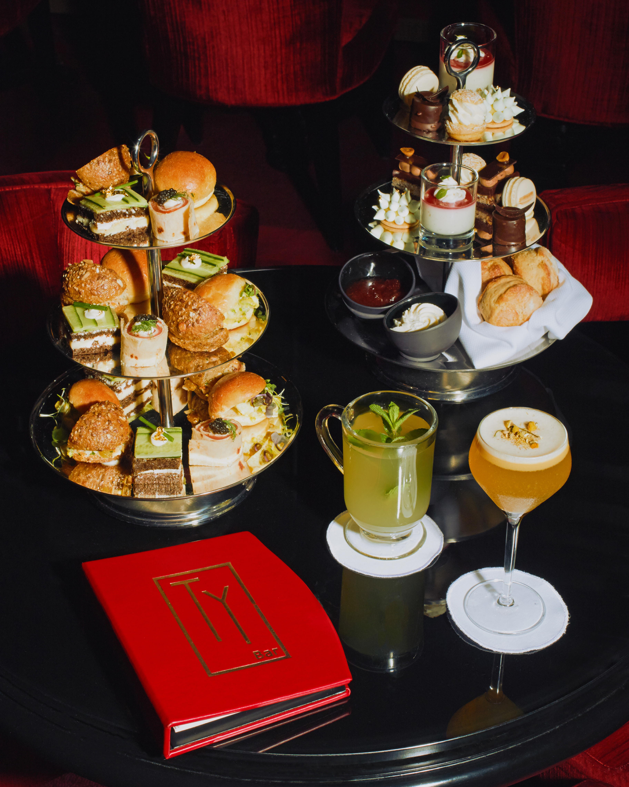 | March 21, 2019, New York, U.S.A.  Celebrate Spring with a Boozy Afternoon Tea at Ty Bar at Four Seasons Hotel New York  https://publish.url/newyork/hotel-news/2019/spring-afternoon-tea-at-ty-bar.html

PRESS CONTACTS

Nieves Alvarez
Digital Marketing Manager
57 East 57th Street
New York
U.S.A.
nieves.alvarez@fourseasons.com

+1 (212) 350-6207

