Four Seasons Resort and Residences Jackson Hole to Host Summer Artist-in-Residence Borbay

May 3, 2017, Jackson Hole, U.S.A.

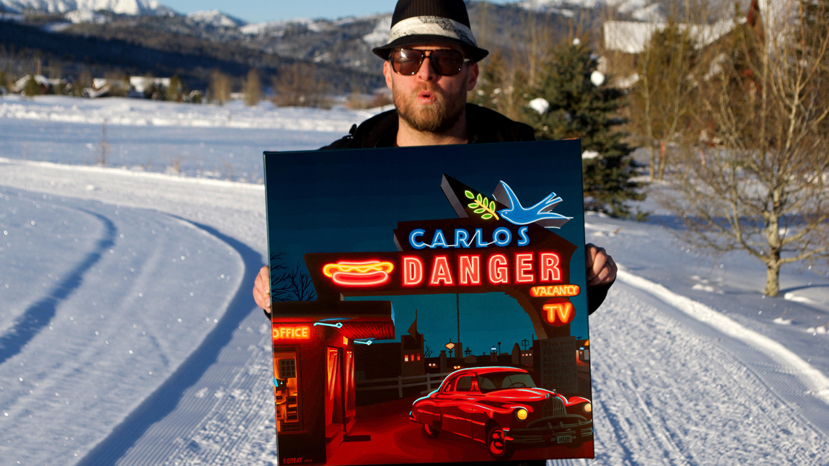
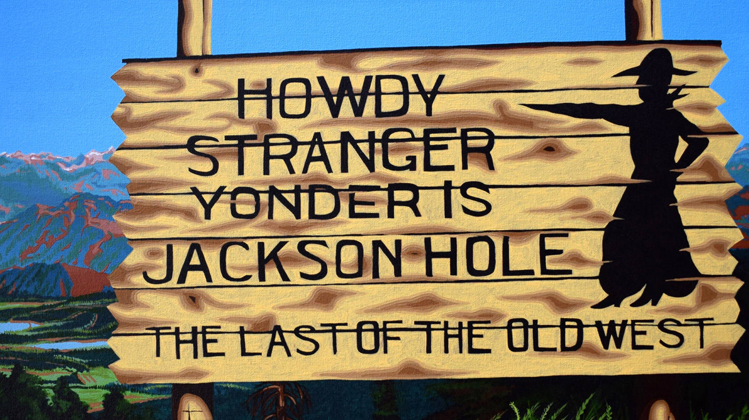 | 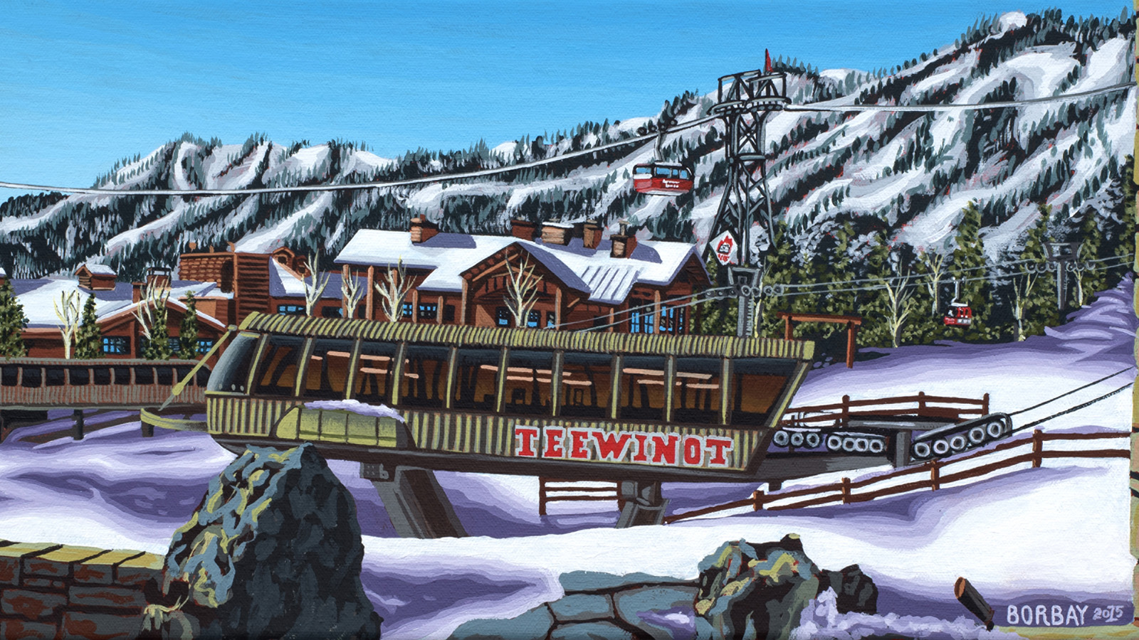 | 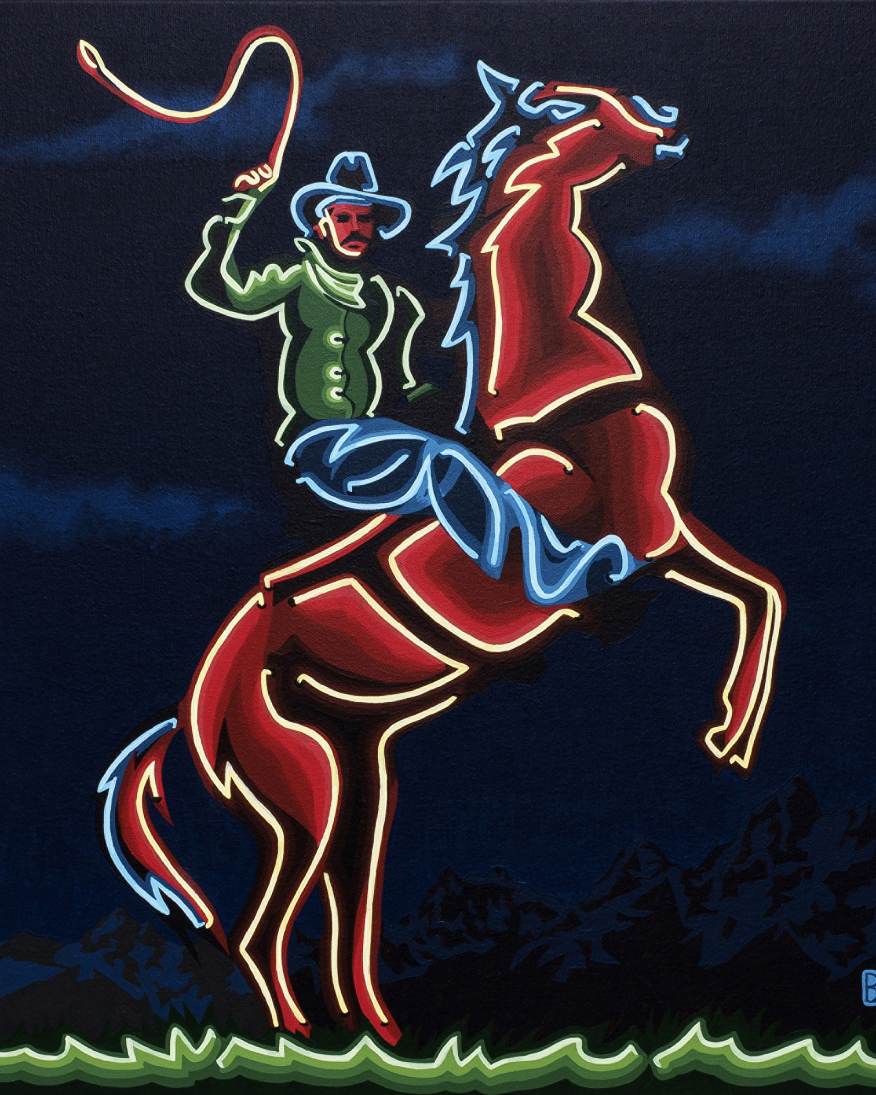
Beginning Saturday, May 27, 2017, guests of
Four Seasons
Resort and Residences Jackson Hole will find Time Out Magazine’s Most Creative New Yorker and Teton Springs resident Borbay painting in the Ascent Lounge. He will create a new work capturing the beauty of Jackson Hole each week, and will exhibit the pieces along the way in an ongoing, pop-up art gallery experience.
“In late 2015, I contacted Nina Braga, Director of Public Relations and Communications for the Resort, to ask if I could paint paint the gorgeous
Four Seasons
view and she loved the idea! We reconnected when I returned in March. Both pieces have now been sold but beyond the success, and splendour of painting in one of the world’s finest resorts, I realised as a work-at-home father of three just how important it is to spend some time outside my studio,” says Borbay.
The public is invited to stop by, grab a cocktail, jump into the time lapse video of his process and join Borbay as he creates. Dan Myers, Food and Beverage Director, had this to say of the collaboration: “During Borbay’s first two mini-residencies, we noticed a certain electricity flowing through Four Seasons. Both our guests and staff were excited to see the creativity and interact with the artist, so we decided to expand the engagement, and bring Borbay in for the entire summer.”
This will be Borbay’s second long term residency. In 2015, he helped create Art Exuma in the Bahamas, and was the first artist-in-residence. Since relocating to Teton Valley, Borbay has shown in a large-scale, solo exhibition at The Art Association of Jackson Hole, and, most recently, shared his work at the Art Barre Soirée, a one-night-only pop-up exhibition hosted by The Certior Group, at Ski Barre in The Aspens.
Join
Four Seasons
Resort and Residences Jackson Hole in following the creative process with #WeHeartLocalArt.
About Borbay
A self-represented artist, Borbay’s work is collected globally, and has been featured by an impressive breadth of revered news outlets. Time Out New York Magazine named him their Most Creative New Yorker. He defaced Andy Warhol’s Marilyn and Major League Baseball hung it up in their Fan Cave. He knew Forbes’ Hip Hop Cash Kings list before Forbes did, and was recruited by the same outlet to write about art business. His collages incorporating New York Post headlines became a New York Post headline. He’s painting the Guggenheim each year for 20 years, and intends to show the series in the Guggenheim itself. His work graced the cover of Zack O’Malley Greenburg’s best-selling business book from Simon & Schuster, Michael Jackson, Inc. In 2016, he was selected by judges from Sotheby’s, Gagosian Gallery and Christie’s Collectrium to show at the globally renowned Accessible Art Fair in Manhattan. Celebrated by everyone from BBC World to the Wall Street Journal Japan, Borbay is thrilled to call
Four Seasons
Resort and Residencies Jackson Hole his summer studio.

RELATED

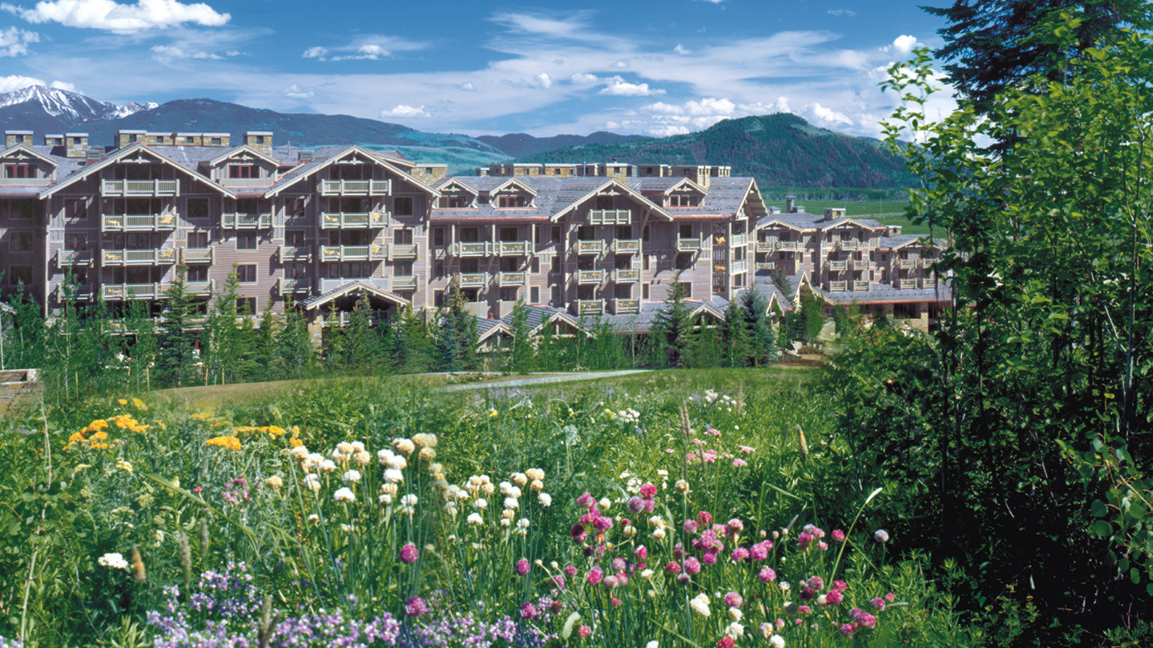 | May 19, 2017, Jackson Hole, U.S.A.  Global Wellness Day at Four Seasons Resort and Residences Jackson Hole  http://publish.url/jacksonhole/hotel-news/2017/global-wellness-day.html
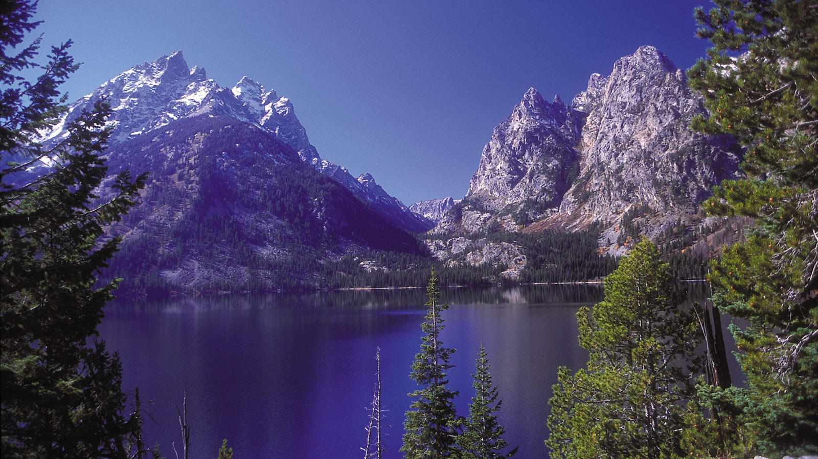 | April 28, 2017, Jackson Hole, U.S.A.  Four Seasons Resort and Residences Jackson Hole Launches a New Volunteer Option for Guests with Grand Teton Trail Stewardship Program  http://publish.url/jacksonhole/hotel-news/2017/grand-teton-train-stewardship-volunteer-program.html

PRESS CONTACTS

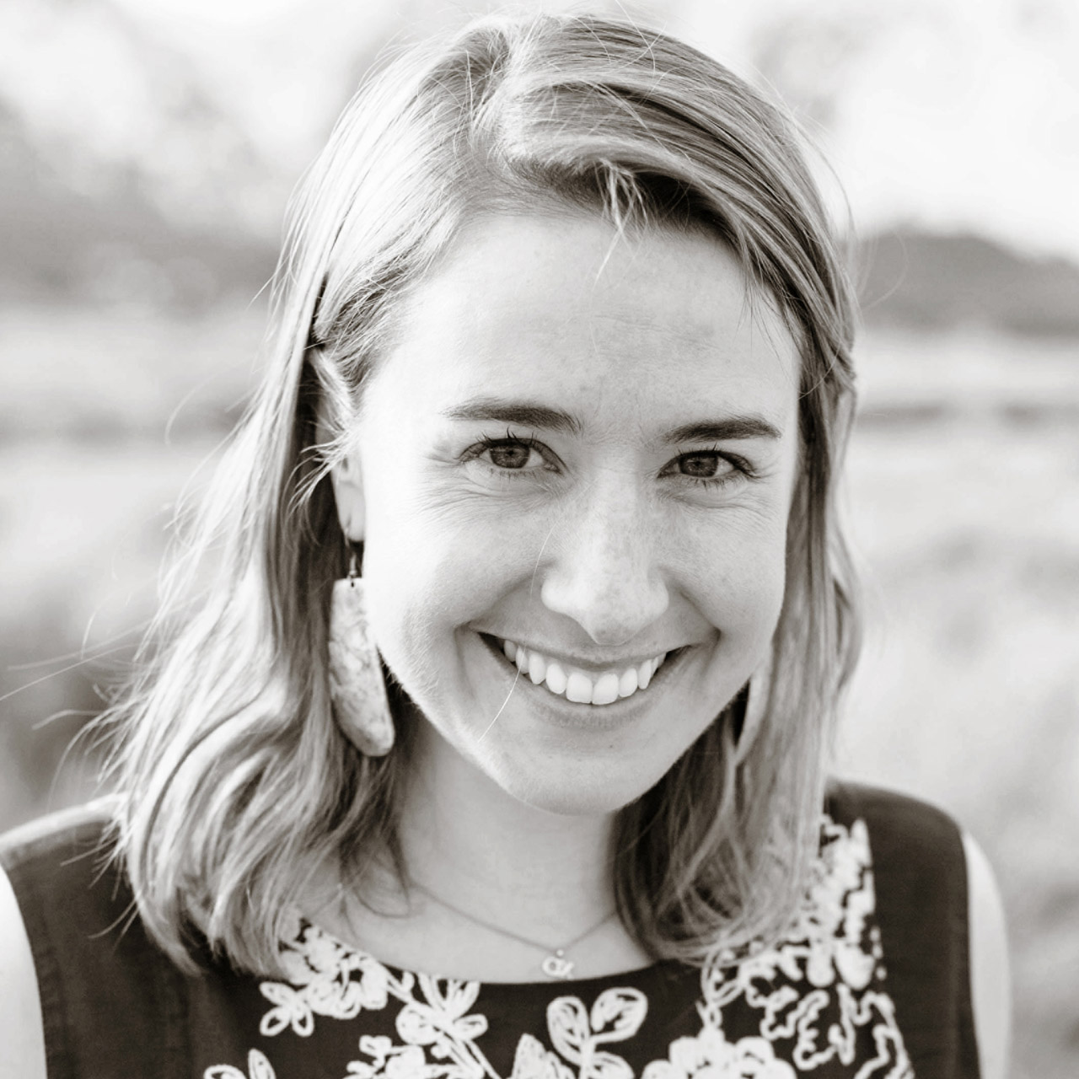 | Nina Braga  Public Relations Director  7680 Granite Loop Road, P.O. Box 544  Teton Village  U.S.A.  nina.braga@fourseasons.com  +1 (307) 732-5062

