Four Seasons Hotel New York Downtown Named Five Star Hotel by Forbes Travel Guide in Official 2019 Star Ratings

Hotel earns prestigious award in its first year and continues the legacy into the second year
February 20, 2019, New York, U.S.A.

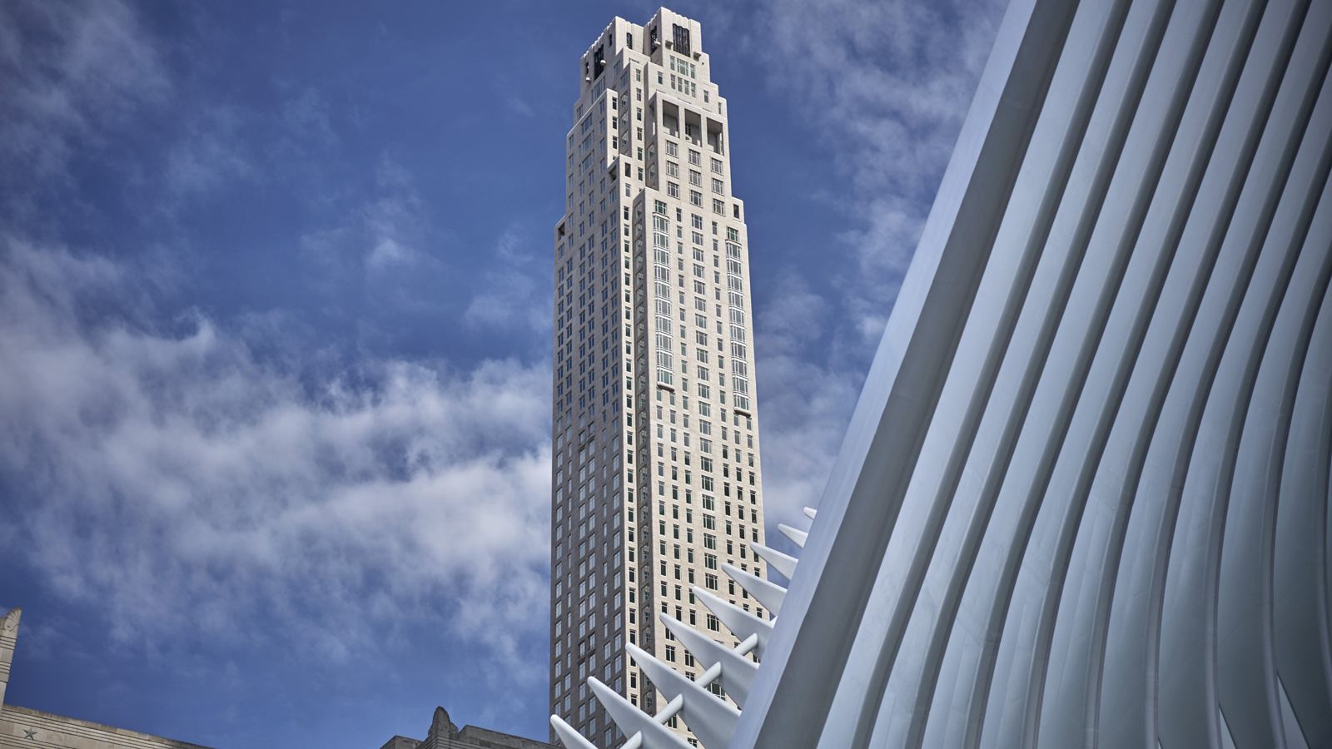
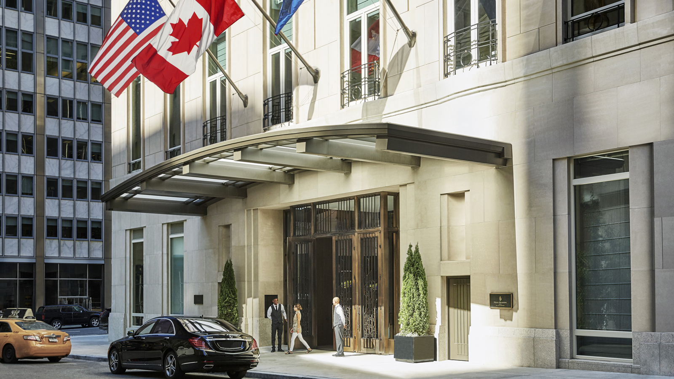 | 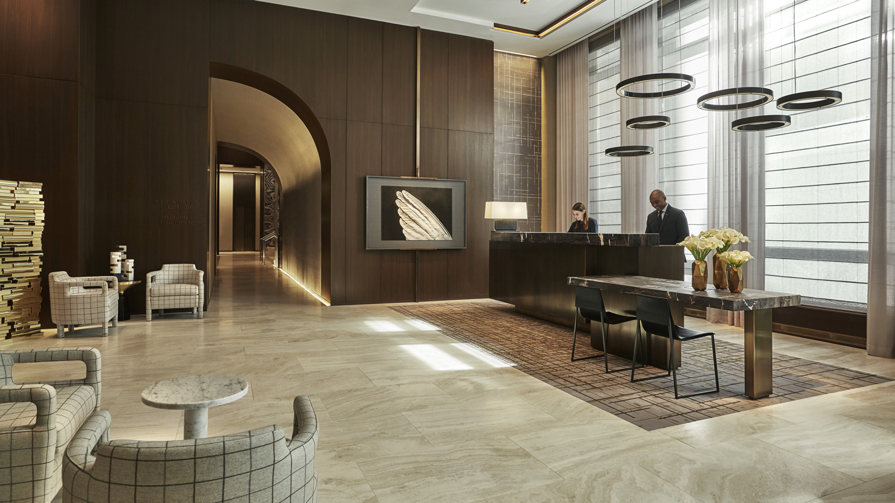 | 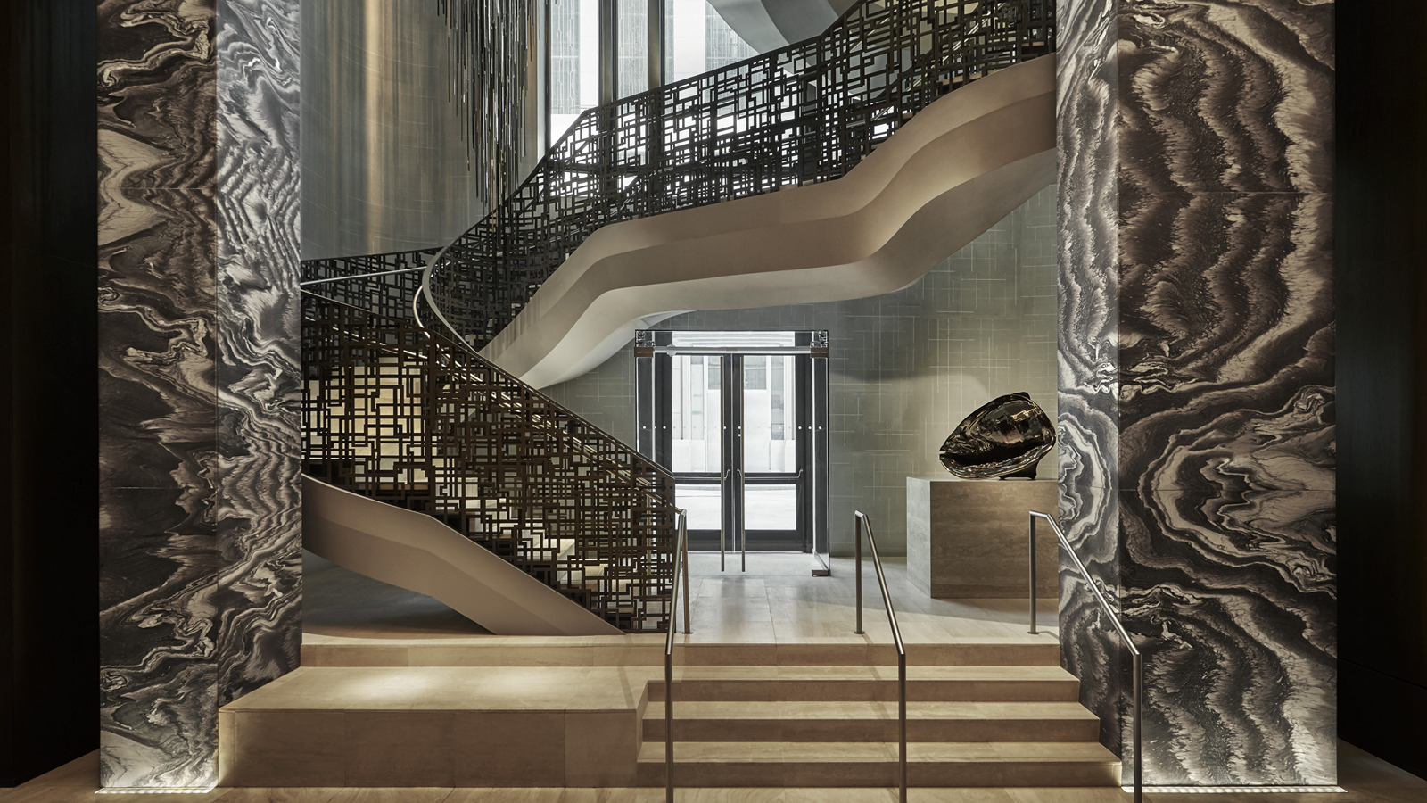
Forbes Travel Guide today unveiled its annual Star Rating list, naming Four Seasons Hotel New York Downtown as a Forbes Travel Guide Five-Star Hotel. Four Seasons New York Downtown originally received the Forbes Five-Star rating in February 2018, achieving the iconic accolade in the first full year of operation.
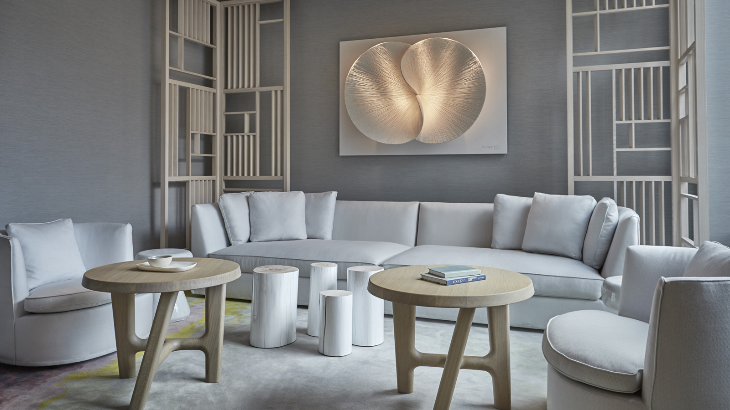
Opened in September 2016, the hotel features 189 guest rooms including 28 suites; 7,000 square feet (650 square metres) of event space; CUT, the first New York restaurant by celebrity restauranteur Wolfgang Puck; and The Spa including seven treatment rooms, an outdoor terrace, 24 hour fitness centre and a 75-foot (23 metre) indoor lap pool.
Ideal for both business and leisure guests, Four Seasons Hotel New York Downtown is perfectly situated close to various neighbourhoods, activities and attractions including One World Observatory, the Oculus, Westfield World Trade Center, Brookfield Place, the Brooklyn Bridge, Tribeca, the Seaport District, Wall Street, Financial District, Battery Park, The Whitney Museum of American Art and the Meatpacking District.
Since opening, Four Seasons Hotel New York Downtown has continued to push the boundaries of a luxury hotel in Downtown New York, with wide-ranging initiatives for in-house guests, residents and locals. The most recent luxury offerings include the launch of an exclusive In-Room SOAK Service, the release of The LocA-List Package with 48-Hour destination itineraries in Health & Wellness, Food & Beverage and Art & Culture; and the launch of a dedicated Health & Wellness Menu, available in both The Spa and In Room Dining. Additionally, The Spa at Four Seasons Hotel New York Downtown continues to see success with the launch of the Resident Healers Program and partnerships with iconic global brands including Soveral, Omorovicza and Dr Burgener.
“We are thrilled to once again be included in the Forbes Five-Star Listing and to be named along-side such a prestigious list of world-class hotels, restaurants and spas globally. This rating is a true testament to the culture and service excellence at Four Seasons Hotel New York Downtown and we are extremely proud of our team,” says Thomas Carreras, General Manager.
“We are delighted to celebrate the 2019 Star Rating winners, an outstanding collection of hotels, restaurants and spas that demonstrates a strong culture of service,” said Filip Boyen, Chief Executive Officer of Forbes Travel Guide.

RELATED

February 14, 2019, New York, U.S.A.
Four Seasons New York Downtown Launches Exclusive In-Room SOAK Service
https://publish.url/newyorkdowntown/hotel-news/2019/new-soak-service.html

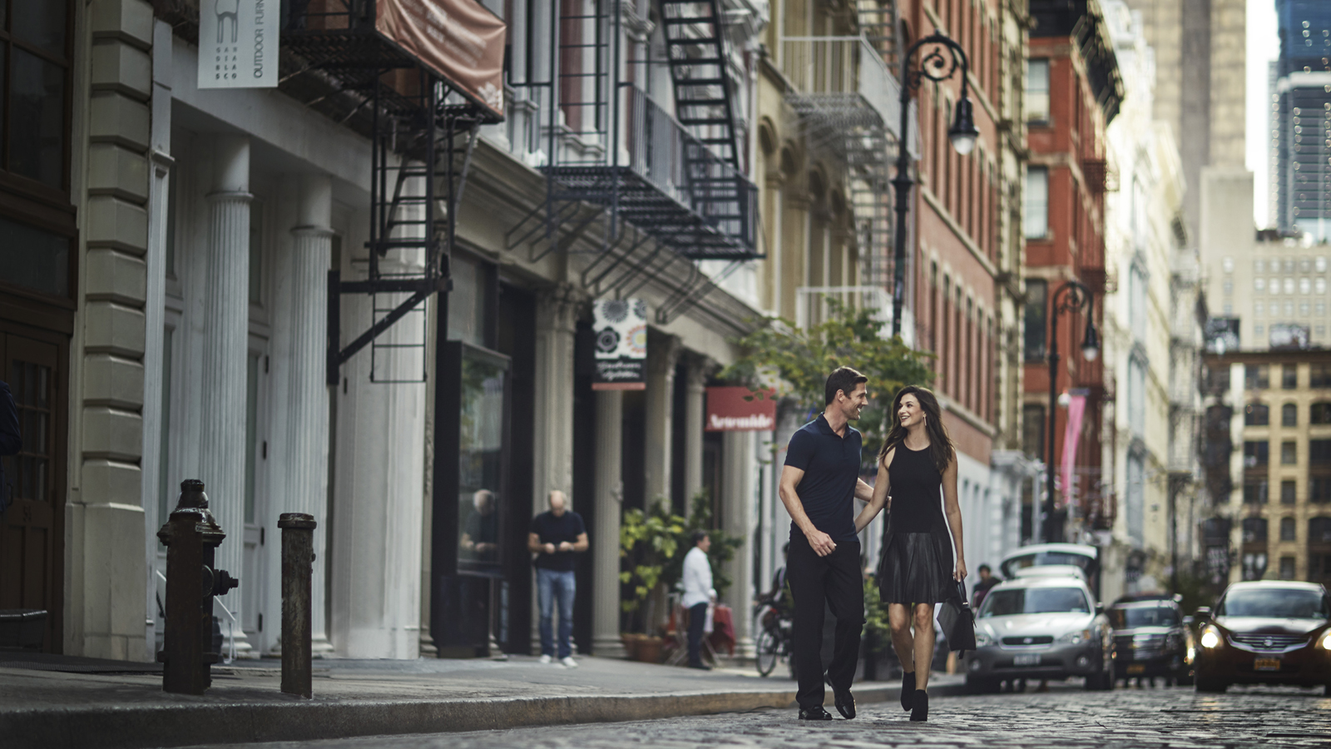 | February 5, 2019, New York, U.S.A.  Four Seasons Hotel New York Downtown Launches the LocA-LIST Package for 2019 Weekend Staycations  https://publish.url/newyorkdowntown/hotel-news/2019/loca-list-staycation-package-and-itineraries.html

PRESS CONTACTS

Kristi Blake
Director of Public Relations and Communications
27 Barclay Street
New York
U.S.A.
kristi.blake@fourseasons.com

+1 (646) 880-1917

