Four Seasons Hotel and Private Residences New Orleans Introduces Chandelier Bar

Lobby Bar features extensive cocktail program by Hadi Ktiri, complemented by cuisine from Alon Shaya
April 27, 2021, New Orleans, U.S.A.

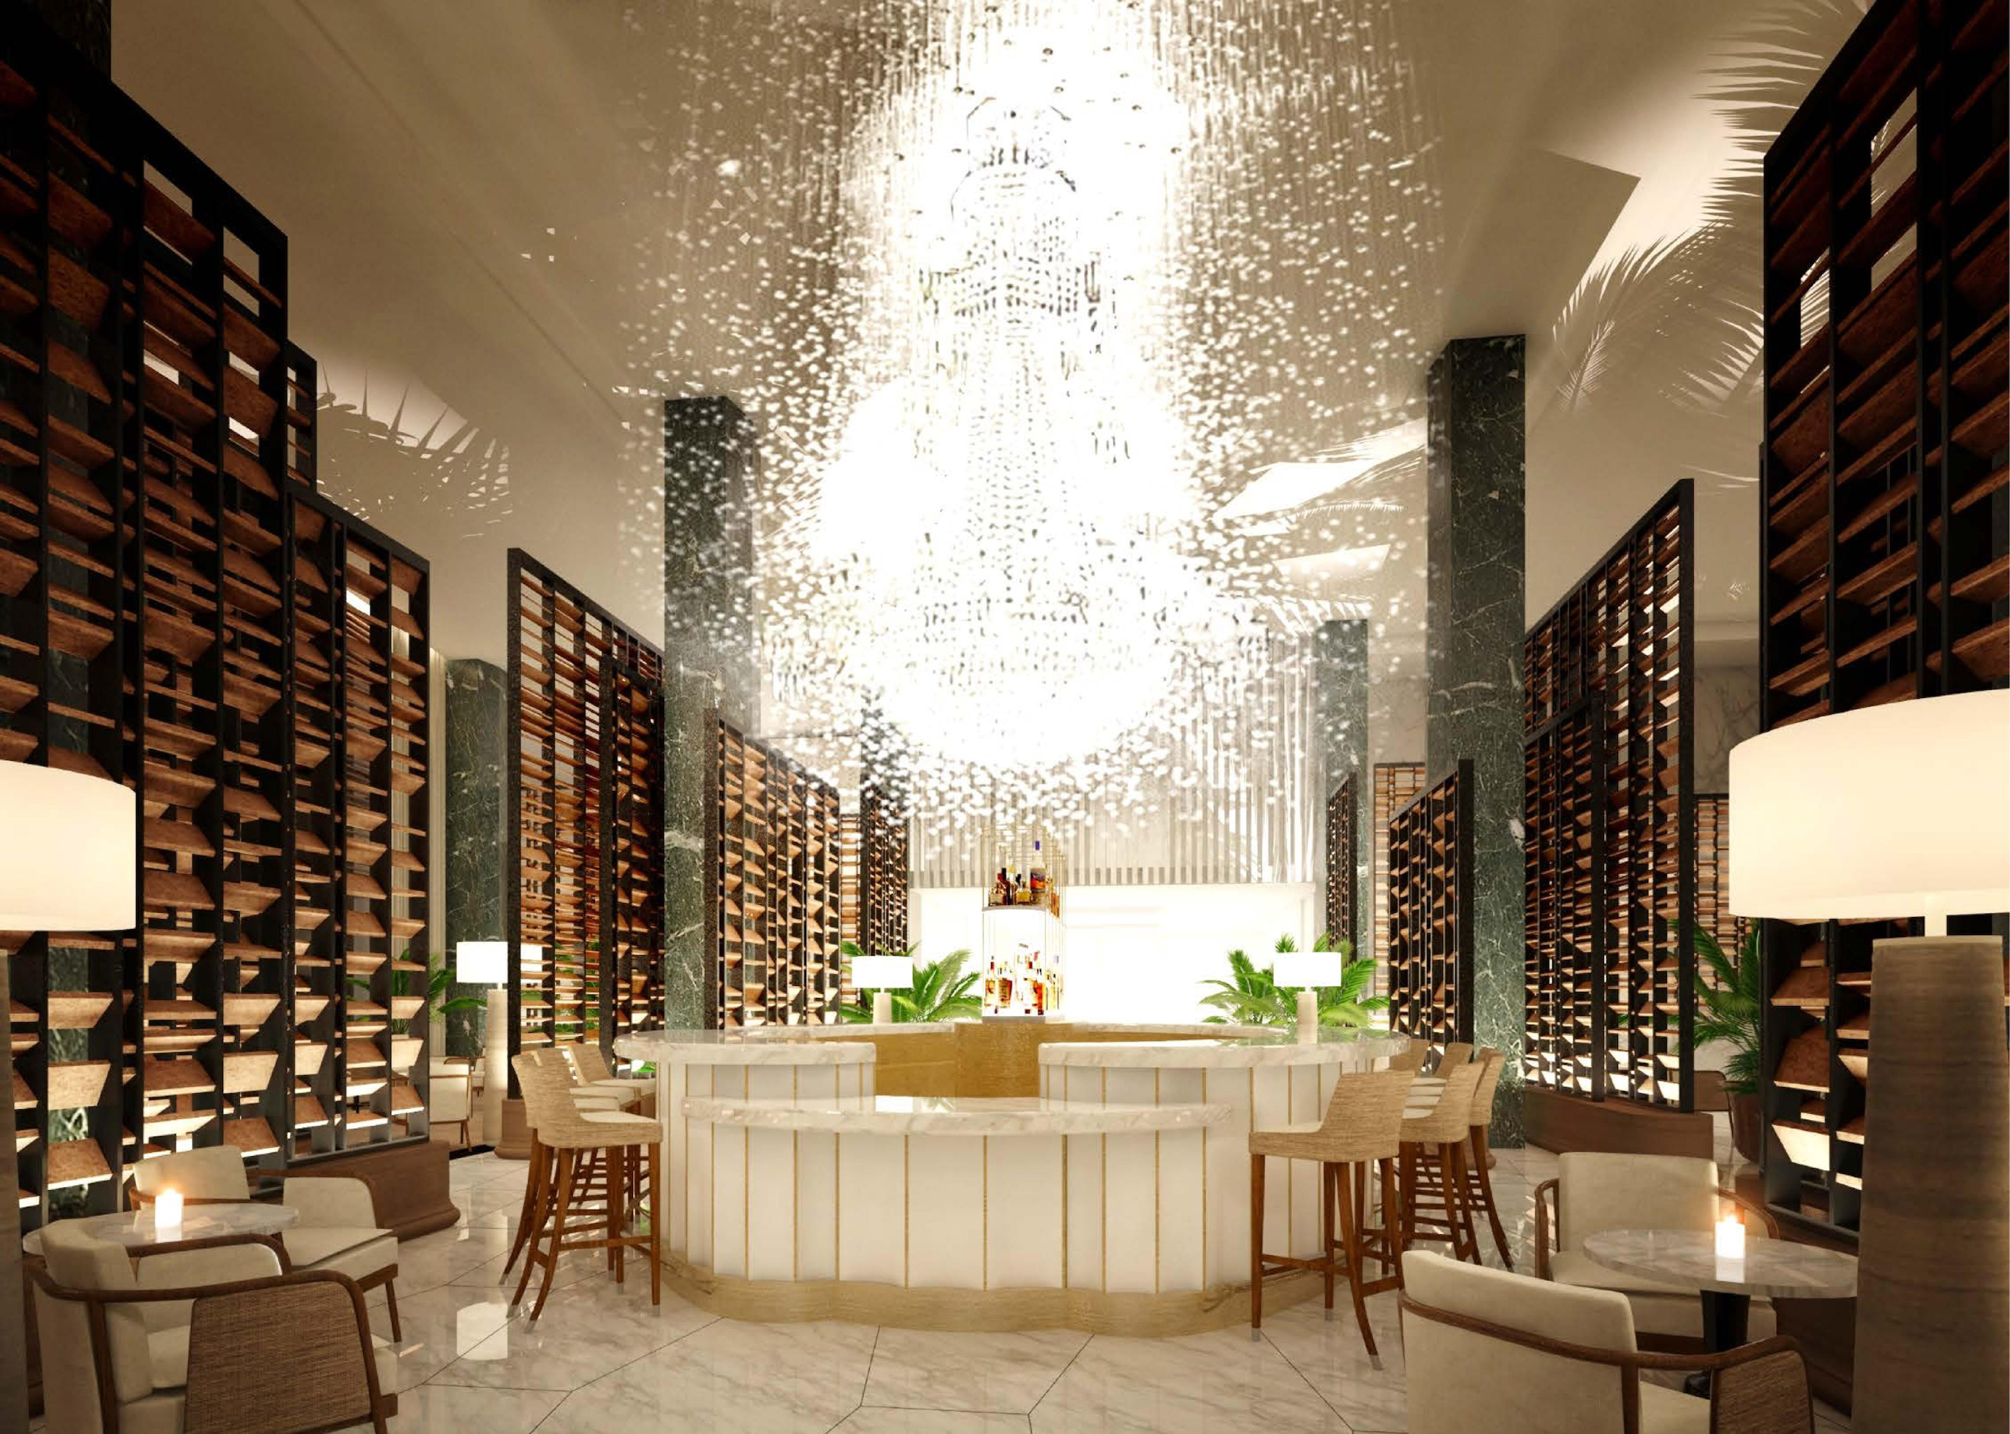
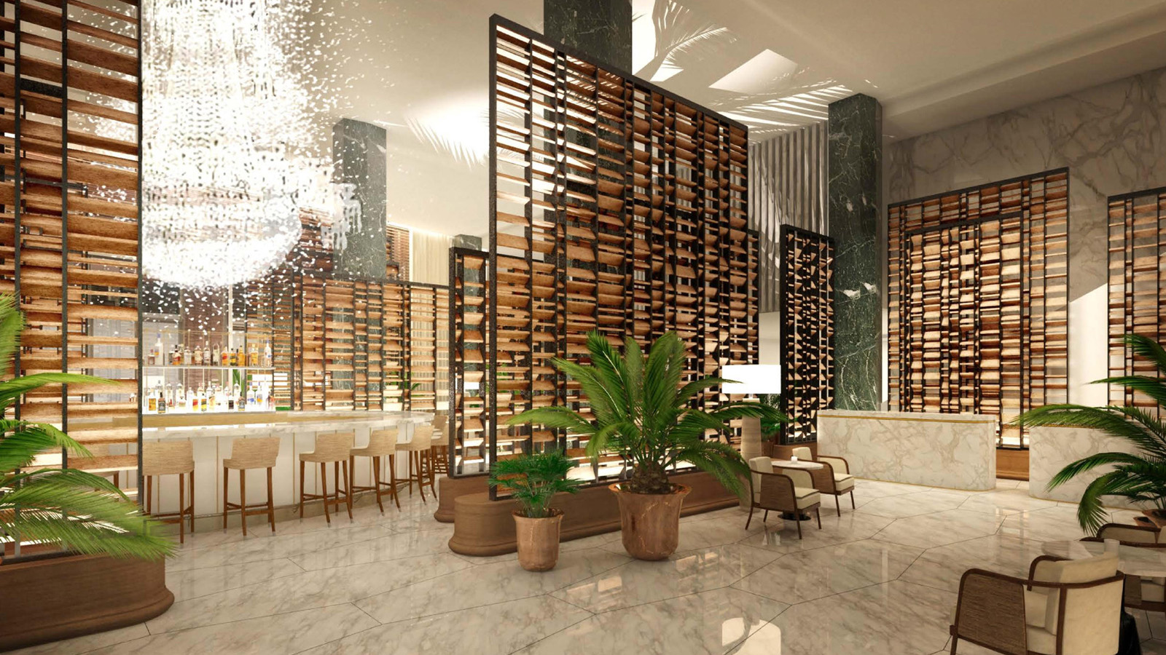 |  | 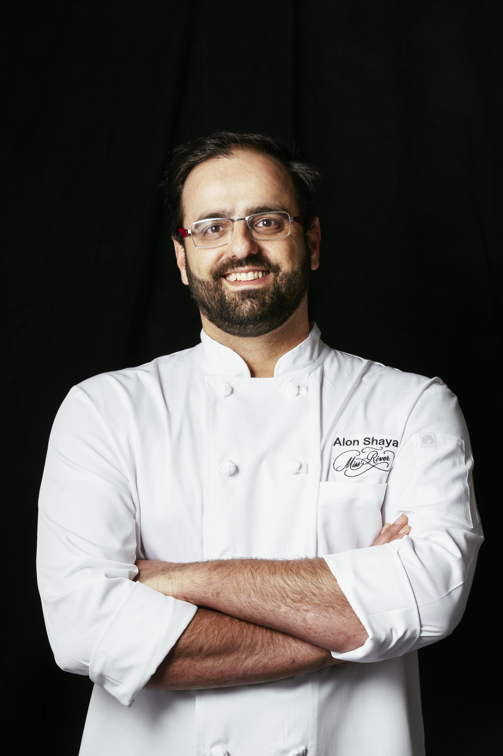
Opening in summer 2021, Four Seasons Hotel and Private Residences New Orleans introduces Chandelier Bar.
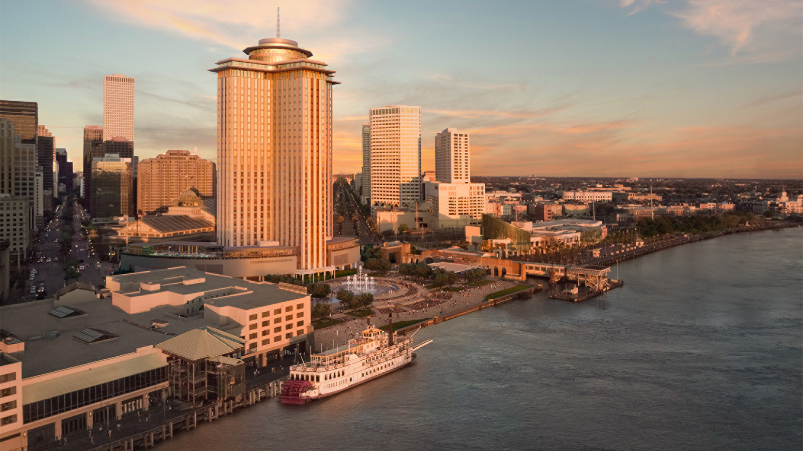
Celebrating the rich and renowned history of New Orleans cocktail culture, Chandelier Bar is the glamorous lower-level centrepiece of Four Seasons Hotel New Orleans. Rooted in tradition, Beverage Manager Hadi Ktiri's purposeful menu reflects stellar executions of the Crescent City's most famous cocktails while enveloped within a namesake custom chandelier of 15,000 crystals.
Here, guests enjoy beautiful executions of New Orleans historical classics such as the Sazerac, Ramos Fizz, Hurricane and French 75, as well as more obscure variations meant to transport guests through creative storytelling and art.
Abuzz with celebration, Chandelier Bar also offers the City’s finest collection of premium Champagnes and sparkling wines, including Dom Pérignon and Ruinart by the glass. Complementing the beverage program are caviar service and a menu from acclaimed New Orleans chef Alon Shaya, showcasing delicious bites meant to be shared and savoured.
Overseeing the bar program at Chandelier Bar and throughout the Hotel, Ktiri gained notoriety as one of the principal bartenders at the famed French 75 Bar at Arnaud’s, and was an integral part of winning the 2017 James Beard Award for Outstanding Bar Program.
“Chandelier Bar is the energy centre of Four Seasons Hotel New Orleans, and a passionate tribute to the illustrious cocktail tradition of the City,” says Mali Carow, General Manager of Four Seasons Hotel and Private Residences New Orleans. “Wrapped within this stunning chandelier, guests from near and far will connect, celebrate, and indulge here as part of their New Orleans experience, tasting New Orleans in every savoured sip.”
Designed by Bill Rooney Interiors, Chandelier Bar is the centrepiece of the lobby, offering 80 seats (17 at the bar, 51 in the lounge, and 12 on the garden terrace) set in curated social spaces. The experience creates a layered story of discovery in a room subdivided by contemporary shutter screens of oak, iron and curated art that create intimate spaces with their arrangement. Enveloped by a grand lighting installation made up of varying crystal and glass arrangements creating the hint of an heirloom chandelier shape, the twinkling reflective gentle movement of the chandelier results in an alluring mood, which changes from morning through night. The Lobby is envisioned as a garden pavilion, with an interior atmosphere composed of an eclectic and contemporary arrangement of classic curiosities, surrounded by a lush garden sanctuary.
The chandelier’s 15,000 glass trimmings (12,500 on the central piece and 2,500 on the outer ring) are comprised of round, pendeloque and almond shaped crystals, and high-quality clear optical glass in tulip and ball shapes. Designed by Preciosa, the chandelier measures 20 L x 14 W x 13.5 H feet (6 L x 4.3 W x 4 H metres), and features Bohemian crystals from Crystal Valley, Czech Republic.
Curated by Kate Chertavian Fine Art, the collection exhibited at Chandelier Bar and throughout the lobby level includes Louisiana-based artist George Dunbar’s clay and gold leaf panels and New York-based artist Leonardo Drew’s relief works on paper. Immediately, visitors are confronted with a visual conversation between local and international artists, as both artists use earth tones and metallic details with a clear influence from the natural world. Leonardo Drew’s paper pulp prints are rich with abstraction, texture and relief, while George Dunbar achieves a similar effect in his beautiful clay and gold leaf panels.
The well-known local artist Dawn Dedeaux’s Water Markers New Orleans: A City Below the Sea lean against the wall in the elevator lobby. These acrylic sculptures are based on the devastating post-Katrina floods of 2005 and represent an actual floodwater level declared by New Orleans homeowners, sharing this recent history visually and elegantly.

RELATED

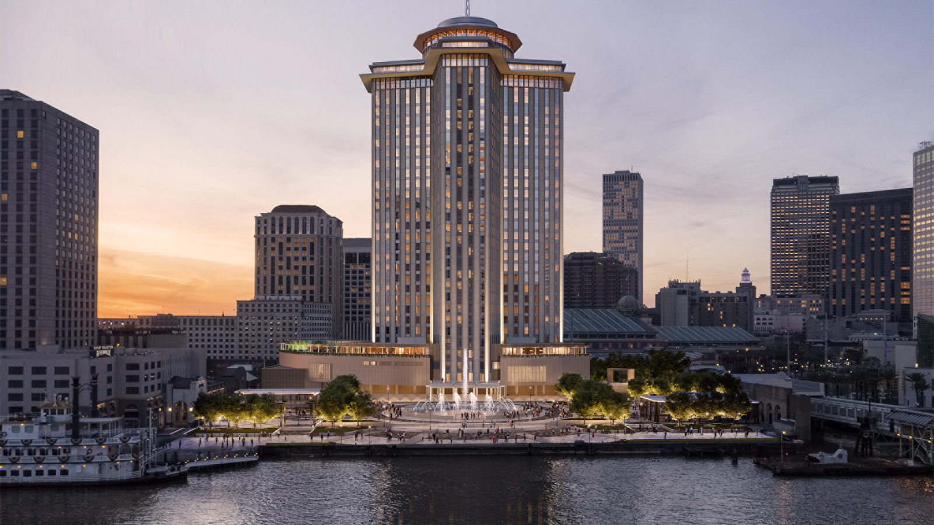 | June 22, 2021, New Orleans, U.S.A.  Now Accepting Reservations: Four Seasons Hotel and Private Residences New Orleans Opens This Summer  https://publish.url/neworleans/hotel-news/2021/reservations-live.html
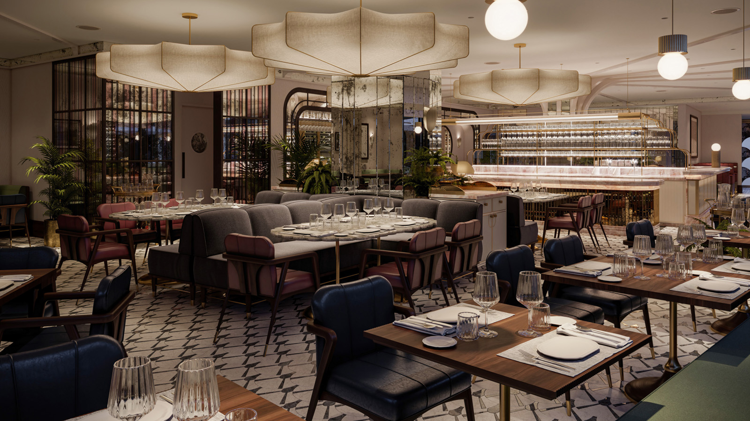 | March 2, 2021, New Orleans, U.S.A.  Four Seasons Hotel and Private Residences New Orleans Announces Details of Signature Restaurant Featuring Alon Shaya  https://publish.url/neworleans/hotel-news/2021/introducing-miss-river-restaurant.html

PRESS CONTACTS

Brad Packer
Director of Public Relations
350 South Beverly Drive, Suite 100
Beverly Hills
USA
brad.packer@fourseasons.com

+1 310 712 1493

