Locals and Guests Invited to Saddle Up for “Ice Rodeo” at Four Seasons Hotel Austin

Spectacular new holiday tradition coming to downtown Austin
October 4, 2022, Austin, U.S.A

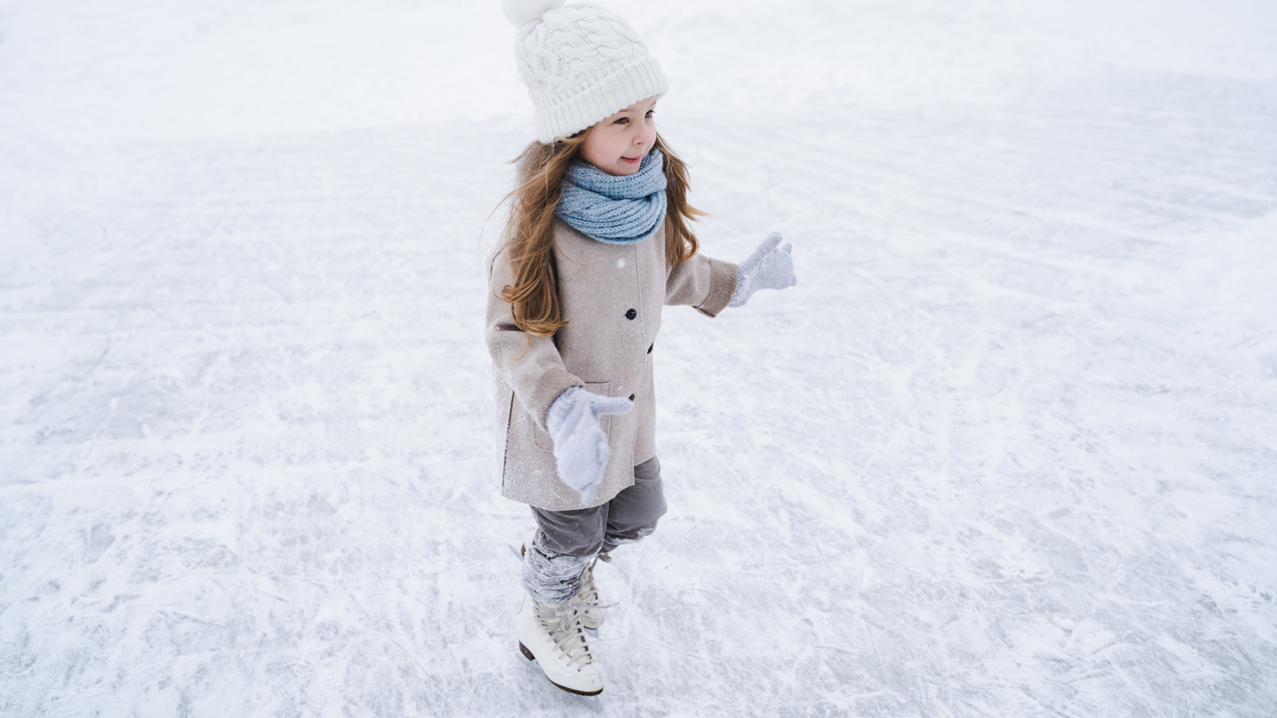
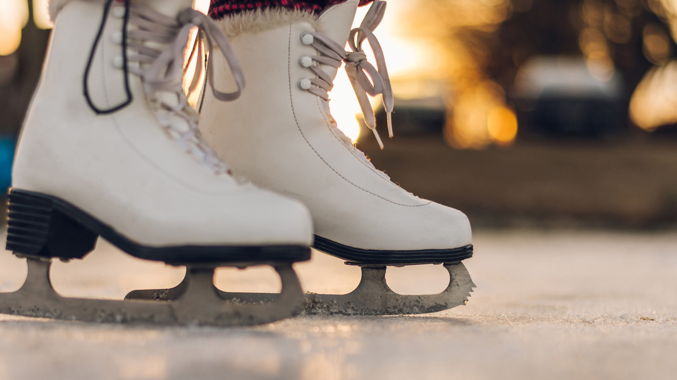 |  | 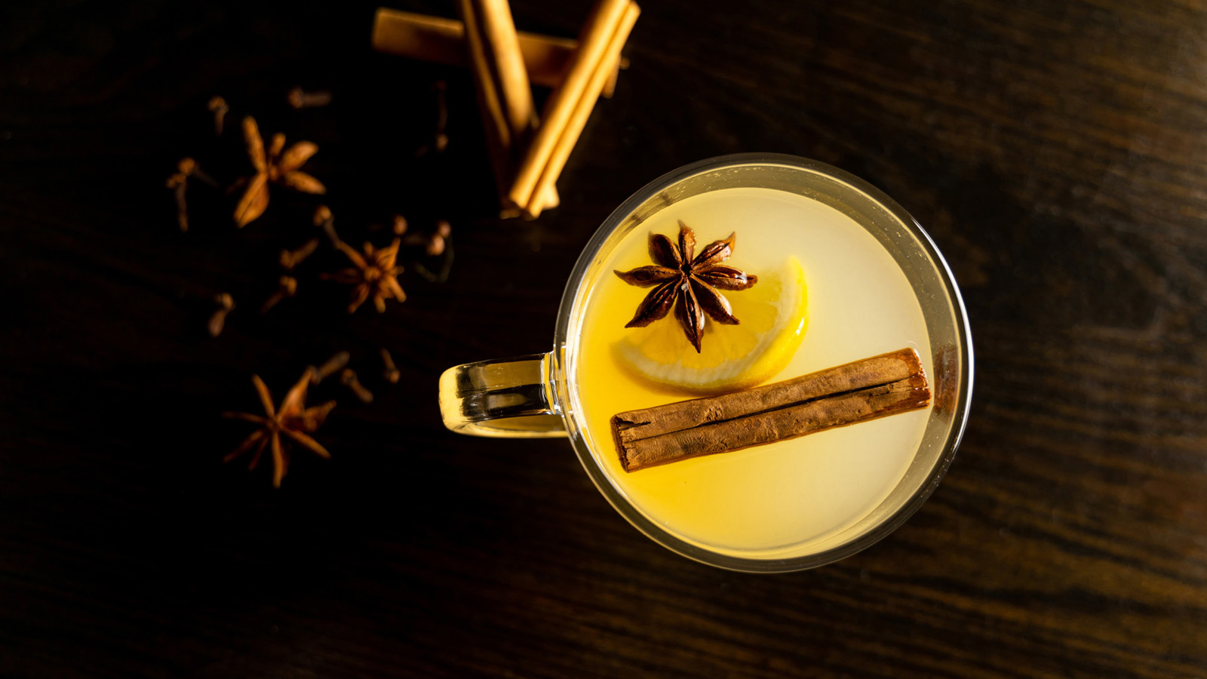
Everything is bigger in Texas, and this year, Four Seasons Hotel Austin is ensuring that holds true for the holidays as well. Set to run November 19, 2022 through January 8, 2023, the luxury Hotel’s immersive new event, “Ice Rodeo,” will bring an arctic wonderland to downtown Austin complete with elaborate art installations, a 30-foot (9 metre) Christmas tree, a life-size gingerbread Airstream trailer, festive food and drink and a 3,360-square-foot (312 square metre) outdoor ice-skating rink.
Produced in partnership with acclaimed Chicago designer Tom Kehoe, the event will deck the Hotel’s halls – and beyond – to transport guests into a festive mindset from the moment they arrive.
“Tom’s incredible talent for design and gift for imagination align perfectly with our goal to create one of the biggest and best holiday events in Texas,” says Regional Vice President and General Manager Beverly Magee. “I can’t wait to see, and for all of our guests and Austin to see, our magical holiday vision come to life.”
For visitors, the merriment starts at the front drive, where the soft twinkle of thousands of white Christmas lights provides an enchanting arrival experience. After a warm greeting from Hotel staff, their holiday stroll continues along a guided pathway past more string lights and larger-than-life holiday art installations, including a festive Texas longhorn sculpture and a 10-foot (3 metre) electric guitar composed of chestnuts, pinecones and other natural elements. An elaborately decorated 30-foot (9 metre) Christmas tree on the Ciclo lawn provides more holiday cheer and additional photo opportunities.
Nearby the towering tree, guests will be able to purchase tickets to “Ice Rodeo,” a fun-for-all-ages event centred around a new 84-foot by 40-foot (26 x 12 metre) ice skating rink, the only one of its kind in Central Texas. The real-ice rink will be situated overtop the Hotel’s pool, allowing visitors to glide beneath the stars in one of Austin’s most picturesque spots.
After taking a turn around the rink, skaters can relax at custom wood-barrel tables and indulge in delicious food and handcrafted drinks prepared by the Hotel’s culinary team. Nearby, intimate fire pits provide a cozy spot to take in the festivities and roast house-made s’mores, including Executive Pastry Chef Amanda Pallagi-Naim’s Hennessy-infused marshmallows for adults.

RELATED

September 14, 2022, Austin, U.S.A
Experience HydraFacial at The Spa at Four Seasons Hotel Austin
https://publish.url/austin/hotel-news/2022/hydrafacial-spa-treatments.html

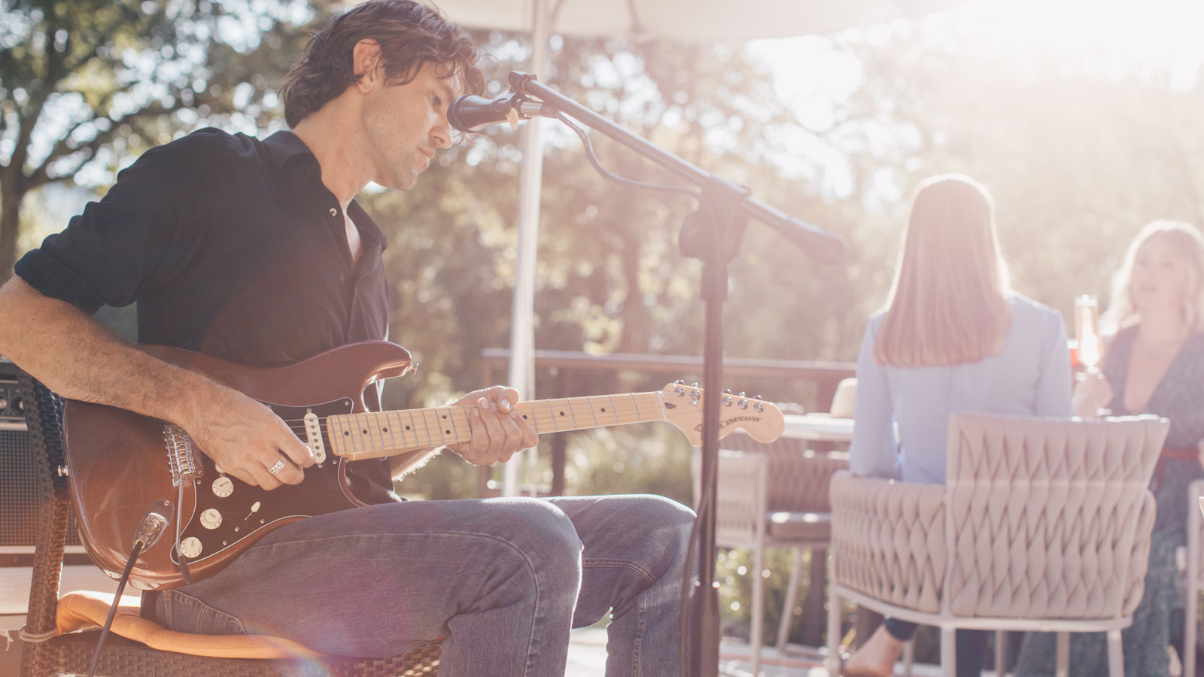 | September 7, 2022, Austin, U.S.A  Autumn Brimming with Events at Four Seasons Hotel Austin  https://publish.url/austin/hotel-news/2022/fall-activities-calendar.html

PRESS CONTACTS

Shelby Lewandoski
Digital Marketing and Communications Manager
98 San Jacinto Boulevard
Austin
USA
shelby.lewandoski@fourseasons.com

+1 512 685 8048

