Bali’s Best-Kept Secret Unveiled: The Healing Village Spa at Four Seasons Resort Bali at Jimbaran Bay Opens to the World

April 25, 2022, Bali at Jimbaran Bay, Indonesia

 | 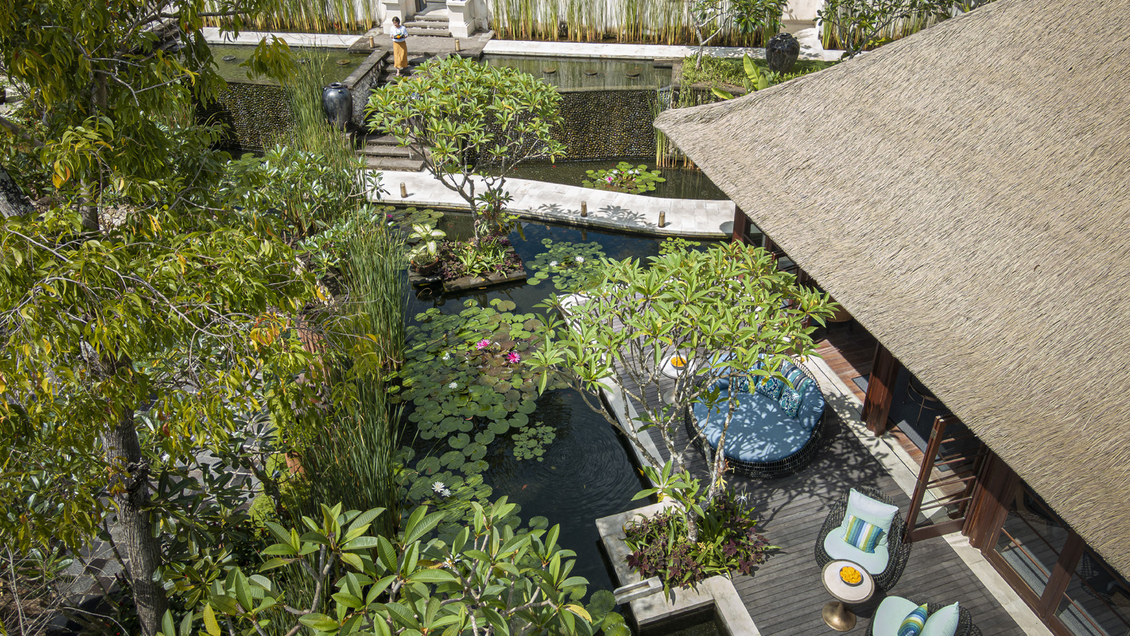 | 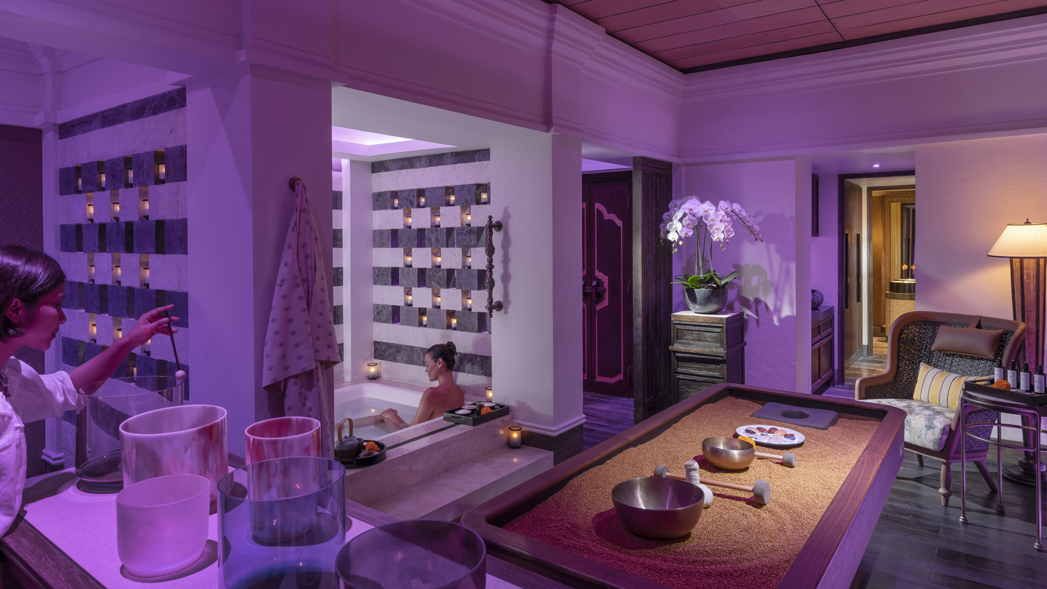
Among its many attributes, Bali is renowned for traditional healing and incredible spa remedies, from soothing massages and energy rebalancing to invigorating body scrubs and nourishing hair treatments. Its spa credentials are now set to soar even further, as the island finally reopens and unveils its best-kept secret: The Healing Village Spa in tranquil Jimbaran Bay.
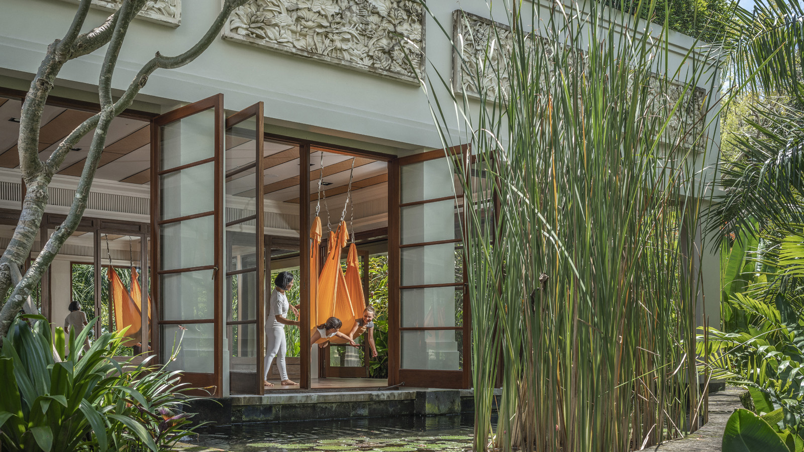
The island’s newest destination spa, the 2,000 square metre (21,500 square feet) Healing Village Spa is seemingly suspended above water with 10 spacious spa suites where expert therapists deliver immersive, transformative treatments. Located within 14 hectares (35 acres) of oceanfront gardens at Four Seasons Resort Bali at Jimbaran Bay, it is open to both in-house and outside guests. The spa’s contemporary Balinese design fuses the island’s rich culture into a state-of-the-art wellness centre, to create the perfect destination for travellers to reconnect to themselves and each other. While it officially opened in September 2020, the spa has been eagerly awaiting the reopening of Bali’s borders to fully showcase its new design and experiences.
“We feel blessed to have such strong cultural and community connections, and to be able to share Bali’s healing wisdom as an antidote to the challenges and pressures of modern life,” says Luisa Anderson, Regional Spa Director, Four Seasons Resorts Bali. “It is a privilege for our expert therapists who bring their loving presence to each treatment, and we are excited to share our new spa and enhanced wellness program with guests from all over the world.”
With reconnecting with self or others high on most travellers’ lists, Luisa recommends specific treatments that cleanse negative energy, open the heart to forgiveness and compassion, and create opportunities for quality time together:
Best for Reconnecting with Self: Celestial Light Ritual in the Illume Room
Cocooned in The Illume Room on a massage bed of crushed quartz crystals, this profound experience draws on the vibrations of gemstones and the transformative effects of light, colour and sound to elevate guests to an otherworldly realm. With the choice of colour and gemstone oils tailored to individual needs and focus areas, experience a bespoke flow of therapies that incorporate crystal massage tools, high-frequency crystal-infused oils, chromotherapy lighting and resonant singing bowls. Together, they bring the body, mind and emotions into balance and induce a state of mesmeric bliss, as guests literally vibrate with positivity.
Best for Couples to Refocus: Baru Detox in the Intan Room
The healing elements of water, colour, sound, minerals and massage combine for a powerful, harmonious experience. A citrus-spiced oil and clay wrap containing 15 natural powders boosts circulation and aids toxin release. Let the vibrations of chromotherapy, hydrotherapy and sound literally wash over with an eco-vichy shower that beams the seven colours of the rainbow over the body to target specific chakra, while a soundtrack of rain falling onto leaves, a faraway tropical storm and wildlife are delivered through the shower’s in-built speakers. A deep tissue massage and mini-facial complete the deep sense of relaxation and sensory immersion.
Best for Intimacy: The Longevity Garden
A private DIY treatment space in a lush "secret" garden. Couples can take their time to enjoy self-directed healing and nourish each other with local organic products including Indonesian volcanic mud wraps and coconut soap. To maximise mineral absorption, there’s a private steam room and double sun loungers equipped with infra-red gemstone therapy mats. A cleanse under the powerful two-metre-high (6.5 feet) waterfall shower is followed by ice bath immersion – recommended for three minutes at sub-10 degrees Celsius to release endorphins, tighten pores, speed up muscular recovery, and invigorate from head to toe.
Best for Friends and Family Groups: Spa Gourmand Experiences
Linger longer and enjoy the enchanting space with someone special, and combine some well-deserved pampering with culinary delights prepared by Four Seasons chefs and served amid the spa’s lush gardens. The Nourish Your Spirit afternoon tea package starts with a two-hour spa treatment including a full body massage and mini facial, before an exquisite three-tiered afternoon tea from Sundara restaurant. The Play Eat Love tennis and breakfast combination starts with a game on the Resort's world-class hard court followed by breakfast in the Spa Garden. A full body massage completes the morning; just the start of another extraordinary day in Bali and quality time together.
About The Healing Village Spa
The Healing Village Spa is open daily from 9:00 am to 9:00 pm for treatments, and from 6:30 am for the gym. The 10 all-suite treatment rooms each have their own private relaxation area and bathroom, and include 6 double rooms for couples as well as the Illume Room for vibrational massages on a bed made of crushed crystals. Guests are also welcome to use the common sauna and steam rooms in the male and female locker areas, at any time.
The yoga studio is set amid lily ponds and offers a dynamic range of classes by resident teachers, including AntiGravity and Restorative Hot Stone Yoga, while the upper floor gym equipped with Life Fitness equipment was developed in conjunction with Harley Pasternak, Four Seasons Global Fitness Advisor.
Adjacent to the spa reception, Italian celebrity stylist Rossano Ferretti opens his first Hair Spa in Indonesia in June 2022. This exclusive venue will offer unique access to Ferretti products and the Ferretti Method: a highly personalised styling approach that works with the natural fall of hair.
The Spa further expands the Resort’s wellness program with ocean-edge yoga and meditation at the Nirvana Shanti Bale, not to mention a year-round calendar of visiting wellness practitioners: a rare opportunity to experience one-to-one therapies from Reiki to Aura-Soma Colour Therapy with some of the world’s leading experts.
The Spa Boutique offers organic face, body and bath products – all free from synthetic chemicals including iSUN Spa product,s which are used in the spa’s signature treatments. The boutique also has aromatic essential oils, bath salts, soaps, incense, facial beauty pillow cases and eye covers, and a range of teas and other products from Muntigunung community enterprise CSR project in East Bali. Fashion options include accessories, tennis and sportswear, leisure and yoga wear, spa robes, slippers, crystal jewellery and leather goods.

RELATED

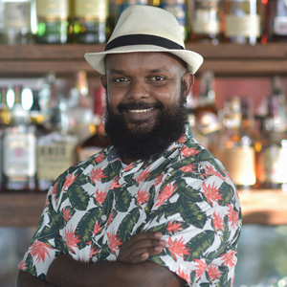 | April 21, 2022, Langkawi, Malaysia  Four Seasons Resort Langkawi Welcomes Anandha Ruben as Head Bartender  https://publish.url/langkawi/hotel-news/2022/new-head-bartender-anandha-ruben.html
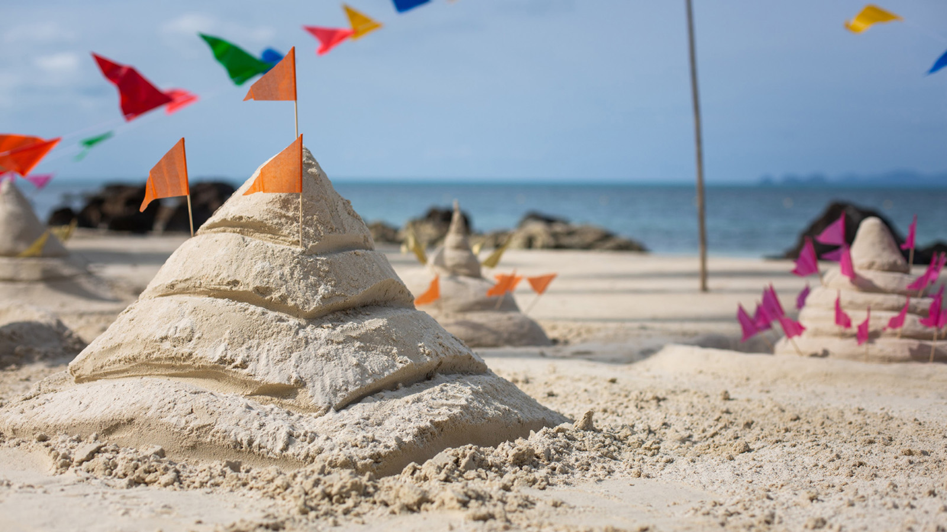 | April 8, 2022, Koh Samui, Thailand  Celebrate Songkran with Four Seasons Resort Koh Samui  https://publish.url/kohsamui/hotel-news/2022/songkran.html

PRESS CONTACTS

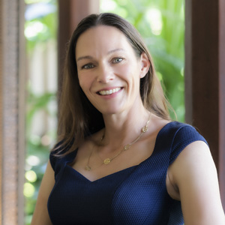 | Marian Carroll  Regional Director of Public Relations and Communication  Jimbaran  Indonesia  marian.carroll@fourseasons.com  +62 (361) 701010

