Exploration of Global Wine to Debut at Four Seasons Hotel Minneapolis

Sommelier Paul Hennessy brings carefully curated wine program to Mara
May 26, 2022, Minneapolis, USA

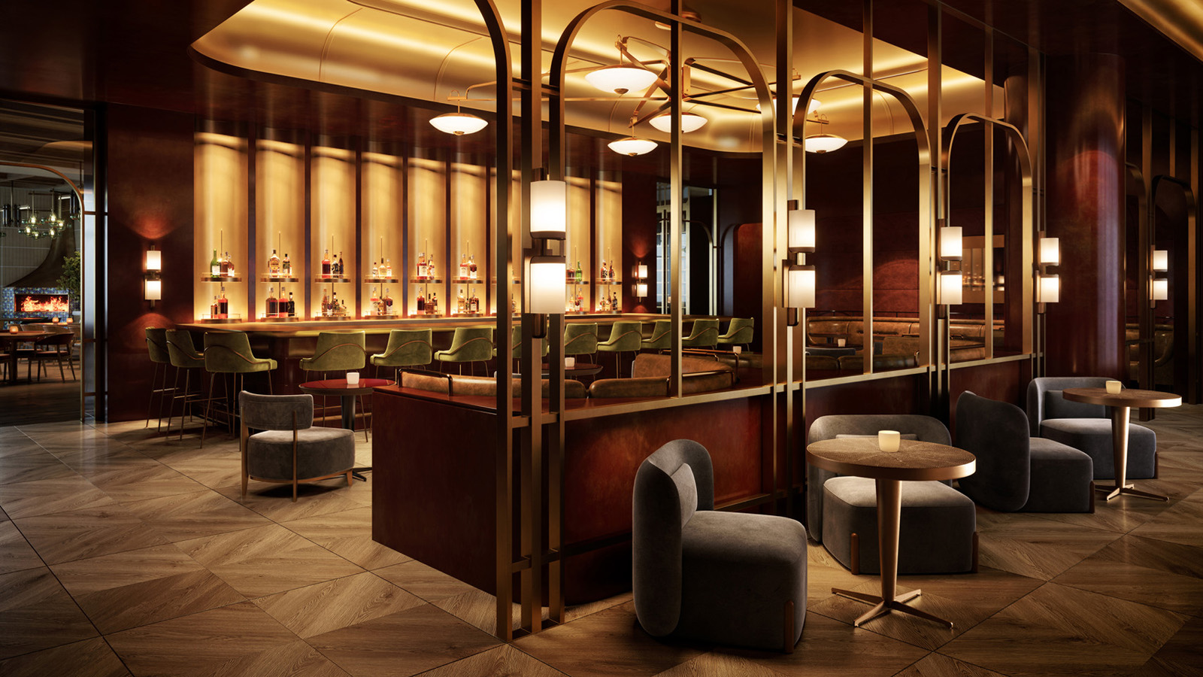
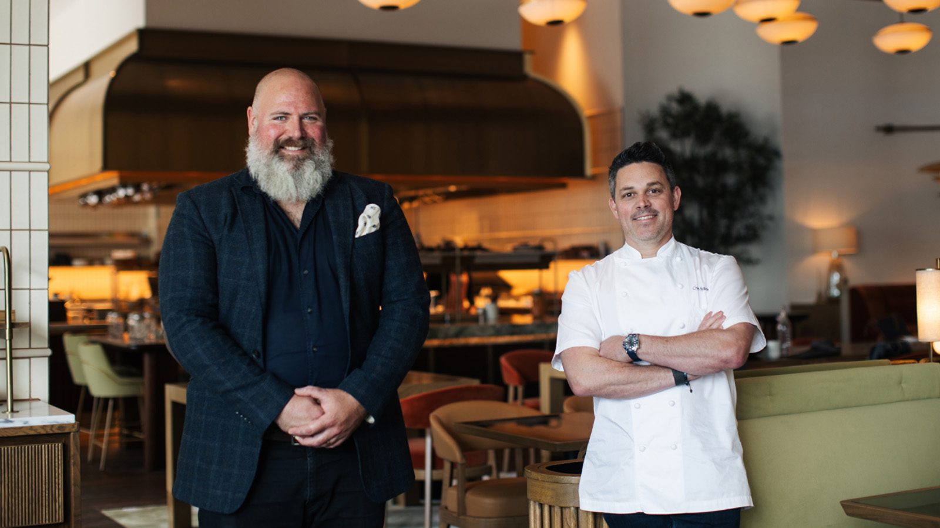
Four Seasons Hotel Minneapolis announces Twin Cities culinary veteran and Sommelier Paul Hennessy as Assistant Bar Manager of Mara, Chef Gavin Kaysen’s Mediterranean-inspired restaurant and bar. Hennessy will play an integral role alongside Beverage Director Adam Witherspoon to develop and curate the Hotel’s unique wine program. Hennessy’s extensive background in oenology and hospitality will help anchor Mediterranean connections of land, sea and craftsmanship through perfected pairings.
“Paul’s extensive knowledge and immense care for the guest experience is aligned with the beverage program Adam is passionately curating,” says Director of Food and Beverage Cindy Tlaiye. “The partnership between food and beverage will set the tone for a truly memorable meal and be as thoughtful as each ingredient of our expertly crafted dishes. We want our guests to be transported, and we are thrilled to have Paul facilitate this journey.”
A World of Possibilities
Made with connection and craftsmanship in mind, Hennessy collaborated with fellow Twin Cities’ wine stewards Amy Waller and Claire Maxwell of Soigné Hospitality to curate selections that invite guests on a journey of Southern France, Italy, Spain, Greece and Lebanon. The mission of this wine program, much like that of Mara’s kitchen, is to provide a linear experience for guests from start to finish. From the first cocktail to the wine pairing with a delicious meal, and all the hydration in between, elements link together for an unforgettable encounter.
“We have an extremely talented group of professionals in our local wine community – many of them women – who deserve a lot of credit for elevating our offerings in the Twin Cities,” says Hennessy. “As my team and I prepare to launch this new program at Mara, I tip my hat to those leaders who helped create this vibrant wine culture in Minnesota. We will do our best to make them proud and build upon what they have started.”
A Taste of Craftsmanship
While the Mediterranean will make its impressionable mark on the beverage selections at Mara, Hennessy has identified some exceptional juxtapositions. For instance, one might not expect a Lebanese rosé or a German riesling to pair well with dishes that are inherently Mediterranean, but after tasting more than 150 wines while defining the list, Hennessy and Witherspoon thoughtfully curated a menu to match the exceptional craftsmanship of the kitchen.
Hennessy will also work with Witherspoon to bring the spirit of the Italian Riviera to the fourth-floor restaurant Riva Terrace. There, beverages will vary to fit the playful, outdoor atmosphere found poolside, with light and refreshing favourites. The menu will provide Italian staples such as Aperol Spritzes while simultaneously surveying an exotic array of options such as Armenian rosé and several Slovenian selections.
Prior to Four Seasons, Hennessy worked at Bachelor Farmer as assistant wine director. As a third-generation bartender, it was there he fell in love with the world of wine. Much like Witherspoon, Hennessy experienced a drink that changed the trajectory of his career. Now with his Court of Master Sommelier Certification and a heart for hospitality, he looks forward to providing guests with unparalleled experiences at Four Seasons Hotel Minneapolis.

RELATED

June 1, 2022, Minneapolis, USA
NOW OPEN: Four Seasons Hotel Minneapolis Ready to Welcome Guests from Near and Far
https://publish.url/minneapolis/hotel-news/2022/now-open.html

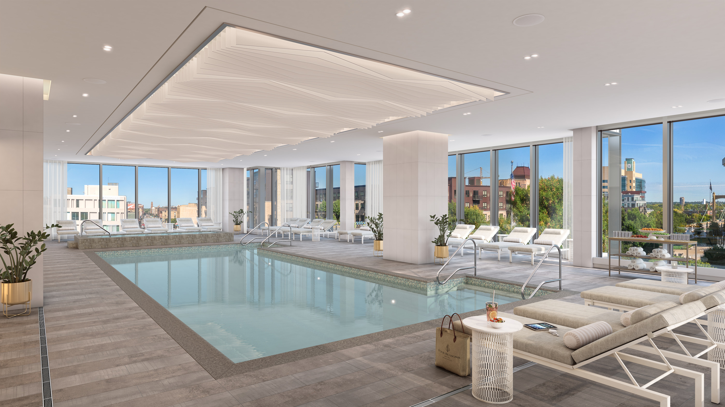 | May 27, 2022, Minneapolis, USA  Spa Reservations Open at Four Seasons Hotel Minneapolis  https://publish.url/minneapolis/hotel-news/2022/spa-reservations-live.html

PRESS CONTACTS

Allie Stoneberg
Director of PR and Communications
245 Hennepin Avenue
Minneapolis
USA
allie.stoneberg@fourseasons.com

+1 651 428 8612

