Four Seasons Resort and Residences Whistler Initiates Lead With Care Program and Launches Whistler Summer Staycation Package

May 26, 2020, Whistler, Canada

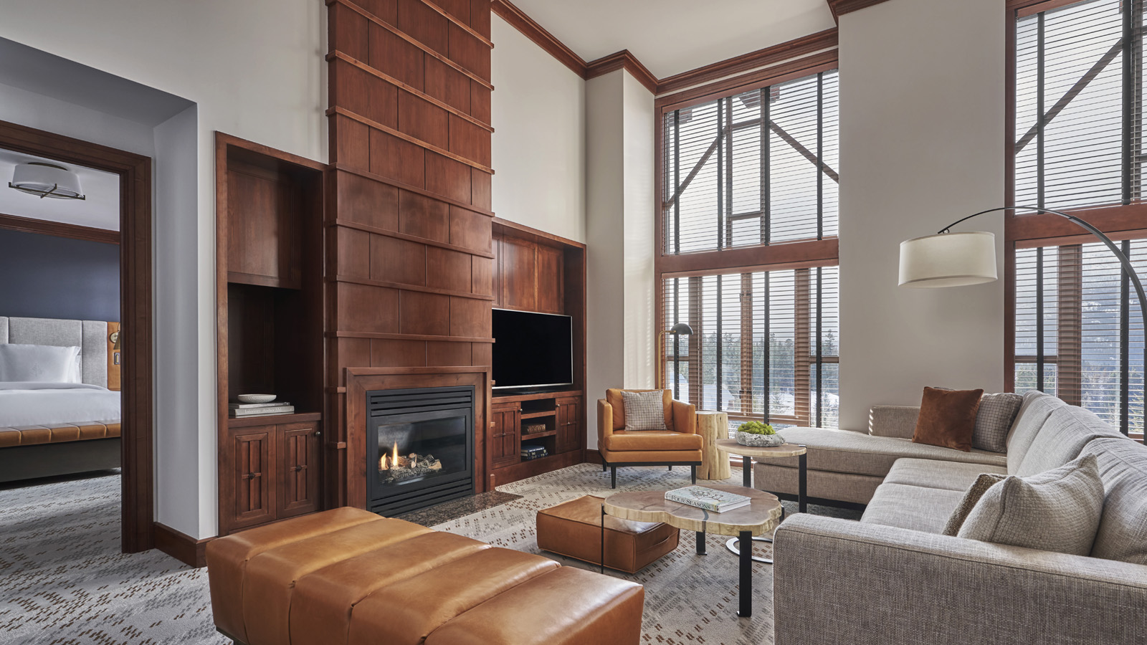
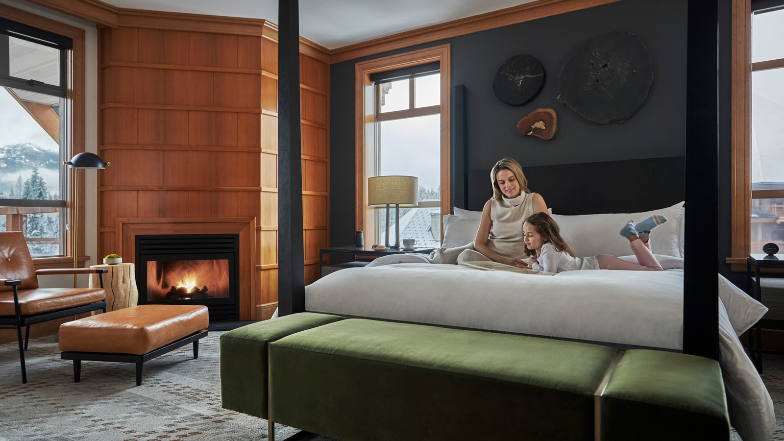
As we stay closer to home this summer, Four Seasons Resort and Residences Whistler invites guests to experience its newly renovated rooms, suites and Private Residences, while surrounded by luminous lakes and evergreen forests.
Whistler Summer Staycation Offer and Newly Designed Guest Rooms and Suites
Guests planning a trip this summer can now take advantage of the Whistler Summer Staycation offer, available online and through travel partners. Especially designed for drive-in guests, this promotion offers exclusive room rates, upgrades and a late check-out, while looking after four-legged family members too.
“We aim to offer our guests an extraordinary escape to their own private retreat with our thoughtfully designed renovated rooms and our Private Residences,” says Ali Mohammed, General Manager at Four Seasons Resort and Residences Whistler. “Most rooms feature a furnished balcony where guests can seize every moment of the outdoors and connect with Whistler’s beautiful alpine scenery.”
Be among the first to experience the Whistler Summer Staycation offer, available for online booking now.
Lead With Care
As we collectively respond to the COVID-19 pandemic, Four Seasons Resort and Residences Whistler continues to ensure that guest, resident and employee health and safety remains its top priority.
As a result, Four Seasons properties across the world have embarked on an important global health and safety program, Lead With Care, which provides ongoing, real-time guidance and clear measures on the evolving COVID-19 situation. Through this program and collaboration, Four Seasons is leveraging world-class medical expertise to focus on enhancing cleanliness, guest comfort and safety and employee training.
A key part of the guest experience will continue to be the Four Seasons App and Chat. This award-winning service will further allow guests to control how they engage with employees. While face-to-face interactions may be more limited, Four Seasons staff will remain as connected as ever. From the comfort of their own device, the App provides a contactless experience that does not compromise Four Seasons genuine care and signature service.
For more information on Lead With Care, click here.
The pursuit of adventure starts in a private retreat on the mountains. By giving guests time and a safe space to relax, connect, explore, share passions, Four Seasons Resort and Residences Whistler is able to create new opportunities for adventure and memory making.

RELATED

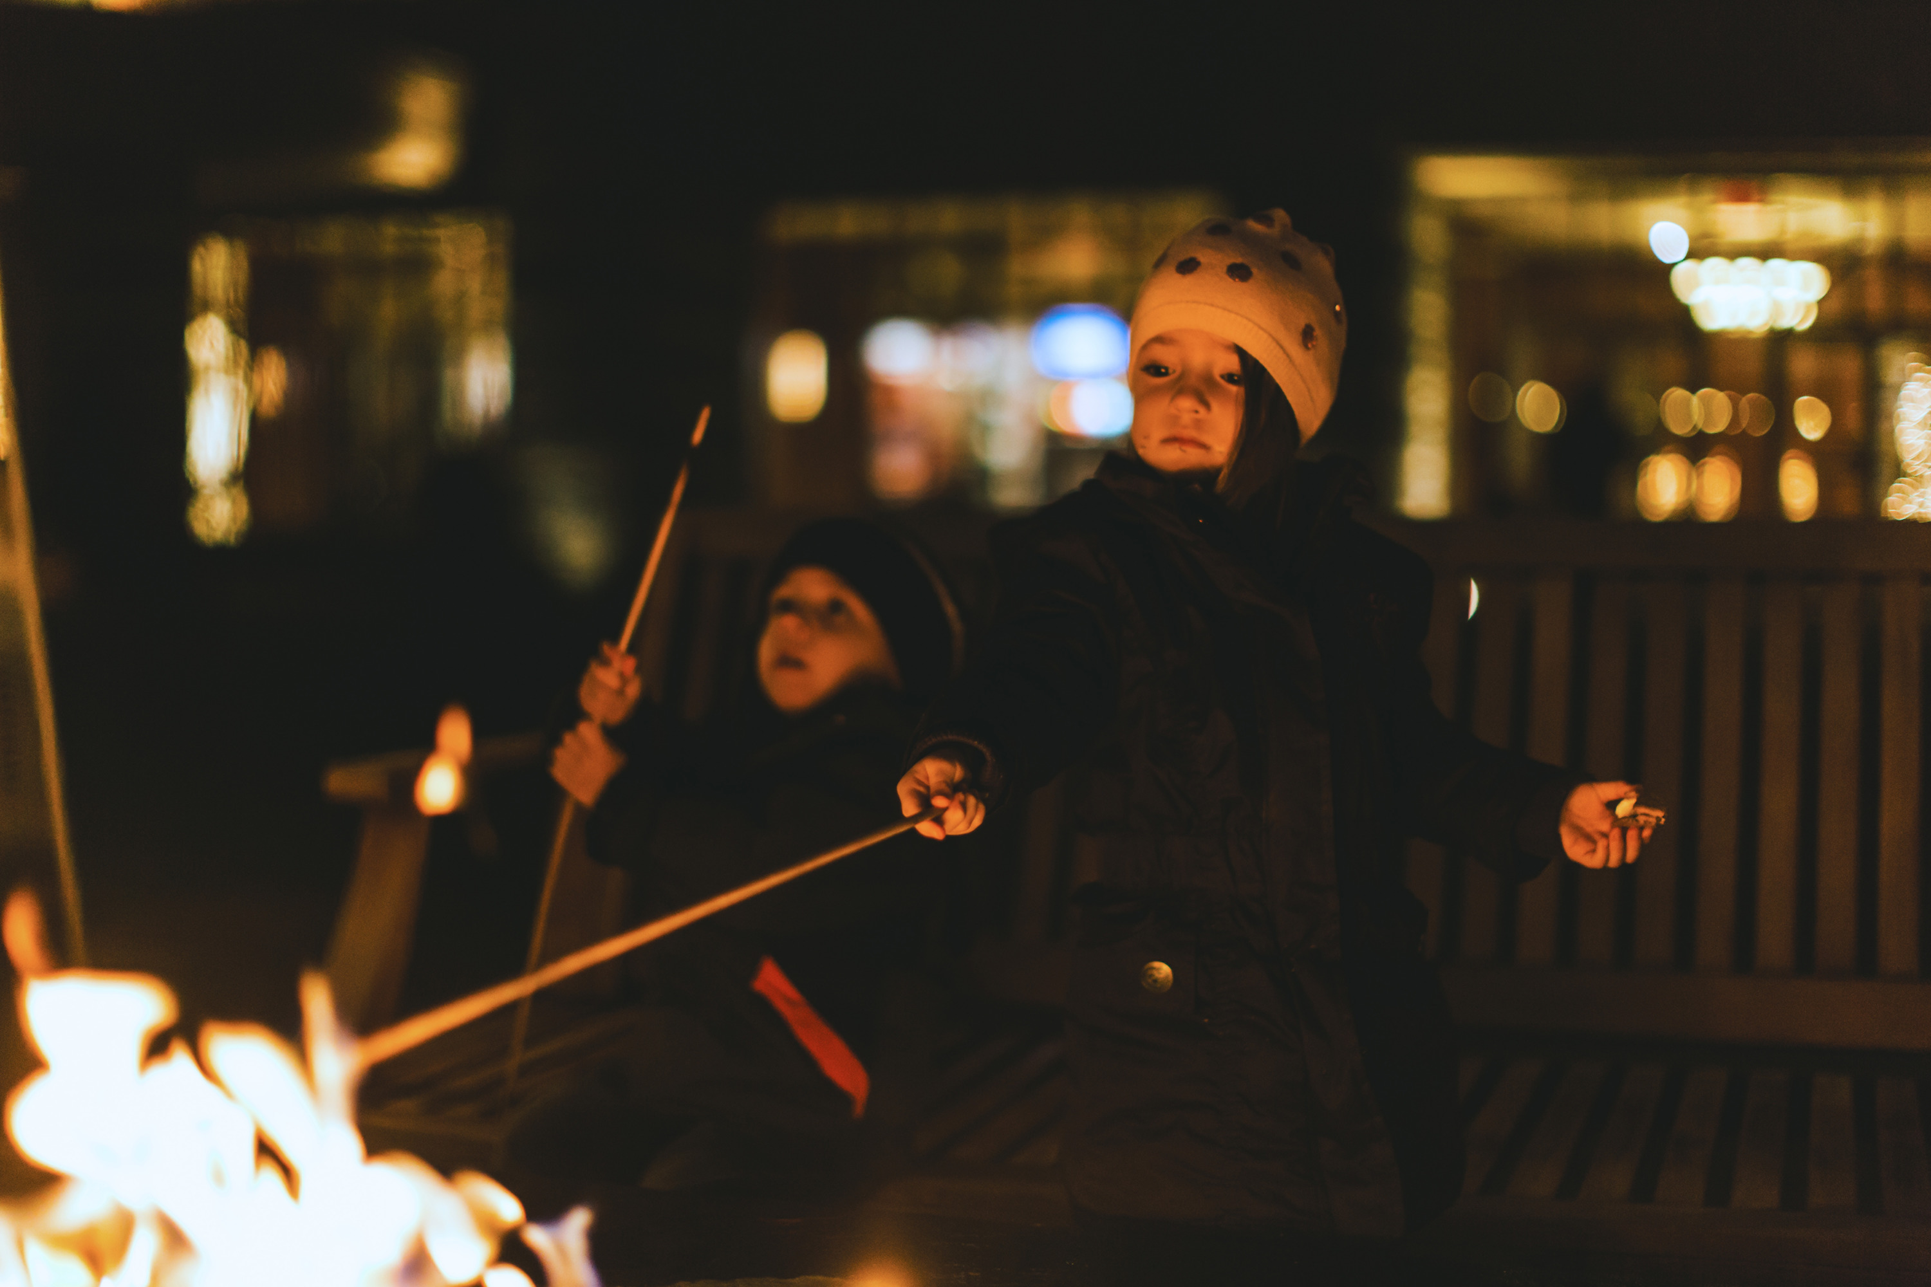 | February 21, 2020, Whistler, Canada  Take a Leap and Make the Most of Gifted Hours at Four Seasons Resort and Residences Whistler This Leap Day  https://publish.url/whistler/hotel-news/2020/take-your-time.html
February 19, 2020, Whistler, Canada
New Names Join Lauren Mote for the Third Volume of the Spirit of the Mountains Cocktail Program at Four Seasons Resort and Residences Whistler
https://publish.url/whistler/hotel-news/2020/new-spirit-of-the-mountains-cocktails.html

PRESS CONTACTS

Chelan Goonetilleke
Director of Marketing
4591 Blackcomb Way
Whistler
Canada
chelan.goonetilleke@fourseasons.com

+1 604 966 7253

