The Top 10 Most Social Media Worthy Locations at Four Seasons Resort Nevis

April 13, 2018, Nevis, West Indies

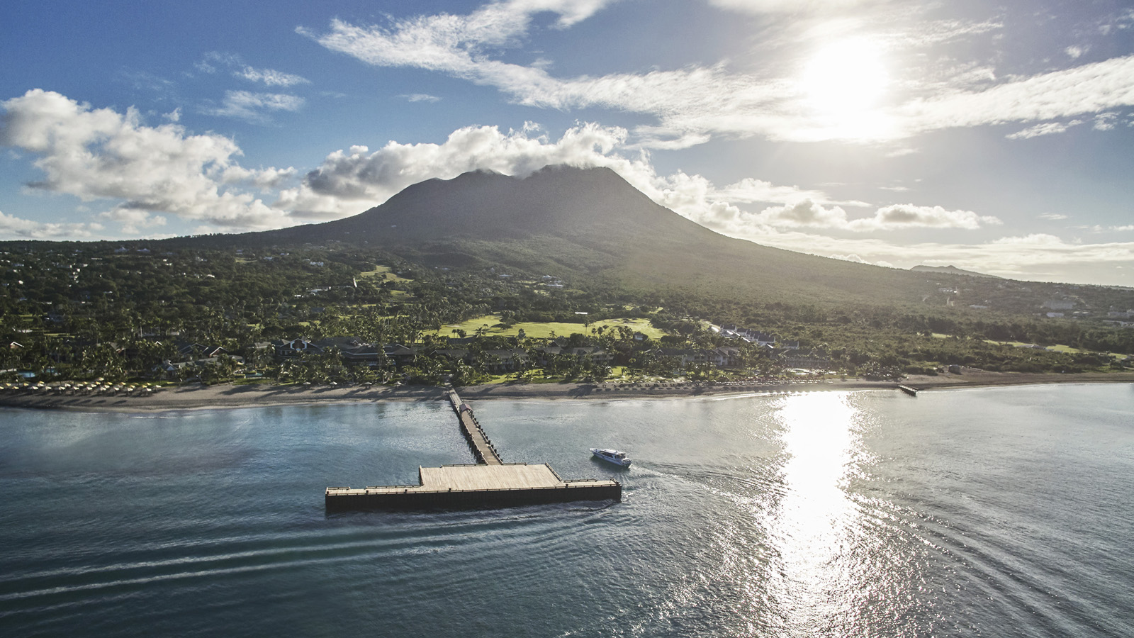
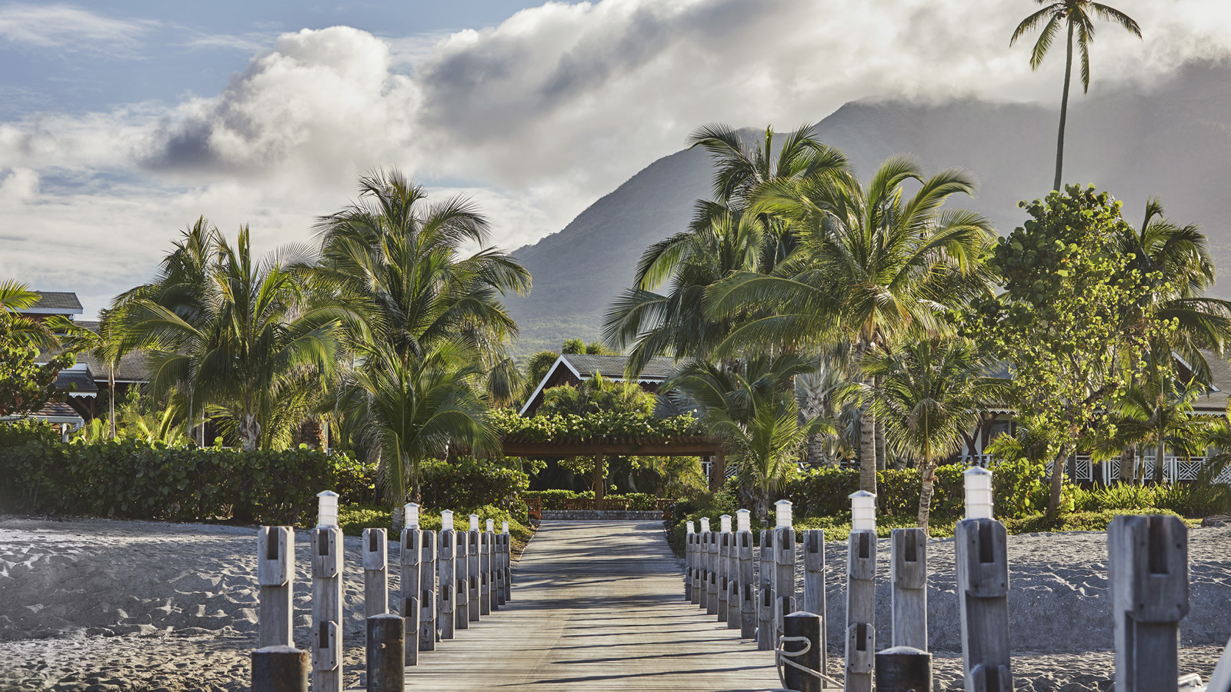 | 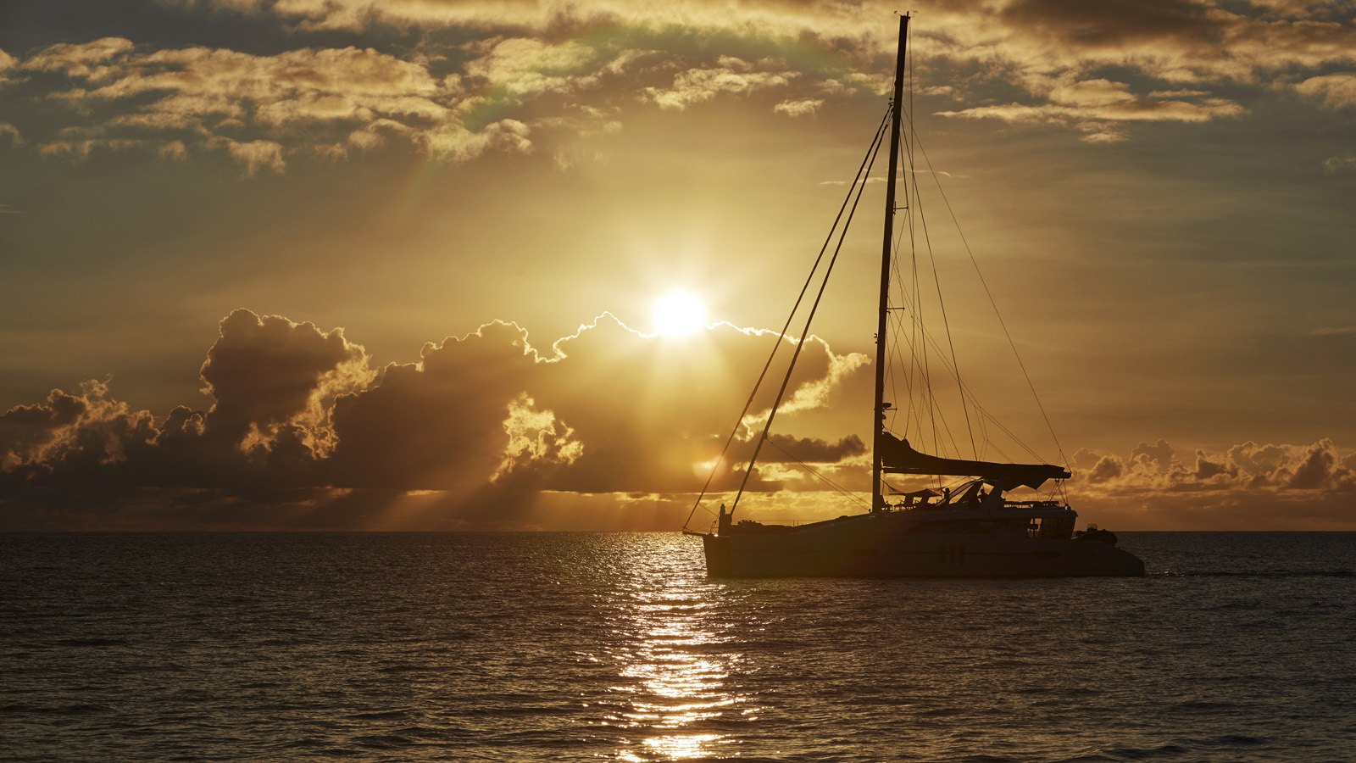 | 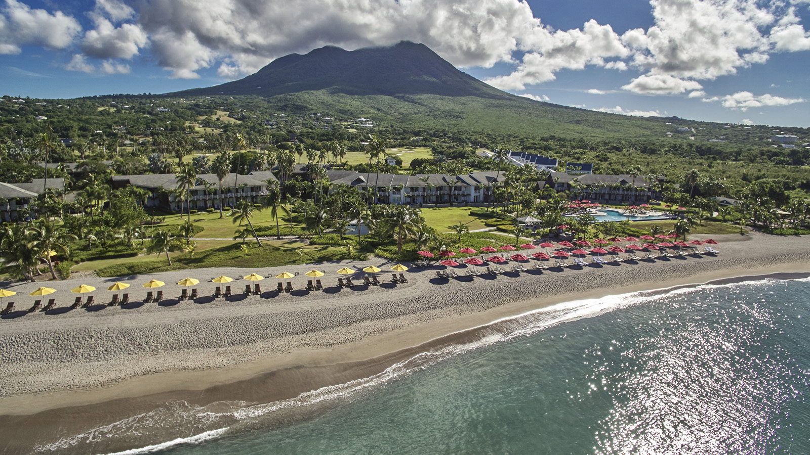
There’s no doubt that an island getaway to
Four Seasons
Resort Nevis provides plenty of gorgeous social media worthy moments. Built on a former sugar and coconut plantation dating to the late 1790s, our Resort maintains Nevis’ quaint and intimate reputation as an untouched Caribbean destination, seamlessly weaving the genuine warmth and charm of the Nevisian culture into a resort experience that celebrates the Caribbean as it was meant to be – unspoiled, undisturbed, and unforgettable.
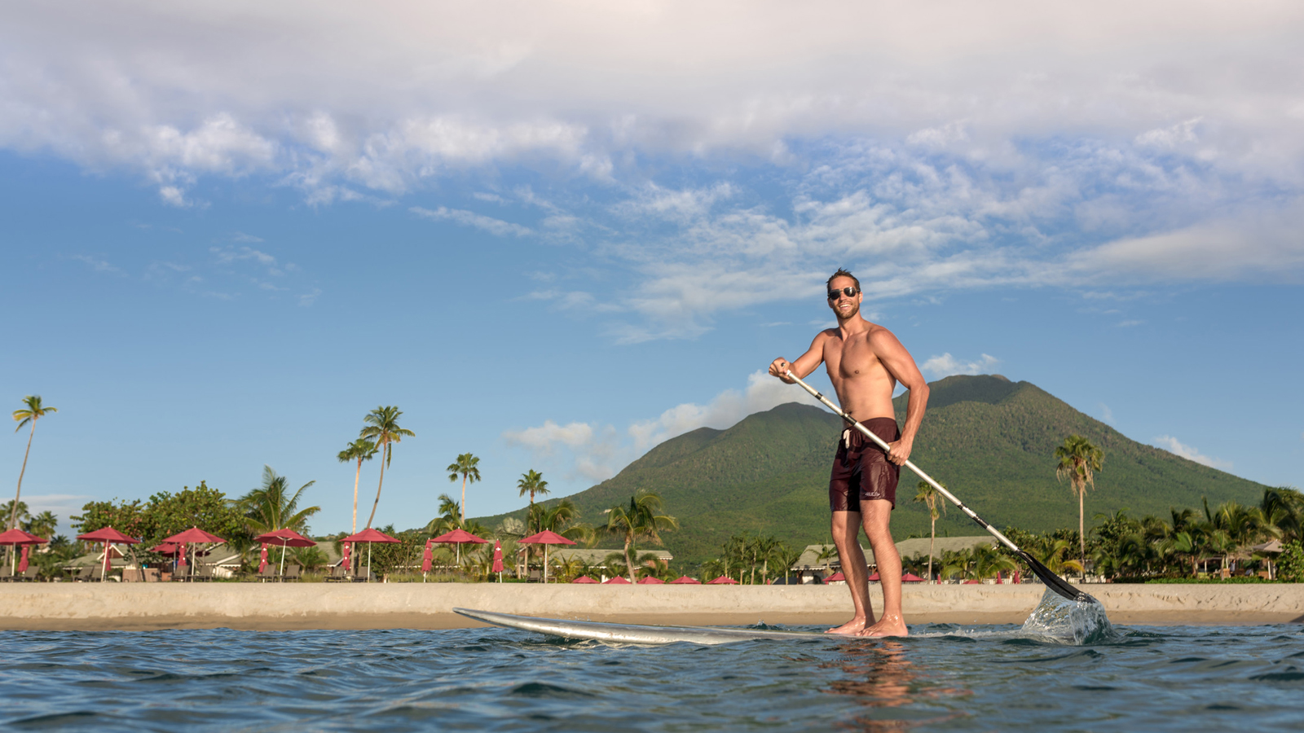 | 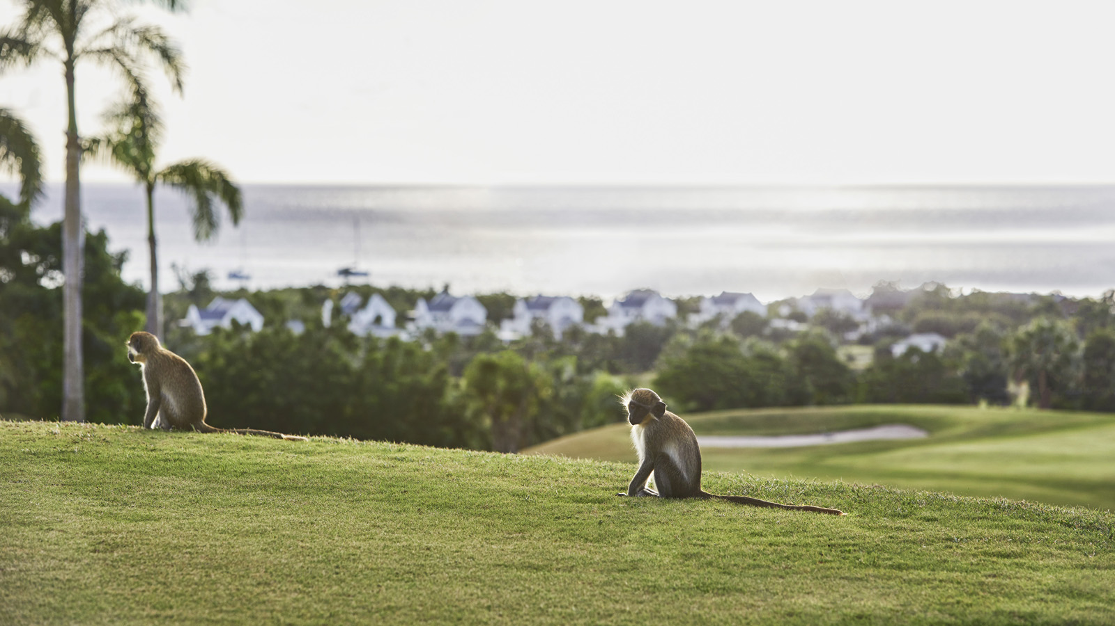 | 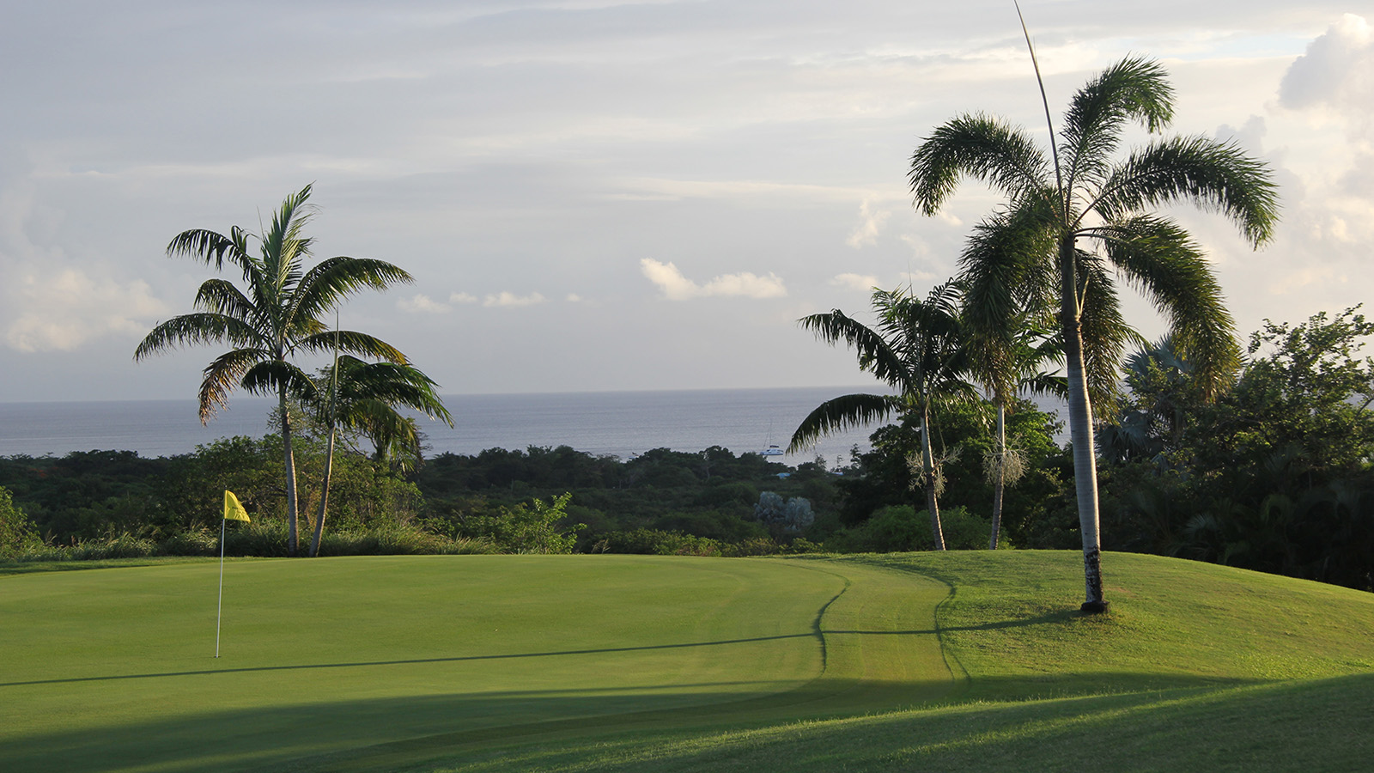
But with so many locations at #FSNevis providing postable photo opps, we’ve put together a handy guide of some of the Resort’s top spots to appear on social media. These are a collection of one-of-a-kind vistas, activities and experiences that are sure to ramp up the number of likes and followers across all of your accounts.
Don’t forget to tag us!
The Pier
Our 7,000 square foot (650 square metre) pier provides a unique and stunning vantage point that you’ll definitely want to capture. Whether looking back towards the lush greenery of the Resort (with a photobomb by none other than the iconic Nevis Peak) or out towards the serene waters of the Caribbean Sea at sunset, you’re sure to find your new profile pic here.
Pinney’s Beach
A half-mile of soft, golden sand stretches between the shade of majestic coconut palms and the warm, clear Caribbean Sea offer ample opportunity for social media posts along Pinney’s Beach. Grab a complimentary stand-up paddleboard and wade offshore with your waterproof phone case for an Instagram-worthy watersports shot.
Golf Course
The Resort’s 18-hole Robert Trent Jones II signature golf course is woven into the landscape of Nevis. In addition to championship calibre golf, the course offers ample opportunity to post a plethora of pictures of the beautiful surroundings. Not only will you find the friendly faces of the island’s green vervet monkeys, but also breathtaking scenery on every green and fairway – from the sugar mill ruin on Hole #2 to signature sea views from Hole #15.
Reflection Pool
The tranquil Reflection Pool is surrounded by a heart-shaped teak deck and features its own lap lane. Designed for adults, this free-form pool's meditative mountain backdrop and view over the sparkling blue waters of the Caribbean make it an ideal space for relaxation, respite and your own private photo shoot.
Great House
Our Great House lobby offers wall-to-wall windows that open up to dramatic views of the Garden Pool and Caribbean Sea. When stopping in for your morning coffee or sunset cocktail, you’ll immediately feel the desire to post a photo of your drink of choice to Twitter or Facebook.
Mango
A short stroll down Pinney’s Beach is the waterfront Mango restaurant, featuring spectacular panoramic views of St. Kitts across the Caribbean Sea. It’s a perfect spot to snap a sunset selfie before a casual Caribbean dinner.
Spa
Our Spa is an authentic Caribbean sanctuary set in a garden amid lush greenery and the brightest of blooms. Following your treatment, pose for a pic surrounded by the tropical flora and fauna or at the Japanese-inspired cold plunge pool with grand views of Nevis Peak.
Garden Games
Located near the Resort’s herb garden, our bocce ball, oversized chess and shuffle board courts not only provide the opportunity for endless fun and games, but also the chance to snag an in-motion boomerang that will be sure to leave your followers fascinated with your Insta Story.
Kastawey
The Kastawey Beach Bar offers a casual toes-in-the-sand beach and a hideaway to enjoy the Caribbean afternoon, capturing the joyful spirit yet serene essence of Nevis. The onsite boat is a replica of the traditional Nevisian fishing boats that can be found roaming the coastline and a great spot for a photo with rum punch in hand.
Moving Targets
Roaming the pools and beach each afternoon are the Kool Rummings Rum Cart and One Love, Two Scoops Gelato Bike. With their bright colours they can’t be missed as they cruise the pathways offering delicious tropical treats like rum punch and homemade gelato and the chance for a photo with the friendly faces of their drivers.

RELATED

April 3, 2018, Nevis, West Indies
Four Seasons Resort Nevis Announces Exclusive Caribbean Residents' Rate for the Summer and Fall
https://publish.url/nevis/hotel-news/2018/caribbean-residents-rate.html

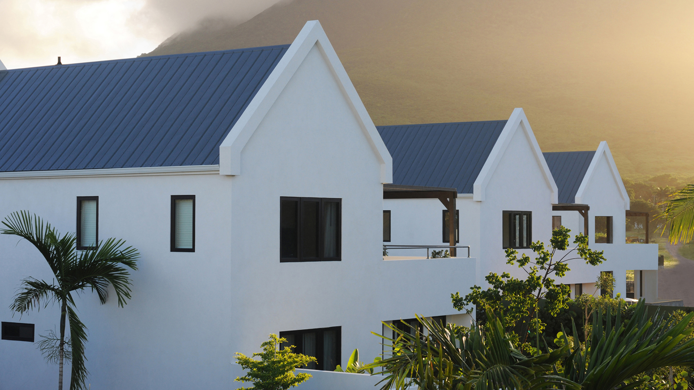 | February 22, 2018, Nevis, West Indies  Four Seasons Resort Nevis Offers More Ways to Enjoy Your Home Away from Home with New Villa Packages  https://publish.url/nevis/hotel-news/2018/new-villa-packages.html

PRESS CONTACTS

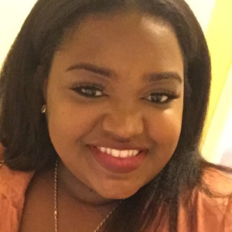 | Gillian Stoney  Digital Marketing Communications Manager  Four Seasons Resort Nevis  Nevis, West Indies, Caribbean  gillian.stoney@fourseasons.com  +1 (786) 655-8507
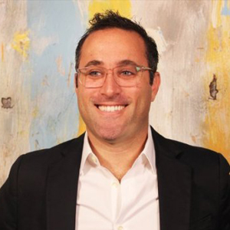 | Mitchell Nover  Director of Public Relations and Communication  3350 SW 148th Avenue, Suite 204  Miramar  U.S.A.  mitchell.nover@fourseasons.com  +1 (786) 655-8509

