Global Wellness Day at the Spa at Four Seasons Hotel London at Ten Trinity Square

The Spa celebrates Global Wellness Day with a program of wellness activities and offerings
June 3, 2021, London at Ten Trinity Square

On Saturday, June 12, 2021, Four Seasons Hotel London at Ten Trinity Square will celebrate Global Wellness Day, a day dedicated to living well, promoting good physical and mental health, and experiential wellness activities.
Recognising the need to stay strong and healthy at this time, the team at Four Seasons Hotel London at Ten Trinity Square has come together to offer a selection of experiences that will nourish, energise and restore the mind and body of guests. The Global Wellness Day program includes:
9:30–10:30 am: Refocus with guided meditation and yoga
Kathleen Eastman will kick off the day at The Spa at Four Seasons Hotel London at Ten Trinity Square with a guided meditation and yoga session that will help guests to slow down, clear their thoughts and refocus both the mind and body.
11:00 am – 12:00 noon / 2:00–3:00 pm: Release tension with mini foot and head massages
For those wanting to take the weight off their feet, The Spa’s team of expert therapists will be on hand to provide complimentary mini foot and head massages to ease tension and soothe tired muscles.
9:00 am – 3:00 pm: Refuel with balanced nutrition
To keep guests energised and prepared for the day, a selection of complimentary smoothie shots and light bites will be available at the Spa Reception.
Advance reservation is required for the activities. Contact +44(0)203 297 9200 or email the Spa team at spa.tentrinity@fourseasons.com.
Share wellness experiences by tagging @FSTenTrinity and using the hashtags #FSWellness and #GlobalWellnessDay.

RELATED

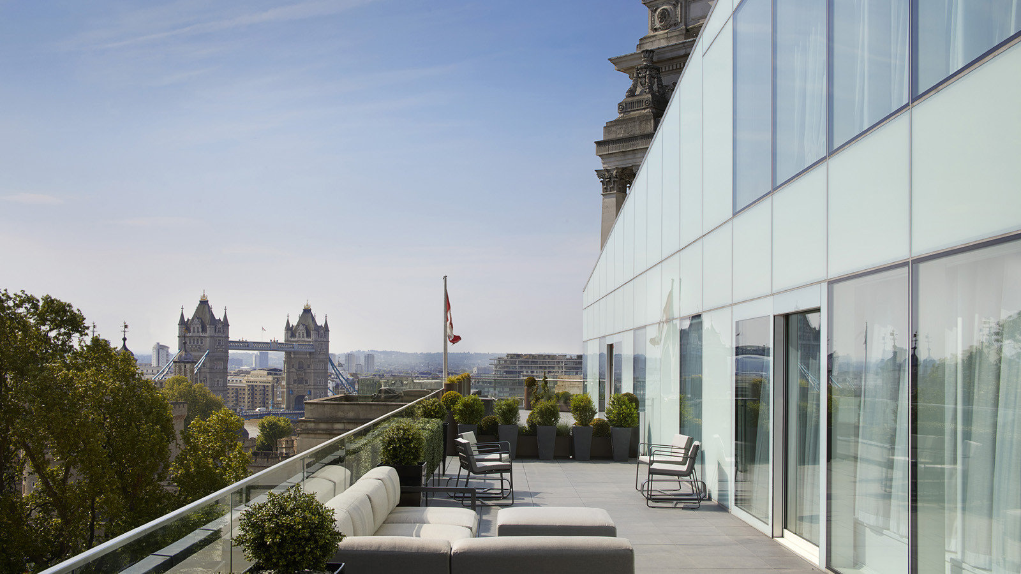 | May 25, 2021, London at Ten Trinity Square  Staycation in Style at Four Seasons Hotel London at Ten Trinity Square  https://publish.url/tentrinity/hotel-news/2021/private-residences-accommodations.html
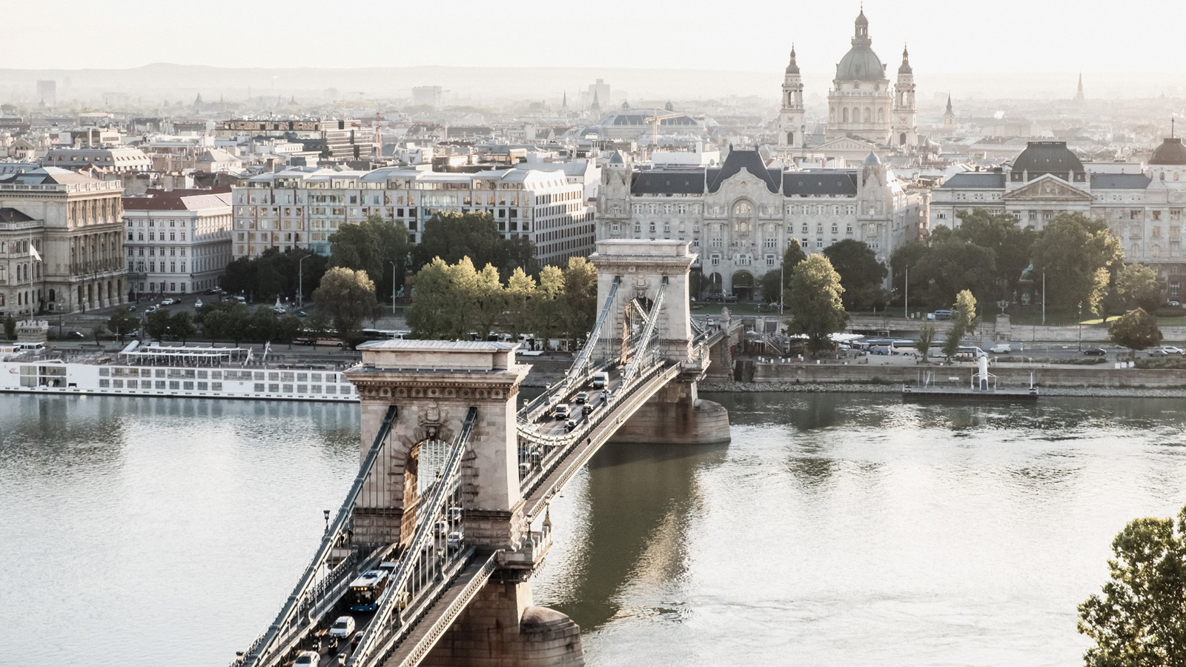 | May 20, 2021, Toronto, Canada  Sechs malerische Roadtrip Routen durch Europa  https://publish.url/news-releases/2021/european-road-trips-4.html

PRESS CONTACTS

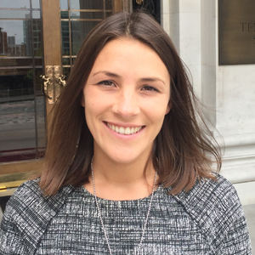 | Gemma Minto  Director of Public Relations  10 Trinity Square  London  UK  gemma.minto@fourseasons.com  +44 (0) 203 297 9232

