Embrace the Spirit of Ramadan in Cairo with Four Seasons Hotel Cairo at The First Residence

The Hotel celebrates Ramadan and invites guests to share the spirit with loved ones, family and friends with an attractive selection of culinary experiences and spa packages that capture the essence of the Holy Month
April 5, 2021, Cairo at The First Residence, Egypt

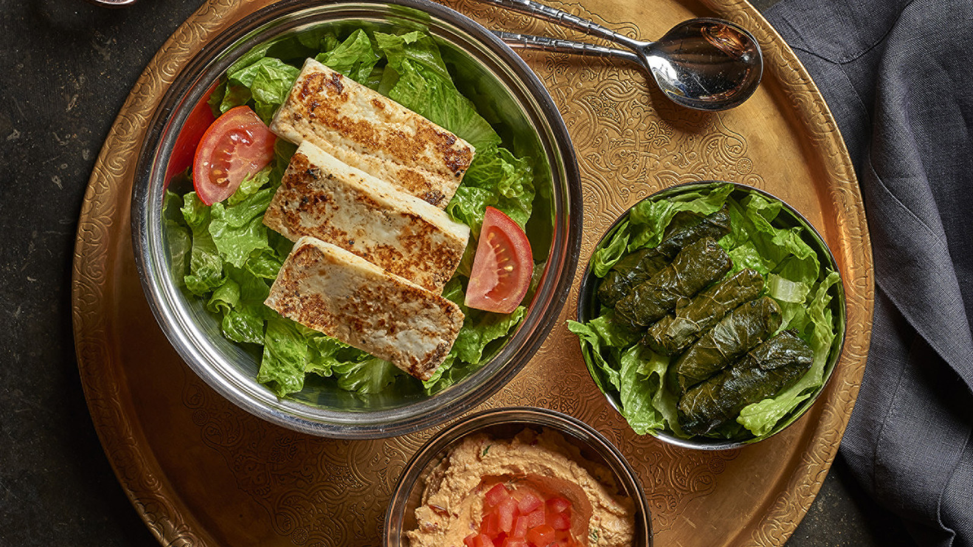
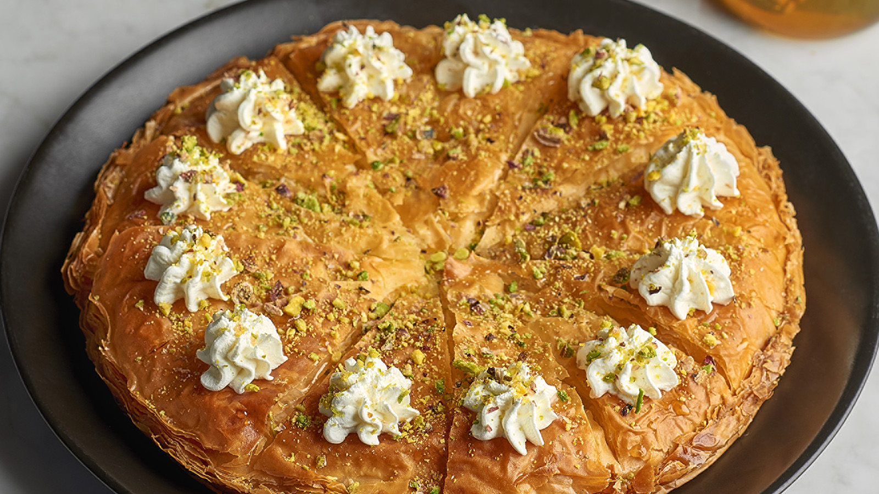 | 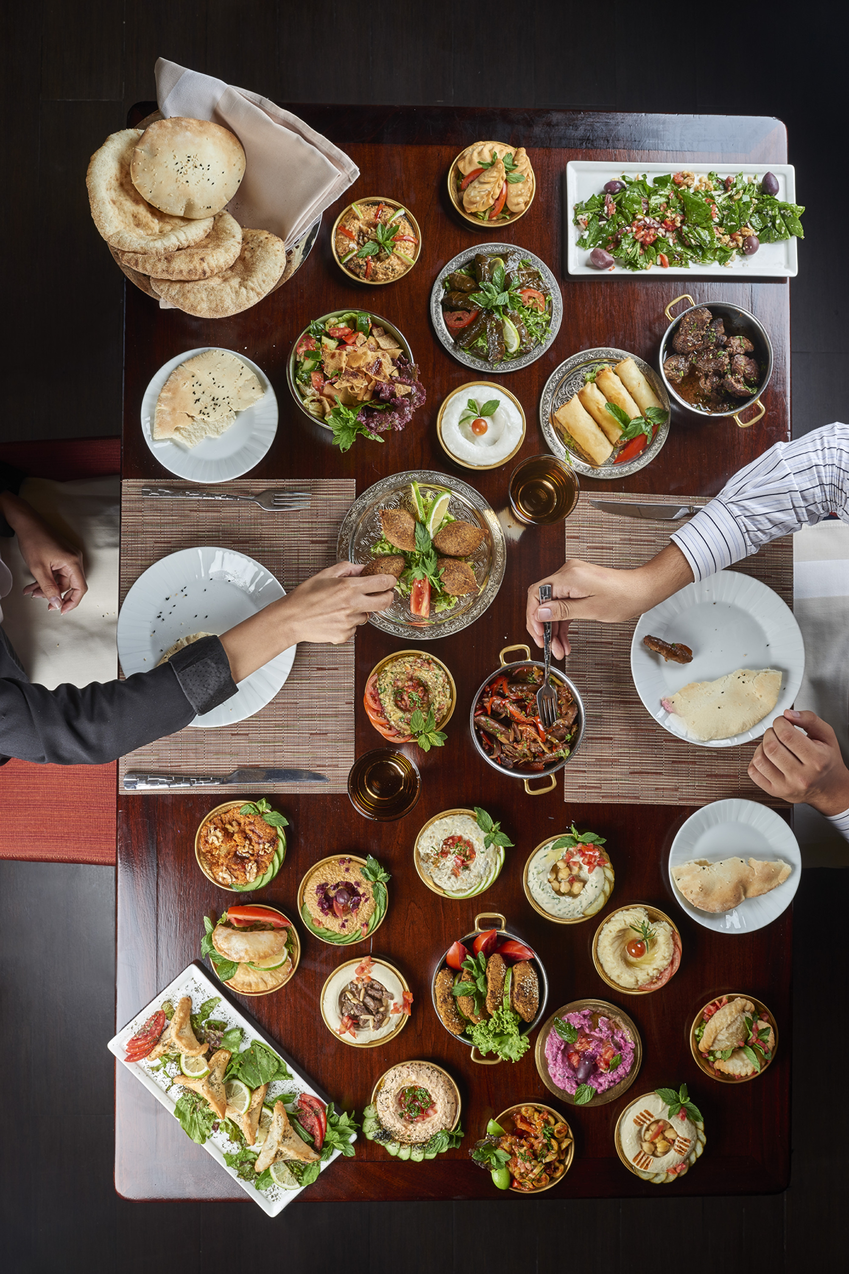 | 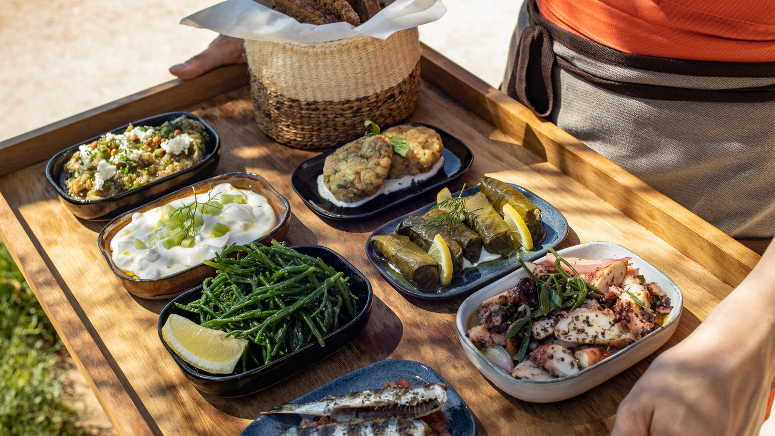
Four Seasons Hotel Cairo at The First Residence unveils delectable culinary offerings in a variety of outlets outdoors with mesmerising views over the River Nile at Zoe or panoramic views of the pool in Aura; or head to the Spa for revitalising packages to help guests celebrate the spirit of the Holy Month.
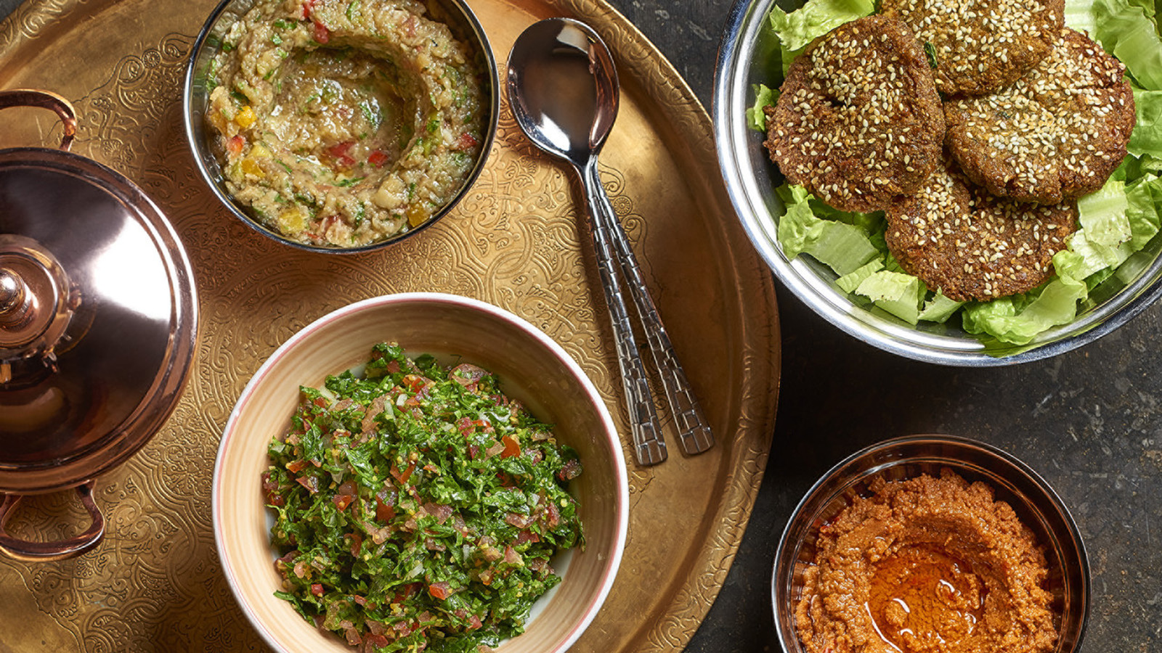 | 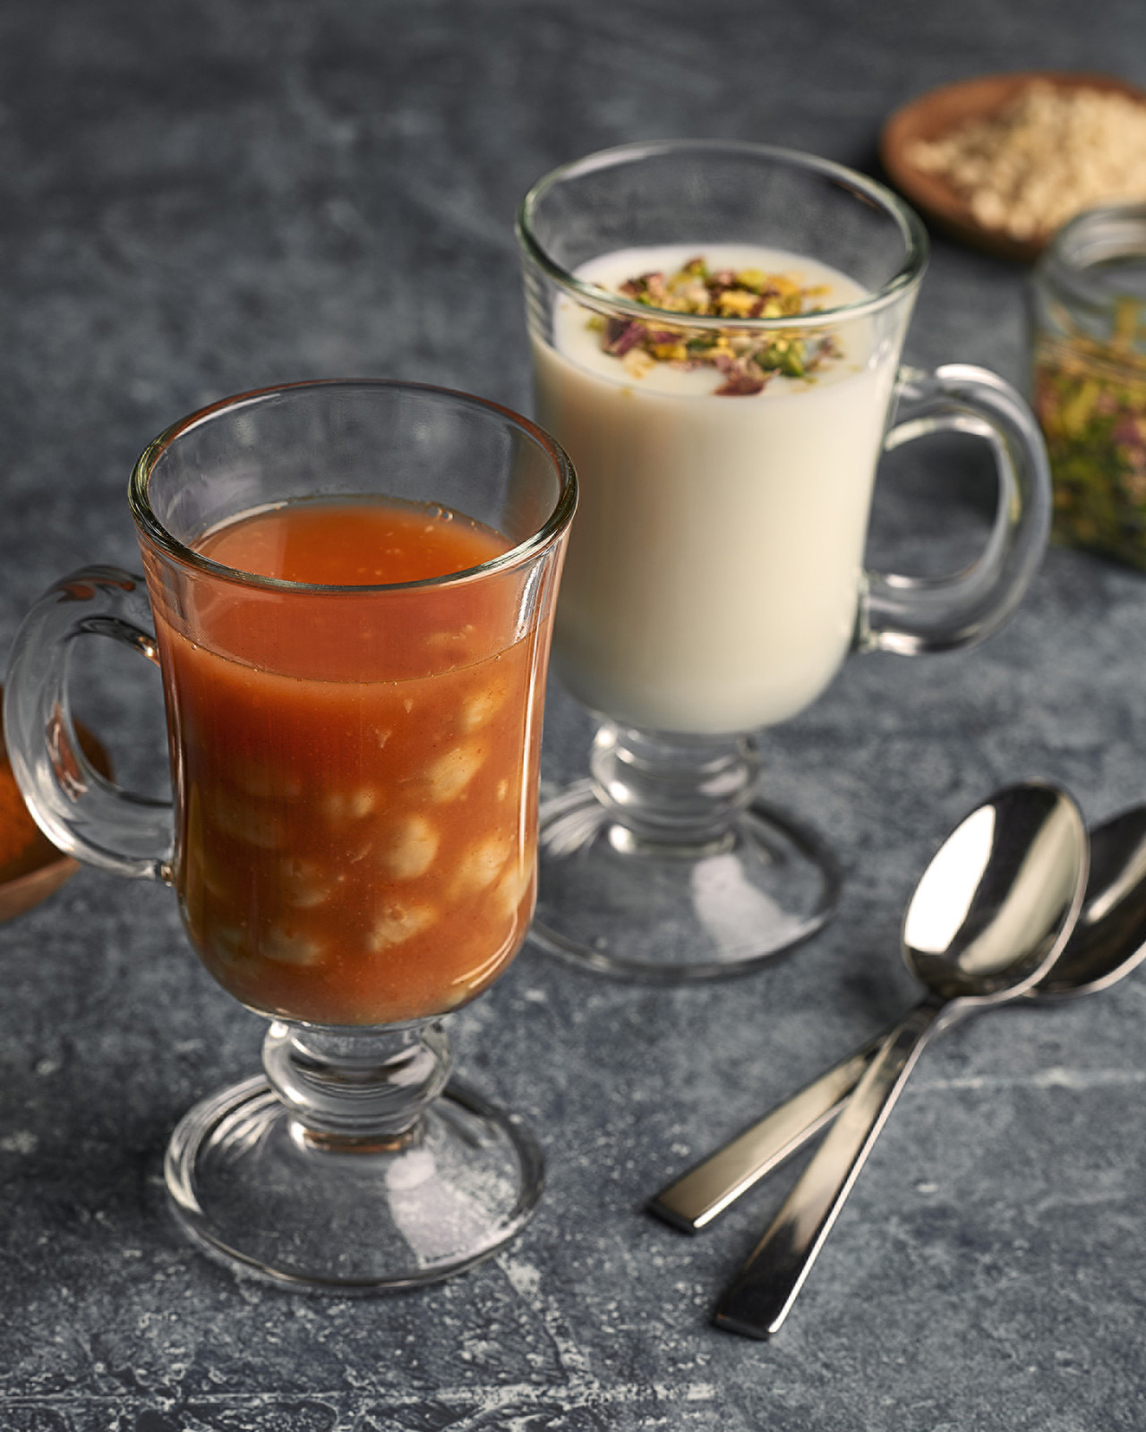
Celebrate Ramadan Outdoors Under the Glittering Stars
Spend Ramadan evenings under the night sky outdoors by the pool and enjoy Iftar family-style set menus for EGP 585 per guest subject to service charge and taxes in renowned Syrian restaurant Aura, exquisitely curated and prepared by Four Seasons chefs, featuring hot and cold mezzes, grills, tajines and delicious Arabic desserts.
For an exclusive Ramadan experience, book a private cabana at the pool deck for an additional EGP 300 subject to service charge and taxes.
For Sohour, families and friends gather starting at EGP 150 per person subject to service charge and taxes, which includes water and a fine selection of nuts. Opt from an a la carte menu and catch up with the latest Ramadan series and enjoy live entertainment in the comfort and safety of Aura's private cabanas.
Children below 6 years dine with the Hotel's compliments; children 6 to 12 years are entitled to 50 percent savings.
Egyptian Ramadan Specialities at La Gourmandise
La Gourmandise restaurant situated in the heart of the First Mall will set the scene with an extravagant Iftar buffet featuring Egyptian and Ramadan favourites, from soups, salads, hot and cold mezzes to main courses, grills, carving station, live stations (all in line with Four Seasons health and safety regulations) and desserts crafted by Four Seasons culinary experts. The Iftar buffet is priced at EGP 600 per guest and is subject to service charge and taxes.
Children below 6 years dine with the Hotel's compliments; children 6 to 12 years are entitled to 50 percent savings.
A Taste of Greece by the Nile
Get a taste of Greece at Zoe restaurant in the outdoors, located at the upper deck of the The First Nile Boat, and indulge in tantalising Mediterranean tastes infused with Middle Eastern influences in the form of two family-style set menus for Iftar and take in sweeping views of the Nile.
Family style set menu starts from EGP 550 per guest, subject to service charge and applicable taxes.
Take in captivating Cairo views and the Nile at night and indulge in an all-Greek Sohour with Egyptian influences from Zoe’s extensive a la carte menu. The Sohour menu starting price of EGP 150 spend per person includes water and a fine selection of nuts and is subject to service charge and taxes.
Children below 6 years dine with the Hotel's compliments; children 6 to 12 years are entitled to 50 percent savings.
Revitalise During the Holy Month with Four Seasons Spa
Ramadan is traditionally seen as a time of renewal. Head to the The Spa at Four Seasons Hotel Cairo at The First Residence and enjoy a day of cleansing, rejuvenation and ultimate relaxation.
The Ramadan Pampering Treatment includes a 60 minutes Swedish massage priced at EGP 1300 inclusive of all applicable taxes, or upgrade to 90 minutes. Treatment is available from 12:00 pm to 9:00 pm daily.
To find out more about the Ramadan Spa schedule, contact the Spa team at +20 23567 2040 or email spa.caf@fourseasons.com
For reservations or enquiries call +(202) 35672021

RELATED

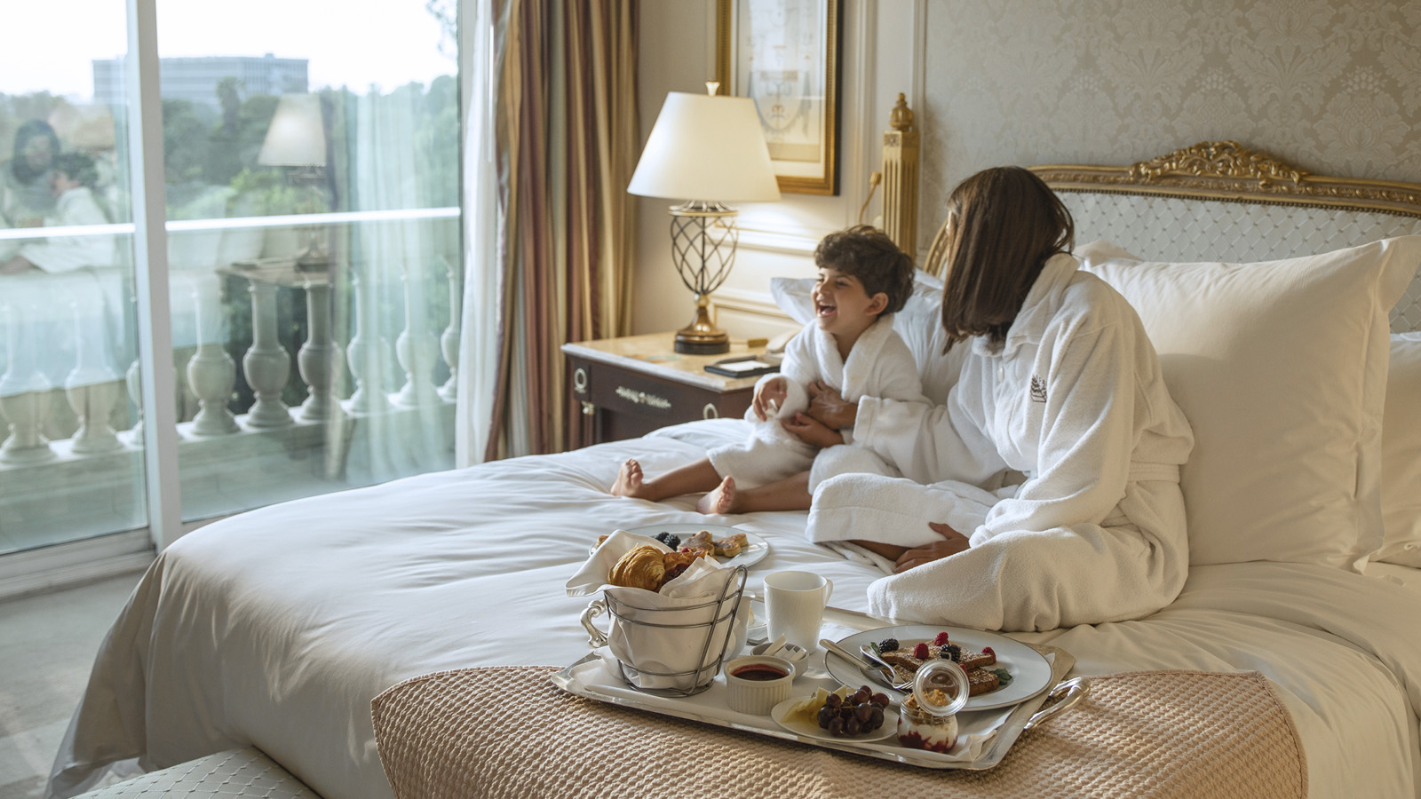 | March 8, 2021, Cairo at The First Residence, Egypt  Mom’s the Word at Four Seasons Hotel Cairo at The First Residence  https://publish.url/cairofr/hotel-news/2021/mothers-day.html
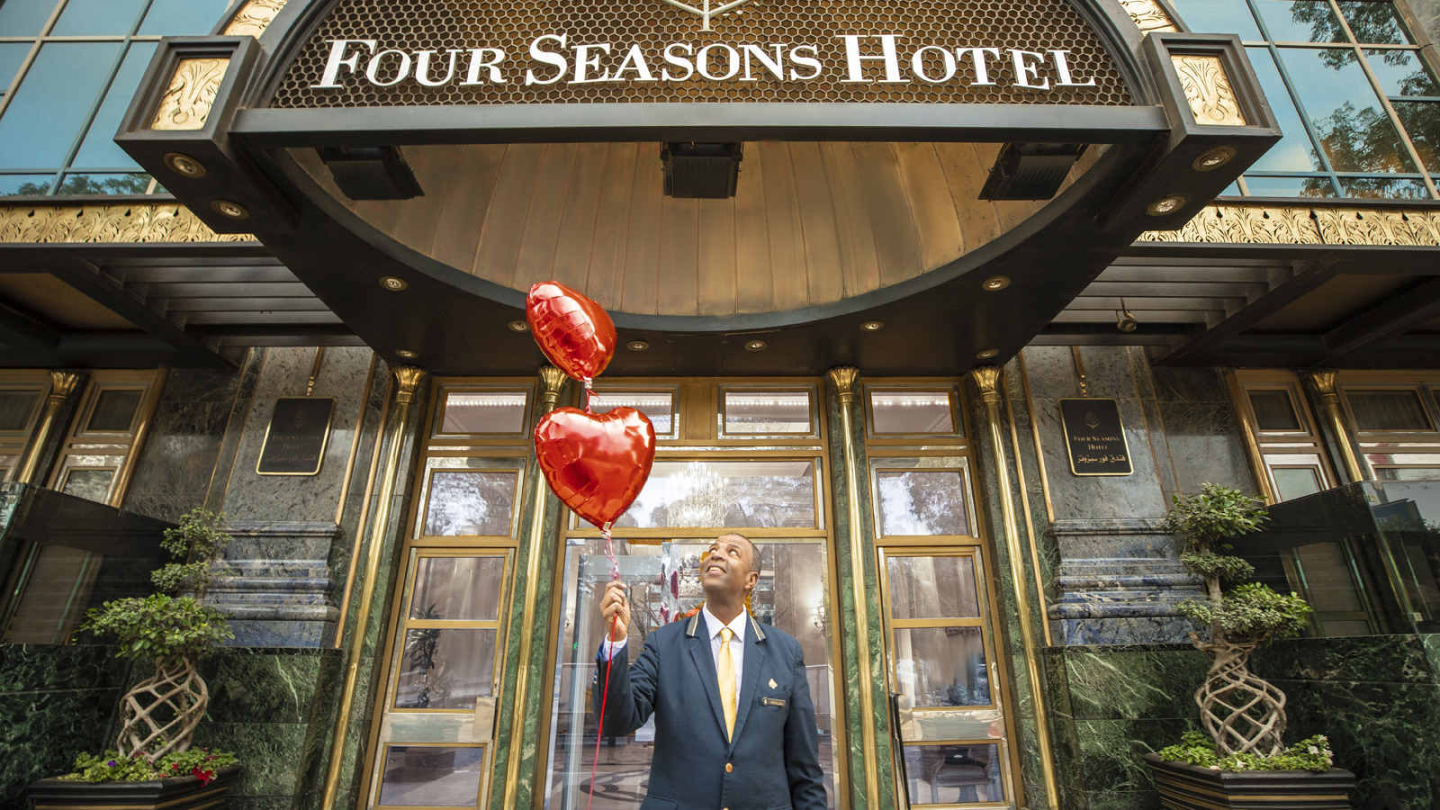 | January 18, 2021, Cairo at The First Residence, Egypt  Love is All Around at Four Seasons Hotel Cairo at The First Residence  https://publish.url/cairofr/hotel-news/2021/valentines-day.html

PRESS CONTACTS

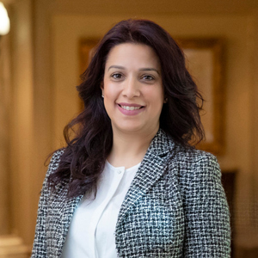 | Hibba Bilal  Director of Public Relations and Communications  35 El Giza Street  Cairo  Egypt  hibba.bilal@fourseasons.com  + 20 2 3567 1600
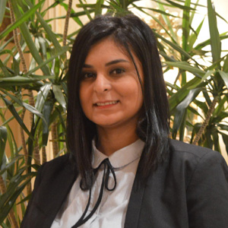 | Mariam Mohsen  Digital Marketing Assistant Manager  35 El Giza Street  Cairo  Egypt  mariam.mohsen@fourseasons.com  +20 2 3567 1600

