Four Seasons Hotel Washington, DC Kicks Off Its 40th Annual Race to Beat Cancer on Global Wellness Day as a Community Virtual Challenge

June 10, 2020, Washington, DC, U.S.A.

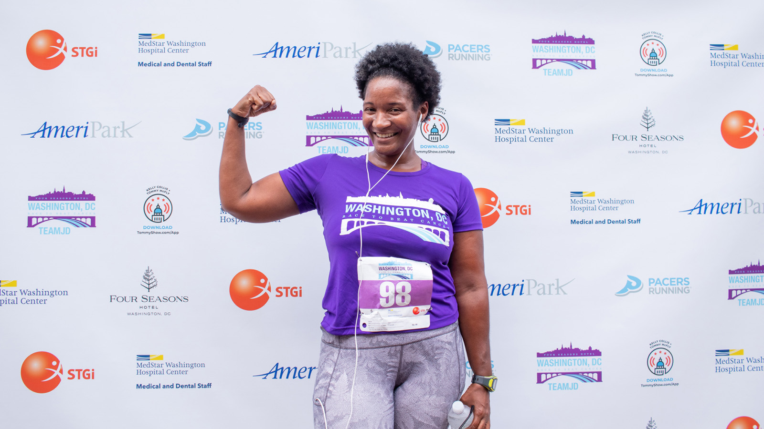
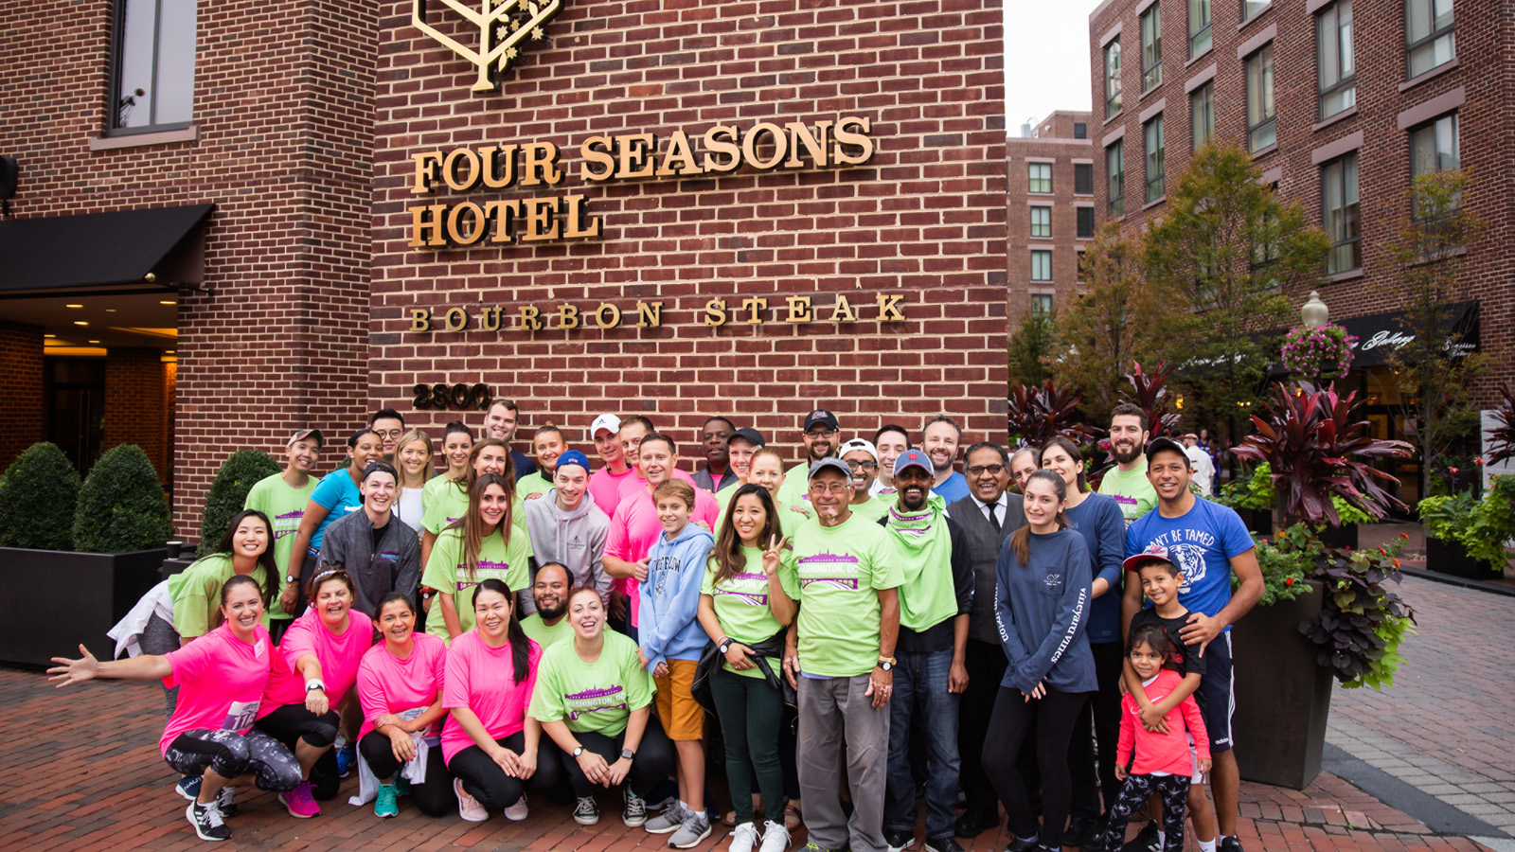 | 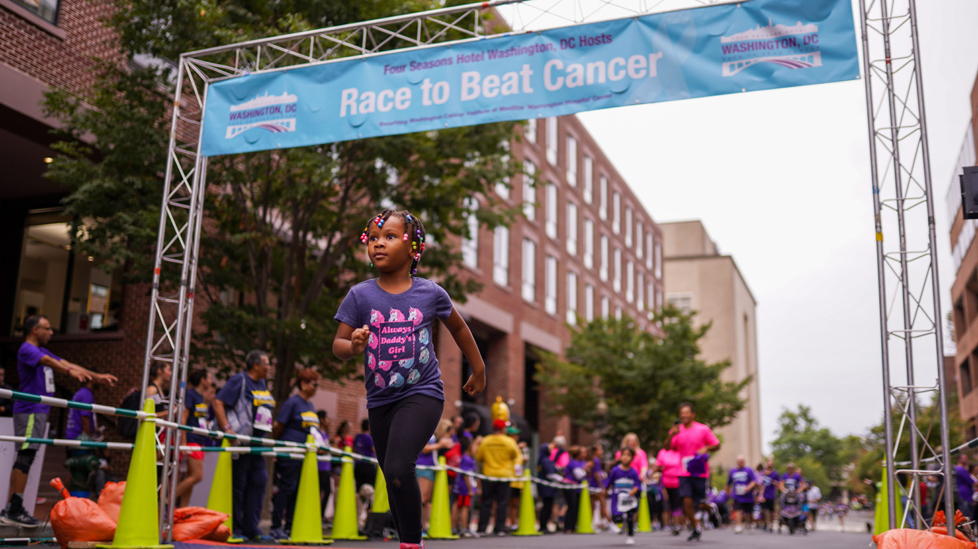
On June 13, 2020, Four Seasons Hotel Washington, DC will begin celebrating the 40th anniversary of Race to Beat Cancer with a week-long virtual challenge to benefit MedStar Washington Hospital Center’s Washington Cancer Institute. This year marks the 40th anniversary of the race in DC and the 20th year in partnership with MedStar Washington Hospital Center’s Washington Cancer Institute.
 | 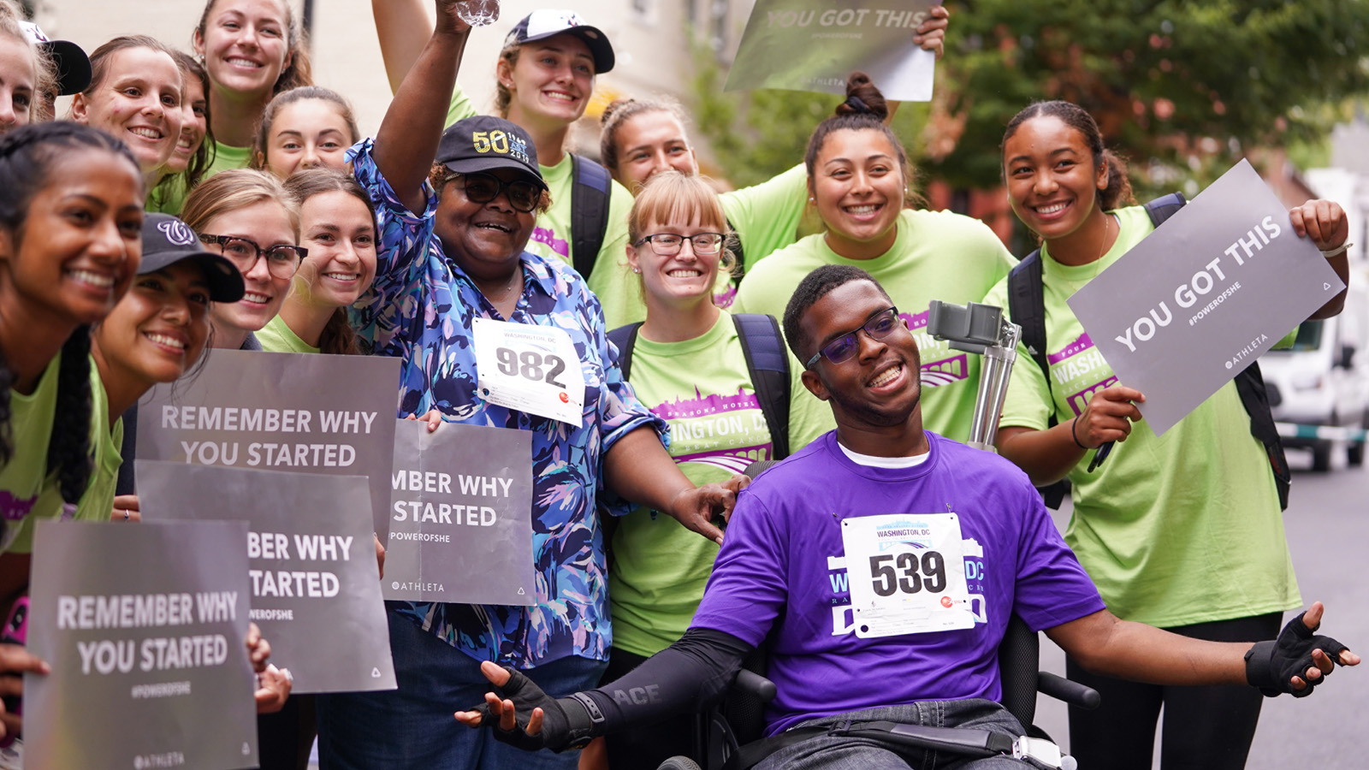 | 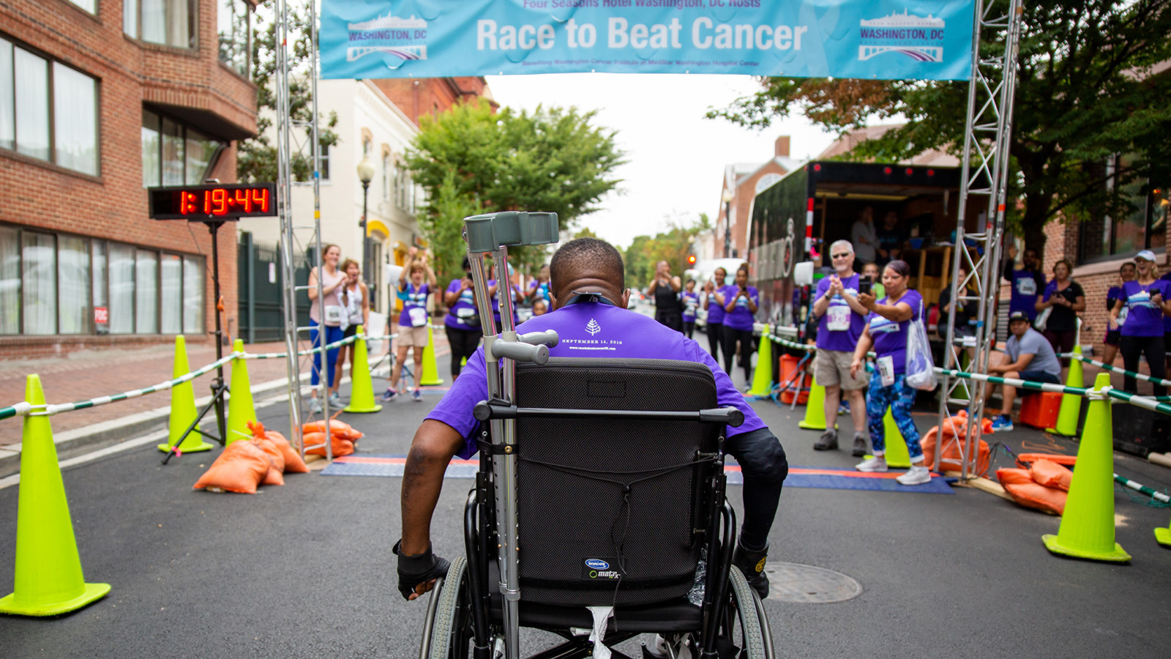
Before the actual race this fall, there will be a weeklong preview challenge starting June 13, which will allow participants to form virtual teams, track their progress and make commitments to their health, both physical and mental health, in the spirit of Global Wellness Day, while raising money for cancer research. Registration for the preview challenge is USD 10, with all proceeds (and additional donations) going towards Medstar Washington Hospital Center’s Cancer Institute. For those who wish to participate but are unable to spare the entry fee, The Race to Beat Cancer Global Wellness Day Challenge will be happy to include them as well. Sign up here.
About Race to Beat Cancer
Since 1980, Four Seasons Hotel Washington, DC has hosted the iconic Race to Beat Cancer benefiting cancer research in Washington, DC as a community 5k race. To ensure the safety and security of all involved, the actual race will be held virtually this year from September 26 to October 3, 2020.
“Race to Beat Cancer is one of the most important events of our year at Four Seasons Hotel Washington DC. For 40 years our team and the DC community have mobilised to race to help fund cancer research and clinical trials,” says David Bernand, Regional Vice President and General Manager, Four Seasons Hotel Washington, DC. “Together, we have raised more than 2.7 million dollars for Medstar Washington Hospital Center and have grown the race to nearly 1,000 participants. More than ever, we need your help. Please make any size donation to join us in breaking the 3-million-dollar barrier of money raised to fight cancer!”
“This annual event raises critical funding for cancer research at Washington Cancer Institute at MedStar Washington Hospital Center. Last year was our most successful year yet as we raised nearly USD 500,000” says Christopher Gallagher, MD, Medical Director of Cancer Services of the Washington Cancer Institute, “Creating a virtual race is the best and safest decision we could make given the circumstances and considering health and safety for all. We will continue to bring excitement, inspiration, hope and gratitude to those supporting cancer survivors and those being treated.”
For those who prefer lifting a fork to a good cause, Four Seasons Hotel Washington, DC Executive Chef Sebastien Giannini has prepared an antioxidant rich, super-foods menu featuring watermelon salad, turmeric-poached salmon and red berries with a basil syrup for dessert, which will be available for one week starting June 13th for pick up orders on Tock. A portion of the proceeds will be donated to Medstar Washington Hospital Center.
About Washington Cancer Institute
The Washington Cancer Institute, a part of MedStar Washington Hospital Center, treats more cases of cancer than any other cancer institute in the region. It is the largest outpatient cancer centre in the District of Columbia, serving nearly 82,000 outpatient visits with about 3,000 new cases of cancer diagnosed annually. With more tha 56 percent of all enrolments from minority populations, the Washington Cancer Institute is a national leader in minority cancer care. No matter what the barriers may be for a patient, Washington Cancer Institute treats each individual and their family with the highest quality, compassionate care.
About Global Wellness Day
Global Wellness Day promotes good physical and mental health through complimentary, educational, and experiential wellness activities around the world.
About Four Seasons Hotel Washington, DC
Four Seasons Hotel Washington, DC remains open, with limited services and in respect of the latest government guidelines, to accommodate guests who need to come to DC. For more information, visit the Hotel's website or call +1 202 342 0444

RELATED

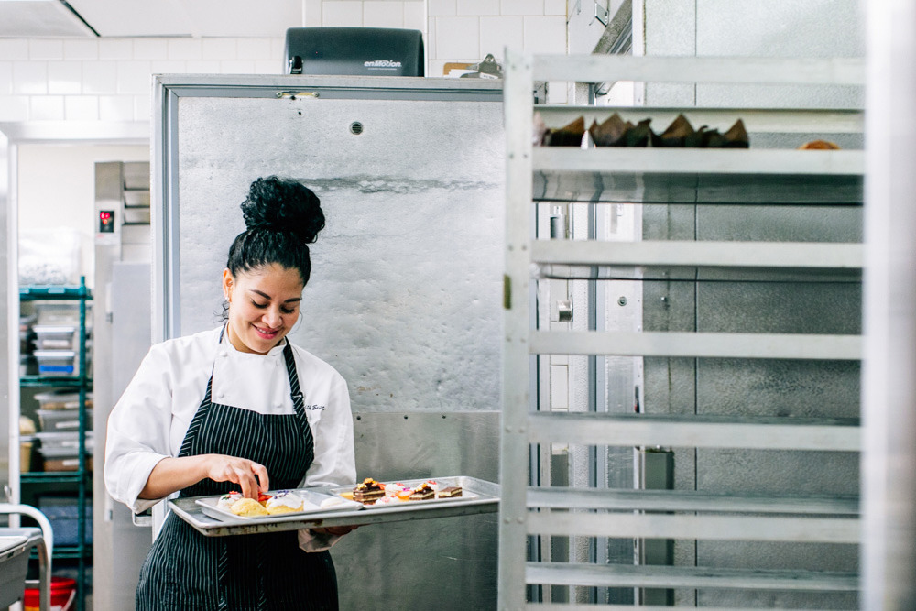 | May 6, 2020, Washington, DC, U.S.A.  Four Seasons Hotel Washington, DC and Mina Group Launch Relief Fund to Assist Furloughed Employees  https://publish.url/washington/hotel-news/2020/relief-fund.html
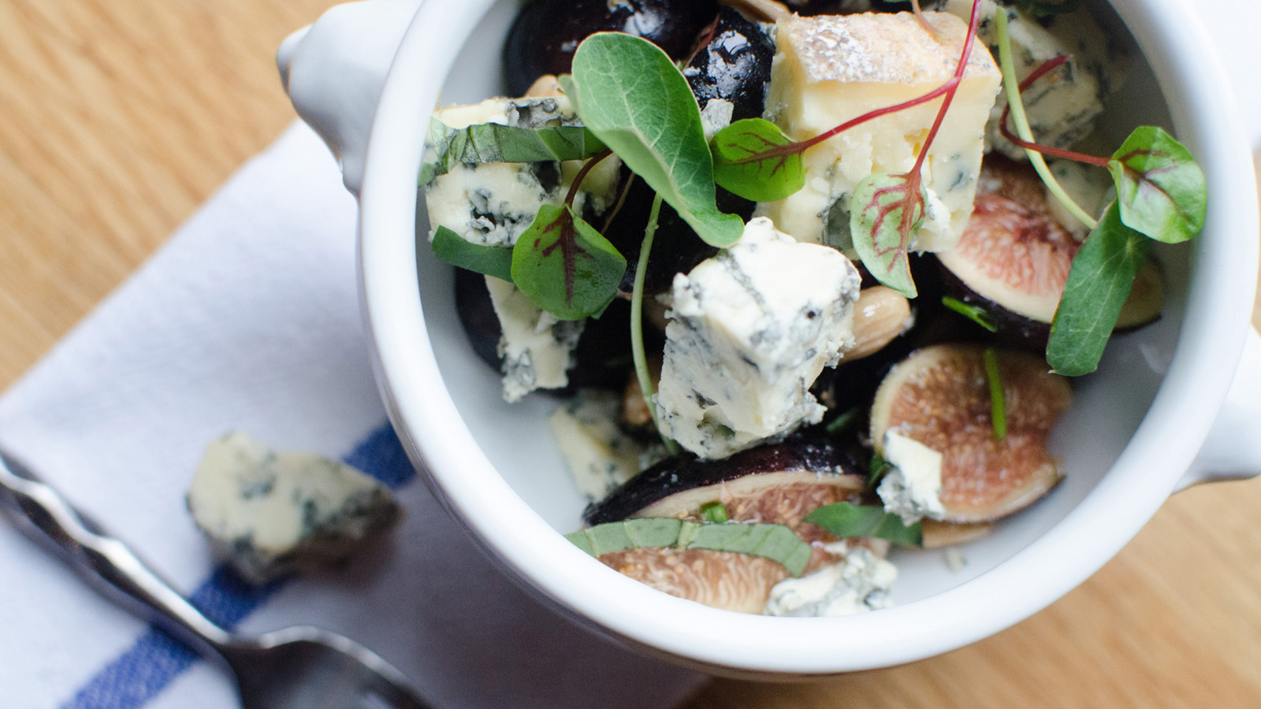 | April 21, 2020, Washington, DC, U.S.A.  Four Seasons Hotel Washington DC Offers Daily Chef’s Menu for Take-Out, Benefitting MedStar Washington Hospital Center  https://publish.url/washington/hotel-news/2020/takeout-menus.html

PRESS CONTACTS

Anina Belle Giannini
Director of Public Relations
2800 Pennsylvania Avenue N.W.
Washington
U.S.A.
aninabelle.giannini@fourseasons.com

+1 202 944 2074

