Brian Doherty Returns to Four Seasons as Executive Chef of Four Seasons Hotel Seattle

Lauded chef to lead culinary operations at Seattle’s only Forbes Five-Star Hotel
March 25, 2022, Seattle, U.S.A.

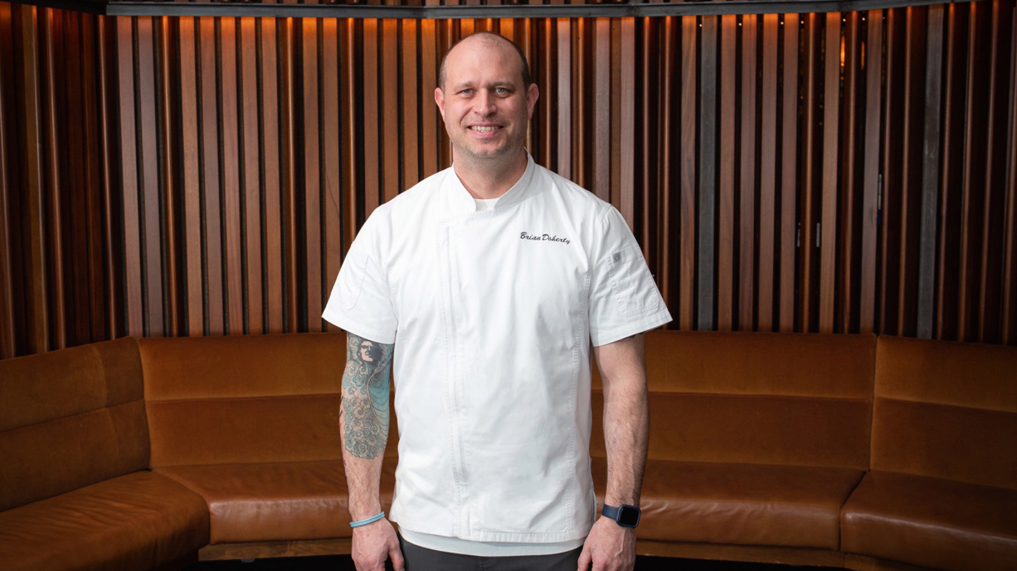
Four Seasons Hotel Seattle, located near the city’s iconic attractions and Washington State’s only Forbes Five-Star property, announces Brian Doherty as Executive Chef. He will lead food and beverage operations, from catering at the Hotel’s 10,570 square feet (982 square metres) of event space to in-room dining at the 147 guest rooms and suites.
Doherty is excited to be back with Four Seasons Hotels and Resorts, a journey he began in 1997 in Seattle when he joined the brand’s original location in the Emerald City.
“I grew up here, my family is near here in Bremerton, Washington and after traveling around, I always miss it and find my way back,” says Doherty. “I have always had a great deal of respect for Four Seasons, its standards, focus on quality, and service.”
Goldfinch Tavern, an Ethan Stowell Restaurant, will continue its partnership with Stowell and day-to-day direction will be helmed by Doherty and the restaurant staff. Seasonal pop-up restaurants at the infinity pool and private cabana dining will also be overseen by Doherty. With panoramic views of Elliott Bay and the Olympic Mountains from the restaurant and event space, Doherty has some of the best views in Seattle.
Prior to rejoining Four Seasons, Doherty was the executive chef for Kirkland, Washington’s The Woodmark Hotel. Other Seattle stints included senior leadership positions at The Mark and SLS Seattle.
At the former Four Seasons Olympic, Doherty was restaurant chef and transferred to Four Seasons Resort Hualalai on the island of Hawaii. His love for Seattle drew him back, this time under the Fairmont flag. Travelling south along the coast, Doherty spend a few years at Fairmont Newport Beach where he collaborated with local farmers on a goat cheese and honey program.
“I have been blessed to work with amazingly talented professionals,” adds Doherty, who looks forward to driving, leading, and developing the culinary team at the downtown Hotel located next to Pike Place Market. “I have a deep passion for food and cooking and hope to teach and develop young culinarians.”
Doherty continues to build a strong food and beverage program at the Hotel, focusing on innovation, being more involved in the community, and using the very best seasonal ingredients of the Pacific Northwest.

RELATED

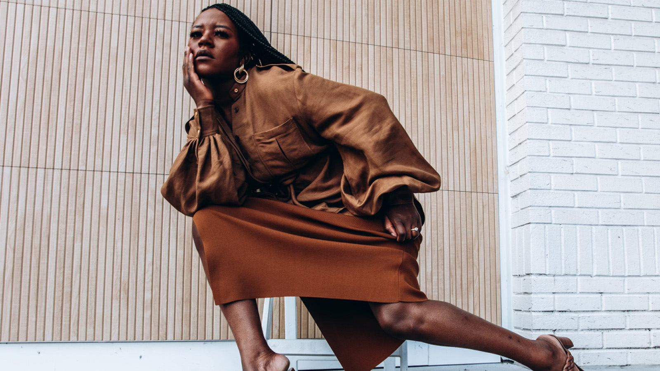 | February 16, 2022, Seattle, U.S.A.  Spring Forward into Fashion with Goldfinch Tavern and Frilancy’s Fashion Brunch at Four Seasons Hotel Seattle  https://publish.url/seattle/hotel-news/2022/frilancys-fashion-brunch.html
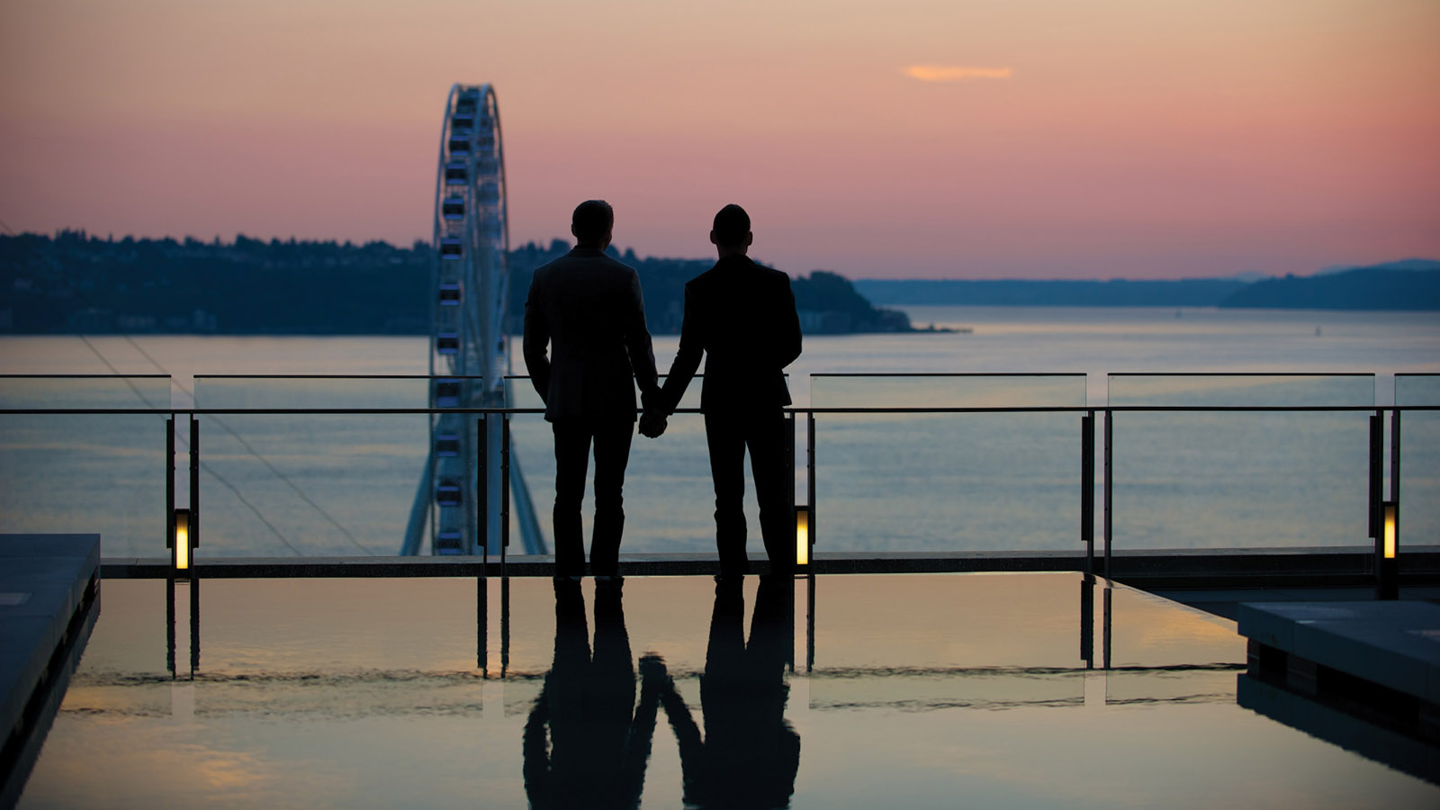 | February 4, 2022, Seattle, U.S.A.  Let Love Win with Romantic Experiences Created for Two at Four Seasons Hotel Seattle  https://publish.url/seattle/hotel-news/2022/valentines-day.html

PRESS CONTACTS

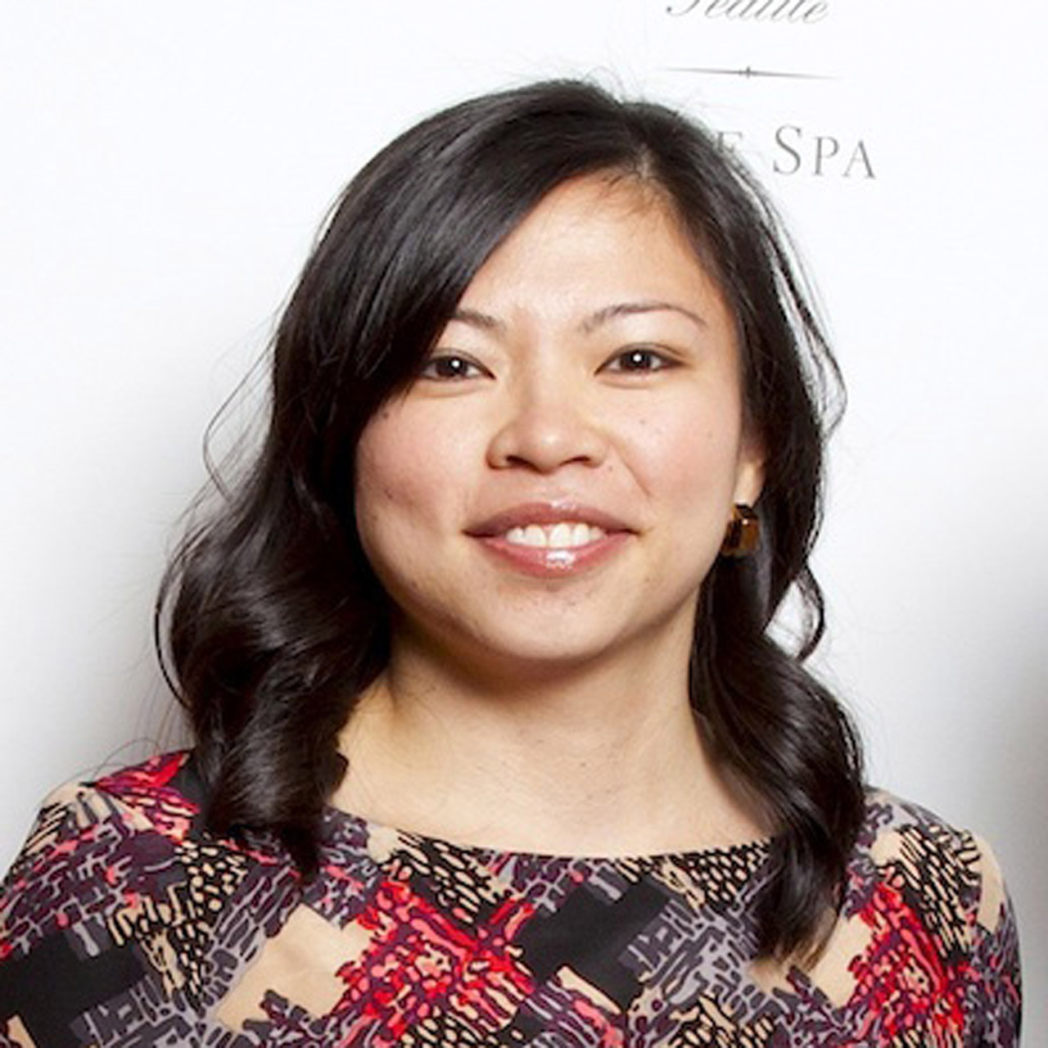 | Meg Paynor  PR Consultant  99 Union Street  Seattle  USA  meg@paynorpr.com  +1 206 913 3848
Crystal Southcote
Digital Media Manager
99 Union Street
Seattle
USA
crystal.southcote@fourseasons.com

+1 206 749 3909

