Heads in the Clouds with Four Seasons Megève Collection Offer “A Night Above the Clouds” in the Dreamiest Suite in Megève

The Idéal suite from Four Seasons Megève Collection sits at the top of the slopes, at an altitude of 1,850 metres (6,070 feet) and offers unparalleled views of Mont Blanc - an exceptional place for souls in search of intimacy at the summit
September 26, 2022, Megeve, France

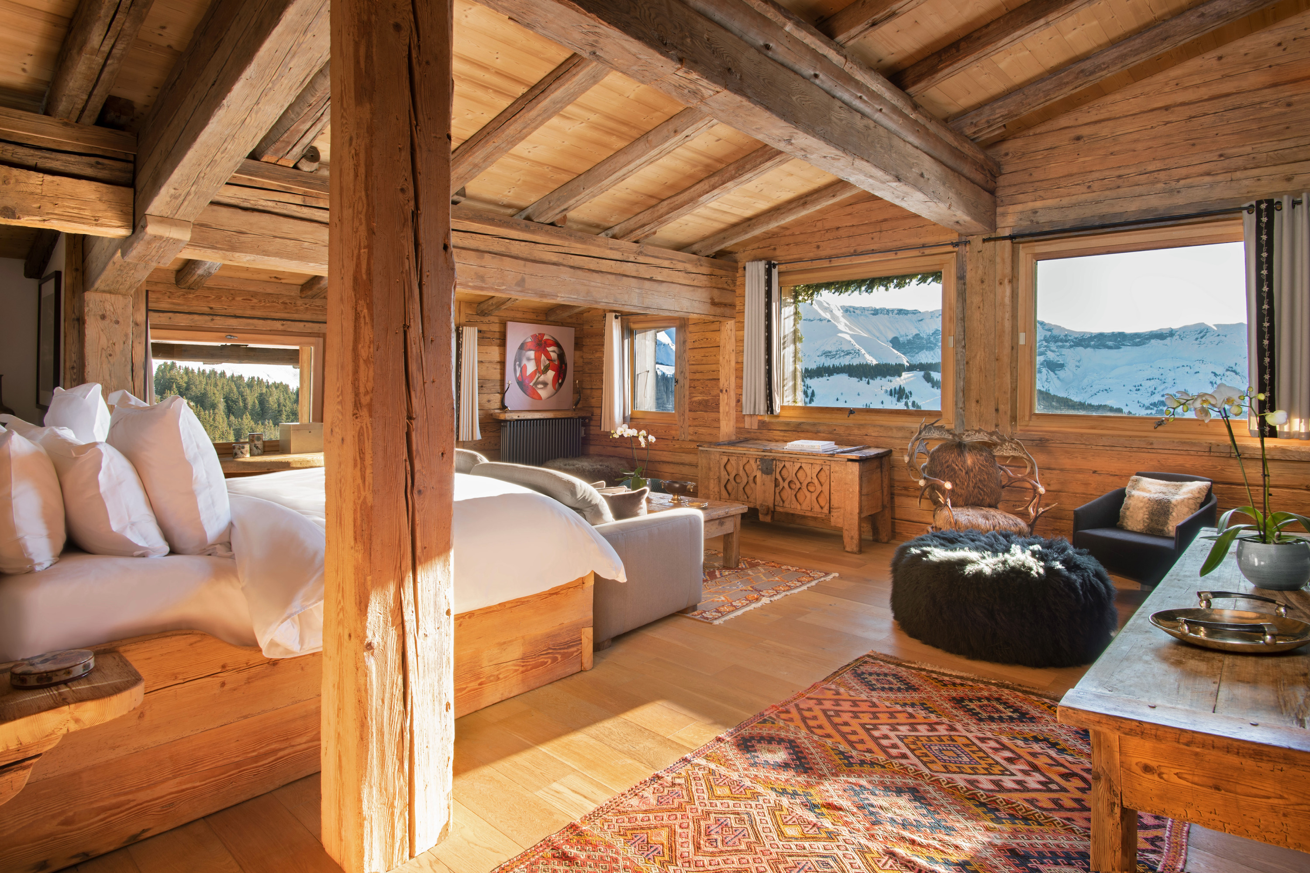
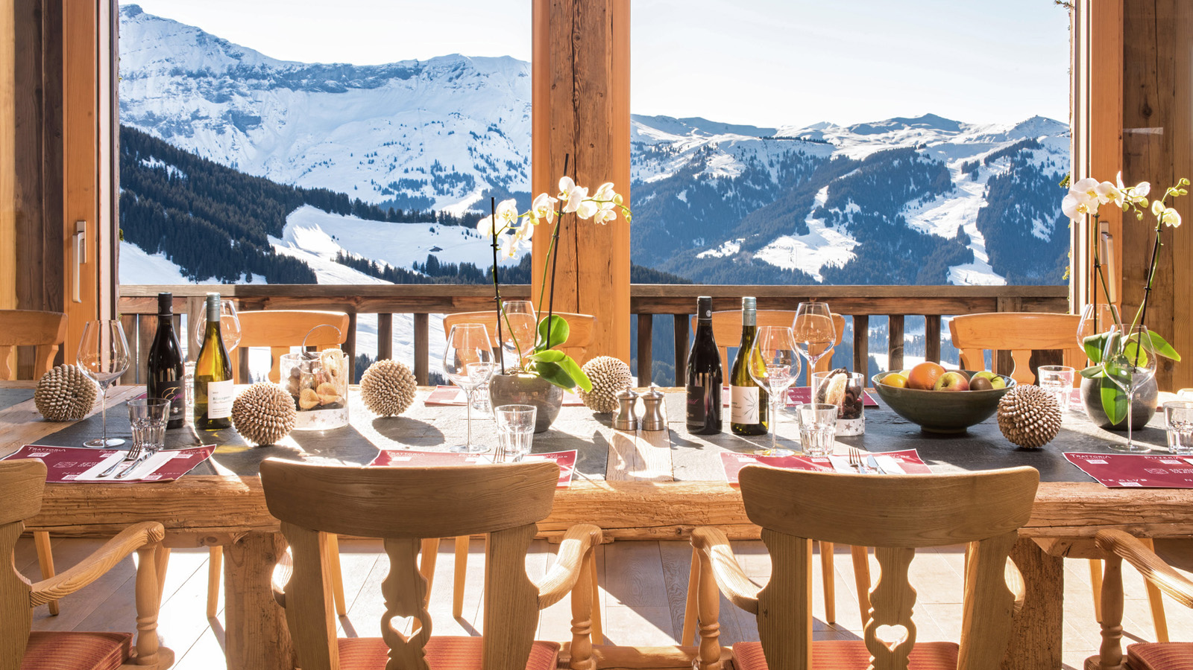 | 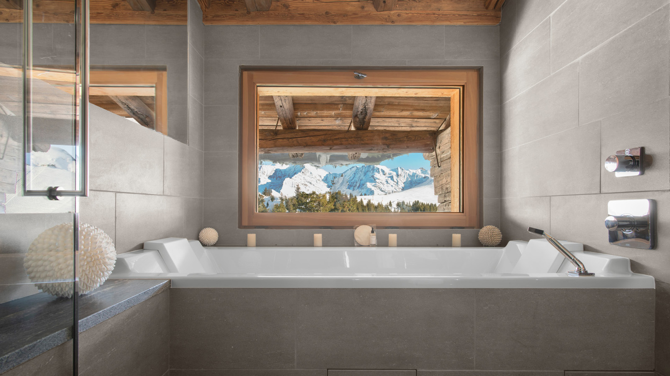
In the sumptuous setting of the chic restaurant l'Idéal 1850 lies the most intimate suite in Megève: the Idéal Suite. Covering 100 square metres (1,100 square feet), this entire floor of luxury borrows the codes of traditional Savoyard chalets while keeping a twist of modernity with its ornamental details - including art objects carefully selected by Baroness Ariane de Rothschild. The primary bedroom offers a spectacular view of the snowy peaks, while the private bathroom with shower and bathtub is an invitation to relax with Mont Blanc as a backdrop. An impressive fireplace and a dining room that reveals a panoramic view of Megève and its snowy valley sublimate the living room. Guests staying at Four Seasons Hotel Megève or Les Chalets du Mont d'Arbois Megève, A Four Seasons Hotel will be able to indulge in this perched suite for one night, accessible only by cable cars.
With a dedicated and attentive butler to coordinate every detail of the stay, guests will enjoy a memorable overnight experience in the most beautiful suite of Megève.
After a 15-minute cable car ride guests will savour a delectable appetizer before dining delicious traditional Savoyard dishes that highlight local cheeses in the suite’s private lounge. The majestic terrace makes the ideal spot for stargazing with a telescope while enjoying the silent charm of a winter night at the top of the mountain.
The next day, a tailored breakfast menu can be savoured while admiring the sight of the pink sunrise gently settling on Mont Blanc and the Aravis mountain range, before enjoying the ultimate privilege of being the first to access the ski slopes. Assisted by the in-house butler, who will prepare the skis and propose a personalized itinerary, the most motivated will take to the slopes on freshly fallen snow for a magical moment. Snowshoes can also be an option for a more leisurely descent.
For those who are eager to explore, concierge Baptiste Andrieu has designed a range of activities for a magical stay. "When the mountains are covered with their snow caps, they become the ideal place for new escapades in the heart of majestic landscapes. From a hot air balloon ride at sunrise, to a charming dog sled ride, or an introduction to electric snowmobiling, we strive to offer exceptional experiences. We suggest taking a helicopter ride to discover all that the Alps have to offer and admire the beauty of the snow-covered peaks from above," says Baptiste.
Guests staying a minimum of three nights in the contemporary chalet Four Seasons Hotel Megève, or in the traditionally decorated Les Chalets du Mont d'Arbois, Megève, A Four Seasons Hotel, can enjoy a night in the Idéal Suite.
The “A Night Above the Clouds” offer includes:
- 2 nights in one of the Four Seasons Megève Collection hotels
- 1 night in the Idéal Suite
- Breakfast for two
- A dinner for two with à la carte Savoyard specialties including a selection of French wine from head sommelier Samy Sbity
- A round-trip pedestrian pass on the ski lifts
- Butler service
Access and ski equipment can be booked as an option.
Rates, based upon two people sharing:
- From EUR 5,350 for a 2-night stay at Les Chalets du Mont d'Arbois, Megève, A Four Seasons Hotel and 1 night in the Idéal Suite
- From EUR 8,950 for a 2-night stay at Four Seasons Hotel Megève and 1 night in the Idéal Suite

RELATED

September 6, 2022, Megeve, France
Four Seasons Hotel Megève Announces Its Reopening on October 20, 2022
https://publish.url/megeve/hotel-news/2022/fall-activities.html

September 6, 2022, Megeve, France
Une parenthèse automnale au cœur des Alpes avec Four Seasons Hotel Megève
https://publish.url/fr/megeve/hotel-news/2022/fall-activities-2.html

PRESS CONTACTS

Emilie Pignol
Marketing and Sales Director
3001, Route Edmond de Rothschild
Megève
France
emilie.pignol@fourseasons.com

+33 7 68 61 90 53

