Four Seasons Resort Punta Mita Launches New “Summer Fridays” Villas and Residences Offer

July 23, 2019, Punta Mita, México

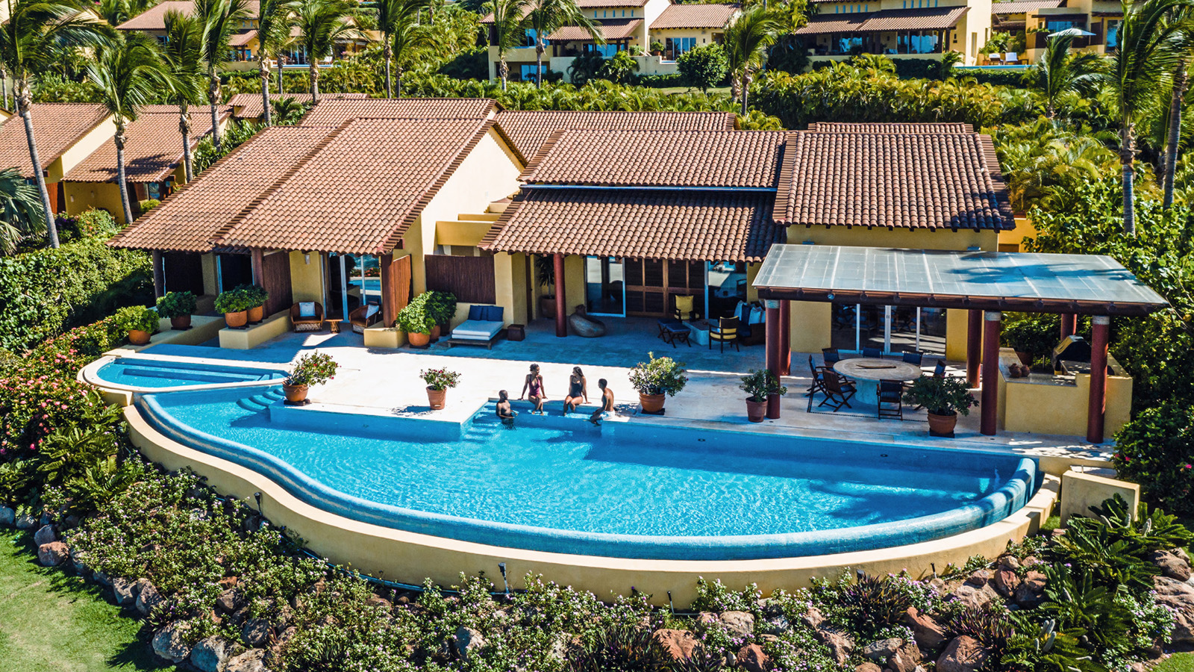
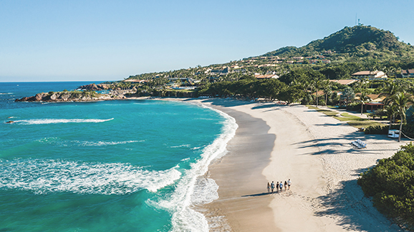 | 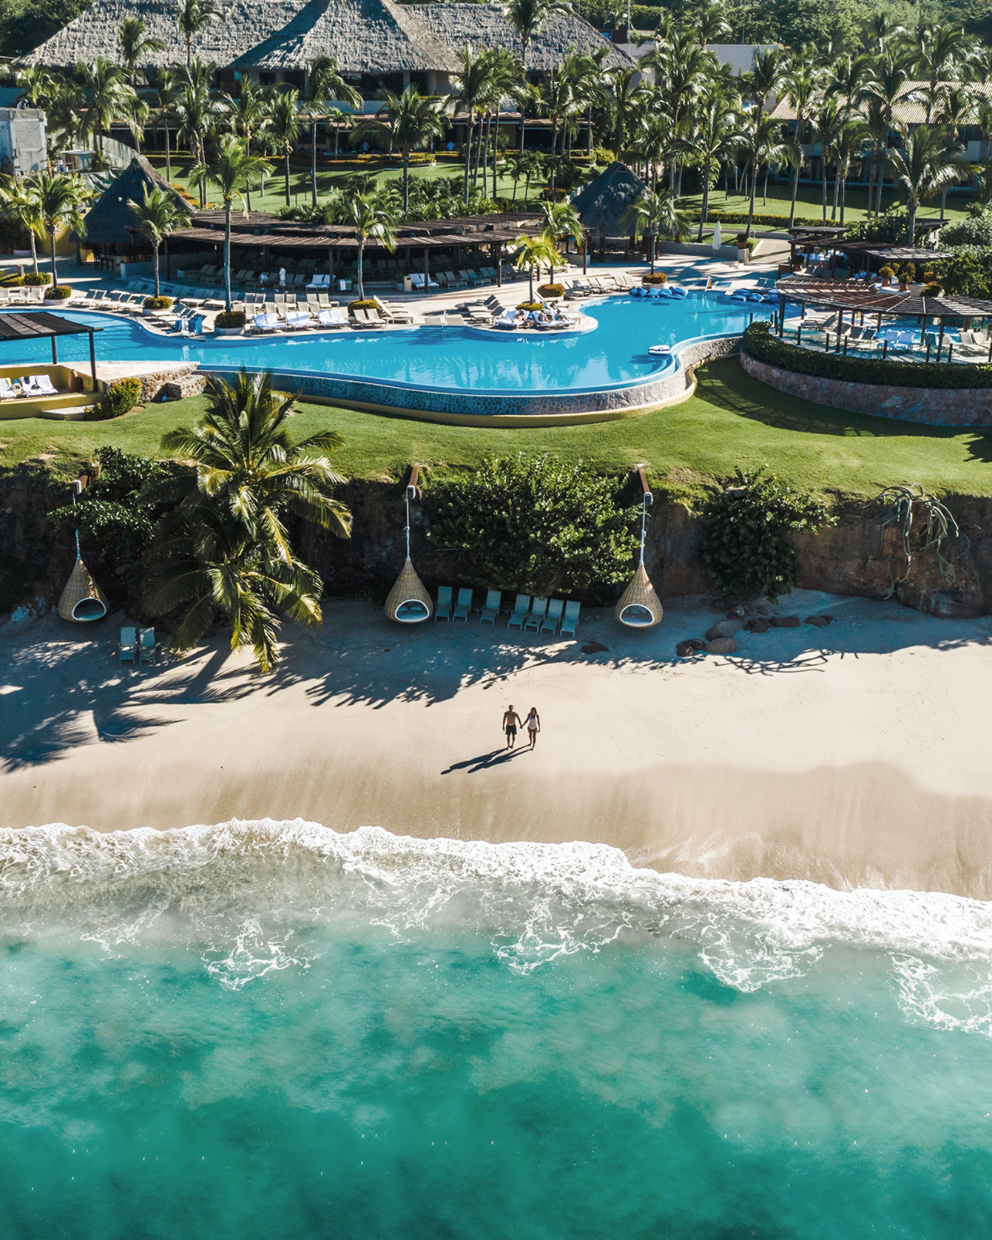 | 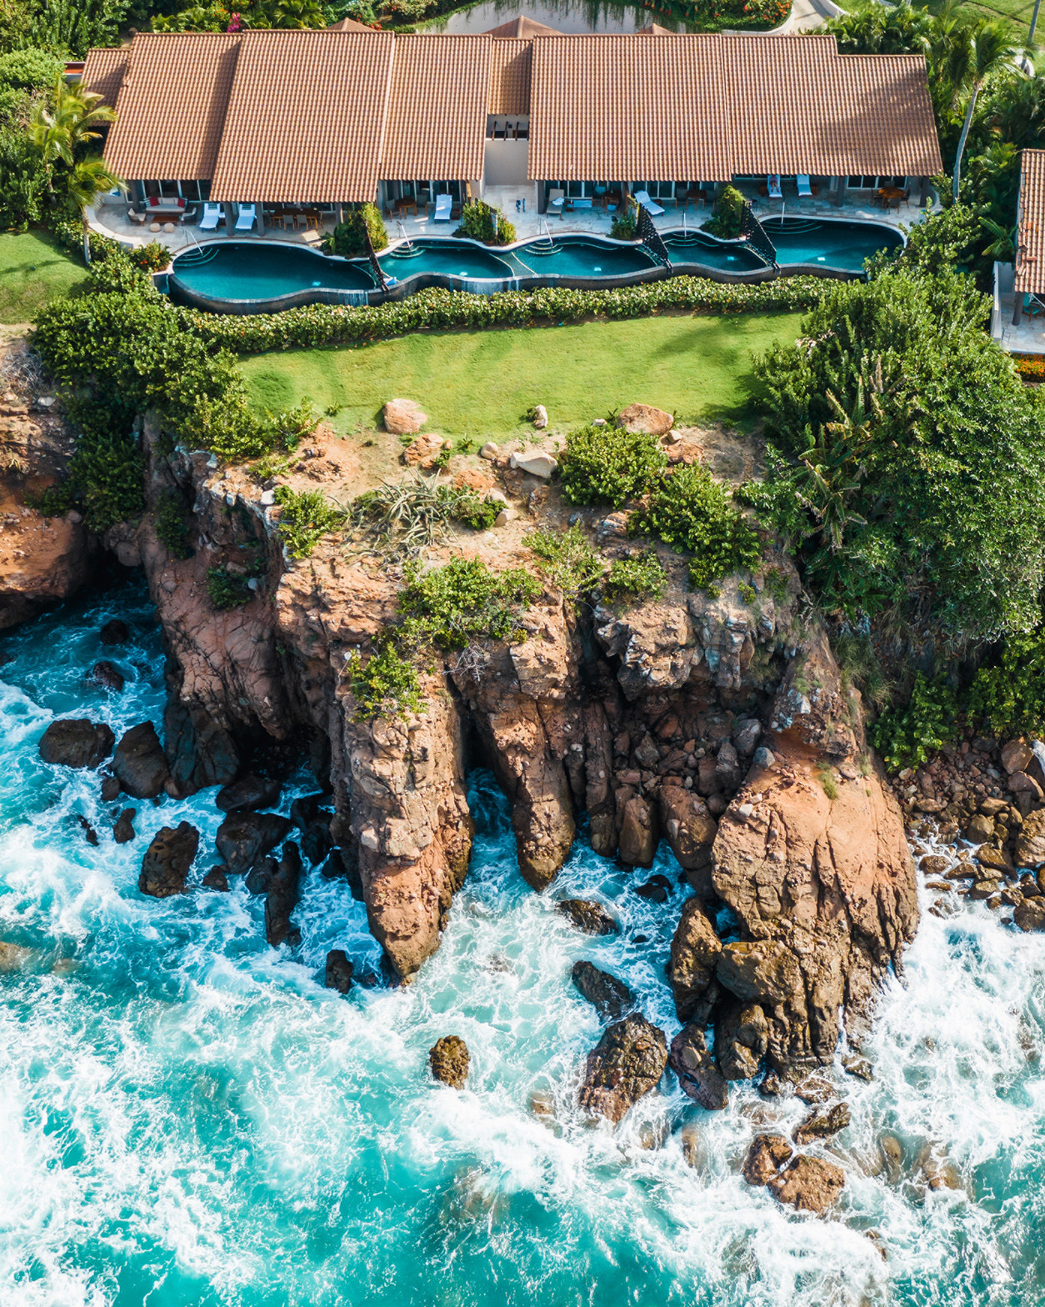
Four Seasons Resort Punta Mita, a five-star oceanfront resort set amid 1,500 acres (600 hectares) of coastal peninsula in the Riviera Nayarit region, invites guests to spend their summer Fridays sipping on Margaritas beside their private pool with the resort’s new Summer Fridays offer. Guest who book a minimum three-night stay in one of the Resort’s 32 villas or residences can enjoy a 15 percent off rate, daily breakfast and happy hour in addition to private airport transfers.
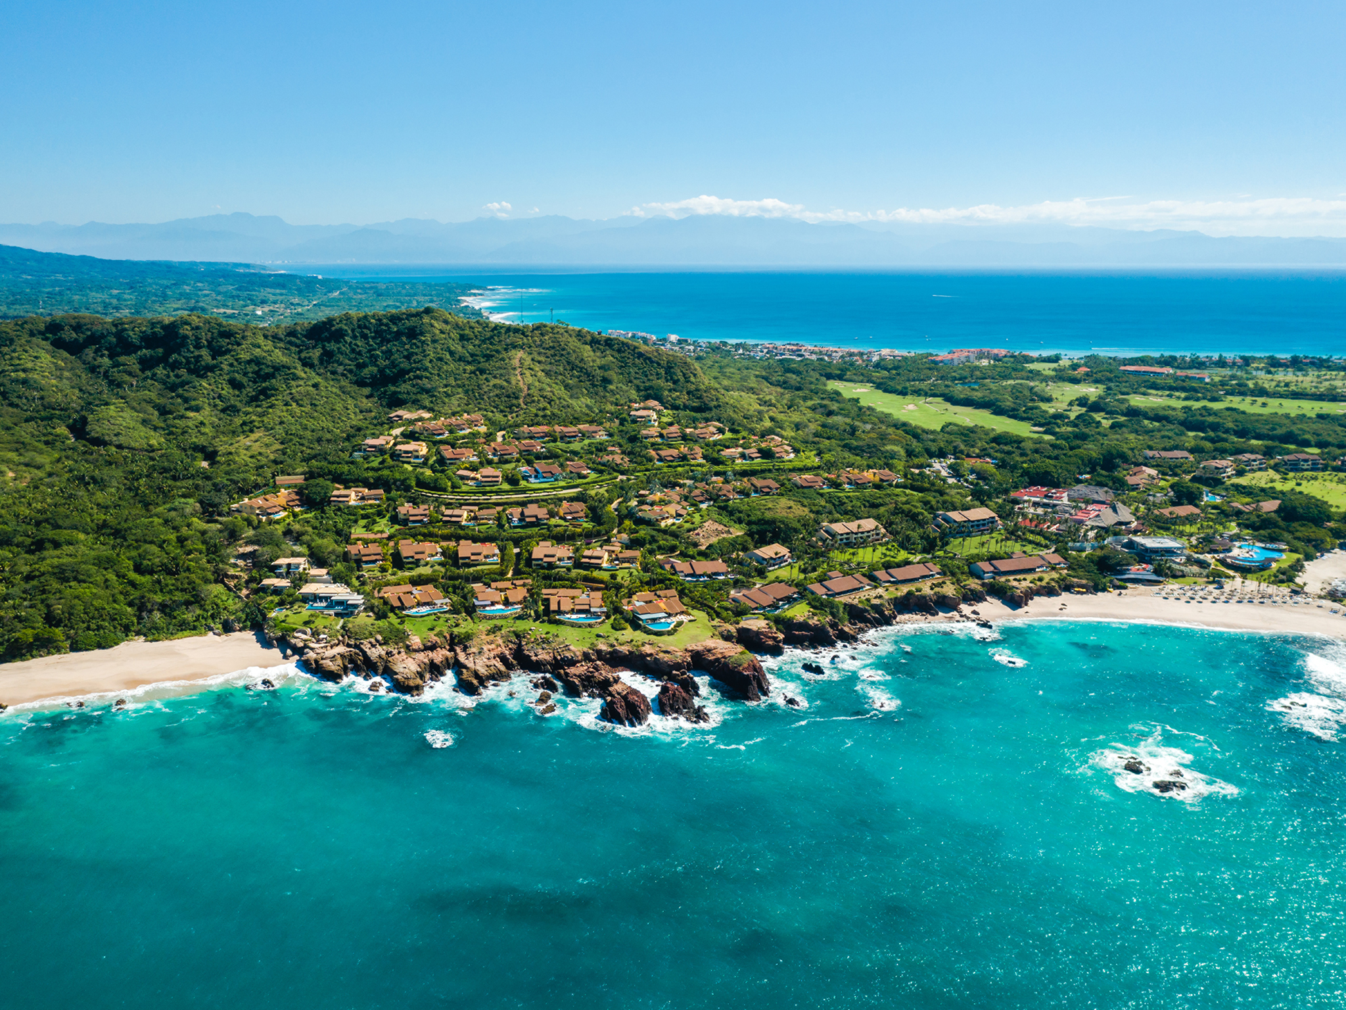
“Every day is a summer Friday in paradise at Four Seasons Resort Punta Mita,” says John O’Sullivan, General Manager, Four Seasons Resort Punta Mita. “Whether guests come for a long weekend or a mid-week retreat, our Summer Fridays package offers families and groups of friends a convenient way to escape to their own private home any day of the week.”
New “Summer Fridays” Package
Book a three-night stay in a villa or residence and receive a 15 percent off rate that includes daily breakfast in the villa or at the Resort’s Dos Catrinas restaurant, daily happy hour with Margaritas accompanied by chips, guacamole and salsa, and private airport transfers. The well-appointed residences and villas also include twice daily Four Seasons housekeeping with pre-arranged times, a private pool and poolside barbecues, a fully appointed kitchen, online shopping option to pre-stock the kitchen and more.
Guests can also celebrate the summer season with the Resort's newest guest experiences including:
- Dos Catrinas Restaurant and Mezcal Tastings: Dos Catrinas, the Resort’s new two-storey restaurant and bar, offers guests stunning ocean views and an imaginative twist on traditional Mexican fare. The inventive space invites guests to savour the Resort’s custom mezcal blend “Los Mitos” as part of a new mezcal tasting experience at the restaurant’s bar. Priced at USD 64 per person.
- Regenerative Mind, Body and Soul Experiences: Guests are invited to recharge and reset through personalised soulful activities from spiritual energy clearing, sound healing and mud rituals to a chakra balancing spa treatment at Apuane Spa, yin yang yoga on a private bluff and a sea foraging culinary experience. Food and beverage are priced at consumption.
To book a stay, call the Resort +52 (329) 291-6000 or visit reserve online.

RELATED

June 5, 2019, Punta Mita, México
Four Seasons Resort Punta Mita Presenta Nuevas Experiencias Culturales, “Soulcations” su Apuesta en Retiros Wellness y Nuevas Aventuras Culinarias
https://publish.url/es/puntamita/hotel-news/2019/new-summer-experiences-2.html

June 5, 2019, Punta Mita, México
Four Seasons Resort Punta Mita Unveils New Cultural Experiences, Soulcation Wellness Retreats and Culinary Adventures
https://publish.url/puntamita/hotel-news/2019/new-summer-experiences.html

PRESS CONTACTS

Kimi Ozawa
Murphy O'Brien PR
11444 Olympic Boulevard, Suite 600
Los Angeles
U.S.A.
fspuntamita@murphyobrien.com

+1 (310) 586-7138

Miguel Peregrina
Director of Public Relations
Punta Mita, Bahia de Banderas
Nayarit
Mexico
miguel.peregrina@fourseasons.com

+52 329 29160000

