Celebrate the Platinum Jubilee with Four Seasons Hotel Hampshire

May 18, 2022, Hampshire, England

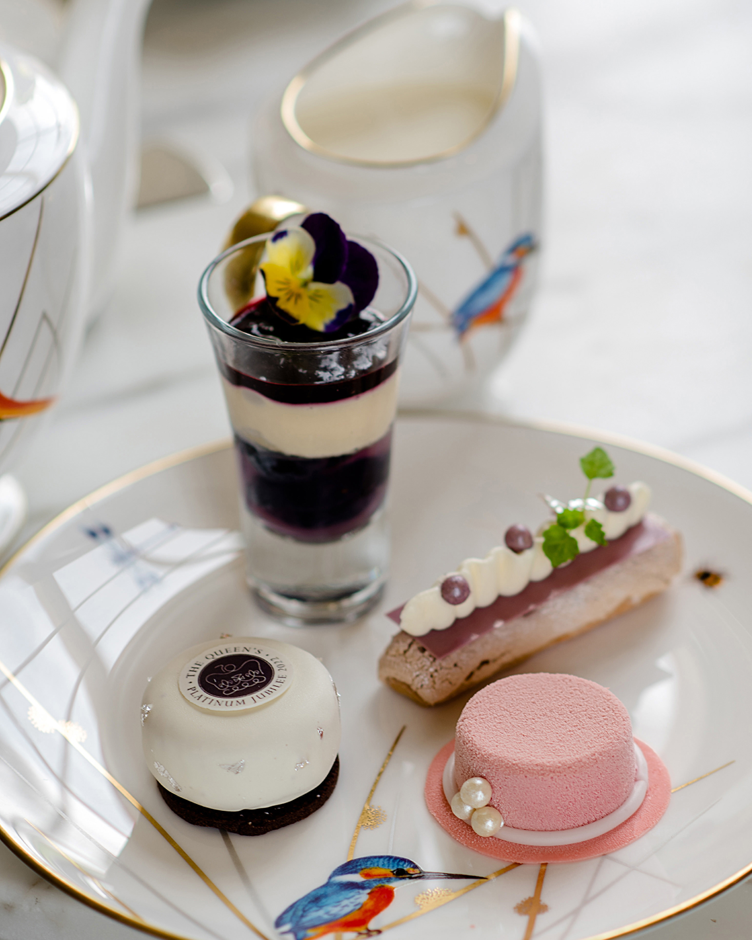
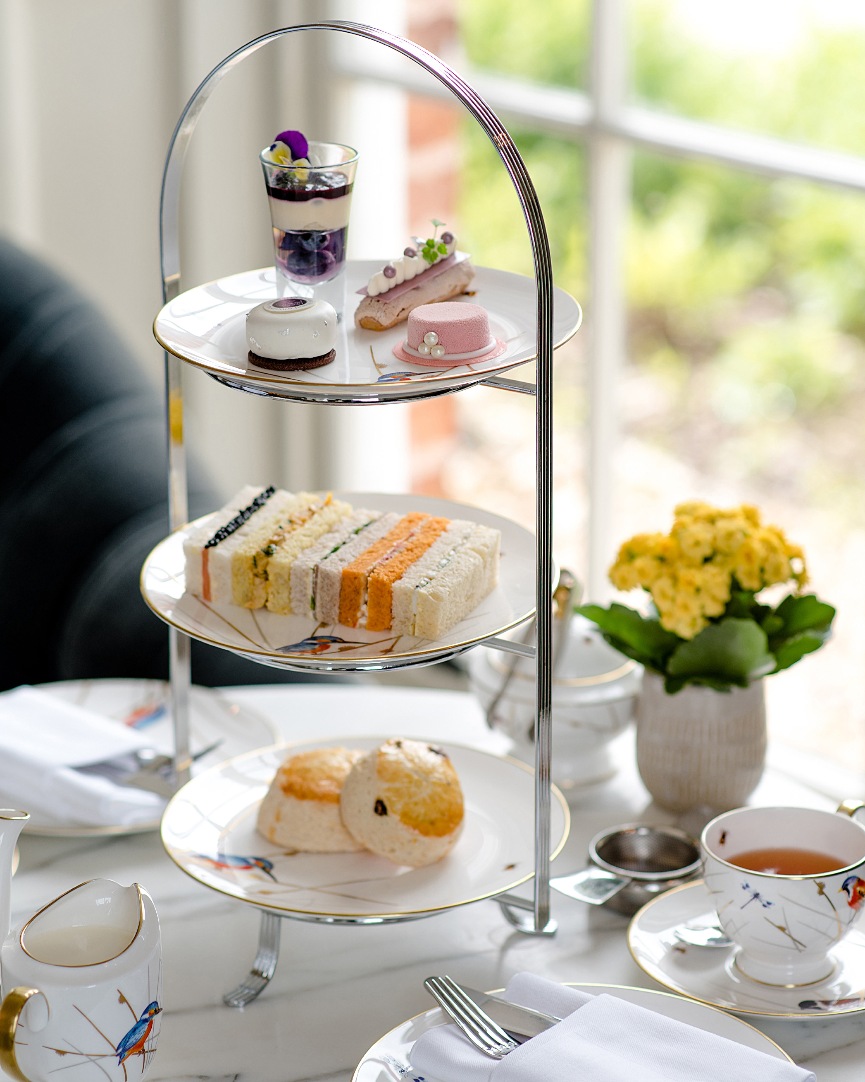 | 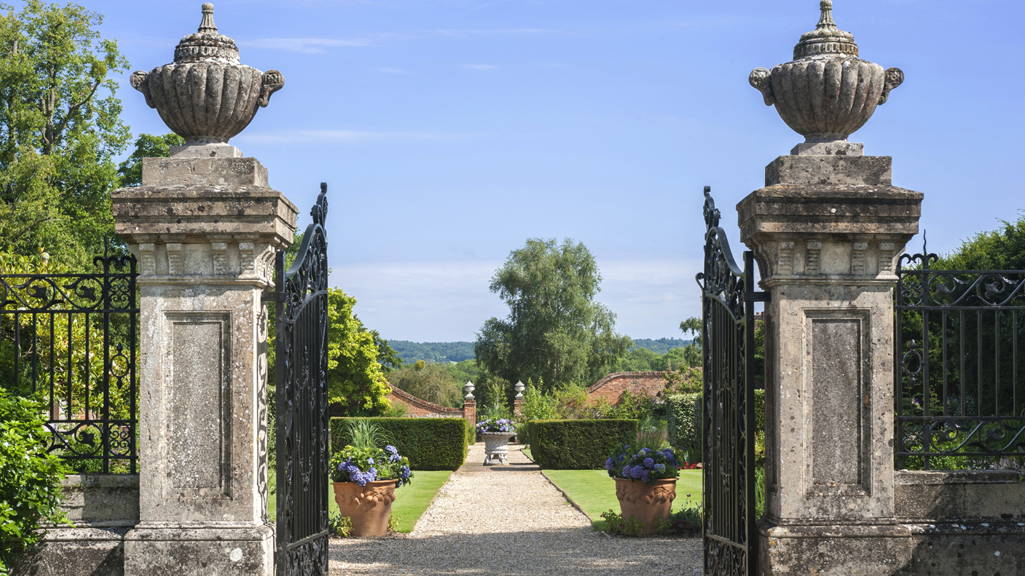 | 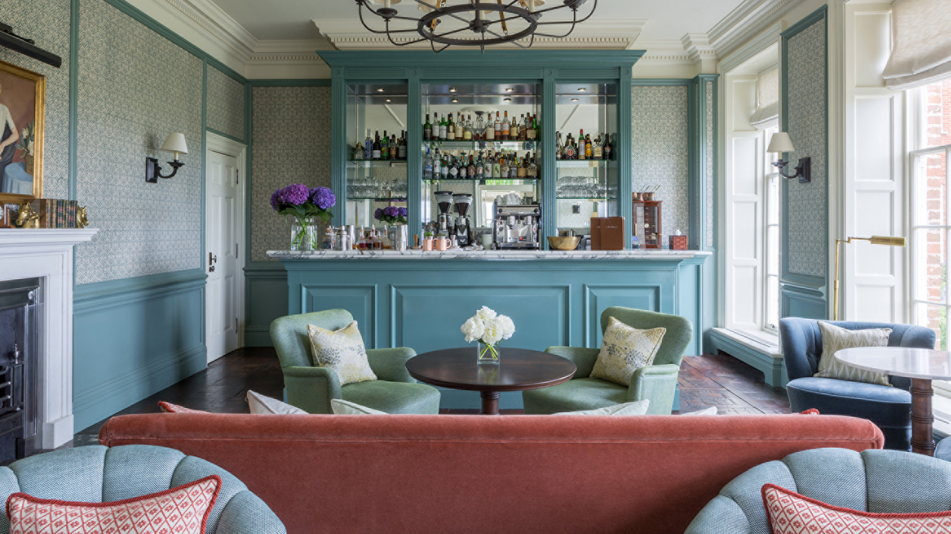
This June marks the special Platinum Jubilee celebrations in honour of Her Majesty The Queen’s 70 years of service. As the country honours this monumental occasion with official royal engagements and a bank holiday weekend, celebrate the festivities at Four Seasons Hotel Hampshire.
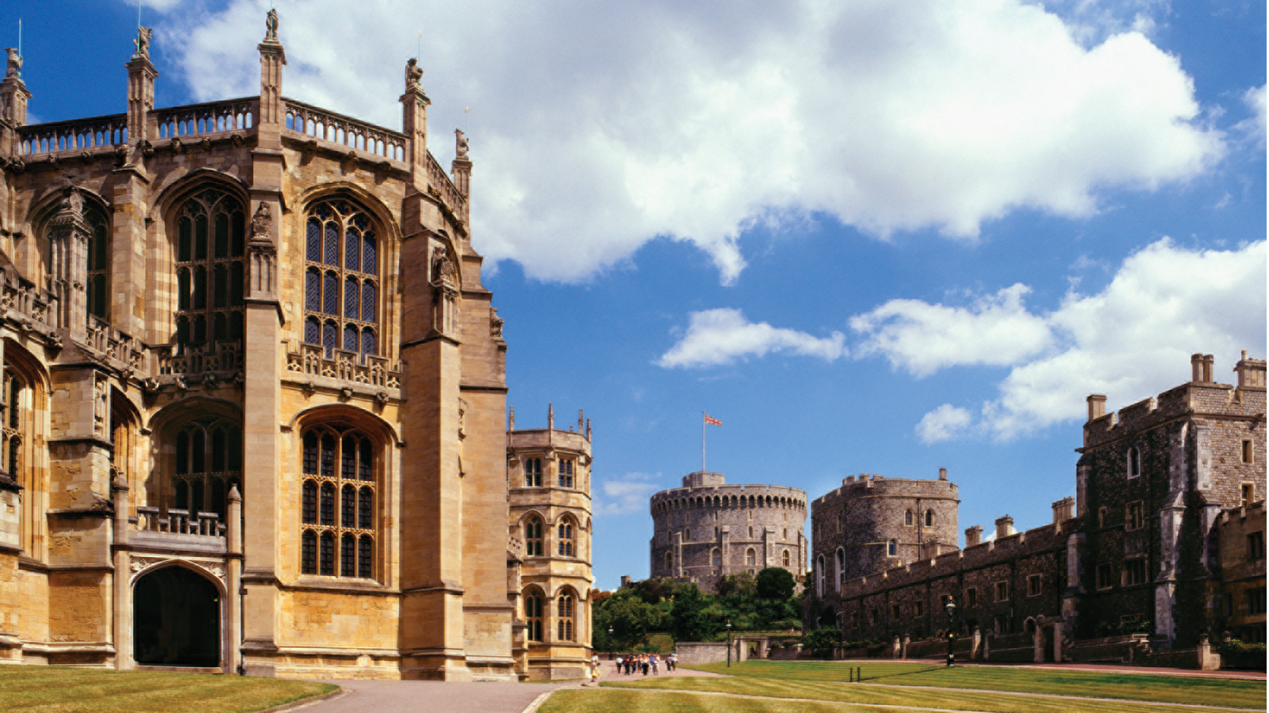
Celebrate Her Majesty
Guests can start their celebrations with a quintessentially British Jubilee-inspired afternoon tea in the 18th century Library. A light raspberry, lychee and rose petal mousse and a British rhubarb and Tahitian vanilla choux will be served alongside a delightful violet and blueberry trifle and an orange and chocolate jaffa cake. Handcrafted by Pastry Chef Maxime Gourlain, the menu is accompanied by a lemon and poppy seed loaf and a selection of delectable finger sandwiches such as coronation chicken on masala bread, in tribute to The Queen.
Available from May 24 to June 7, 2022 at GBP 38 per person, the afternoon tea will be served with a choice of tea options and for a touch of added glamour, a glass of champagne at GBP 49. Those wishing to dine al fresco in the warmer weather can enjoy the offering on the Library terrace.
Toast the Historic Moment
Toast the occasion with a glass of Hampshire grown sparkling wine from the Hotel’s Coates and Seely vintage Albion coach. Located at the front of the manor house, guests will be able to enjoy a special taste from one of the best vineyards in the British countryside and unwind as they take in the beautiful views of the rolling Hampshire hills.
Available June 2 and 3, 2022, serving Brut Reserve, GBP 19 per glass.
Join in the Royal Festivities
Enjoy the Jubilee celebrations at Four Seasons Hotel Hampshire with the majestic Jubilee horse display outside the front of the country estate. Meet special Royal Guards and resident horses Orlando and Elton, along with mischievous little pony Choice for a special salute to the country’s Queen and Monarch.
The Jubilee horse display will take place on June 5, 2022.
Walk the Platinum Jubilee Trail
For those looking to explore the great British countryside during their stay, Queen Elizabeth Country Park, situated in the South Downs National Park, is only a 40-minute drive from the Hotel. Consisting of 2,000 acres (800 hectares) of picturesque woodland and pasture, spend time solving riddles and searching for royal pictures along the Queen’s Platinum Jubilee walking trails - an opportunity to enjoying nature with a royal twist this Jubilee weekend.
Perfect for the little ones, from May 28 to June 5, 2022 at GBP 3 per trail, it includes a guide, pack of pencils and a craft to take home to decorate. Trails will be available to buy online and from the Visitor Centre at Queen Elizabeth Park or can be organised through the Hotel’s concierge.
For more information on the Platinum Jubilee weekend at Four Seasons Hotel Hampshire contact 01252 853 000.

RELATED

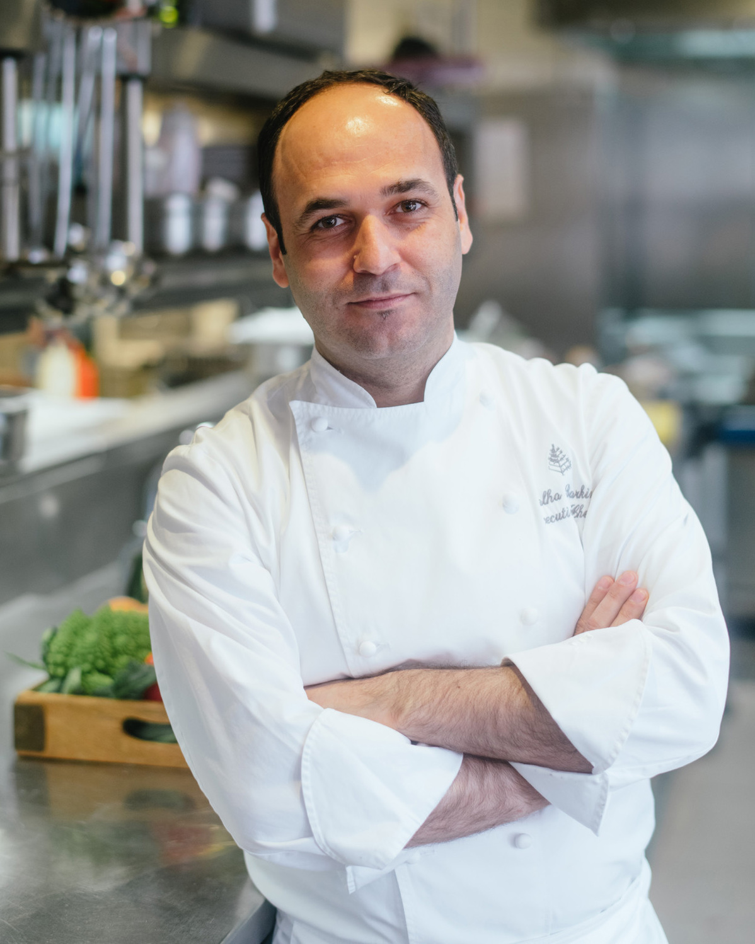 | May 30, 2022, Hampshire, England  Four Seasons Hotel Hampshire Appoints Talha Barkin as Executive Chef  https://publish.url/hampshire/hotel-news/2022/new-executive-chef-talha-barkin.html
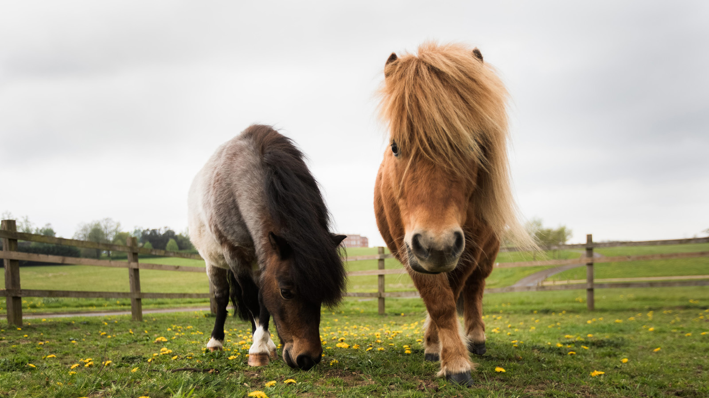 | April 7, 2022, Hampshire, England  Celebrate Easter at Four Seasons Hotel Hampshire  https://publish.url/hampshire/hotel-news/2022/easter.html

PRESS CONTACTS

Poppy Law
Public Relations Manager
Dogmersfield Park, Chalky Lane
Hook
United Kingdom
poppy.law@fourseasons.com

+44 (0)1252 853 000

Freya Costello
Senior Director of PR & Communications
Hamilton Place, Park Lane
London
England
freya.costello@fourseasons.com

+44 7788232969

