Time-Travel in the Old City with Four Seasons Hotel Baku

September 11, 2019, Baku, Azerbaijan

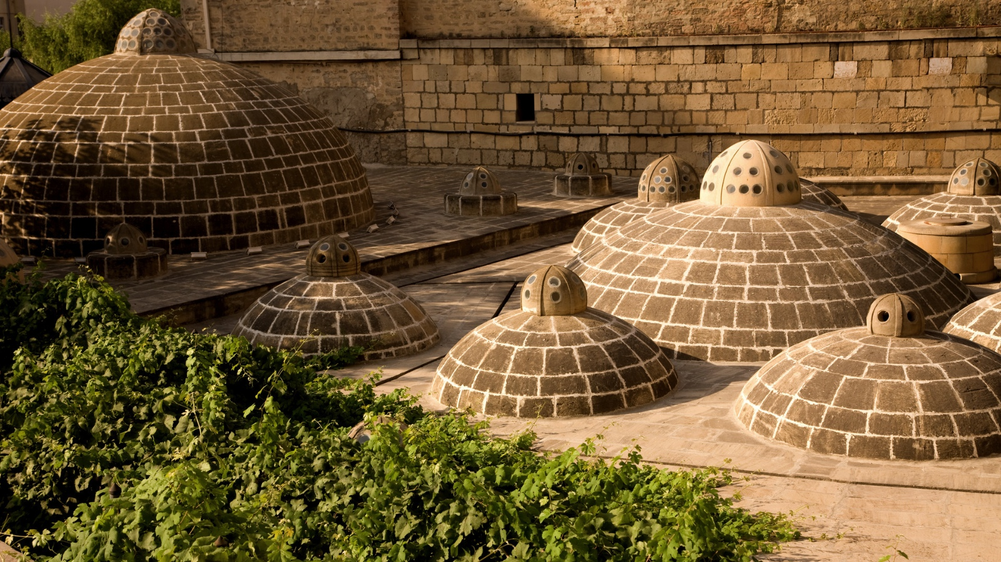
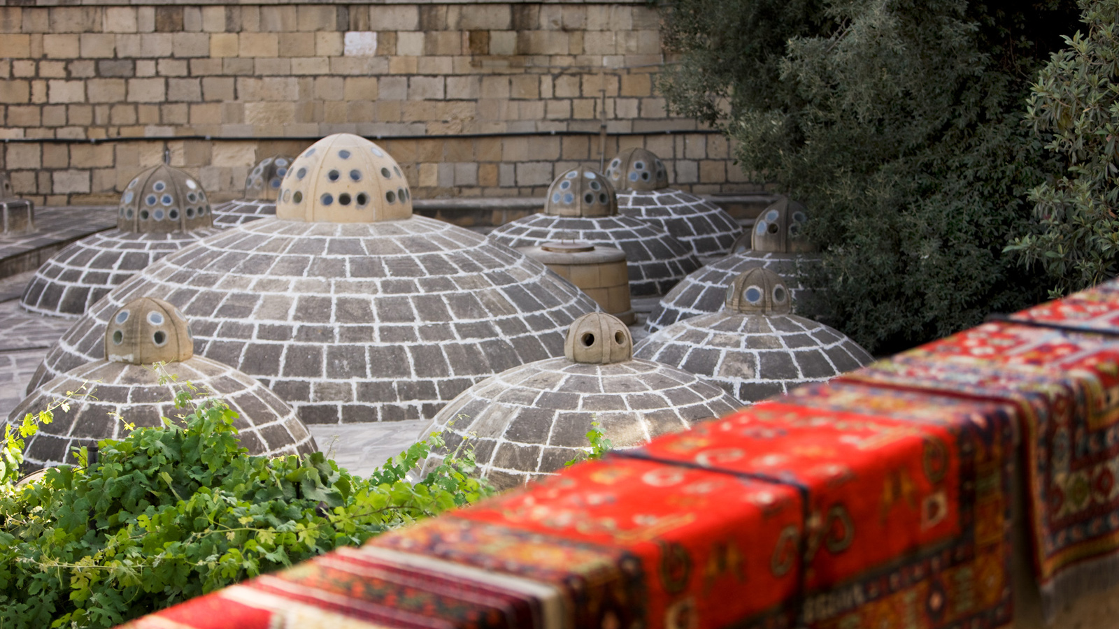 | 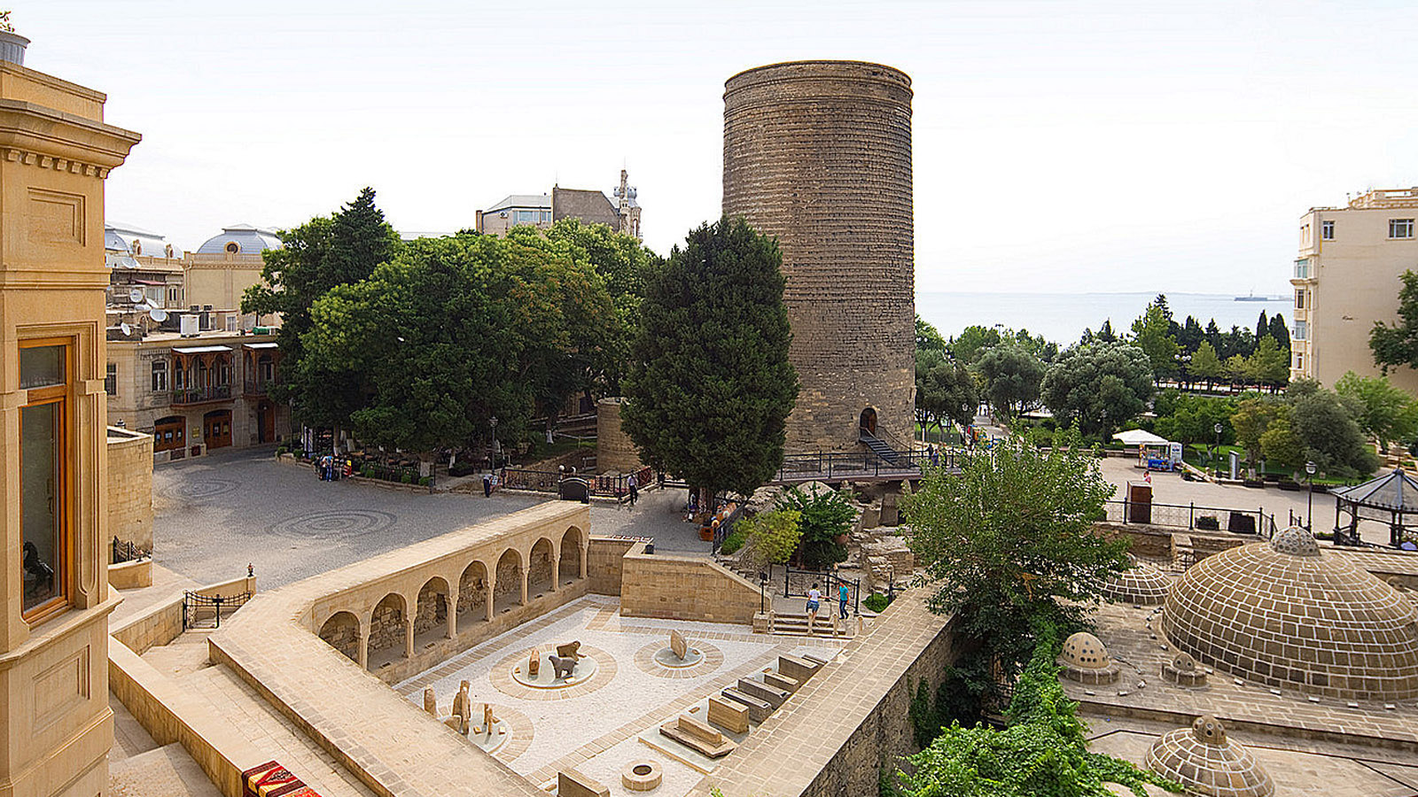 | 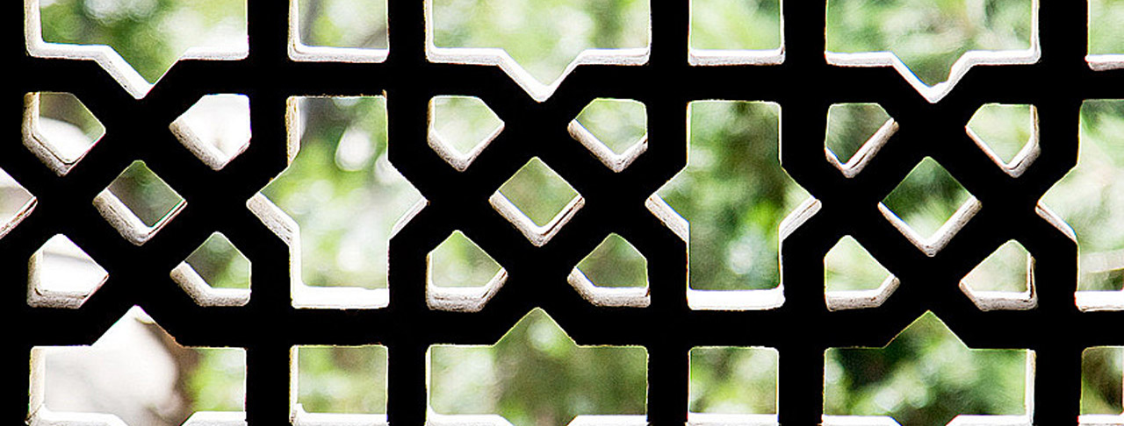
Every city has its own unique story to share with the world. We travel to discover hidden gems of different destinations and then treat each memorable experience we get to have as a true treasure. Beautiful Azerbaijan is full of such gems and it proudly offers its guests the special moments they travel for.
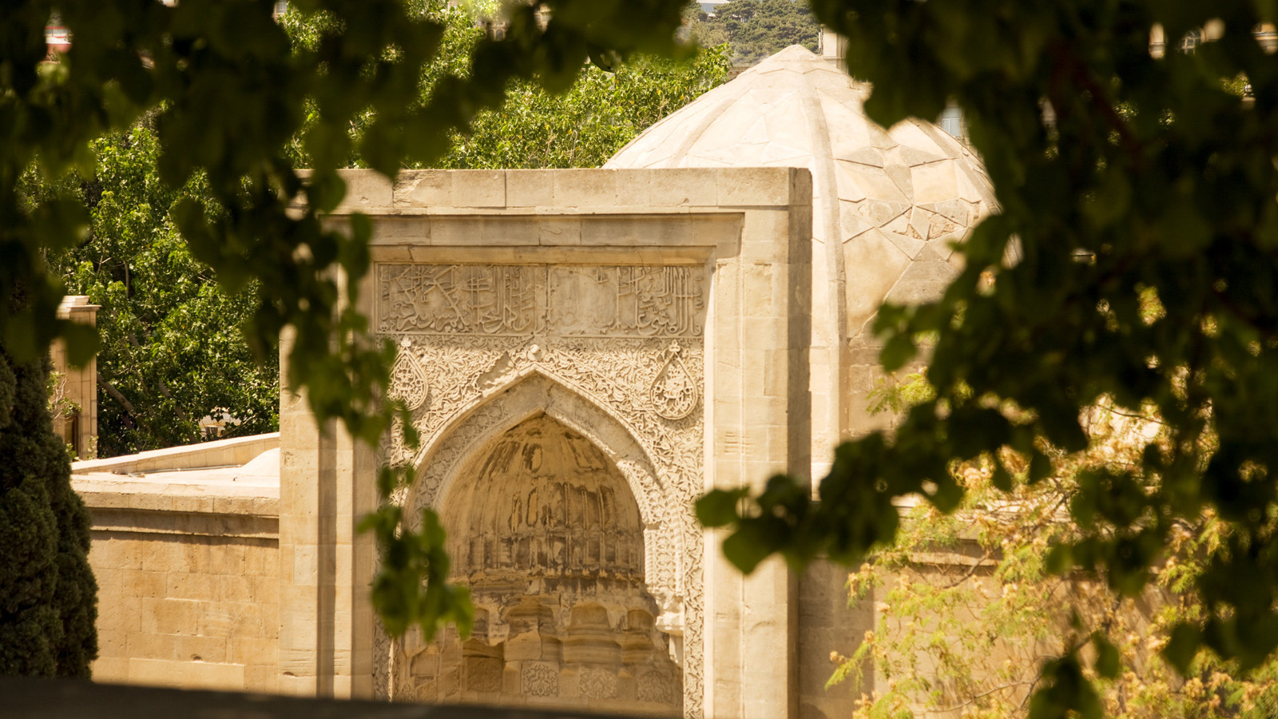 | 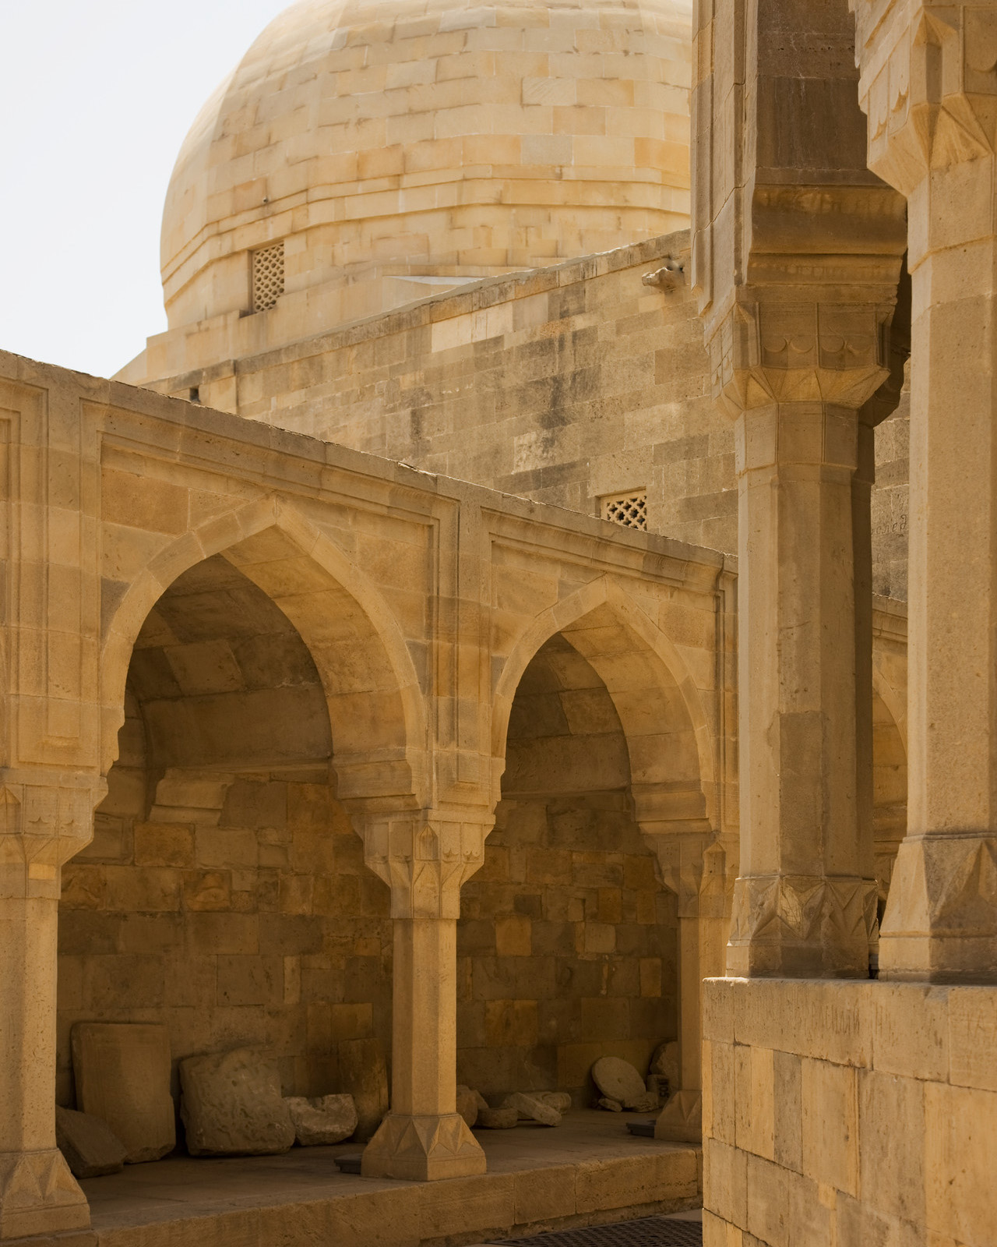
Overlooking the Old City, some of the rooms of Four Seasons Hotel Baku offer guests an opportunity to see to the most historical part of Baku right from their balconies.
Located just few steps away from the Hotel, Old City is definitely one of those places you cannot get enough of. With its beautiful maze of alleys one can wonder around for hours; museums; mosques; hamams; palaces and monuments like Maiden Tower dated back to the 12th century; Old City was the first place in the whole country to be inducted to the UNESCO World Heritage Site in 2000.
The radiance of Old City lies in the mix of its architecture which mirrors its long history. It’s worth mentioning that “Icheri Sheher” (the Inner City, as locals call it) is still a residential area with homes to more than 1,000 families. While exploring its cozy little streets, one may feel the warmth of Azerbaijani people and observe both how they live today and how they lived centuries ago: children playing with each other; neighbors sitting on benches and enjoying good old backgammon with a hot tea on side in a pear shaped glass, and of course, the most common residents of this place - cats.
“I think of Icherisheher as of an old friend, who is joyful but also melancholic, always curious, sometimes sad, leaving you with a longing to come back to talk and to get to know him better,” says Public Relations Manager of the State Administration of Historical-Architectural Reserve "Icherisheher," Zeynab Jahan.
Maiden Tower
Being known as one of the symbols of Baku – the Maiden Tower is located right in front of the Old City. This exceptional eight floor pillar overlooking the Caspian Sea has quite a story to tell its visitors. The Maiden Tower is covered with various legends and tales: from dramatic love stories to historical fictions. Currently it houses a museum, which presents the story of historic evolution of Baku. It is highly recommended to climb the tower as the views from the roof takes in the alleys and minarets of the whole Old City and not only.
The Palace of the Shirvanshahs
The second biggest monument of the Inner City was described by the UNESCO as “one of the pearls of Azerbaijan’s architecture”. This complex is a must-see due to its rich history and again, the stunning view of Baku from the hilltop.
Though the history of the palace dates back to 9th century, the prosperity of the Shirvanshah Palace falls to the 14th-13th centuries, when the capital of Shirvanshahs (the dynasty known for their commitment to support culture, existing longer than any other dynasty in Islamic World) was moved from Shamakhi to Baku.
The parts of the Shirvanshah complex were not created at the same time: instead each section was added on different levels, 5.6 metres (18 feet) above one another as the need arose. Despite this fact, they group well as the architects of each building relied on the traditions of one school.
Hospitality of the Old City
There is more to stumble on in the Old City as it is full of hidden treasures: the ceramics center of the artist Mir-Teymur Mamedov; Baku Marionette Theatre; Museum of Miniature Books; home museums of well-known Azerbaijani musicians, artists and poets.
The Concierge team of Four Seasons Hotel Baku will gladly assist each guest who would like to learn more about this unique place located right behind the hotel.
Plan an unforgettable trip to Baku with special offers from Four Seasons Hotel Baku and enjoy the Old City to the fullest.

RELATED

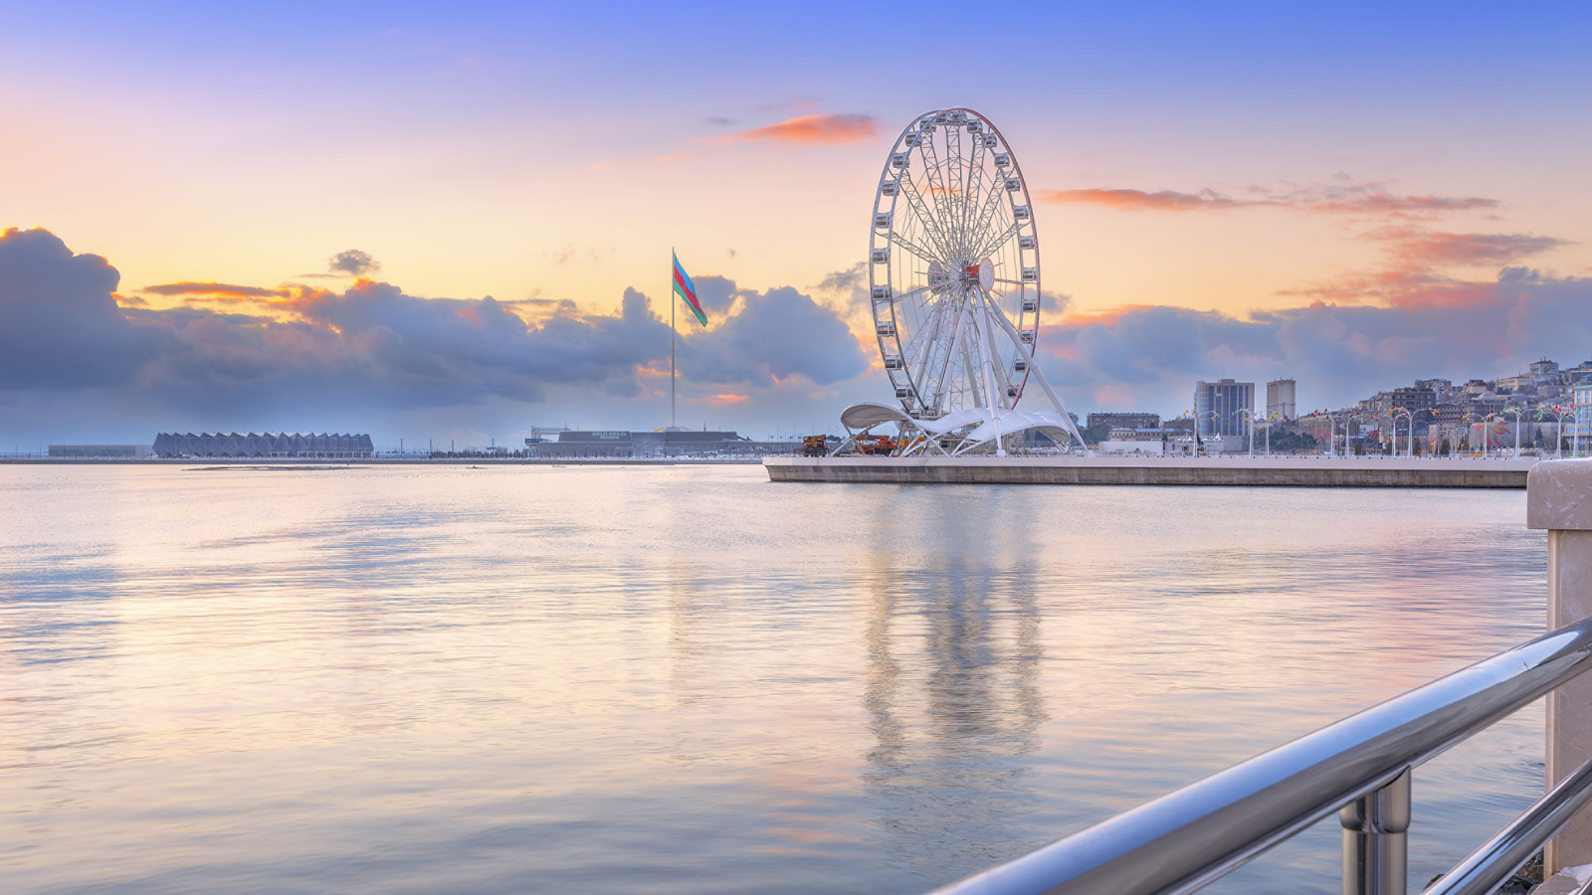 | July 23, 2019, Baku, Azerbaijan  This Summer Discover the Best of Baku with Special Offers from Four Seasons Hotel Baku  https://publish.url/baku/hotel-news/2019/summer-offers.html
July 23, 2019, Baku, Azerbaijan
Насладитесь бакинским летом, воспользовавшись специальным предложением от Four Seasons Hotel Baku
https://publish.url/ru/baku/hotel-news/2019/summer-offers-2.html

PRESS CONTACTS

Leila Aliyeva
Public Relations Manager
1, Neftchilar Avenue
Baku
Azerbaijan
leila.aliyeva@fourseasons.com

+994 12 404 2424

