Swim with the World’s Largest Known Population of Mantas at Four Seasons Resort Maldives at Landaa Giraavaru

Resort places guests in the heart of the action with “Manta Hot Dates”
August 29, 2022, Maldives at Landaa Giraavaru, Republic of Maldives

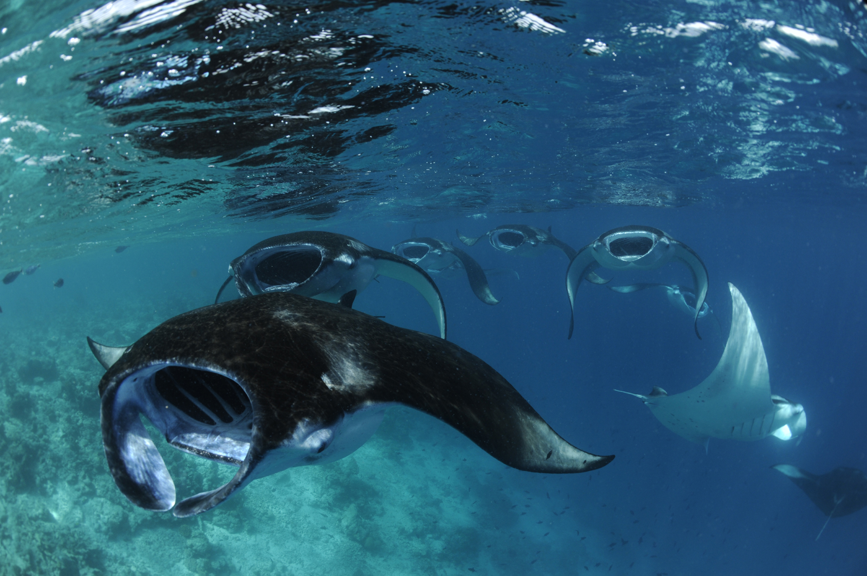
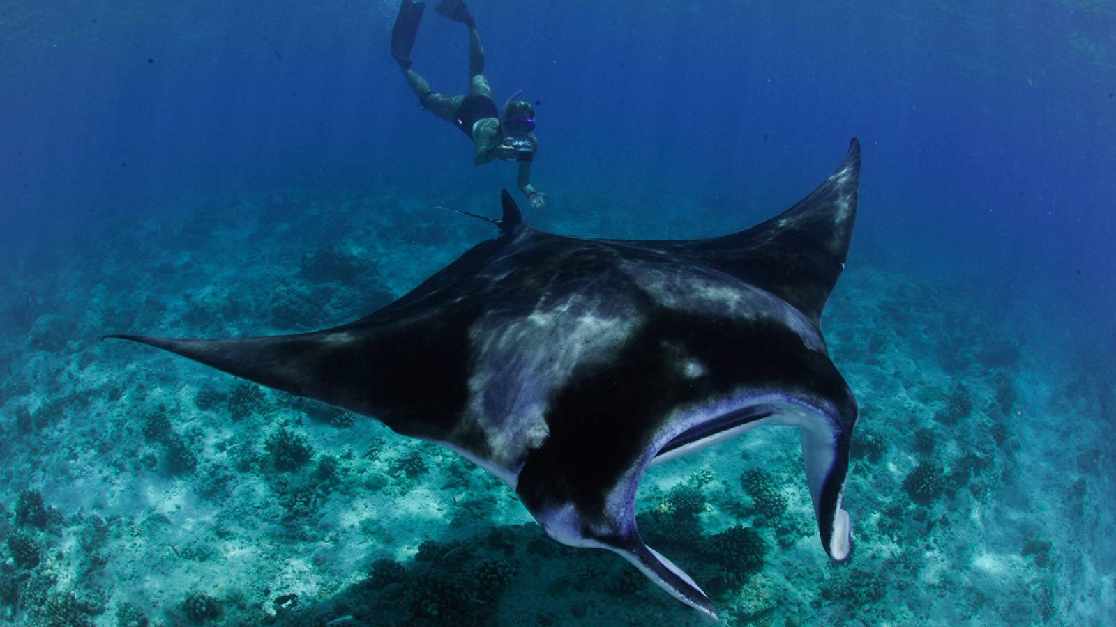 | 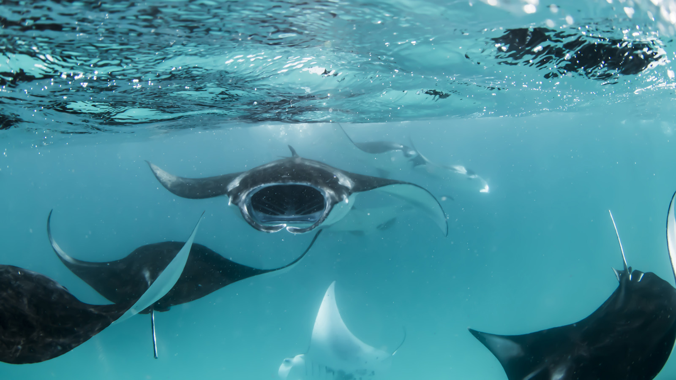
It’s that time of year again, when the seasonal plankton-rich currents in the Baa Atoll UNESCO Biosphere Reserve attract the world’s largest known population of manta rays for a feeding frenzy. And Four Seasons Resort Maldives at Landaa Giraavaru – the birthplace of worldwide charity, The Manta Trust – is the best place to stay to experience this breath-taking phenomenon.
If last year’s manta ray season is anything to go by, an incredible treat awaits manta ray spotters. The Manta Trust, whose researchers run The Maldivian Manta Ray Project (MMRP) at Four Seasons Landaa Giraavaru, broke records in 2021 with the highest number of estimated sightings in a research season: 7,248 between May and November with September seeing 2,045 sightings alone, the first time that recorded estimated sightings have exceeded 2,000 in a single month in the Maldives. In addition, MMRP added 207 new mantas (those seen for the first time) to its database, taking the total recorded Maldivian mantas rays to an awe-inspiring 5,312: the world’s largest-known population.
“It’s an absolute privilege to share the wonder of these incredible creatures with guests at Landaa Giraavaru,” comments Beth Faulkner of the Maldivian Manta Ray Project. “Education is highly important to us. To meet a manta is life-changing and inspires a desire to take care of our ocean’s gentle giants – that’s our goal.”
Making the Most of Each Manta Moment
There are many more ways that guests can interact with mantas during their stay at Landaa Giraavaru. The Resort’s Manta-on-Call service supplies guests with a "manta phone" that rings when mantas are sighted nearby, before a speedboat whisks them to the site for an incredible open water snorkelling experience.
It's because of the in-depth research undertaken – including analysis of monsoon currents and other predicting factors – that MMRP is able to gain an insider’s perspective on mass aggregation dates. The result? The following hot dates for 2022 – the times when large groups of manta rays are most likely to be seen in the waters around Landaa Giraavaru:
- August 25-29
- September 8-12
- September 24-28
- October 8-12
- October 23-27
- November 6-10
- November 22-26
Note that manta ray sightings are subject to weather conditions and the temperament of these gentle giants.
To book a stay at Four Seasons Landaa Giraavaru and swim alongside manta rays this season, click here, email: reservations.mal@fourseasons.com or call the Central Reservations department at tel: (960) 66 00 888.

RELATED

October 11, 2023, Koh Samui, Thailand
Celebrating the Island of Lights and Dazzle at Four Seasons Resort Koh Samui
https://publish.url/kohsamui/hotel-news/2023/festive-season.html

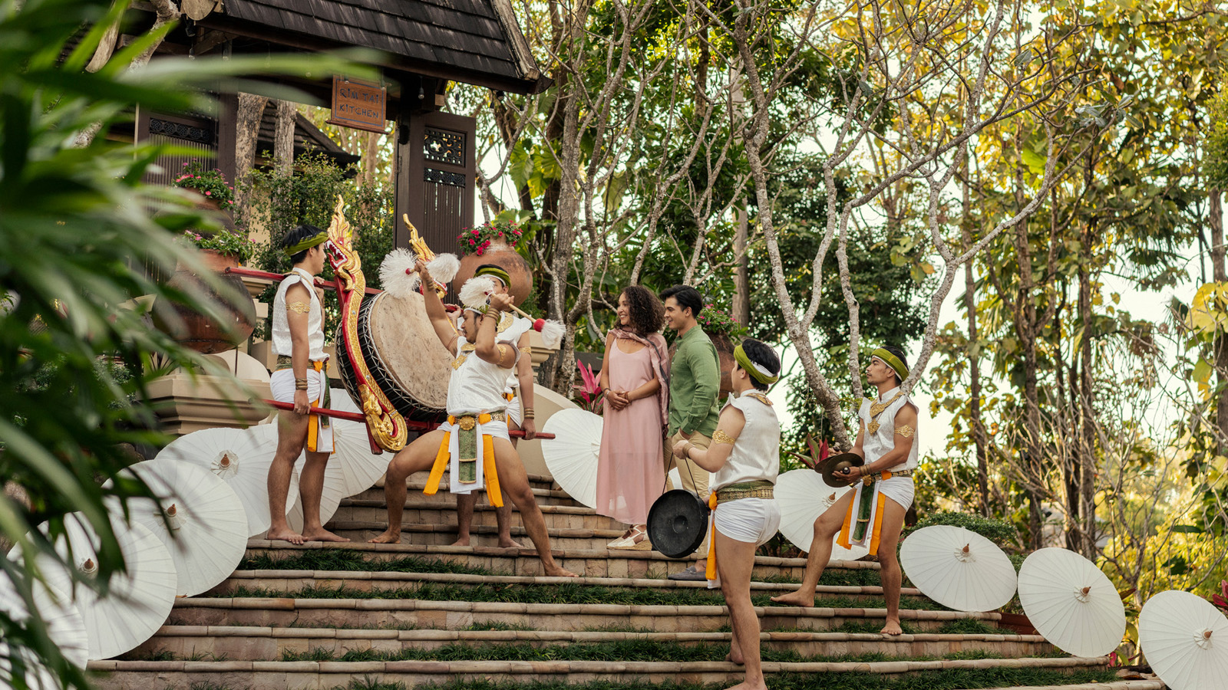 | October 10, 2023, Chiang Mai, Thailand  Countryside Festivities and Lanna Charm Await at Four Seasons Resort Chiang Mai  https://publish.url/chiangmai/hotel-news/2023/festive-season.html

PRESS CONTACTS

Juliana Ang
Senior Director of Public Relations and Communications
Tourism Court, #04-00, 1 Orchard Spring Lane
Singapore
247729
juliana.ang@fourseasons.com

(65) 6514 82 81

