Love at First Bite This Valentine’s Day at Four Seasons Hotel Singapore

January 21, 2022, Singapore

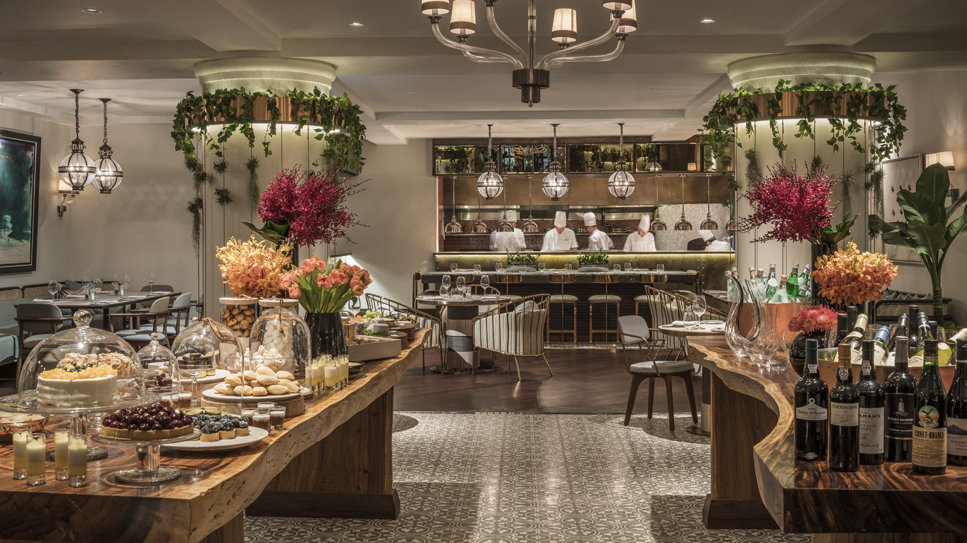
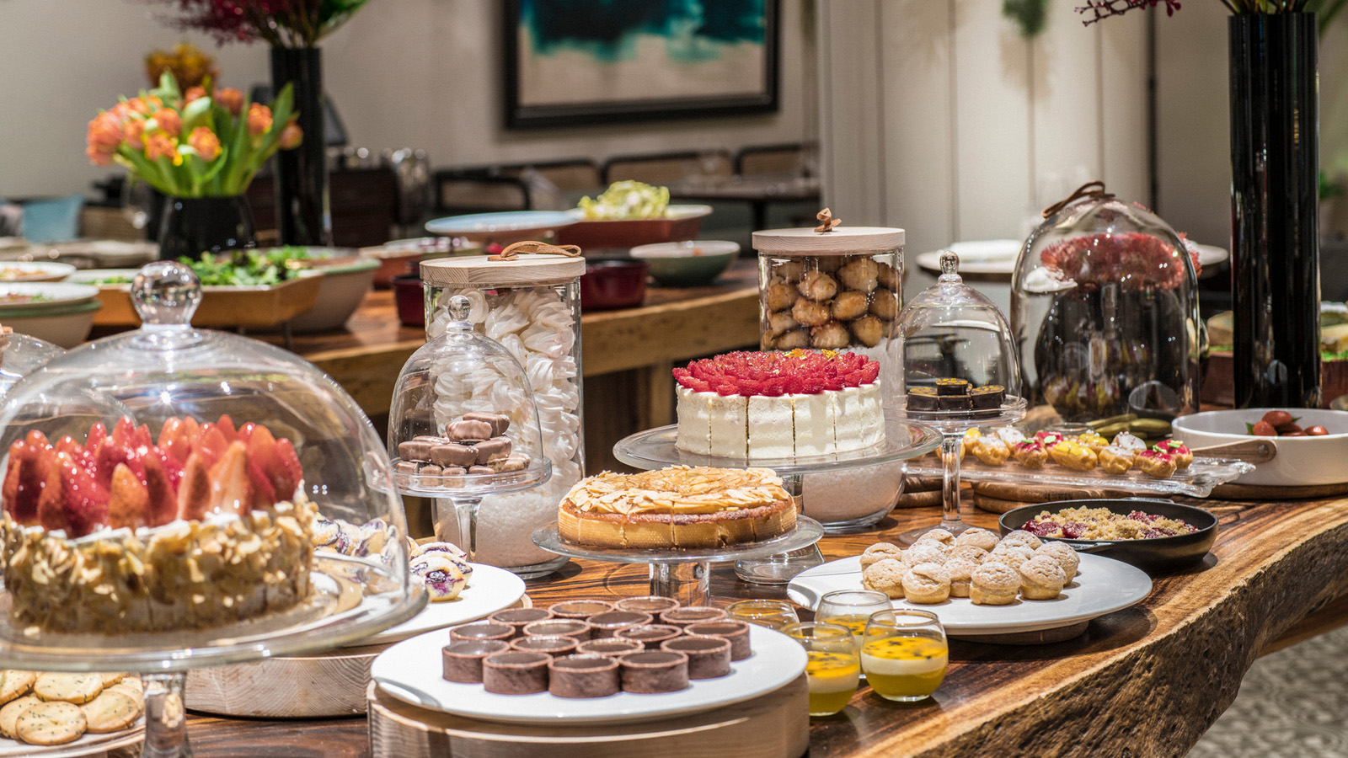
Let sparks fly over an alluring three-act menu for two designed by French-Vietnamese Chef de Cuisine Pierre Barusta, himself hailing from the city of love, at the botanical modern brasserie One-Ninety at Four Seasons Hotel Singapore.
Toast to Cupid’s favourite day of the year with a prelude of craft Valentine’s cocktails by the enigmatic duo of One-Ninety Bar, Gabriel Carlos and Sophia Kang.
Indulge the evening away with a luscious seafood tower adorned with a handpicked selection of freshly shucked French oysters, tuna tartare, Hokkaido scallop carpaccio, and hamachi tiradito. For a pop of luxury, ossetra prestige caviar can be included too if wished, at a supplement.
For mains, savour a classic tender roasted veal tenderloin, pan-seared wild sea bass and mussels from the Atlantic, or pumpkin Acquerello risotto with black truffle and pecorino cheese.
Bring the evening to an elegant finale with a spread of dessert and treats from the buffet by Executive Pastry Chef Audrey Yee, a Four Seasons veteran and graduate of the renowned Le Cordon Bleu School in London.
Valentine’s Day Dinner is available at One-Ninety, February 13 and 14, 2022, 6:00 to 10:30 pm from SGD 248 per couple, with an option for unlimited Taittinger Brut Réserve NV and selected wines at a supplement.
For reservations, call 6831 7250, book online or email one-ninety.sin@fourseasons.com

*All prices stated above are subject to prevailing government taxes and service charge.

RELATED

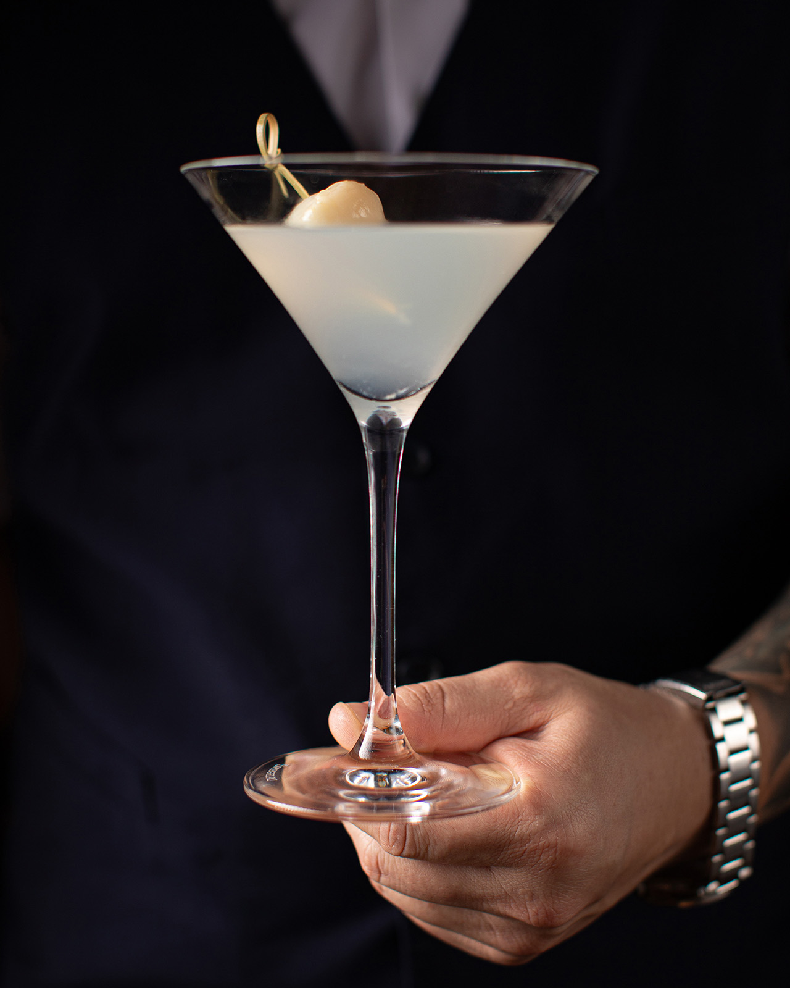 | November 9, 2023, Singapore  Nobu Bar Presents: Social Hours Sundowner Sips at Four Seasons Hotel Singapore  https://publish.url/singapore/hotel-news/2023/nobu-bar-social-hours.html
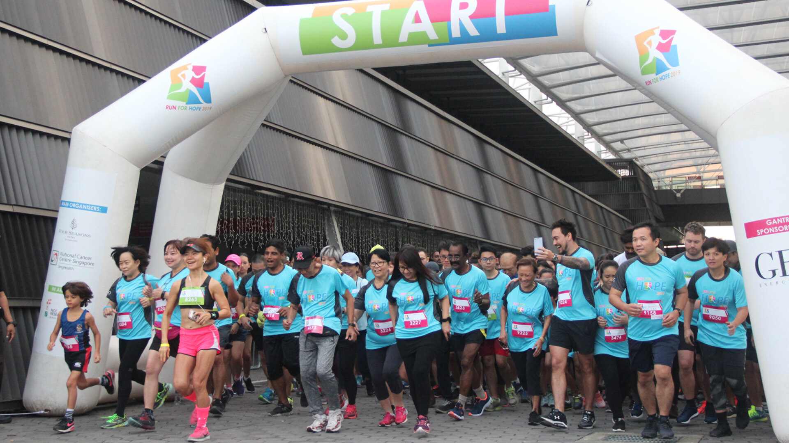 | October 24, 2023, Singapore  Run For Hope 2023 Marks 30 Years of Raising Funds for Cancer Research Through Annual Run Organized by Four Seasons Hotel Singapore  https://publish.url/singapore/hotel-news/2023/run-for-hope.html

PRESS CONTACTS

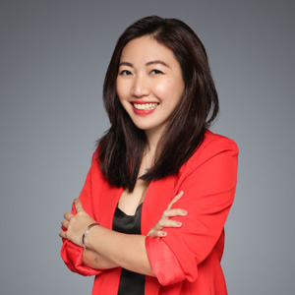 | Andreana Soh  Director of Public Relations and Communications  190 Orchard Boulevard  Singapore  Singapore  andreana.soh@fourseasons.com  (65) 6831 7130

