Pranic Psychoterapist and Healer Raaj Nair at AyurMa

Visiting Master at Four Seasons Resort Landaa Giraavaru from January 20 to February 16, 2023
November 8, 2022, Maldives at Landaa Giraavaru, Republic of Maldives

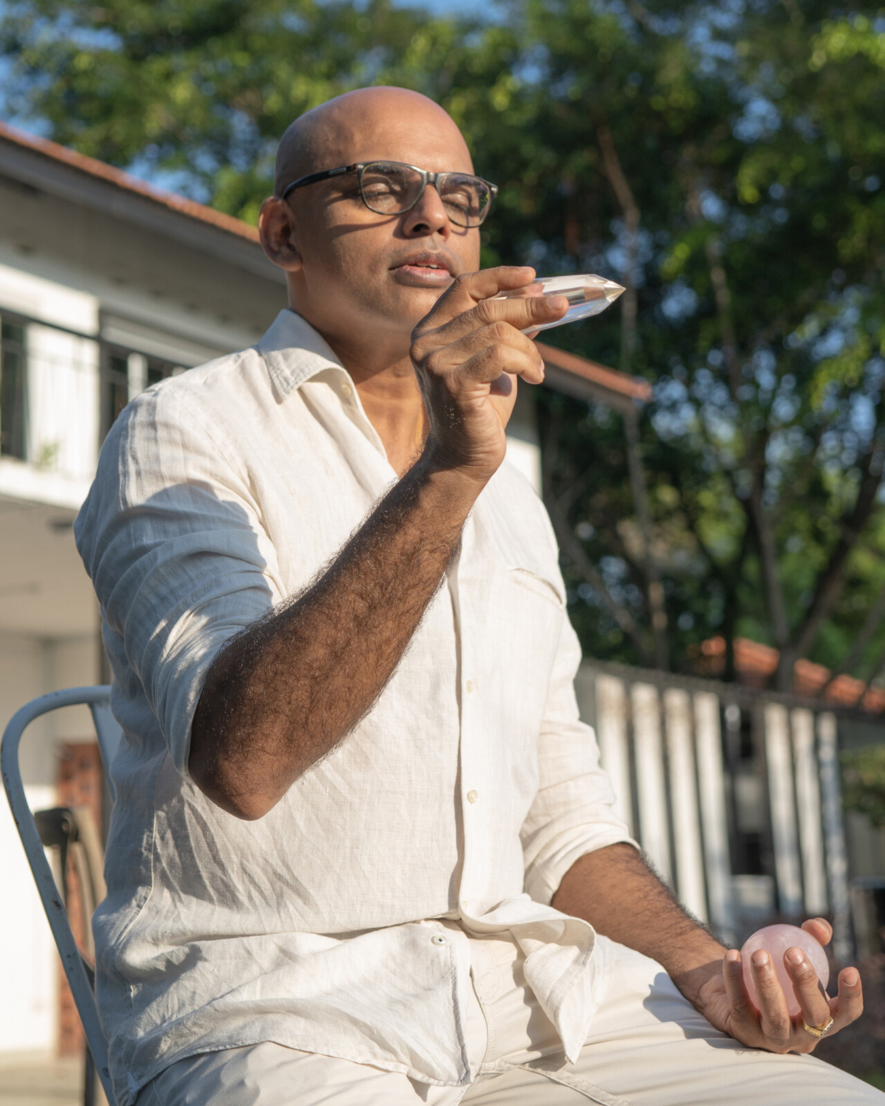
AyurMa’s heartfelt health haven – the evolution of 15+ years of wellbeing innovation at Four Seasons Resort Maldives at Landaa Giraavaru – offers unique individual and shared experiences spanning Ayurveda, Yoga Therapy, Wellness and Planetary Wellbeing, designed to cultivate care for ourselves, others, the oceans and the entire planet.
As part of its offerings, AyurMa’s Visiting Masters program connects guests to industry-leading wellness practitioners specialising in areas ranging from Pranic Healing to Elemental Acupuncture.
From January 20 to February 16, 2023, AyurMa will be hosting visiting master Raaj Nair, Pranic Psychotherapist and Healer. From the resolution of old trauma through Pranic ("life energy") Psychotherapy to the release of emotions through crystal spa treatments, Raaj’s intuitive approach is a powerful blend of the practical and spiritual.
Raaj has trained with some of the world’s most acclaimed practitioners – including Masters of Pranic Healing – using the teaching of one of the foremost energy Masters, Grand Master Choa Kok Sui. His Pranic Psychotherapy sessions address a variety of mental health conditions including depression, trauma, obsession, and addiction, and can also be used to improve communications and address long-standing challenges between couples.
Rates
- Crystal Spa (30 minutes) – USD 275++
- Pranic Facial (60 minutes) – USD 325++
- Pranic Healing (75 minutes) – USD 350++
- Pranic Psychotherapy (90 minutes) – USD 375++
Explore AyurMa’s upcoming line-up of Visiting Masters.
To book a transformative experience with Raaj Nair, click here, email: reservations.mal@fourseasons.com or contact the Central Reservations Department at tel: (960) 66 00 888.

RELATED

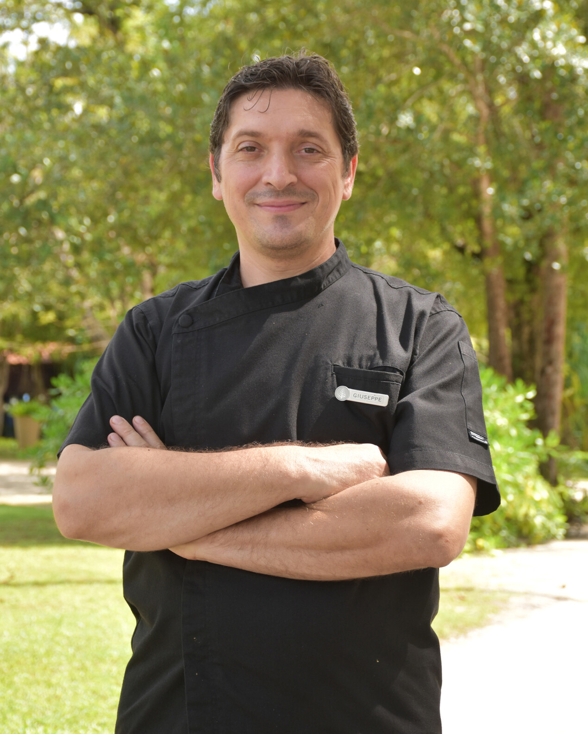 | November 8, 2022, Langkawi, Malaysia  Four Seasons Resort Langkawi Appoints Giuseppe Pucciarelli as Executive Chef  https://publish.url/langkawi/hotel-news/2022/new-executive-chef-giuseppe-pucciarelli.html
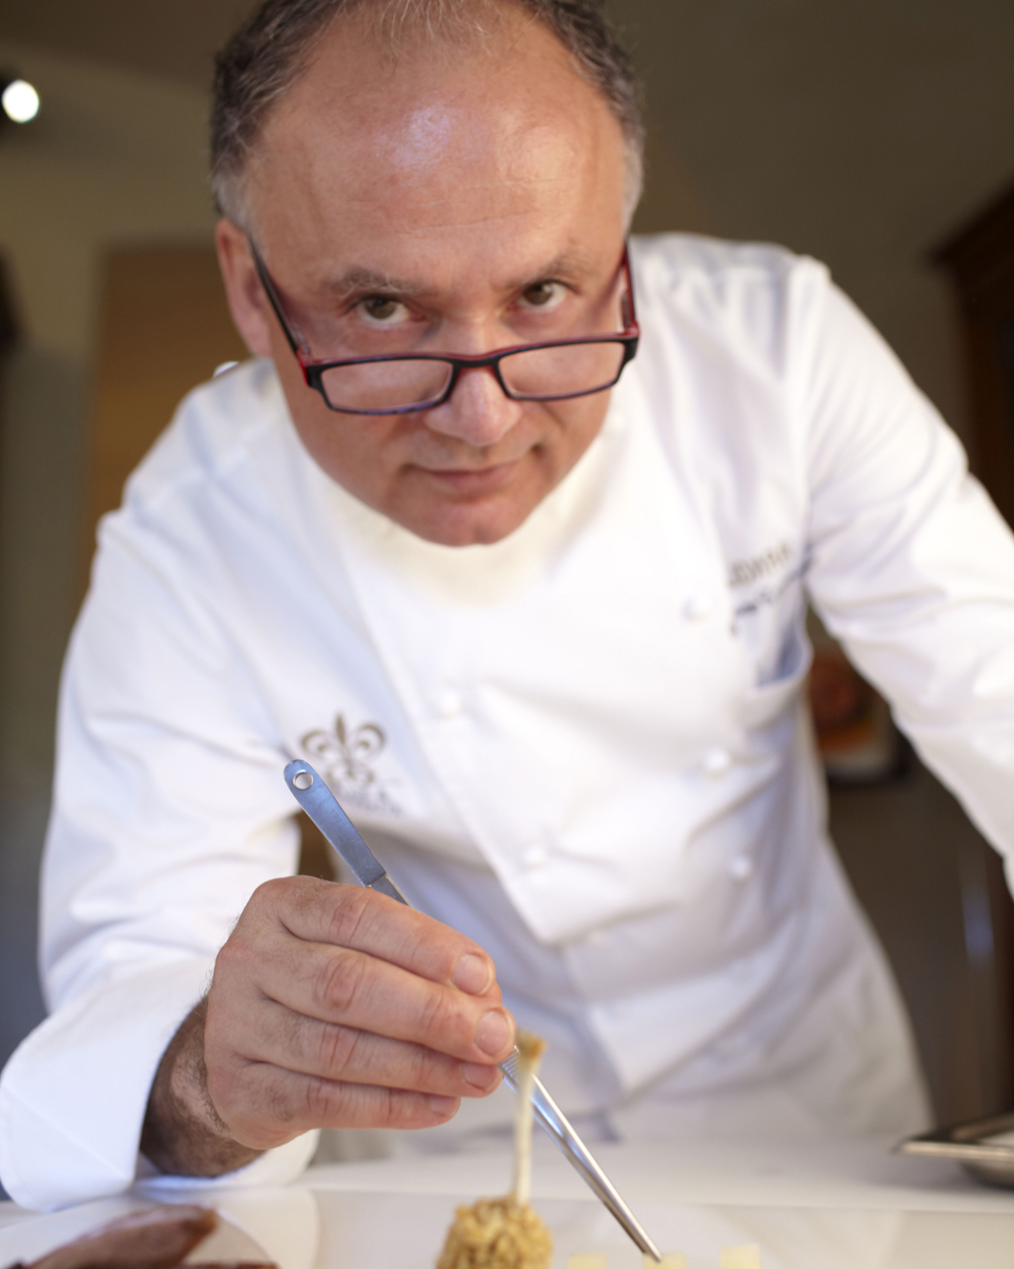 | November 4, 2022, Maldives at Landaa Giraavaru, Republic of Maldives  Two Michelin-Starred Chef Gaetano Trovato Returns to Four Seasons Resort Maldives at Landaa Giraavaru This November to Launch New Menu Celebrating 40 Years of Arnolfo Culinary Artistry  https://publish.url/maldiveslg/hotel-news/2022/new-experiences-with-chef-gaetano-trovato.html

PRESS CONTACTS

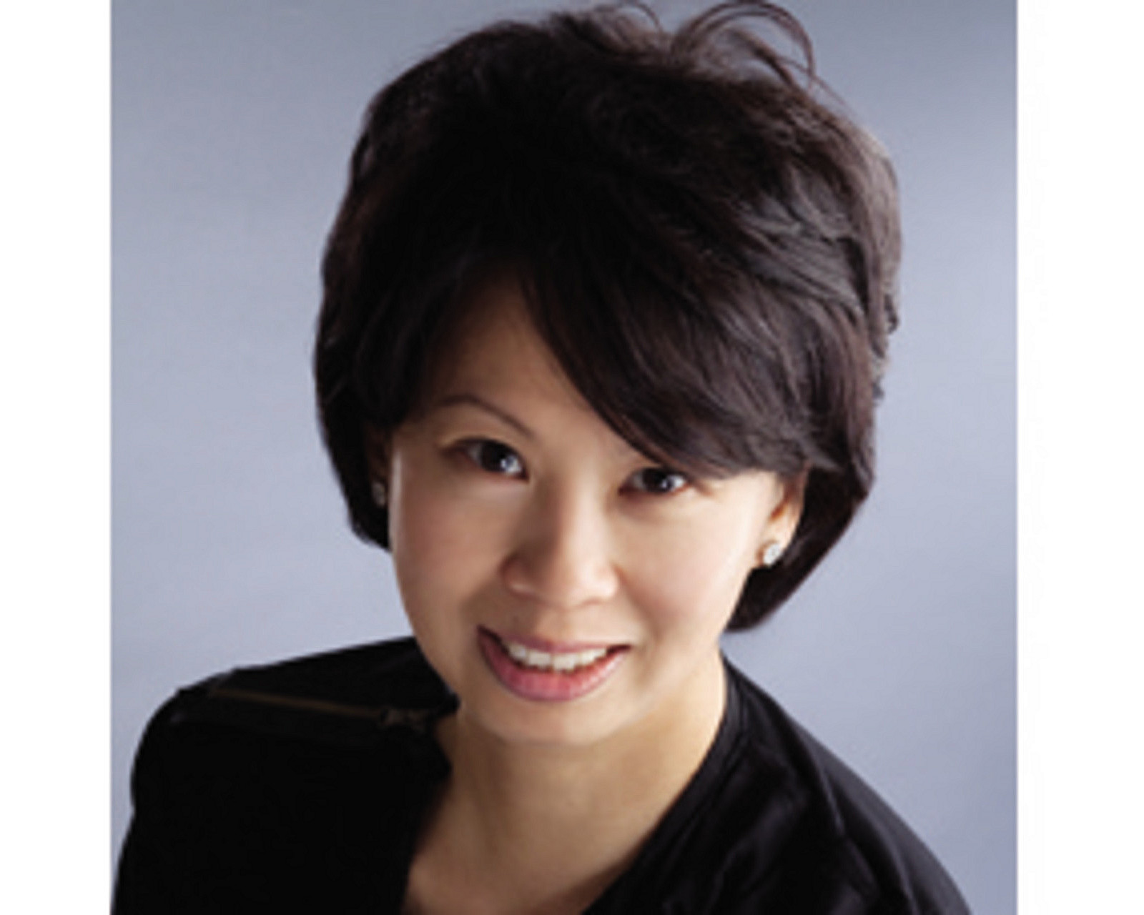 | Juliana Ang  Senior Director of Public Relations and Communications  Tourism Court, #04-00, 1 Orchard Spring Lane  Singapore  247729  juliana.ang@fourseasons.com  (65) 6514 82 81

